GENERAL CONFEDERATION OF LABOR OF VIETNAM

**TON DUC THANG UNIVERSITY**

**FACULTY OF INFORMATION TECHNOLOGY**



**REPORT OF TOOL WEBRTC JITSI**

*Instructing Lecturer*: **MSc NGUYỄN QUỐC BÌNH**

*Student’s name*: **TRƯƠNG BÙI QUỐC DUY – 518H0617**

**LÊ MINH ĐỨC - 518H0335**

**PHẠM VĂN TUÂN – 518H0680**

**NGUYỄN TRUNG TÍN – 518H0674**

**NGUYỄN VÕ KHÁNH DUY – 518H0086**

*Class* **: 18H50302**

*Course*  **: 22**

**HO CHI MINH CITY, 2020**

GENERAL CONFEDERATION OF LABOR OF VIETNAM

**TON DUC THANG UNIVERSITY**

**FACULTY OF INFORMATION TECHNOLOGY**



**REPORT OF TOOL WEBRTC JITSI**

**Instructing Lecturer: Mr Lê Ngọc Thạch**

**Student’s name: TRƯƠNG BÙI QUỐC DUY – 518H0617**

**LÊ MINH ĐỨC - 518H0335**

**PHẠM VĂN TUÂN – 518H0680**

**NGUYỄN TRUNG TÍN – 518H0674**

**NGUYỄN VÕ KHÁNH DUY – 518H0086**

*Class* **: 18H50302**

*Course*  **: 22**

**HO CHI MINH CITY, 2020**

ACKNOWLEDGEMENT

I would like to send my sincere thanks and deep gratitude to the teachers of the school Ton Duc Thang University. Especially the teachers in the my faculty information technology. The school has allowed me to practice in the faculty to have more time for my thesis. And I would also like to thank the teachers Mr Lê Ngọc Thạch enthusiastically guided me to complete the internship well.

In the process of internship and report making internships, due to limited knowledge and practical experience, the report cannot avoid shortcomings, I hope to receive suggestions from teachers. for me to learn a lot of skills, experience and will complete better the upcoming graduation report

Thank you sincerely!

**THE ASSIGNMENT IS COMPLETED AT TON DUC THANG UNIVERSITY**

I guarantee that this is my assignment and under the guidance of the teacher

Mr Lê Ngọc Thạch;. The content and research results in this topic are honest and have not been published in any way before. The figures in the tables serving the analysis, comments and assessments were collected by the author himself from different sources specified in the references.

In addition, the project also uses a number of comments, reviews as well as data from other authors, organizations and agencies that have cited and annotated the source.

**If any fraud is detected, I am fully responsible for the content of my project.** Ton Duc Thang University is not related to copyright and copyright infringement caused by me during the implementation process (if any).

*Ho Chi Minh City, May 11, 2020*

*Author*

*(sign and clearly state full name)*

*Trương Bùi Quốc Duy*

*Lê Minh Đức*

*Phạm Văn Tuân*

*Nguyễn Trung Tín*

*Nguyễn Võ Khánh Duy*

**EVALUATION OF INSTRUCTING LECTURER**

**Confirmation of the teacher instructor**

_______________________________________________________________________________________________________________________________________________________________________________________________________________________________________________________________________________________________________________________________________________________________________________________________________________

Ho Chi Minh City, May 11, 2020

(Sign and write full name)

**The assessment of the teacher marked**

_______________________________________________________________________________________________________________________________________________________________________________________________________________________________________________________________________________________________________________________________________________________________________________________________________________

Ho Chi Minh City, May 11, 2020

(Sign and write full name)

SUMMARY

TABLE OF CONTENTS

ACKNOWLEDGEMENT i

SUMMARY iv

TABLE OF CONTENTS 1

LIST OF FOMULAS, PICTURES, GRAPHS 2

CHAPTER 1 – REQUIREMENTS ENGINEERING 3

CHAPTER 2 – JITSI VIDEOBRIDGE DESIGN 5

LIST OF FOMULAS, PICTURES, GRAPHS

**LIST OF FOMULAS**

No table of figures entries found.

**LIST OF PICTURES**

Picture 1: Application Stack 5

**LIST OF GRAPHS**

**No table of figures entries found.**

CHAPTER 1 – REQUIREMENTS ENGINEERING

* 1. **Introduction**

Jitsi is a set of open-source projects that allows you to easily build and deploy secure videoconferencing solutions. At the heart of Jitsi are Jitsi Videobridge and Jitsi Meet, which let you have conferences on the internet, while other projects in the community enable other features such as audio, dial-in, recording, and simulcasting.

Jitsi started life as a way to talk to people over the internet using audio and video. Over the course of a decade, though, it’s become so much more. Today, Jitsi is:

* A vibrant developer community.
* The foundation of some really amazing products.
* A crazy-good, completely free video conferencing solution that anyone can use.
  1. **Mission**
* Unlike other videoconferencing technologies, Jitsi Videobridge, the heart of Jitsi, passes everyone’s video and audio to all participants, rather than mixing them first.
* The result is lower latency, better quality and, if you are running your own service, a much more scalable and inexpensive solution.
* Jitsi is compatible with WebRTC, the open standard for Web communication.
* Jitsi supports advanced video routing concepts such as simulcast, bandwidth estimations, scalable video coding and many others.
* Ubuntu and Debian packages for easy installation.
  1. **Project Scope**

- Requirements management planning: Gather requests required by the collection team to take on this job, report requests, check requirements, remove requests.

- Collect requirements: Identify the requirements to collect, the aspirations of the people involved. Provides the means for product improvement to add scope to the project.

- Scope: Detailed product description, project description. Determine requirements within the system, requirements outside the system.

Work division structure: Split finished products, hand over parts to working parts, provide an overview of the system's structure.

- Control the scope: Monitor the status of the system, speed up the progress and quality of each stage, and reduce unintended costs.

CHAPTER 2 – JITSI VIDEOBRIDGE DESIGN

**2.1 Overview**

The design of the Rendez-Vous service can be viewed as a WebRTC stack in which each layer involves different stakeholders. When setting up the only thing users need to do is to open their browser and type a URL. We didn’t want it to be any more complicated than that.

The figure below shows our service stack as it was deployed at RENATER :

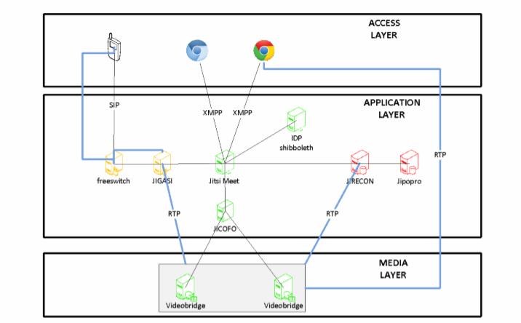

Picture 1: Application Stack

We enter into the WebRTC world with the access layer. This is the area involving browsers or SIP audio devices (forinteroperability). The browser downloads and executes the Jitsi Meet application. This is a Javascript application embedding WebRTC capabilities. The Jitsi Meet application calls the getUserMedia (gUM) and the peer connection API.

It also establishes signaling and managed media sessions with XMPP Jingle.

The application layer is the area where signaling is operated and different processes are involved to provide services such as load balancing, authentication and so on.

When the whole process ends to relate the browser with the Jisti Videobridge (Media Layer), media streams are directly sent between browser and Videobridge without relay while signaling is still held by Jicofo and Prosody services.

**2.2 Jitsi Meet**

This component provides the javascript application and establishes the BOSH transport layer for XMPP signaling.

Then once application is executed and signaling is handled, User always communicate via Jicofo because it is responsible for signaling and relays to the videobridge. Jitsi Meet is useful application with many features such as screen sharing, etherpad for editing documents, multi user chatroom… This application is simple to use and doesn’t require technical skills to be used.

**2.3 Jicofo: JItsi Conference Focus**A Conference Focus is a signaling entity that orchestrates a session. Formerly this role was held by the first participant who joined the room. The process was embedded into the browser, which caused some amount of unreliability. Indeed, it was frequent that browser holding the focus crashed and all participants into the room were kicked off.

As the client-side focus was identified as a source of instability, the role was implemented server side as the Jicofo application. Jicofo currently plays the following roles: JRES 2015 - Montpellier 4/13

1. Managing Colibri channels for participants and establishing media flow to/from the JVB.

2. Bridge load balancing based on conference count.

3. Can handle client authentication (optionally)

4. Takes part in some features implementation like audio muting, recording, SIP calls. It is processing and forwarding client requests to corresponding components. Verifies user permissions: only moderators are allowed to start new SIP call or mute others.

Jicofo is the central signaling component in the system.

**2.4 Jitsi Videobridge**

Jitsi Videobridge acts as media server in the Jitsi infrastructure. This is the core of the system. It implements many features such as simulcast, DTLS/SRTP, Last N, ICE and others.

Before we dive deeper into details let us make sure we are all on the same page with regard to the basics. Different kinds of models are available to stream media, but some of them are more reliable than others.

**Full mesh**

In this model each point is connected to all other points. The main problem with this is that it does not scale. In the figure

below each segment is bidirectional. So, possible combinations increase significantly when adding a node.

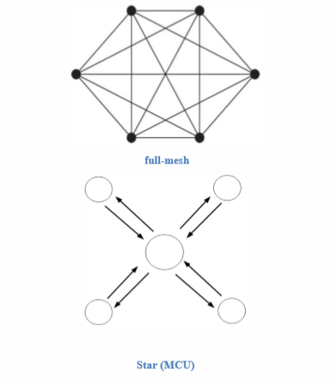

**Traditional MCUs** use a star model. End-points send their streams to the central point and it sends to each of them a stream containing a mix of everyone else’s content.

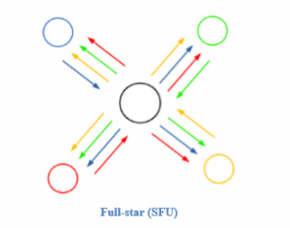

**Selective Forwarding Units (SFUs)** are a third way of approaching media distribution. Similarly to full-mesh architectures, all participants receive independently all streams from everyone else. Contrary to full-mesh apps though, participants in SFU hosted conferences only need to send their outgoing streams once. It is the responsibility of the SFU to then deliver it to everyone else (or at least the participants that are considered appropriate receivers). Also, contrary to an MCU, an SFU does not operate with media. It may inspect and analyse packets but it would never need to implement any encoding, decoding or compositing features. This helps SFUs perform orders of magnitude better than MCUs in terms of CPU consumption. It also eliminates the need for any codec licenses for the SFU.