

**Requirement Analysis and Usability**

**The Group 18**

**Group Members**

**Names Registration No**

Areesh Zahid (**group leader**) 19508

Muhammad Zeeshan Saleem 18003

Sagar Kumar 42256

Muhammad Bilal Shahid 42496

Zaffar Khan 42277

*Submitted to:* **Dr. Mansoor Ebrahim / Ghazala Shafi**

**ERD Diagram**

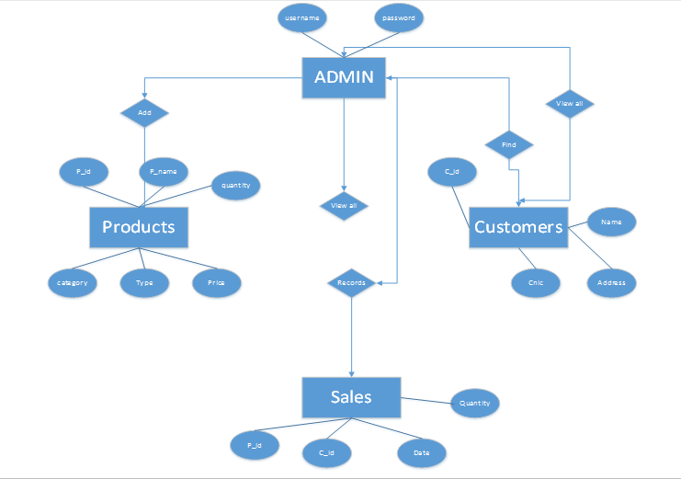

**Use Case Diagram**

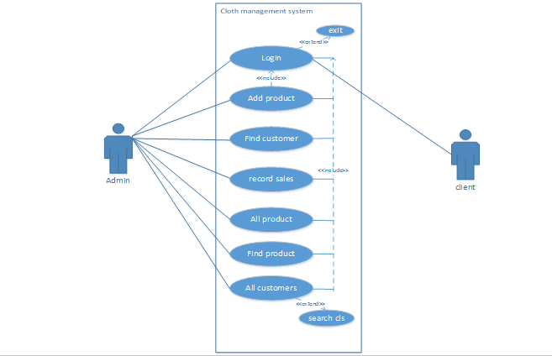

**Actor View Narrative**



**PAPER PROTOTYPING**

**Admin Login:**

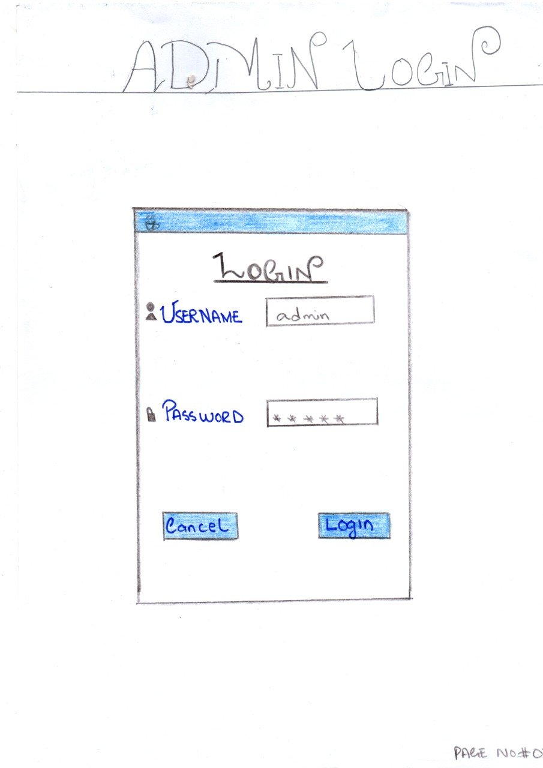

**Home Page:**

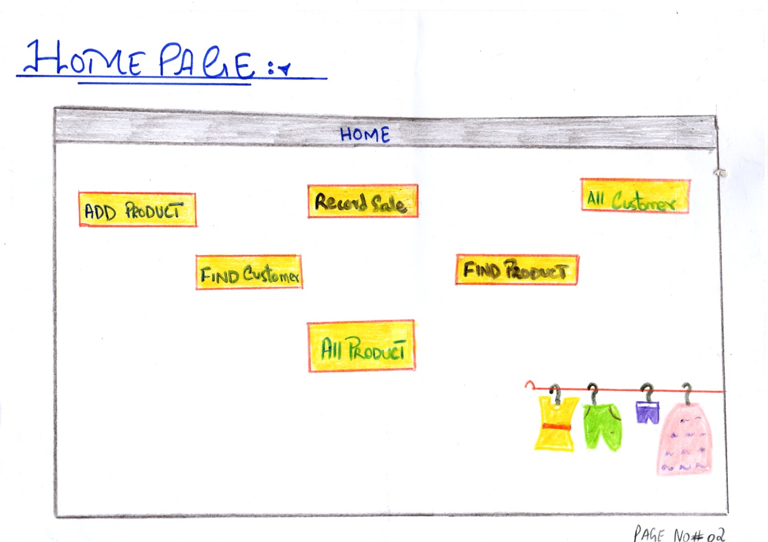

**Add Product:**

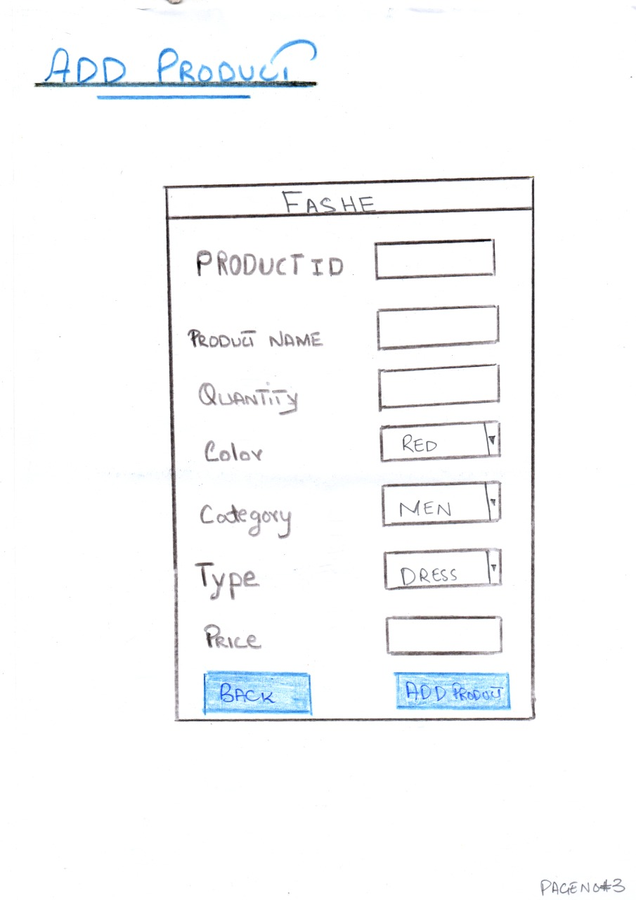

**Au Product:**

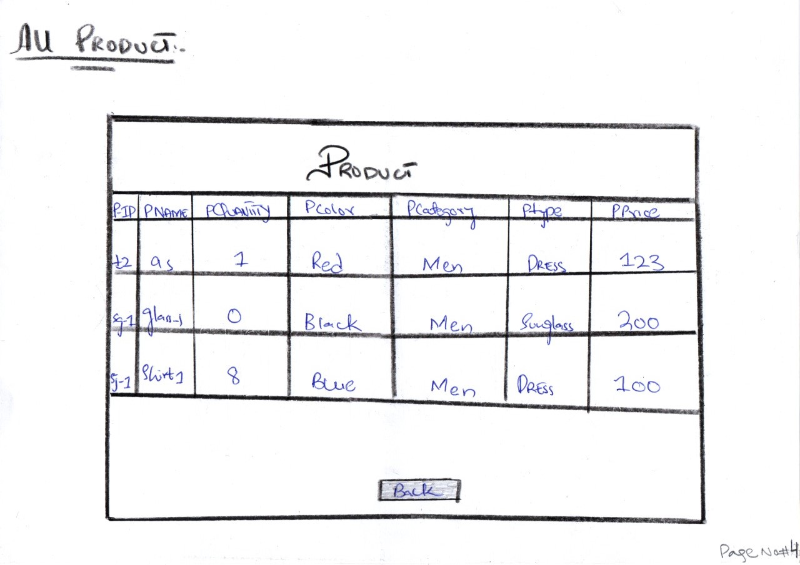

**Find Product:**

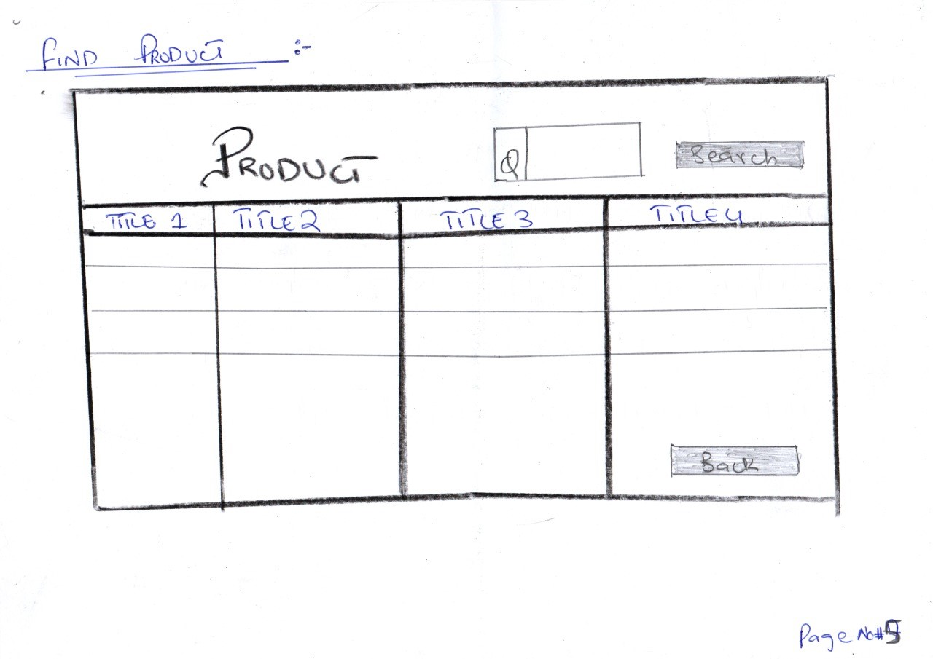

**Customer:**

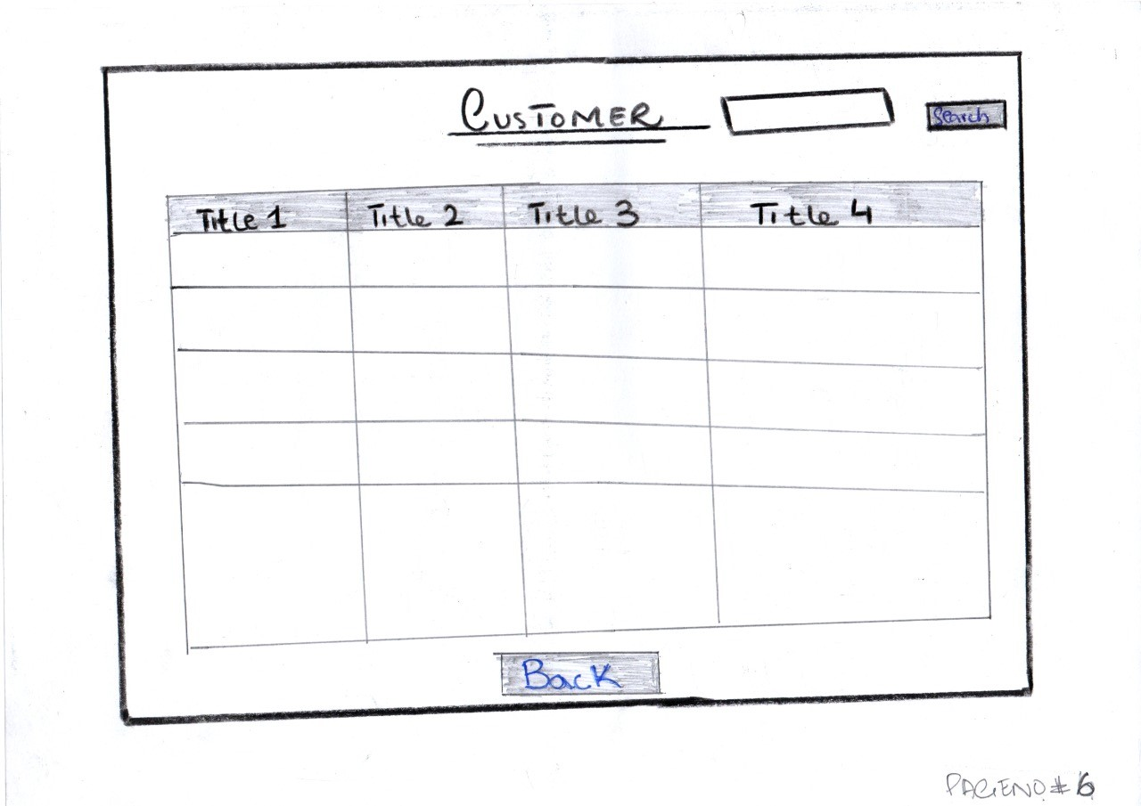

**Au Customers:**

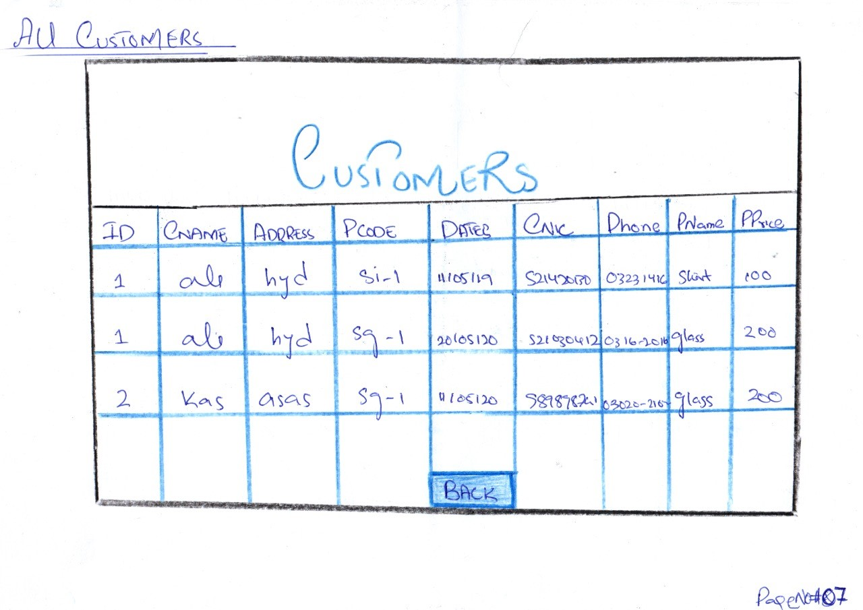

**Record Sales:**

