Software Engineering Lab 8
Selenium Testing
Name: M.Sathyanarayanan
Reg No.: 24BCE1689
Write 5 test cases for my project and execute any two of them using Selenium, and record the execution.
Project: GearVault: equipment rental web application
Website: https://d2wvsbj3dzkosr.cloudfront.net
Tools Used
Selenium IDE 4 (desktop version), Google Chrome, Windows 11
Test Cases
TC ID | Test Case | Steps | Expected Result | Actual Result | Status
TC01 | Sign up as a new customer | 1. Open the login page  2. Click Create account  3. Enter name, email and password  4. Click Create Account | Account is created and the user is logged in. Navbar shows the email and CUSTOMER role. | Same as expected | Pass
TC02 | Login with correct email and password | 1. Sign up and then sign out  2. Enter the same email and password  3. Click Sign In | User is taken to the Equipment Inventory page with the correct email shown. | Same as expected | Pass
TC03 | Login with wrong password | 1. Sign up and then sign out  2. Enter the email with a wrong password  3. Click Sign In | Error "Invalid email or password" is shown and user is not logged in. | Same as expected | Pass
TC04 | Search the catalog without logging in | 1. Click Inventory  2. Select category Cameras  3. Type "Sony A7" in search  4. Click Sony A7 IV | Only matching items are listed and the Sony A7 IV details page opens. | Same as expected | Pass
TC05 | Access a page without permission | 1. As a guest, open /bookings  2. Sign up as a customer  3. Open /analytics | Guest is sent to the login page. Customer gets "403 Access Denied" on the manager page. | Same as expected | Pass

Execution
The test cases were created in Selenium IDE and run against the deployed website. TC01, TC03 and TC04 were executed and recorded. A short pause was added after each step so the actions can be seen clearly in the video. All test cases passed.
Video link: https://drive.google.com/file/d/1A10zaxsSlfkxD9OIeIspgWKUrmTOpHFy/view?usp=sharing
Screenshots
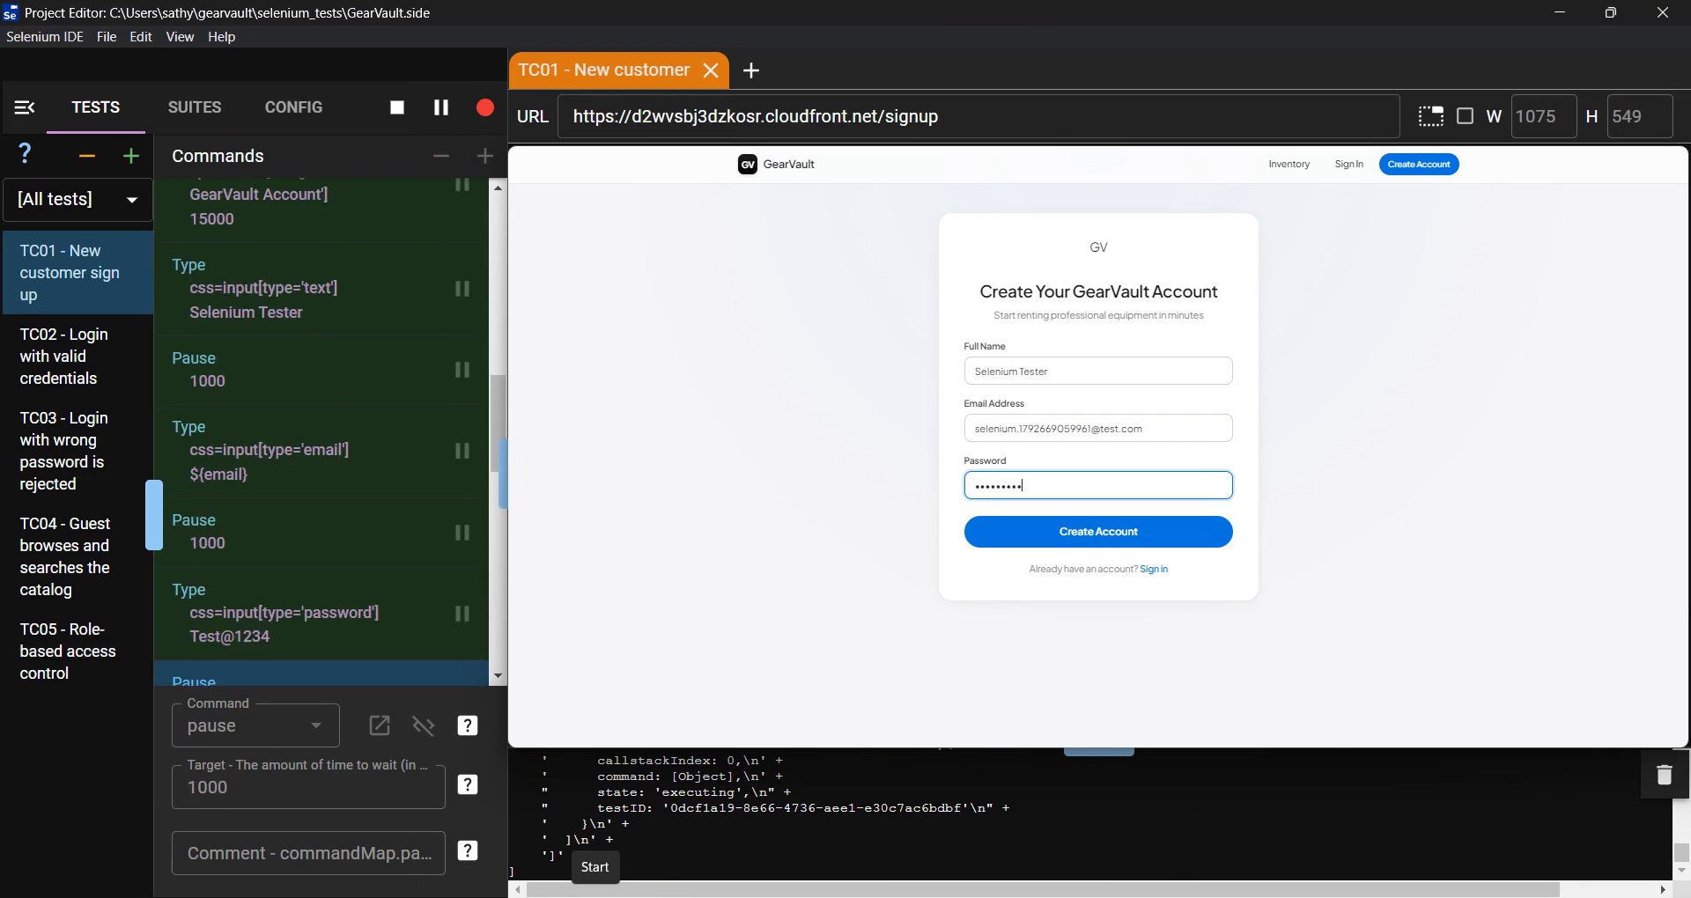
Fig 1: TC01 running in Selenium IDE (filling the sign up form)
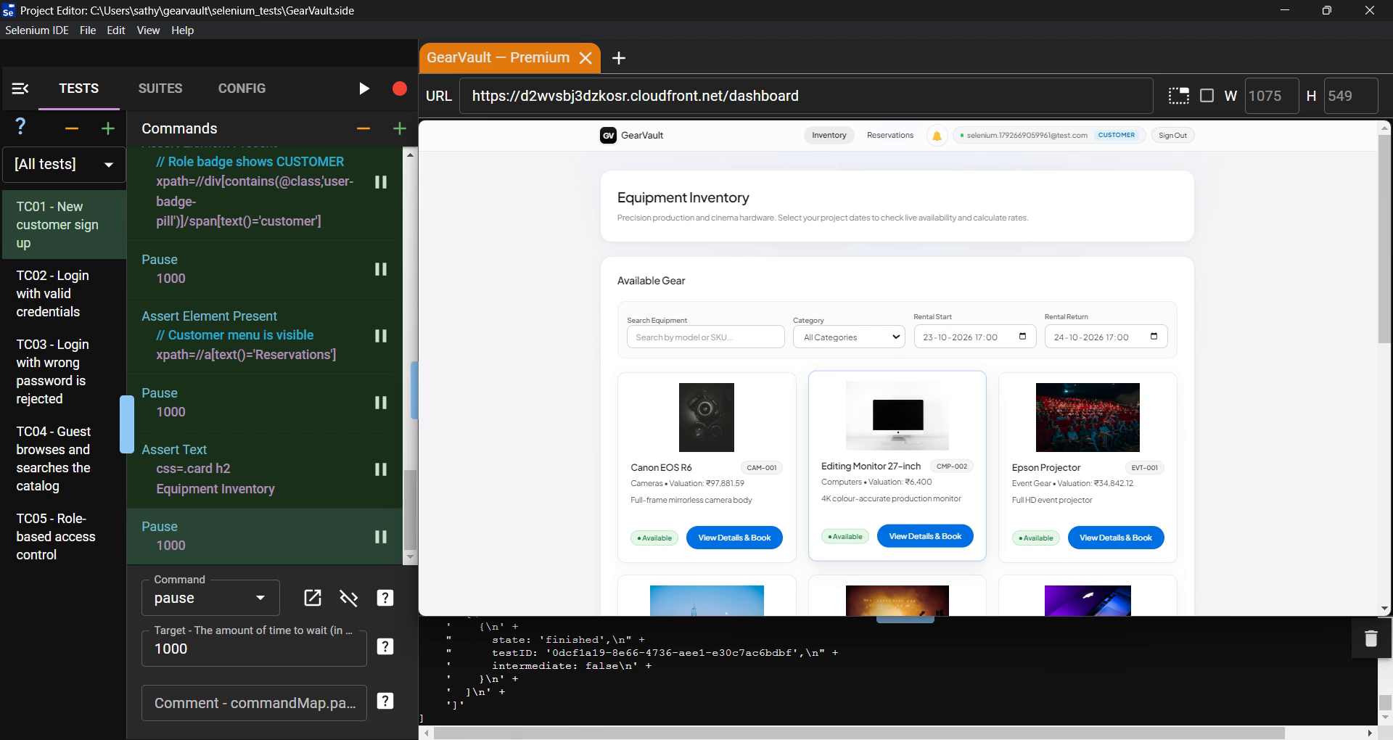
Fig 2: TC01 passed, user logged in as customer
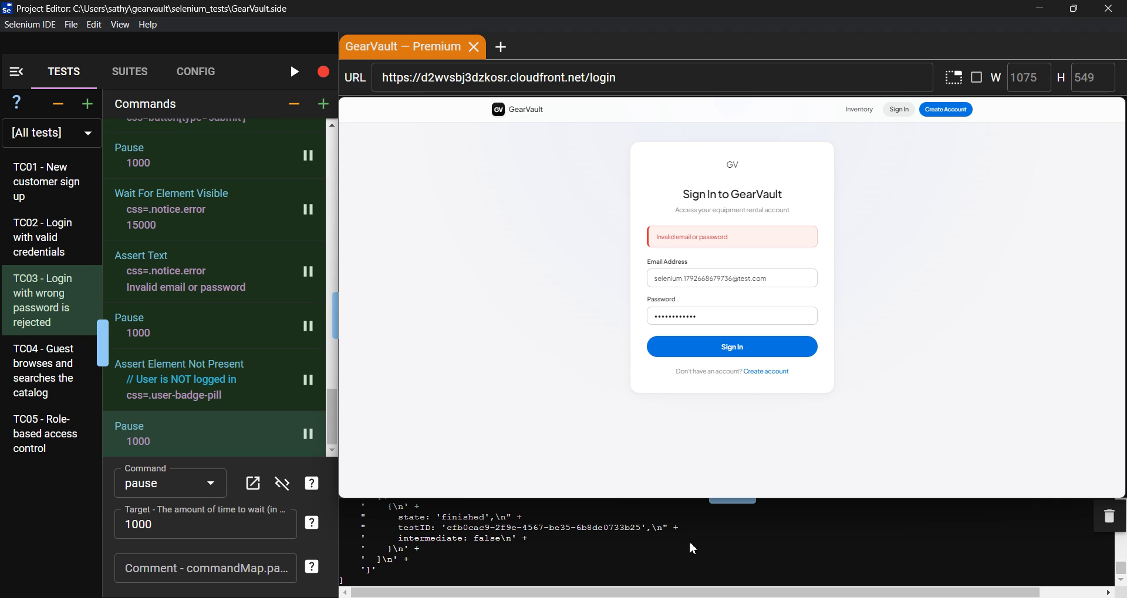
Fig 3: TC03 passed, wrong password shows an error
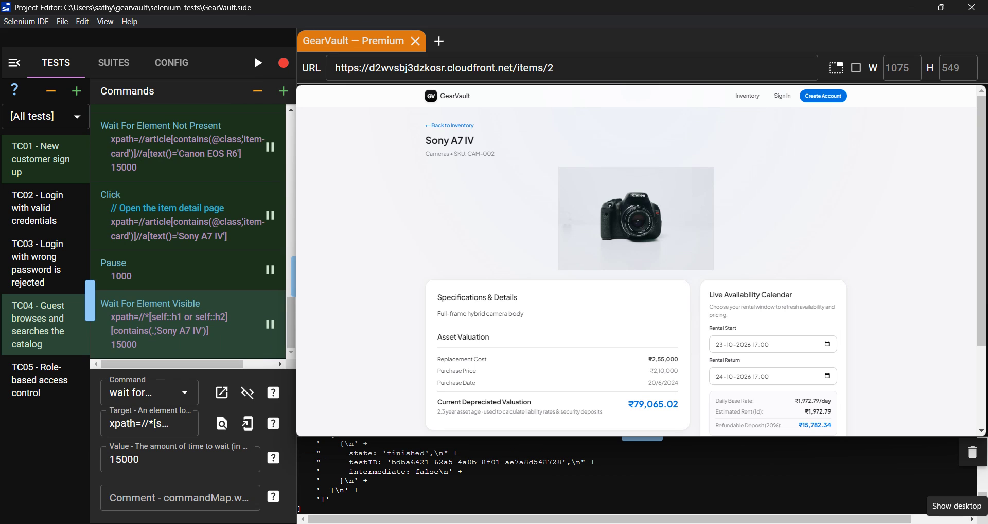
Fig 4: TC04 passed, Sony A7 IV page opened after search
Result
All 5 test cases passed. Three of them were executed and recorded using Selenium IDE.

