Software Engineering Lab 8
Selenium Testing – GearVault Equipment Rental System
Name: M.Sathyanarayanan
Reg No.: 24BCE1689
Date: 22 October 2026
Task: Provide any 5 test cases for the project. Execute any two test cases using Selenium, record the execution and upload the recording.

1. Introduction
GearVault is a web-based professional equipment rental system. Customers browse a catalog of cameras, audio, lighting and computer gear, book equipment for a date range, and track their reservations. Staff and managers have separate dashboards for dispatch, analytics, disputes and inventory. The application is deployed on AWS (CloudFront, S3, ECS and RDS PostgreSQL).
This lab tests the core user-facing flows with Selenium IDE: account sign-up, login (valid and invalid), catalog browsing and search, and role-based access control. Five test cases were written; all five were executed, and three of them (TC01, TC03, TC04) were recorded on video.

2. Test Environment
Item | Details
Application under test | https://d2wvsbj3dzkosr.cloudfront.net
Deployment | AWS – CloudFront + S3 (frontend), ECS (Flask API), RDS PostgreSQL
Testing tool | Selenium IDE 4.0.1 (desktop app)
Browser | Chromium (built into Selenium IDE)
Operating system | Windows 11
Test project file | GearVault.side (5 test cases, one suite)
Locator strategy | CSS selectors and XPath

Each test starts as a logged-out guest by clearing the browser session. Tests that need an account create one with a unique email (selenium.<timestamp>@test.com), so every test is independent and can be re-run any number of times. The recorded tests include a 1-second pause after each step so the actions are easy to follow on video.

3. Test Cases
ID | Title | Type | Recorded
TC01 | New customer sign up | Positive | Yes
TC02 | Login with valid credentials | Positive | No
TC03 | Login with wrong password is rejected | Negative | Yes
TC04 | Guest browses and searches the catalog | Positive | Yes
TC05 | Role-based access control | Negative / Security | No

3.1 TC01 – New customer sign up
Test Case ID | TC01
Title | New customer sign up
Type | Positive / Functional
Objective | A new visitor can create an account and is logged in as a customer.
Precondition | User is not logged in.
Test Data | Full name: Selenium Tester; Email: selenium.<timestamp>@test.com (unique each run); Password: Test@1234

Step | Action | Expected Result
1 | Open /login | "Sign In to GearVault" page is shown
2 | Click "Create account" | "Create Your GearVault Account" page is shown
3 | Enter full name, unique email and password | Fields accept the input
4 | Click "Create Account" | User is redirected to the Equipment Inventory dashboard
5 | Check the navigation bar | Shows the new email, a CUSTOMER role badge and a "Reservations" link

Actual Result | Account created; dashboard shows the new email and the CUSTOMER badge.
Status | Pass (recorded)

3.2 TC02 – Login with valid credentials
Test Case ID | TC02
Title | Login with valid credentials
Type | Positive / Functional
Objective | A registered user can sign in with the correct email and password.
Precondition | A registered account exists (the test registers one, then signs out).
Test Data | Email: selenium.<timestamp>@test.com; Password: Test@1234

Step | Action | Expected Result
1 | Register a new account, then click "Sign Out" | Sign In page is shown
2 | Enter the same email and password Test@1234 | Fields accept the input
3 | Click "Sign In" | User is redirected to "Equipment Inventory"
4 | Check the navigation bar | Shows the user's email and the CUSTOMER badge

Actual Result | User signed in and was redirected to the dashboard with the correct email and role.
Status | Pass

3.3 TC03 – Login with wrong password is rejected
Test Case ID | TC03
Title | Login with wrong password is rejected
Type | Negative / Security
Objective | Wrong credentials are rejected and no session is created.
Precondition | A registered account exists (the test registers one, then signs out).
Test Data | Email: selenium.<timestamp>@test.com; Password: WrongPass999

Step | Action | Expected Result
1 | Register a new account, then click "Sign Out" | Sign In page is shown
2 | Enter the correct email with password WrongPass999 | Fields accept the input
3 | Click "Sign In" | Red error message "Invalid email or password" is shown
4 | Check the navigation bar | No user badge: the user is not logged in

Actual Result | "Invalid email or password" was displayed and the user stayed logged out.
Status | Pass (recorded)

3.4 TC04 – Guest browses and searches the catalog
Test Case ID | TC04
Title | Guest browses and searches the catalog
Type | Positive / Functional
Objective | Anyone can browse, filter and search the equipment catalog without logging in.
Precondition | User is not logged in. Catalog contains "Canon EOS R6" and "Sony A7 IV" under Cameras.
Test Data | Category: Cameras; Search text: Sony A7

Step | Action | Expected Result
1 | Click "Inventory" | Equipment Inventory page with item cards
2 | Select Category "Cameras" | "Canon EOS R6" is listed
3 | Type "Sony A7" in Search Equipment | "Sony A7 IV" is listed and "Canon EOS R6" disappears
4 | Click "Sony A7 IV" | Item detail page with the heading "Sony A7 IV" opens

Actual Result | Filter and search narrowed the list correctly; the Sony A7 IV detail page opened.
Status | Pass (recorded)

3.5 TC05 – Role-based access control
Test Case ID | TC05
Title | Role-based access control
Type | Negative / Security
Objective | Protected pages cannot be reached by guests or by users with the wrong role.
Precondition | User is not logged in.
Test Data | New customer account (selenium.<timestamp>@test.com / Test@1234)

Step | Action | Expected Result
1 | As a guest, open /bookings | User is redirected to the Sign In page
2 | Register a new customer account | Logged in as CUSTOMER
3 | Check the navigation bar | No "Analytics" link (manager only)
4 | Open /analytics directly | "403 — Access Denied" page is shown

Actual Result | Guest was redirected to login; customer saw no manager menu and got "403 — Access Denied".
Status | Pass

4. Execution Summary
ID | Test Case | Execution | Result
TC01 | New customer sign up | Selenium IDE – recorded | Pass
TC02 | Login with valid credentials | Selenium IDE | Pass
TC03 | Login with wrong password is rejected | Selenium IDE – recorded | Pass
TC04 | Guest browses and searches the catalog | Selenium IDE – recorded | Pass
TC05 | Role-based access control | Selenium IDE | Pass

Total: 5 test cases | 5 passed | 0 failed | 3 recorded (2 were required)

5. Execution Recording
The three recorded executions are combined into one video. Each test is introduced by a 3-second title card showing the test case number, its description and the expected result.
Video file | GearVault_Selenium_Tests.mp4 (1 min 14 s)
Video link | [Paste the uploaded video link here]
Timestamps | 0:00 – TC01 New customer sign up | 0:25 – TC03 Wrong password | 0:57 – TC04 Catalog search

6. Screenshots
Each screenshot shows the Selenium IDE window: the 5 test cases and the command list (completed steps in green) on the left, and the GearVault application being driven on the right.
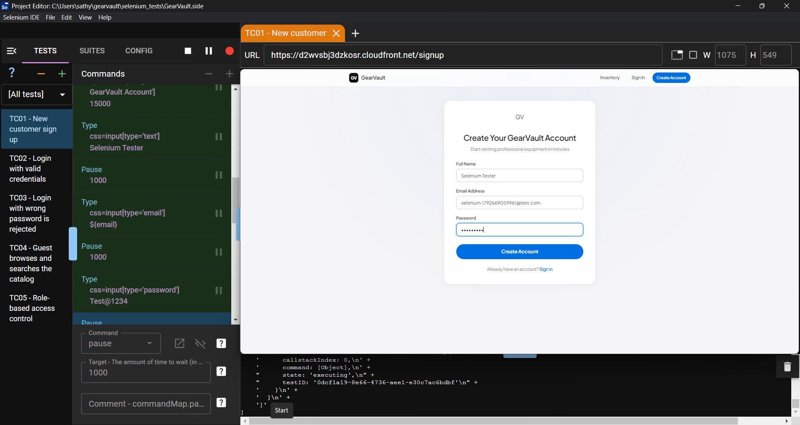
Figure 1 – TC01 in progress: Selenium IDE filling in the sign-up form step by step
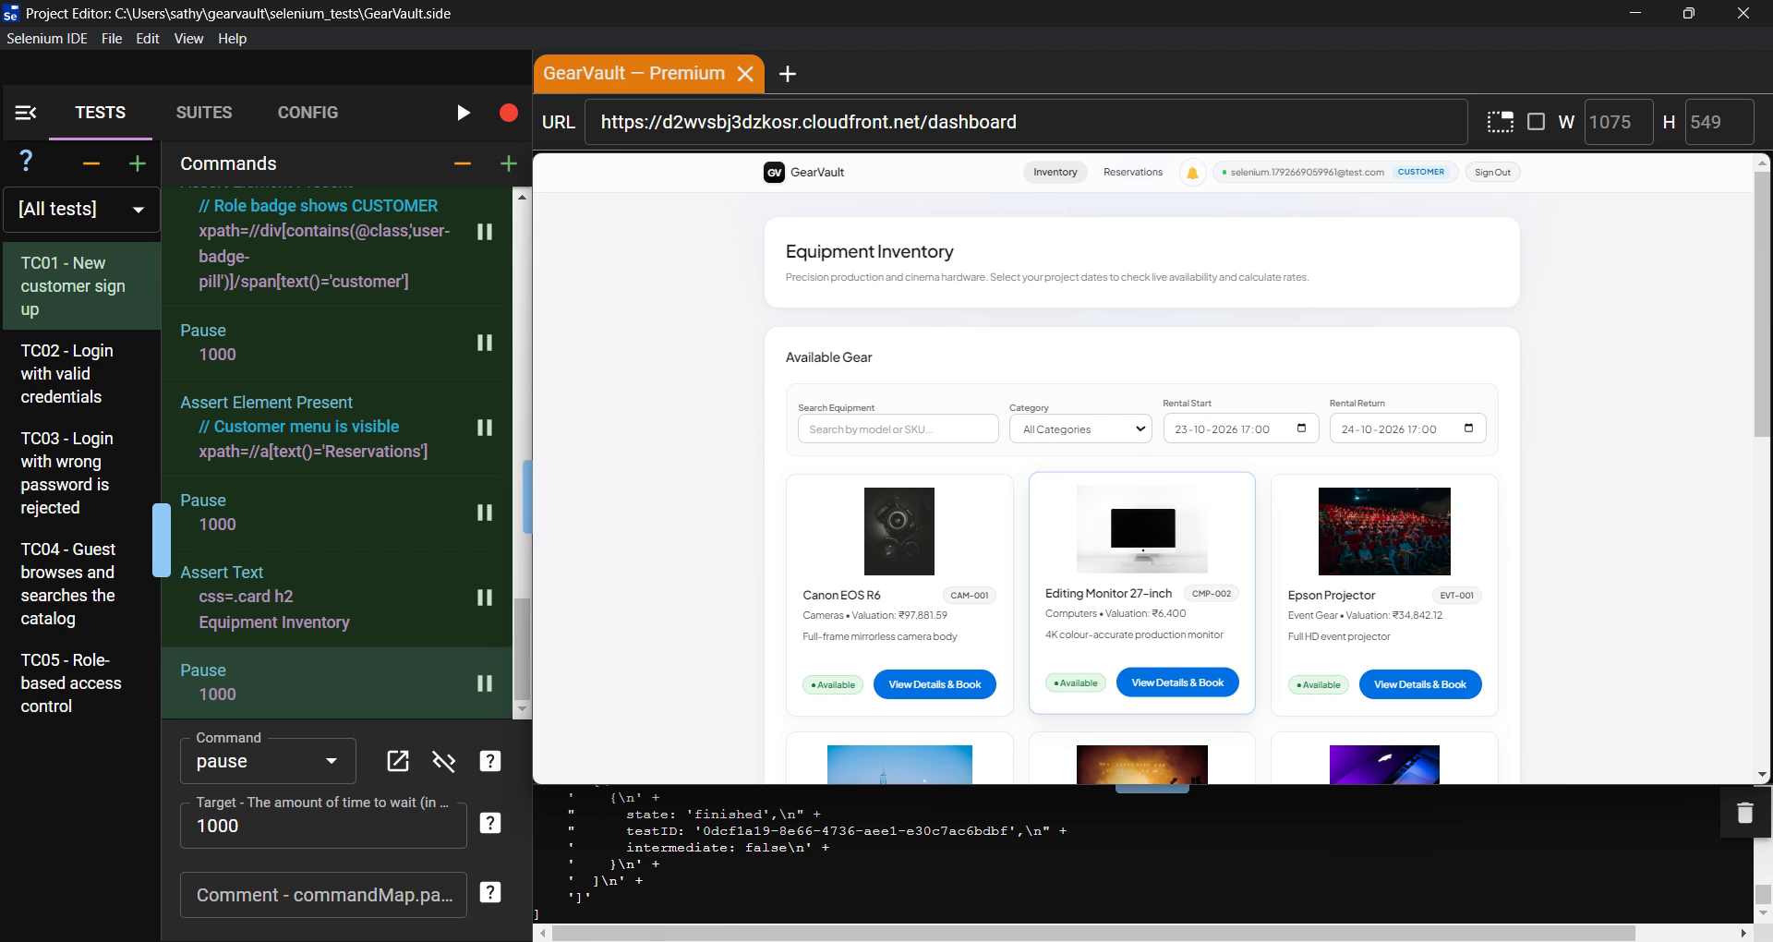
Figure 2 – TC01 passed: new customer logged in, navbar shows the email and the CUSTOMER badge
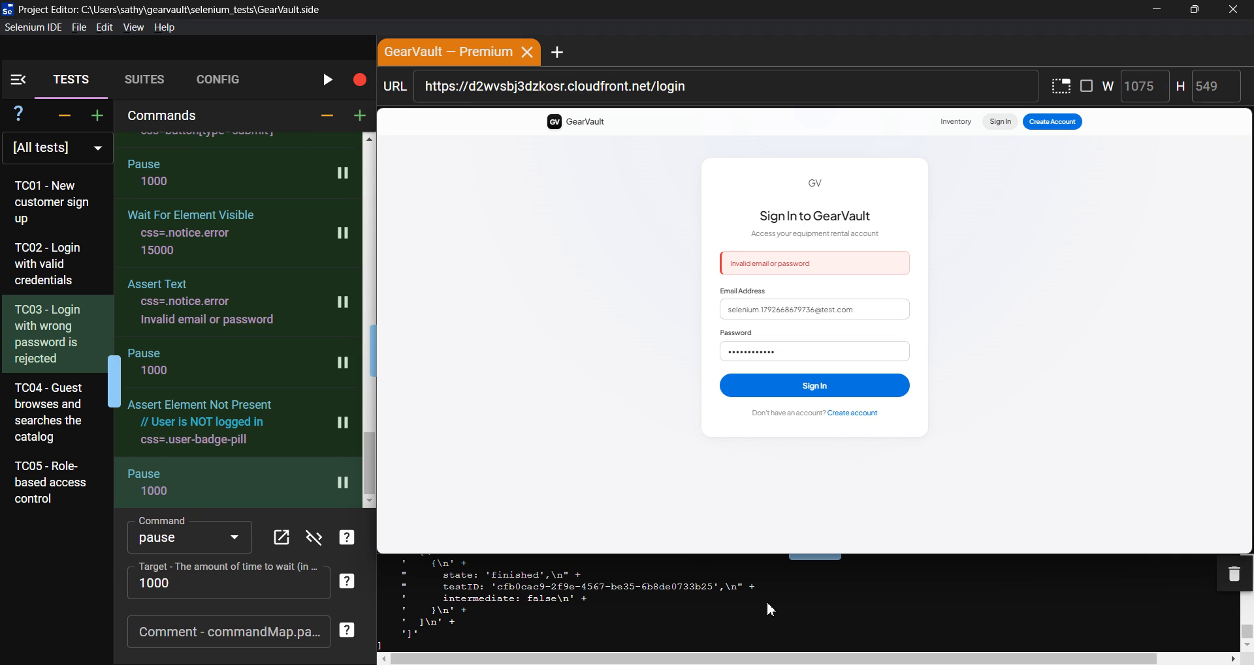
Figure 3 – TC03 passed: wrong password rejected with "Invalid email or password"
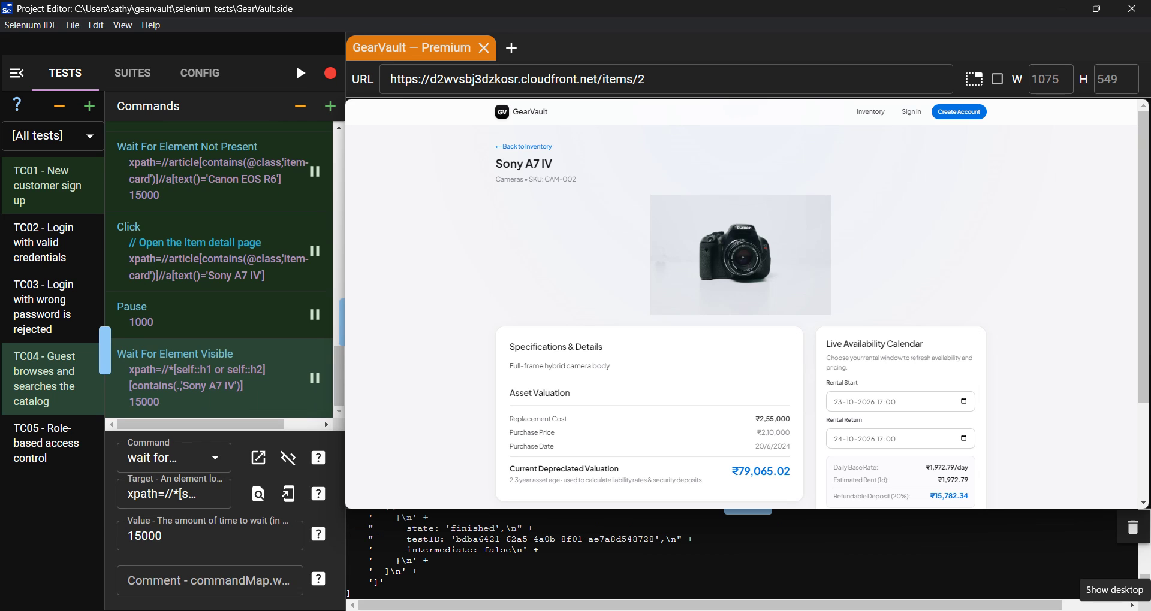
Figure 4 – TC04 passed: Cameras filter + "Sony A7" search opened the Sony A7 IV detail page

7. Issues Found and Fixed
- linkText locator failure: In Selenium IDE 4, steps using the linkText= locator (for example clicking "Create account") failed intermittently with "Cannot read properties of undefined (reading 'findElements')". All linkText locators were replaced with equivalent XPath locators (//a[text()='Create account']), after which every test passed consistently.
- Asynchronous loading: The category dropdown loads after the page, so selecting "Cameras" immediately caused a retry. A waitForElementPresent step was added before the selection.
- setSpeed not supported: Selenium IDE 4 does not support the setSpeed command, so pause steps were used to slow down the recorded runs.

8. Conclusion
Five test cases covering sign-up, valid and invalid login, catalog search and role-based access control were designed and automated with Selenium IDE against the live AWS deployment of GearVault. All five passed. Three executions were recorded and combined into a single video. The tests confirmed that authentication works correctly, invalid credentials are rejected, the public catalog filter and search work for guests, and protected pages are restricted by role.

