Third Milestone of Airline System

# ***Made by:***

* Abd El Rahman Mohamed Sakr 18010965
* Ziad Hassan Mahmoud Mahgoub 18010720
* Amr Ahmed Foad Elzahaby 18011174
* Seif El Din Wael Ali Salem 18010832
* Mohamed Mostafa Badran 18011621

**We will discuss in this report the new features added to the system, these systems are:**

1. Admin can manage ticket now.
2. User has more functionalities in booking tickets.
3. Logging in and signing up are more secure now.
4. Links are added for contacting the company and for support.

# Admin’s Ticket Manager

* Admin can edit the ticket’s cost and passenger number for any ticket that is not expired.
* 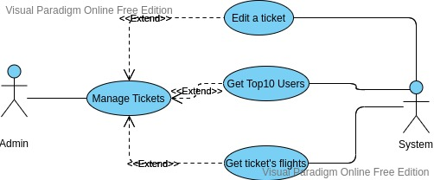Top 10 users that bought highest number of tickets.
* Admin can get all flights of a ticket.

# Image

# Secure Environment

* The password of the user must not be sent directly to the other side since the traffic may not be secured.
* Password is encrypted in a side and decrypted in the other side using RSA cryptographic algorithm.
* Client must have a public and private key, and send its public key to the server and vice versa.
* Password is decrypted on server side, the database holds the actual value of password.

