Third Milestone of Airline System

Made by:
- Abd El Rahman Mohamed Sakr 18010965
- Ziad Hassan Mahmoud Mahgoub 18010720
- Amr
- Seif El Din Wael Ali Salem 18010832

We will discuss in this report the new features added to the system, these systems are:
- Admin can manage ticket now.
- User has more functionalities in booking tickets.
- Logging in and signing up are more secure now.
- Links are added for contacting the company and for support.

Admin’s Ticket Manager
- Admin can edit the ticket’s cost and passenger number for any ticket that is not expired.
- Top 10 users that bought highest number of tickets.
- Admin can get all flights of a ticket.

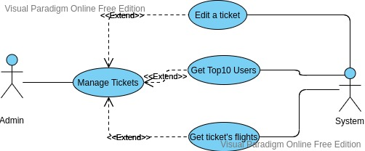

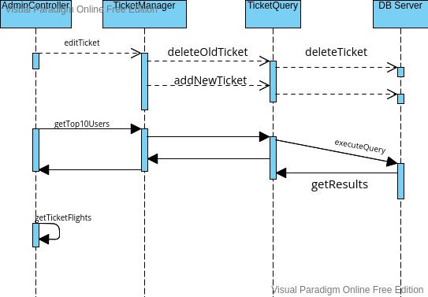

User’s Ticket Manager

Secure Environment
- The password of the user must not be sent directly to the other side since the traffic may not be secured.
- Password is encrypted in a side and decrypted in the other side using RSA cryptographic algorithm.
- Client must have a public and private key, and send its public key to the server and vice versa.
- Password is decrypted on server side, the database holds the actual value of password.

