

**COE420 Software Engineering**

**Lab 1: Version Control**

**Academic Integrity Pledge**

|  |
| --- |
| As a student of American University of Sharjah, I here by state that I will abide by the AUS Integrity Pledge that:   * I will hold myself accountable for all that I say and write. * I will hold myself responsible for the academic integrity of my work * I will not carry out unauthorized copying or printing of the work of others * I will not misrepresent my work nor give or receive unauthorized aid * I will behave in a manner that demonstrates concern for the personal dignity, rights and freedoms of all members of the community * I will respect university property and the property of others; and * I will not tolerate a lack of respect for these values.   **Member_A Student Name: Syed Muhammad Kumail**  **Member_A Student IDs: 76684**  **Member_B Student Name: Mohamed Abdelaty**  **Member_B Student IDs: 72311** |

**Link to the GitHub repository: [1 mark]**

* https://github.com/Software-EngineeringNK/COE420Lab1.git

**Paste Screenshots under each exercise with subheadings and figure captions as needed:**

**Exercise 1.2: Creating an organization [1 mark]**

1 screenshot of organization created with the members (as owners) on GitHub

**Exercise 1.4: Creating a repository [1 mark]**

1 screenshot of repository created in the organization on GitHub

**Exercise 3: Configure your details [1 mark]**

1 screenshot from **each** team member showing the running of the commands to create identity in git.

Member A:

Member B: (was already configured)

**Exercise 4: Cloning the remote repository [1 mark]**

1 screenshot from **each** team member showing cloning the repository from the terminal

Member A:

Member B:



**Exercise 5: Initial Commit (member_A) [4 marks (individual)]**

* Screenshots of successfully running the commands to push **file1.txt** file to remote repository and to get fileB.txt (getting **status** of repository, **adding** to staging area, **committing** to local repository, viewing commit details and **pushing** to remote repository).

Adding to Staging Area:



Checking status:

Committing to local repo:

Pushing to remote repo:

**Exercise 6: Getting Updated Version and pushing new changes (member_B) [4 marks (individual)]**

* Screenshots of successfully running the commands to get file1.txt and pushing fileB.txt (getting **status** of repository, **adding** to staging area, **committing** to local repository, viewing commit details and **pushing** to remote repository)

Pulling FileA.docx

Creating FileB.txt and then adding to the stating area, then getting the status

**Committing** to local repo AND then **pushing**:

**Exercise 7: Getting updated version [1 mark]**

* 1 Screenshot from **each** team member showing they got the most updated version.

Member A:

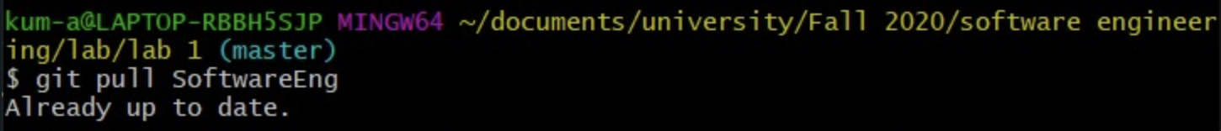

Member B:



* Screenshot of the commits made from GitHub under code showing all commits from member_A and member_B

