SOFTWARE REQUIREMENTS SPECIFICATION
Vehicle Parking System
Software Engineering | Mini-Project Deliverable - Part 1
Version: 2.0
Standard: IEEE 830-1998
Date of Submission: 28 September 2026
TEAM 10
Ananya V (PES1UG24CS061)
Amogh Sharma (PES1UG24CS053)
Nagaraja Gari Ram Sai Govind (PES1UG24CS912)

Document Control
Problem Statement PS-10: VEHICLE PARKING SYSTEM
A software-only parking management system with smart slot assignment and predictive availability
Stack: Python (Flask) | SQLite | HTML, CSS, JavaScript

Revision History
Version | Date | Description | Author
SRS 1.0 | 05 Sep 2026 | Initial SRS draft. | Team 10
SRS 1.1 | 12 Sep 2026 | Added smart slot assignment and predictive availability. | Team 10
SRS 2.0 | 26 Sep 2026 | Measurable requirements with IDs, use case diagram, full security section, TBDs resolved. | Team 10

Approvals
Role | Name | Signature / Email | Date
Course Coordinator
Project Guide
Team Lead | Team 10 | Digital Submission | 28 Sep 2026
Team Representative | Team 10 | Digital Submission | 28 Sep 2026

Table of Contents
1. Introduction
1.1 Purpose
1.2 Document Conventions
1.3 Intended Audience and Reading Suggestions
1.4 Product Scope
1.5 References
2. Overall Description
2.1 Product Perspective
2.2 Product Functions
2.3 User Classes and Characteristics
2.4 Operating Environment
2.5 Design and Implementation Constraints
2.6 User Documentation
2.7 Assumptions and Dependencies
3. External Interfaces
4. System Features (Detailed)
5. Non-Functional Requirements (Detailed)
6. Quality Attributes & Acceptance Tests
7. UML Use-Case Diagram
8. Requirements Traceability Matrix
9. Other Requirements
Appendix A: Glossary
Appendix B: Analysis Models
Appendix C: To Be Determined List

1. Introduction

1.1 Purpose
This SRS specifies the requirements for the Vehicle Parking System (VPS) v2.0, built by Team 10 for problem statement PS-10. It is the reference for development, and the Test Plan (Part 2) traces every test case back to it.

1.2 Document Conventions
IDs: REQ-<MODULE>-NN (functional), NFR- (non-functional), SEC- (security), QA- (quality), BR- (business rule), OR- (other).
"Shall" = mandatory. Each requirement is a single, testable statement. Priority: H/M/L. Verification: T = Test, D = Demo, I = Inspection.

1.3 Intended Audience and Reading Suggestions
Developers and testers should read Sections 3 to 5; evaluators may start with Section 2 and the use case diagram in Section 7.

1.4 Product Scope
VPS is a software-only web application that simulates a car park: slot allocation, vehicle entry and exit, fee calculation, mock payment and reporting. Two advanced features set it apart: smart slot assignment using BFS over a grid model with a drawn route, and predictive availability based on average dwell time. Real hardware, live payments and multi-facility deployment are out of scope.

1.5 References
IEEE Std 830-1998 (SRS); IEEE Std 829-2008 (Test Documentation); OWASP Top 10 (2021); course handout "Mini-Project Deliverables Part-1"; PS-10 problem statement.

2. Overall Description

2.1 Product Perspective
A new, self-contained, three-layer application: browser UI, Flask business logic (allocation, BFS, fees, prediction) and a local SQLite database. Physical devices are replaced by software stand-ins (Section 3.2).

2.2 Product Functions
Live slot tracking; simulated entry/exit with ticket and QR code; BFS slot assignment with route map; fee calculation with mock payment and receipt; predicted wait time when full; reports with CSV/PDF export; role-based login with audit log.

2.3 User Classes and Characteristics
Driver (simulated): uses entry, exit and availability screens; no login.
Attendant: logs in; processes entry, exit and payment; views the slot grid.
Administrator: inherits Attendant rights; configures layout, rates and grace period; views reports and audit log.

2.4 Operating Environment
Windows 10/11, macOS 12+ or Ubuntu 22.04+; Python 3.10+, Flask 3.x, SQLite 3; Chrome, Edge or Firefox on localhost. Reference machine: Core i5, 8 GB RAM.

2.5 Design and Implementation Constraints
No physical hardware; mock payment only; stack fixed as Python (Flask), SQLite, HTML/CSS/JS; must start with one command and no internet; prediction must use an explainable heuristic, not an ML model.

2.6 User Documentation
README with setup, start command, demo credentials and walkthrough; tooltips on every simulated action.

2.7 Assumptions and Dependencies
Single-machine evaluation; vehicles identified by typed plate or ticket ID; only free, open-source libraries (Flask, Flask-WTF, qrcode, ReportLab).

3. External Interfaces

3.1 User Interfaces
Entry screen: plate, vehicle type (Two-Wheeler/Car/EV), accessible checkbox; shows ticket, QR, slot, route and gate status. Exit screen: ticket ID, fee breakdown, Pay (Mock), receipt. Admin dashboard: live slot grid, counts, overstay alerts, settings, reports, audit log. Errors appear next to the field; layout works at 1366 x 768 and above.

3.2 Hardware Interfaces (Simulated)
LPR/RFID is replaced by typed plate or generated ticket/QR; occupancy sensors by a slot status field; boom barrier by an on-screen Open/Closed gate; payment terminal by a mock module.

3.3 Software Interfaces
SQLite 3 (parameterised queries only); mock payment function pay(ticket_id, amount) returning {status, reference}; Flask, Flask-WTF (CSRF), Werkzeug (hashing), qrcode, ReportLab (PDF).

3.4 Communications Interfaces
HTTP on localhost:5000; the dashboard polls a JSON endpoint every 500 ms. No external network calls.

4. System Features (Detailed)

4.1 Slot Availability Tracking (High)
ID | Requirement | Pri. | Ver.
REQ-SLOT-01 | Slot status (Vacant/Occupied/Reserved) shall change within 1 s of the triggering entry, exit or reservation. | H | T
REQ-SLOT-02 | Vacant counts per category and a slot grid shall be shown on the entry screen and admin dashboard. | H | D
REQ-SLOT-03 | Each slot shall have one category (Two-Wheeler, Car, Accessible, EV); vehicles get matching slots only. | H | T
REQ-SLOT-04 | If the category is full, entry shall be refused with "No <category> slot available" and the predicted wait. | H | T

4.2 Vehicle Entry/Exit Logging (High)
ID | Requirement | Pri. | Ver.
REQ-LOG-01 | Entry shall accept a plate of 4 to 10 letters/digits (spaces ignored, stored upper case) and a vehicle type. | H | T
REQ-LOG-02 | A unique ticket ID (VPS-YYYYMMDD-NNNN) and QR code shall be generated and linked to the slot. | H | T
REQ-LOG-03 | Entry and exit times shall be recorded to the nearest second. | H | T
REQ-LOG-04 | Entry shall be rejected for a plate that already has an active ticket. | H | T

4.3 Payment Processing (High)
ID | Requirement | Pri. | Ver.
REQ-PAY-01 | Fee = Rs. 0 within the grace period, else started hours x hourly rate (defaults: Two-Wheeler Rs. 20, Car Rs. 40, EV Rs. 50; configurable). | H | T
REQ-PAY-02 | One mock payment step shall return Success, or Failure when the admin enables "force failure". | H | T
REQ-PAY-03 | On success, a receipt shall show ticket, plate, slot, times, duration, rate, amount and payment reference. | H | T

4.4 Reporting and Analytics (Medium)
ID | Requirement | Pri. | Ver.
REQ-REP-01 | Daily, weekly and monthly occupancy (%) and revenue (Rs.) reports shall be generated for a date range. | M | T
REQ-REP-02 | Reports shall export to CSV and PDF with figures identical to the screen. | M | T
REQ-REP-03 | Peak hour and average utilisation per category shall be shown. | M | T

4.5 User and Access Management (High)
ID | Requirement | Pri. | Ver.
REQ-USR-01 | Two roles: Administrator (all functions) and Attendant (entry, exit, payment, slot grid only). | H | T
REQ-USR-02 | Every admin action shall be logged with user, action, timestamp and old/new values. | H | T

4.6 Smart Slot Assignment and Wayfinding (High)
ID | Requirement | Pri. | Ver.
REQ-NAV-01 | The facility shall be modelled as an editable grid (max 10 x 10) of Road, Slot, Wall, Entrance and Exit cells. | H | T
REQ-NAV-02 | The vacant matching slot with the shortest BFS path from the entrance (or exit, if selected) shall be assigned; ties go to the lower slot number. | H | T
REQ-NAV-03 | A 2D grid shall show slot status, the assigned slot and the computed path. | H | D
REQ-NAV-04 | If the target is taken or the path blocked before confirmation, the next best slot shall be assigned within 500 ms. | H | T

4.7 Predictive Slot Availability (Medium)
ID | Requirement | Pri. | Ver.
REQ-PRED-01 | Dwell time of every completed ticket shall be stored per vehicle type. | M | T
REQ-PRED-02 | Estimate = min over occupied slots of max(0, average dwell - time parked), rounded up to a whole minute. No ML model. | M | T
REQ-PRED-03 | The entry screen shall show "Next <category> slot expected in about N min", or "Estimate unavailable" with fewer than 5 records. | M | T
REQ-PRED-04 | The admin shall be able to seed 200 synthetic records over the previous 14 days. | M | T

5. Non-Functional Requirements (Detailed)

5.1 Performance Requirements
ID | Requirement | Pri. | Ver.
NFR-PERF-01 | Entry/exit (submit to updated status) shall complete within 1 s for 95% of 20 trials. | H | T
NFR-PERF-02 | The dashboard shall reflect a change within 1 s without manual refresh. | H | T
NFR-PERF-03 | At least 10 parked vehicles and 5 simultaneous entries shall be handled without error. | H | T
NFR-PERF-04 | BFS assignment shall complete within 500 ms for up to 50 nodes. | H | T
NFR-PERF-05 | A 30-day report shall be generated within 3 s. | M | T

5.2 Safety and Reliability Requirements
ID | Requirement | Pri. | Ver.
NFR-REL-01 | Invalid input shall be rejected with a specific message; no stack trace shall be shown. | H | T
NFR-REL-02 | No slot shall ever be assigned to two active tickets, even under simultaneous requests. | H | T
NFR-REL-03 | All data shall persist in SQLite; no committed data is lost on restart. | H | T
NFR-REL-04 | A failed payment shall leave the ticket active and slot occupied (single transaction). | H | T

5.3 Security Requirements
Security Objectives
ID | Objective
SO-01 | Confidentiality: only authenticated staff reach staff screens; passwords cannot be read back.
SO-02 | Integrity: ticket, slot, fee and payment data change only through validated workflows.
SO-03 | Accountability: every admin change is traceable to a user and time.
SO-04 | Robustness: malformed or hostile input cannot crash the app or corrupt data.

Security Requirements
ID | Requirement | Obj. | Ver.
SEC-01 | Passwords shall be stored only as salted one-way hashes (Werkzeug scrypt). | SO-01 | T, I
SEC-02 | 5 consecutive failed logins shall lock the account for 5 minutes and be logged. | SO-01 | T
SEC-03 | Role checks shall run on the server for every protected route; violations return HTTP 403 and are logged. | SO-01/02 | T
SEC-04 | All SQL shall be parameterised and all input validated against allow-list patterns. | SO-02/04 | T, I
SEC-05 | All user-supplied text shall be HTML-escaped on output (XSS prevention). | SO-02/04 | T
SEC-06 | Session cookies shall be HttpOnly and SameSite=Lax; sessions expire after 15 min idle or on logout. | SO-01 | T
SEC-07 | State-changing requests shall require a valid CSRF token, else HTTP 400. | SO-02 | T
SEC-08 | The audit log shall be append-only; no UI or endpoint may edit or delete entries. | SO-03 | T, I

TLS, OAuth/SSO, PCI-DSS and encryption at rest are out of scope (Appendix C).

6. Quality Attributes & Acceptance Tests
These quality attributes and business rules apply across all features.
ID | Requirement | Pri. | Ver.
QA-USE-01 | 4 of 5 first-time users shall complete entry to receipt within 3 minutes unaided. | H | T
QA-MOD-01 | UI, business logic and data access shall be in separate modules. | M | I
QA-MNT-01 | Code shall have docstrings and pass flake8 (PEP 8) with no errors. | M | I
QA-POR-01 | The app shall run unchanged on Windows, macOS and Linux (Python 3.10+). | M | T

BR-01: 5-minute grace period (configurable 0 to 30). BR-02: fees charged per started hour (2 h 10 min = 3 h). BR-03: vehicles parked over 24 h are flagged "Overstay" (informational).

7. UML Use-Case Diagram
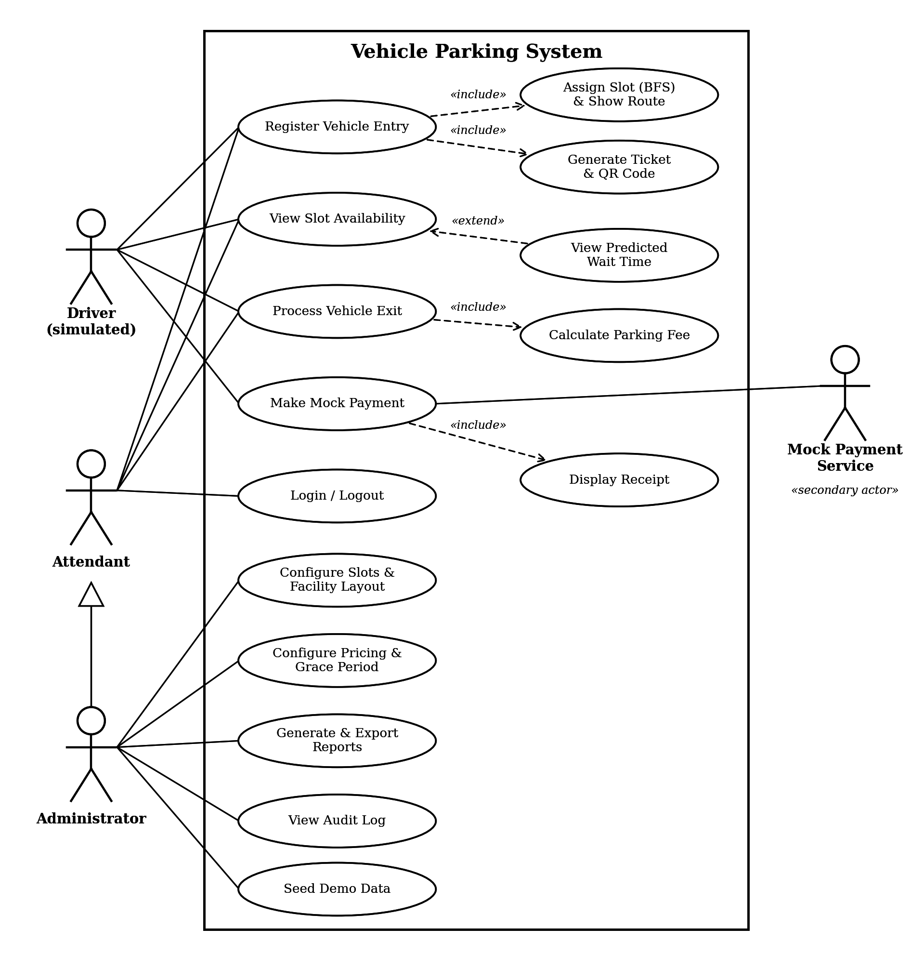
Figure 1: UML Use Case Diagram
Figure 1 shows the four actors and their use cases. The Administrator inherits every Attendant use case. <<include>> marks steps that always run (slot assignment and route, ticket and QR generation, fee calculation, receipt) and <<extend>> marks the predicted wait time, which is shown only when a category is full.

8. Requirements Traceability Matrix (RTM)
Requirement(s) | Test Case(s) | Status
REQ-SLOT-01, 02, 03, 04 | TC-01, TC-10, TC-03, TC-05 | Pass
REQ-LOG-01, 02, 03, 04 | TC-01, TC-02 | Pass
REQ-PAY-01, 02, 03; BR-01, BR-02 | TC-06, TC-07 | Pass
REQ-REP-01, 02, 03; NFR-PERF-05 | TC-08 | Pass
REQ-USR-01, 02 | TC-15 | Pass
REQ-NAV-01, 02, 03, 04 | TC-04 | Pass
REQ-PRED-01, 02, 03; REQ-PRED-04 | TC-05; TC-09 | Pass
NFR-PERF-01, 02, 04 | TC-10 | Pass
NFR-PERF-03, NFR-REL-02 | TC-11 | Pass
NFR-REL-01; NFR-REL-04; NFR-REL-03 | TC-02; TC-07; TC-12 | Pass
SEC-01, 02 / SEC-03, 08 / SEC-04, 05 / SEC-06, 07 | TC-14 / TC-15 / TC-16 / TC-17 | Pass
QA-USE-01; QA-POR-01, OR-02 | TC-13; TC-12 | Pass
BR-03, OR-01, OR-04 | TC-09 | Pass
QA-MOD-01, QA-MNT-01, OR-03 | Code inspection (flake8: 0 errors) | Pass

Coverage: every SRS v2.0 requirement is traced and verified (100%).

9. Other Requirements
OR-01: first run loads a 6 x 8 layout with 20 slots (10 Car, 4 Two-Wheeler, 2 Accessible, 4 EV), an Admin and an Attendant account. OR-02: starts with python run.py. OR-03: code organised by rubric area. OR-04: an admin-only Demo Clock advances app time (5 min / 1 h / 1 day) to simulate durations.

Appendix A: Glossary
BFS: breadth-first search, shortest path in an unweighted graph. Dwell time: exit time minus entry time. Demo Clock: app-level time offset. Mock payment: stubbed payment with no real transaction. CSRF/XSS: request forgery / script injection attacks.

Appendix B: Analysis Models
Use case model: Figure 1. Workflow: plate entered, slot assigned and ticket issued, exit, fee, mock payment, receipt, slot freed. Slot states: Vacant to Occupied on entry; back to Vacant on successful payment; Reserved set by admin.

Appendix C: To Be Determined List
TBD-01 to 03, 05, 06 resolved in v2.0 (Flask, SQLite, web UI, 6 x 8 default grid, per-category prediction). TBD-04 (open): real hardware and production security, future scope.

