SOFTWARE ARCHITECTURE AND DESIGN SPECIFICATION
Vehicle Parking System
Software Engineering | Mini-Project Deliverable - Part 3
Version: 1.0
Standard: IEEE 1016-2009 / Architecture Description Reference
Date of Submission: 28 September 2026
TEAM 10
Ananya V (PES1UG24CS061)
Amogh Sharma (PES1UG24CS053)
Nagaraja Gari Ram Sai Govind (PES1UG24CS912)

Document Control
System: Vehicle Parking System (Software-Only Demo)
Status: Academic / Course Submission
Technology Stack: Python (Flask) | SQLite | HTML, CSS, JavaScript

Revision History
Version | Date | Description | Author
1.0 | 28 September 2026 | Initial Software Architecture & Design Specification based on SRS v2.0 and Test Plan VPS-TP-01 | Team 10

Approvals
Role | Name | Signature / Email | Date
Course Coordinator
Project Guide
Team Representative | Team 10 | Digital Submission | 28 Sep 2026

Table of Contents
1. Introduction
1.1 Purpose
1.2 Scope
1.3 Audience
1.4 Definitions
2. Document Overview
2.1 How to Use This Document
2.2 Related Documents
3. Architecture
3.1 Goals & Constraints
3.2 Stakeholders & Concerns
3.3 Component (UML) Diagram
3.4 Component Descriptions
3.5 Chosen Architecture Pattern and Rationale
3.6 Technology Stack & Data Stores
3.7 Risks & Mitigations
3.8 Traceability to Requirements
3.9 Security Architecture
3.10 Data Architecture
3.11 Deployment Architecture
3.12 External Interfaces and Constraints
3.13 Performance and Reliability Considerations
4. Design
4.1 Design Overview
4.2 UML Sequence Diagrams
4.3 API Design
4.4 Error Handling, Logging & Monitoring
4.5 UX Design
4.6 Class Design
4.7 Data Design
4.8 Design Traceability
4.9 Open Issues & Next Steps
5. Appendices
5.1 Glossary
5.2 References
5.3 Tools

1. Introduction

1.1 Purpose
This document presents the software architecture and detailed design of the Vehicle Parking System (VPS). It is the third project deliverable and is based on SRS Version 2.0 and Test Plan VPS-TP-01. It follows the organisation of an IEEE Software Design Description (IEEE 1016-2009) and uses architecture-description ideas from ISO/IEC/IEEE 42010:2022. Diagrams use UML notation.

1.2 Scope
The system is intentionally described as a software-only demonstration. Physical sensors, cameras, boom barriers and live payment gateways are not assumed. These are represented by software controls or mock services, as specified in the SRS.

1.3 Audience
Developers, testers, evaluators and project team members using the architecture and design specification for implementation and demonstration.

1.4 Definitions
BFS: breadth-first search, shortest path in an unweighted graph. Dwell time: exit time minus entry time. Demo Clock: app-level time offset. Mock payment: stubbed payment with no real transaction. CSRF/XSS: request forgery / script injection attacks.

2. Document Overview

2.1 How to Use This Document
Provides architectural deliverables including component descriptions, architecture pattern, traceability, security architecture, UML sequence diagrams, API design and error handling.

2.2 Related Documents
Vehicle Parking System Software Requirements Specification; Vehicle Parking System Software Test Plan; IEEE Std 1016-2009; ISO/IEC/IEEE 42010:2022.

3. Architecture

3.1 Goals & Constraints
The purpose of the architecture is to divide the Vehicle Parking System into manageable components with clear responsibilities. The architecture supports slot availability tracking, simulated vehicle entry and exit, fee calculation, mock payment, reporting, role-based access, smart slot assignment using BFS, and predictive slot availability using a simple dwell-time heuristic.
The application runs locally on a single laptop or desktop. The stack is fixed by SRS 2.5: Python 3.10+ with Flask for the business logic and routes, SQLite for storage, and HTML, CSS and JavaScript pages served by Flask for the user interface.

3.2 Stakeholders & Concerns
Drivers need a simple parking workflow and clear slot information. Attendants need entry, exit, payment and slot-grid functions. Administrators need configuration, reporting and audit functions. Developers and testers need modular components that can be implemented and verified independently.

3.3 Component (UML) Diagram
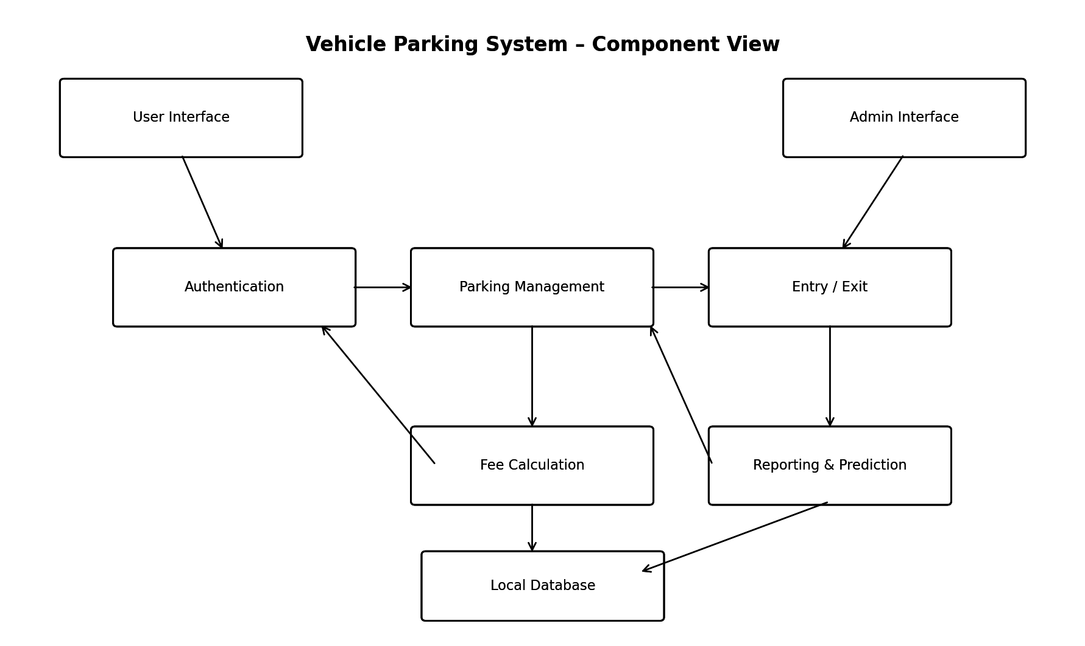
Figure 3.1. Component diagram of the Vehicle Parking System
The component diagram shows the main logical components and their interactions. The User Interface and Admin Interface send requests to the application services. These services read and update persistent information in the local database. Fee calculation, reporting/prediction and entry/exit processing are kept separate so that each part can be tested independently.

3.4 Component Descriptions
Component | Main Responsibility | Related SRS Requirements
User Interface | Accepts vehicle details, shows available/assigned slots, route information, fee and receipt. | REQ-SLOT-02, REQ-LOG-01, REQ-NAV-03, REQ-PRED-03
Admin Interface | Provides slot configuration, pricing, reports and administrative controls. | REQ-USR-01, REQ-USR-02, REQ-REP-01 to 03
Authentication & Access | Validates credentials and checks user roles before protected operations. | REQ-USR-01, SEC-01 to SEC-03
Parking Management | Maintains slot status, categories and assignment. | REQ-SLOT-01 to 03
Entry / Exit Management | Creates tickets, timestamps events and closes parking sessions. | REQ-LOG-01 to 03
Fee Calculation | Calculates parking charge from duration, rate and grace period. | REQ-PAY-01, BR-01, BR-02
Mock Payment | Provides a simulated payment success/failure response without real transactions. | REQ-PAY-02, NFR-REL-04
Reporting & Analytics | Produces occupancy, revenue, peak-hour and utilization reports. | REQ-REP-01 to 03
Smart Slot Assignment | Represents the facility as a graph and selects a slot using BFS and configured priority. | REQ-NAV-01 to 04
Predictive Availability | Uses historical dwell time and current occupancy to estimate next vacancy. | REQ-PRED-01 to 04
Local Database | Persists slots, tickets, users, transactions, audit records and historical data. | NFR-REL-02, NFR-REL-03

3.5 Chosen Architecture Pattern and Rationale
The selected architectural pattern is the Layered (3-Tier) Architecture Pattern. The presentation layer is separated from the application/business layer, which is separated from the data layer.
Layer | Responsibilities | Examples in VPS
Presentation Layer | User interaction and display of results. | Entry screen, exit screen, slot grid, admin dashboard
Application Layer | Business rules and system operations. | Slot allocation, BFS, fee calculation, prediction, authentication
Data Layer | Persistent storage and retrieval. | Users, slots, tickets, transactions, audit log, history

The layered pattern was selected mainly because it matches the project's scale and the SRS quality requirements. The project is a local academic demonstration rather than a large distributed production system. A more complex microservices architecture would add deployment and communication overhead without being necessary for the current scope.
- Separation of concerns makes individual modules easier to understand.
- Business rules can be tested without depending directly on the user interface.
- The database can be changed from SQLite to MySQL later with limited changes to the upper layers.
- The same business layer could later serve a mobile or kiosk front end without changes.
- The architecture supports future hardware integration without requiring the entire application to be redesigned.

3.6 Technology Stack & Data Stores
Python 3.10+ and Flask 3.x (routes, templates and JSON endpoints); SQLite 3 as a single local database file, accessed only through parameterised queries; HTML, CSS and JavaScript in the browser, with the slot grid refreshed by polling a JSON endpoint every 500 ms. Supporting libraries: Werkzeug (password hashing), Flask-WTF (CSRF tokens), qrcode (ticket QR codes) and ReportLab (PDF export).

3.7 Risks & Mitigations
Risk | Mitigation
Complexity for a small academic project | Use the layered pattern rather than a more complex distributed architecture.
Future hardware integration | Keep simulated hardware behind software interfaces so it can be replaced later.
Database technology change | Keep data access separated from the upper layers.

3.8 Traceability to Requirements
Requirement ID | Requirement Summary | Architecture Component(s)
REQ-SLOT-01 | Update slot status on entry/exit | Parking Management + Entry/Exit + Database
REQ-SLOT-02 | Display real-time slot availability | User Interface + Parking Management
REQ-SLOT-03 | Support slot categories | Parking Management + Admin Interface
REQ-LOG-01 to 03 | Capture vehicle entry/exit and ticket details | Entry/Exit Management + Database
REQ-PAY-01 to 03 | Calculate fee, mock payment and receipt | Fee Calculation + Mock Payment + UI
REQ-REP-01 to 03 | Reports and analytics | Reporting & Analytics + Database
REQ-USR-01 to 02 | Role-based login and audit logging | Authentication + Admin Interface + Database
REQ-NAV-01 to 04 | Graph, BFS assignment, route and reassignment | Smart Slot Assignment + Parking Management + UI
REQ-PRED-01 to 04 | Historical dwell-time prediction and display | Predictive Availability + Database + UI
NFR-PERF-01 to 05 | Response and pathfinding performance | Application Layer + Local Database
NFR-REL-01 to 04 | Validation, no double assignment and persistence | Business Layer + Database
SEC-01 to 08 | Hashing, lockout, role checks, validation, CSRF, audit | Authentication + Validation + Audit Log
QA-USE-01, QA-MOD-01, QA-MNT-01, QA-POR-01 | Usability, modularity, maintainability, portability | Layered Architecture + UI + Prediction Component
BR-01 to 03 | Grace period, fee rule and overstay flag | Fee Calculation + Reporting

3.9 Security Architecture
The security design is intentionally basic because the SRS defines this as an academic software-only demo. Production-grade controls such as OAuth, PCI-DSS compliance, encryption in transit and penetration testing are explicitly outside the current scope.
- Authentication: administrators and attendants must log in before any staff screen is shown.
- Password protection: passwords are stored as hashes rather than plain text.
- Role-based authorization: the server checks the role on every protected route; an attendant calling an admin route gets HTTP 403 and the attempt is logged.
- Session and request protection: HttpOnly, SameSite=Lax cookies with a 15-minute idle timeout, CSRF tokens on every state-changing request, and a 5-minute lockout after 5 failed logins (SEC-02, SEC-06, SEC-07).
- Input validation: all user-entered fields are validated before processing or storing data.
- Database safety: parameterized database operations should be used to reduce injection risk.
- Audit logging: administrative changes such as pricing or slot-category changes are recorded with user, action, old/new value and timestamp.
- Mock payment isolation: payment processing is simulated and does not accept or store real card or bank details.
Security Step | Purpose
1. Login | Check username and password hash.
2. Authentication result | Create an authenticated session if credentials are valid.
3. Role check | Allow or deny the requested function based on the user's role.
4. Input validation | Reject empty, malformed or suspicious values.
5. Authorized operation | Perform the requested business operation.
6. Audit logging | Record important administrative actions.

3.10 Data Architecture
All data lives in one local SQLite database. The main tables are listed below. A unique index on the slot of every open ticket stops the same slot being given to two vehicles (NFR-REL-02).
Entity / Table | Important Data | Purpose
User | user_id, username, password_hash, role | Authentication and access control
Vehicle | vehicle_id, plate_number, vehicle_type | Vehicle identity and type
ParkingSlot | slot_id, status, category | Parking space state
ParkingTicket | ticket_id, vehicle_id, slot_id, entry_time, exit_time, status | Parking session tracking
Payment | payment_id, ticket_id, amount, status, timestamp | Mock payment record
AuditLog | log_id, user_id, action, old_value, new_value, timestamp | Administrative accountability
DwellHistory | record_id, vehicle_type, entry_time, exit_time, duration | Predictive availability history

3.11 Deployment Architecture
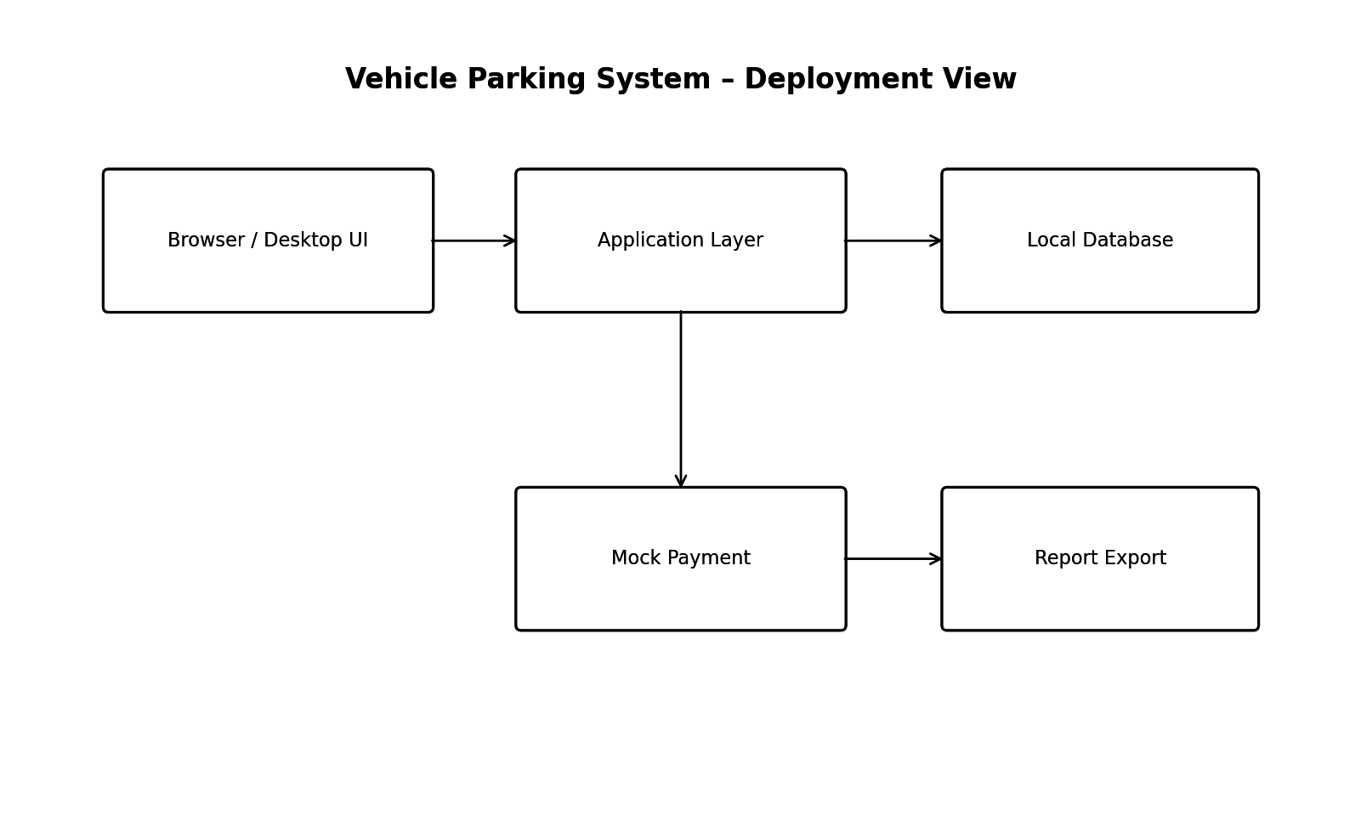
Figure 3.2. Deployment view for the local demonstration environment
Everything runs on one machine. The browser talks to the Flask server over HTTP on localhost:5000, and Flask reads and writes the SQLite file directly. No cloud service or third-party network call is needed.

3.12 External Interfaces and Constraints
- User interface: entry screen, exit screen and admin dashboard.
- Simulated hardware: manual plate entry or generated ticket/QR code represents vehicle detection; a database flag represents slot occupancy; an on-screen gate indicator represents a boom barrier.
- Database interface: local relational database for persistent information.
- Payment interface: mock/stubbed payment function that returns success or failure without contacting a real gateway.
- Communication: HTTP on localhost:5000 between the browser and Flask; no external calls.
- Constraints: no physical hardware, no live payment processing, no paid services, and no required cloud deployment.

3.13 Performance and Reliability Considerations
Target | Design Response
Entry/exit within 1 second | Keep allocation and database operations local and lightweight.
Dashboard update within 1 second | Refresh the slot state immediately after successful entry/exit.
At least 10 parked vehicles | Use persistent local storage and avoid unnecessary repeated queries.
BFS within 500 ms for up to 50 nodes | Use a simple adjacency/grid representation and standard BFS.
No double assignment | Check slot state during allocation before committing the ticket.
Persistence after restart | Store system state in the local database rather than memory only.

4. Design

4.1 Design Overview
The detailed design converts the architecture into modules, interactions, interfaces and data structures. The design remains consistent with the SRS workflow: vehicle entry → slot assignment → ticket generation → parking → vehicle exit → fee calculation → mock payment → receipt → slot release.
Two main sequence diagrams are included because they represent the two most important end-to-end workflows of the system. Additional class, API, data and error-handling details are included to make the design implementable.

4.2 UML Sequence Diagrams
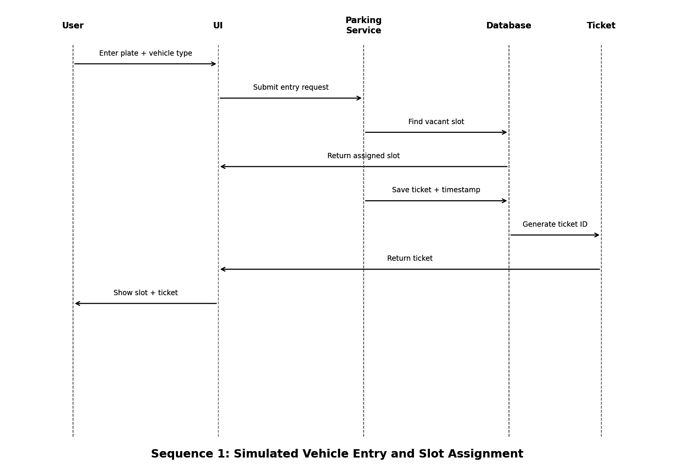
Figure 4.1. Sequence diagram for simulated vehicle entry and slot assignment
The user provides the plate number and vehicle type. The UI sends the request to the parking service. The service finds a suitable vacant slot, stores the ticket and timestamp, and returns the ticket information to the UI. If smart assignment is enabled, the parking service can use the BFS component before saving the assignment.
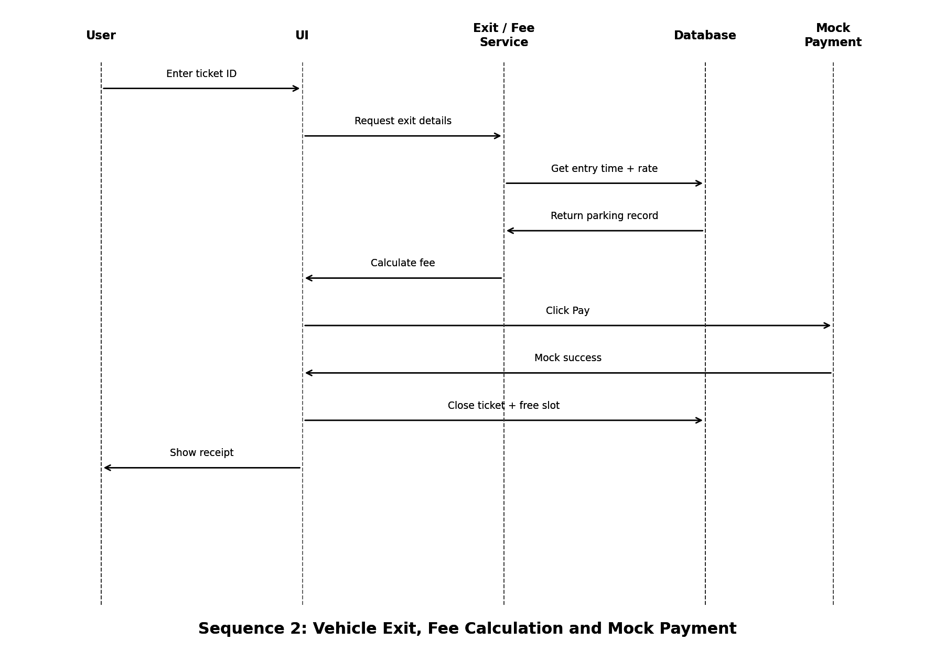
Figure 4.2. Sequence diagram for vehicle exit, fee calculation and mock payment
At exit, the user enters the ticket ID. The system retrieves the parking record, calculates the fee according to the configured rate and grace period, and shows a mock payment action. After successful simulated payment, the ticket is closed, the exit timestamp is saved, the slot becomes vacant, and the receipt is displayed.

4.3 API Design
The Flask backend exposes the following JSON endpoints. State-changing requests need a valid session and CSRF token (SEC-06, SEC-07).
Method | Endpoint | Purpose | Main Input | Response / Status
POST | /api/login | Authenticate user | username, password | Session/token; 200 or 401
POST | /api/users | Create user | name, username, password, role | User ID; 201 or 400
GET | /api/slots | Get slot status | optional category/status | Slot list; 200
POST | /api/parking/entry | Create parking session | plate, vehicle_type | ticket + slot; 201 or 409
GET | /api/parking/{ticketId} | Get ticket details | ticketId | Parking record; 200 or 404
POST | /api/parking/exit | Close parking session | ticketId | Fee + receipt; 200 or 404
POST | /api/payment/mock | Process mock payment | ticketId, amount | Success/failure; 200
GET | /api/reports/occupancy | Get occupancy report | date range | Report data; 200
GET | /api/reports/revenue | Get revenue report | date range | Report data; 200
POST | /api/admin/slots | Add/update slot | slot details | Updated slot; 201/200
GET | /api/prediction/next-vacancy | Get estimated vacancy | vehicle_type/optional | Estimate; 200

4.4 Error Handling, Logging & Monitoring
The system should handle errors at the UI, business-logic and database levels. Error messages should be understandable to a student/demo user and should not expose internal database details.
Situation | Example Error Code | Expected Handling
Empty plate number | 400 / PLATE_REQUIRED | Reject request and ask for plate number.
Invalid vehicle type | 400 / INVALID_VEHICLE_TYPE | Reject request and show valid choices.
No vacant slot | 409 / NO_SLOT_AVAILABLE | Inform user that no suitable slot is currently available.
Ticket not found | 404 / TICKET_NOT_FOUND | Do not calculate a fee or change slot state.
Ticket already closed | 409 / TICKET_CLOSED | Reject duplicate exit request.
Slot conflict during assignment | 409 / SLOT_CONFLICT | Recheck availability and select next suitable slot.
Payment mock failure | 402 / PAYMENT_FAILED | Do not close the ticket or release the slot until payment is confirmed, according to the demo rule.
Unauthorized access | 401 / UNAUTHORIZED | Ask user to log in.
Forbidden admin action | 403 / FORBIDDEN | Deny access and keep admin data hidden.
Database error | 500 / DATABASE_ERROR | Show a generic message and preserve data consistency where possible.
Unexpected application error | 500 / INTERNAL_ERROR | Log the technical error for debugging and show a simple user message.

For reliability, a failed operation should not leave the system in an inconsistent state. For example, an entry request should not create a ticket without an assigned slot, and an exit request should not release the slot if the required payment step fails.

4.5 UX Design
The UI is designed around the demo flow rather than a large production interface. The screens should be simple enough for a first-time evaluator to complete the entry → assign slot → exit → pay → receipt workflow without detailed instructions.
- Entry screen: plate number, vehicle type, Simulate Entry button and assigned slot/ticket result.
- Facility map / slot view: vacant, occupied and assigned slot states with the calculated route when smart assignment is used.
- Exit screen: ticket ID input, parking duration, fee, mock Pay button and receipt.
- Admin dashboard: live slot grid, slot category configuration, pricing, reports and audit information.
- Prediction display: a simple message such as an estimated next-vacancy time when sufficient history exists.

4.6 Class Design
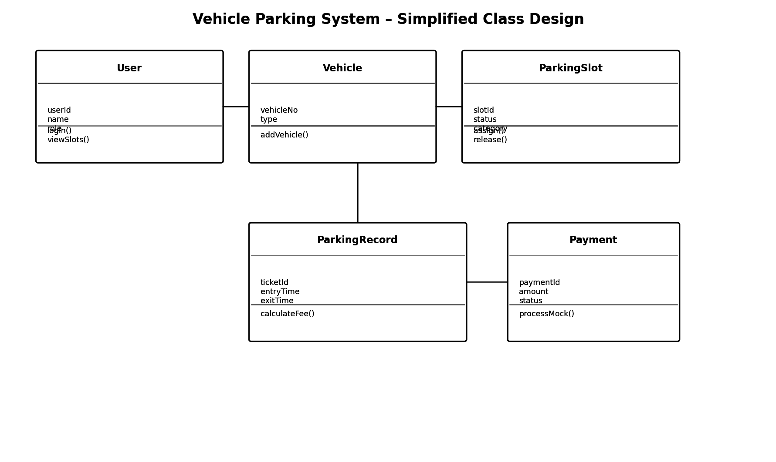
Figure 4.3. Simplified UML class design
The class design is kept small enough for the academic project. User represents system users, Vehicle stores vehicle information, ParkingSlot stores slot state, ParkingRecord represents a parking session, and Payment stores the mock payment result. Additional helper classes or service classes can be introduced during implementation if required.

4.7 Data Design
The main relationships are: a user can be associated with parking operations; a vehicle can have multiple parking records over time; each active parking record references one slot; and a completed parking record can have one mock payment record. Audit logs are associated with administrative users.
Key Field | Type / Example | Rule
ticket_id | String / QR-compatible ID | Unique for every parking session
plate_number | String | Required and validated
slot_id | String | References an existing parking slot
status | Enum/String | Vacant, Occupied or Reserved
entry_time | DateTime | Required when ticket is created
exit_time | DateTime | Set when ticket is closed
amount | Decimal | Calculated from duration and rate
role | Enum/String | Admin, Attendant or other supported role
password_hash | String | Never store the plain password

4.8 Design Traceability
SRS Requirement | Design Element | Verification Reference
REQ-LOG-01 / 02 | Entry UI + ParkingRecord + Entry API | TC-01, TC-02
REQ-SLOT-01 | ParkingSlot status update logic | TC-01, TC-10
REQ-PAY-01 | Fee Calculation service | TC-06
REQ-PAY-02 / 03 | Mock Payment + Receipt UI | TC-07
REQ-REP-01 to 03 | Reporting service + report export | TC-08
REQ-USR-01 / 02 | Authentication + role check + AuditLog | TC-15
REQ-NAV-01 to 04 | Facility graph + BFS service + map UI | TC-04
REQ-PRED-01 to 04 | DwellHistory + prediction service | TC-05, TC-09
NFR-REL-01 to 04 | Validation + transaction consistency + database persistence | TC-02, TC-07, TC-11, TC-12
SEC-01 to 08 | Hashing, lockout, role checks, validation, CSRF, audit log | TC-14 to TC-17

The verification references above are aligned with the existing Vehicle Parking System Test Plan, which already maps the SRS requirements to test cases. This makes the architecture/design traceable through testing.

4.9 Open Issues & Next Steps
Decision | Reason | Future Extension
Layered architecture | Simple for the project and supports modularity. | Can later split services if system size increases.
Local relational database | Matches the single-machine demo requirement. | Can move to a hosted database for multi-facility deployment.
BFS for smart slot assignment | Simple, explainable shortest-path method for the facility graph. | Can later support weighted paths or Dijkstra/A*.
Heuristic prediction | SRS requires an explainable average-dwell-time approach rather than a trained ML model. | Can later be replaced by a trained prediction model.
Mock payment | Real transactions are explicitly out of scope. | Can later integrate a real gateway with proper security controls.
Software simulation of hardware | Avoids requiring physical devices for the course demo. | Can later connect LPR/RFID, sensors and barriers.

5. Appendices

5.1 Glossary
BFS: breadth-first search, shortest path in an unweighted graph. Dwell time: exit time minus entry time. Demo Clock: app-level time offset. Mock payment: stubbed payment with no real transaction. CSRF/XSS: request forgery / script injection attacks.

5.2 References
- IEEE Std 1016-2009, IEEE Standard for Information Technology—Systems Design—Software Design Descriptions.
- ISO/IEC/IEEE 42010:2022, Systems and software engineering - Architecture description.
- Vehicle Parking System (Mini Project), Software Requirements Specification, Version 2.0.
- Vehicle Parking System, Software Test Plan, VPS-TP-01, Version 1.0.
Note: IEEE 1016-2009 defines the information content and organization of a Software Design Description. The IEEE Standards Association currently lists IEEE 1016-2009 as inactive-reserved, while ISO/IEC/IEEE 42010:2022 is the active standard for architecture descriptions. For this course submission, the document follows the requested IEEE SDD approach and incorporates the architecture-description structure relevant to the assignment.

5.3 Tools
The design uses UML-style diagrams and standard document tools for the architecture and design specification.

