16. Detailed Design

Class User Major Functions (PDL)

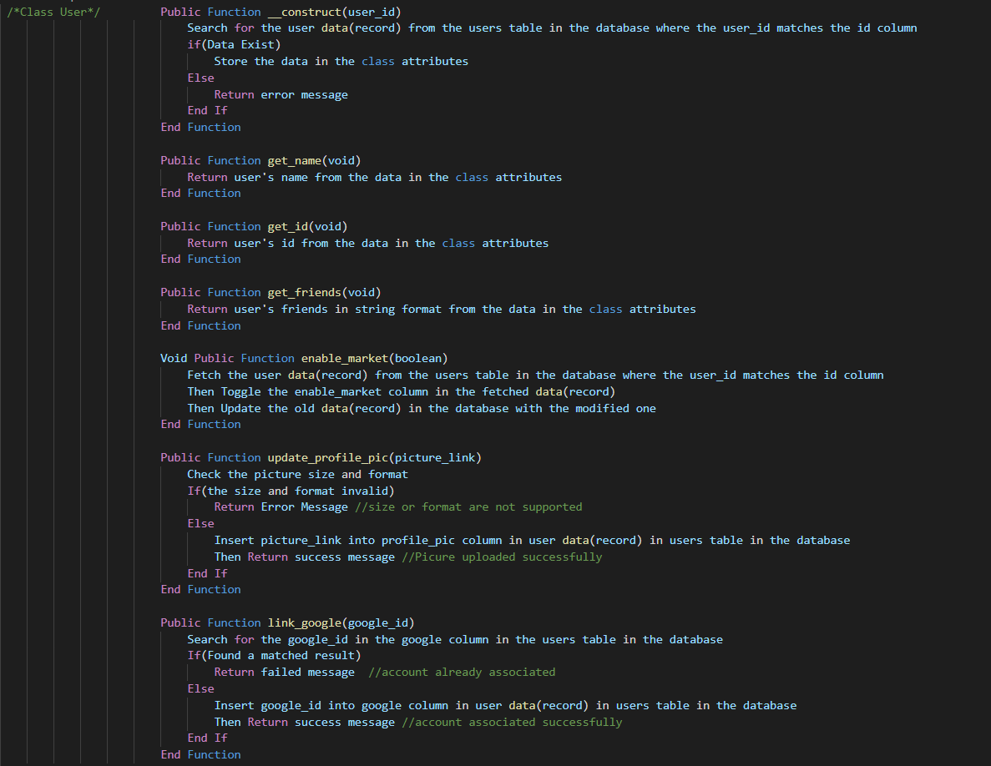

Class Verification Major Functions (PDL)

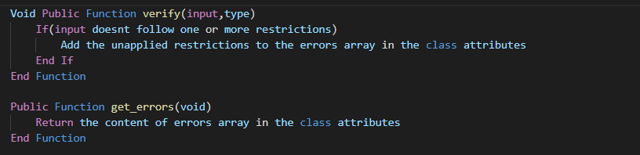

Class Friendship Major Functions (PDL)

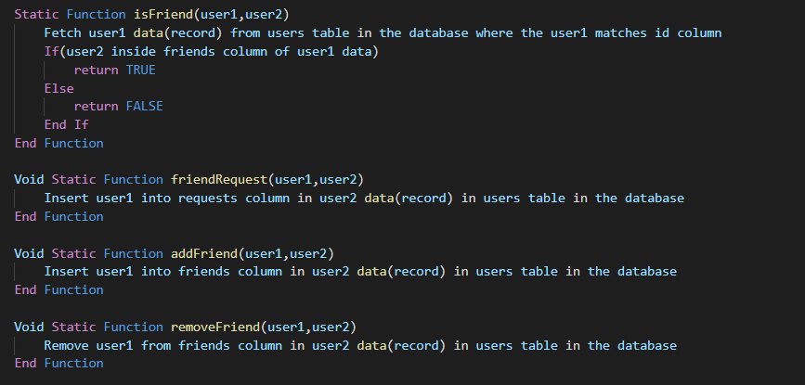

Class Notification Major Functions (PDL)

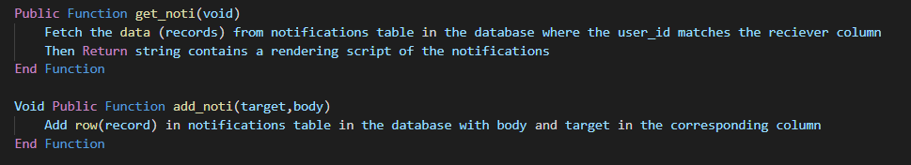

Class Post Major Functions (PDL)

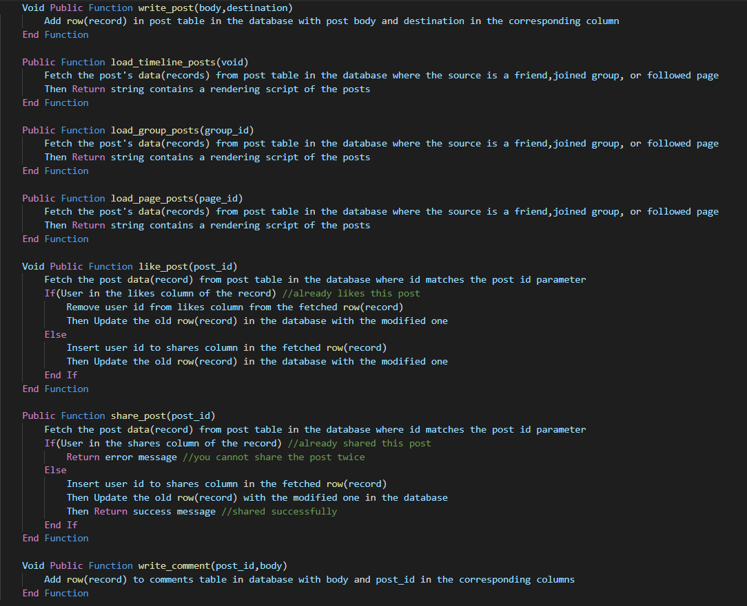

Class Marketplace Major Functions (PDL)

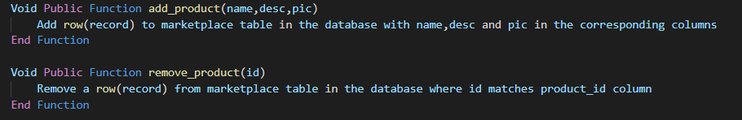

Class Group Major Functions (PDL)

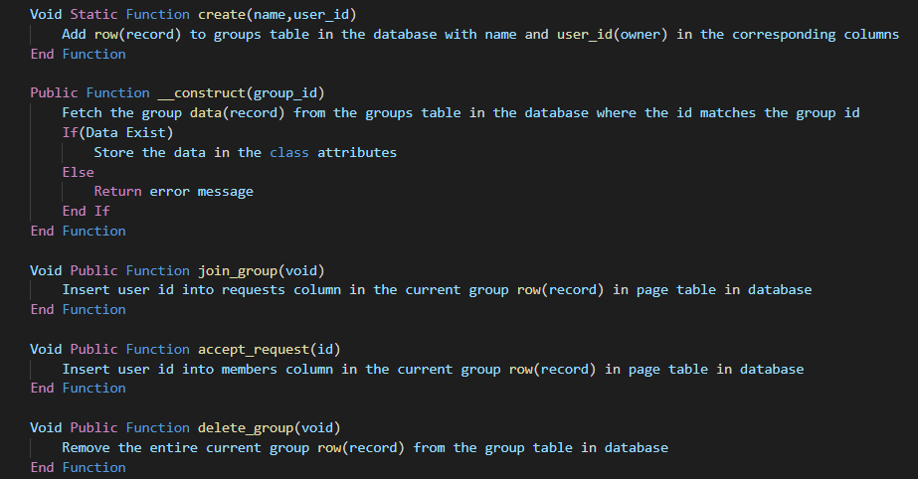

Class Page Major Functions (PDL)

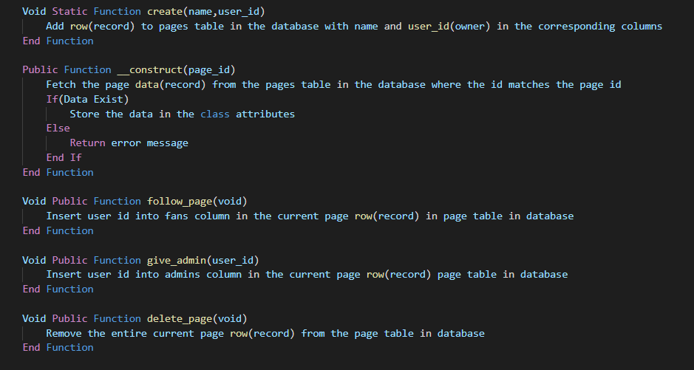

Class Admin Major Functions (PDL)

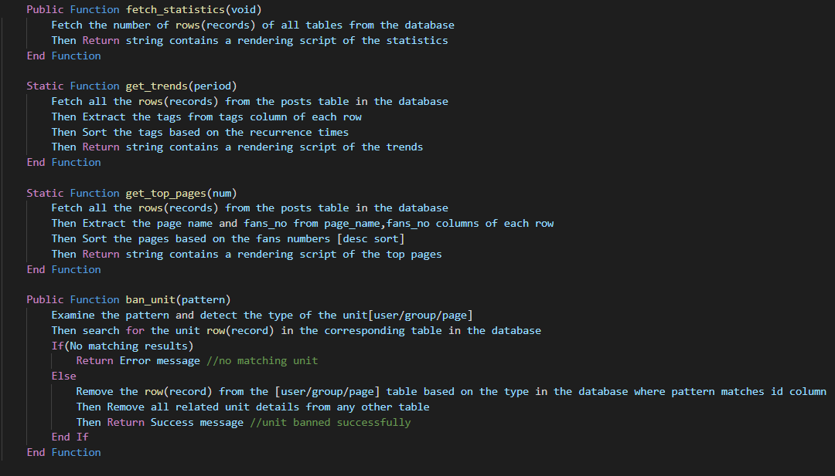

Class Chat Major Functions (PDL)

