Champion Document
Feature: Session / Level Coordinator (TL1) — Algernon
Name: ___Breana Sinipete__ Mark: _____ / 30

1. Brief Introduction
My feature for Algernon is the Session / Level Coordinator (TL1). It owns the answer to “what is happening right now”: which level is loaded, how much time is left, whether the run has been won or lost, and what happens next. Every other feature is a service; this is the thing that uses them.
What it does. Concretely, my code:
- Drives the top-level session state machine: Boot → Menu → LevelLoading → Playing → Paused → Won → Lost → RunComplete.
- Resolves level progression and per-level configuration (maze size, hazard density, active distortions, time limit) from LevelCatalogue.
- Owns the countdown timer (RunTimer) and the time-out loss condition.
- Runs per-frame orchestration while Playing: pushes the player’s current maze cell to the movement/objective feature (F3) and the hazard/distortion feature (F4), polls both for objective completion and death events, and arbitrates the resulting win/loss verdict through a pluggable LevelRule hierarchy.
- Tracks run statistics: elapsed time, deaths, puzzles solved, levels cleared.
- Bootstraps the scene and owns initialisation ordering across every other feature.
- Is the custodian of Contracts/ — the interface and enum definitions every other feature compiles against.
What it deliberately does NOT do.
- It does not generate the maze or place geometry — that belongs to the level-generation feature (F2); I receive a built level and its exit cell as input.
- It does not move the player, resolve line-of-sight, or decide when an objective is complete — that belongs to F3; I only poll the boolean result.
- It does not detect hazard collisions or raise the death event itself — that belongs to F4; I only consume the event it raises.
- It does not render the HUD, play audio, or draw menus — that belongs to F6; I only publish State, the timer, and RunStatistics for them to read.
- It does not hard-code what “solved” means for a level — that logic is authored once per LevelRule subclass and composed per level, not embedded in the coordinator.

2. Use Case Diagram with Scenario

Use Case Diagrams
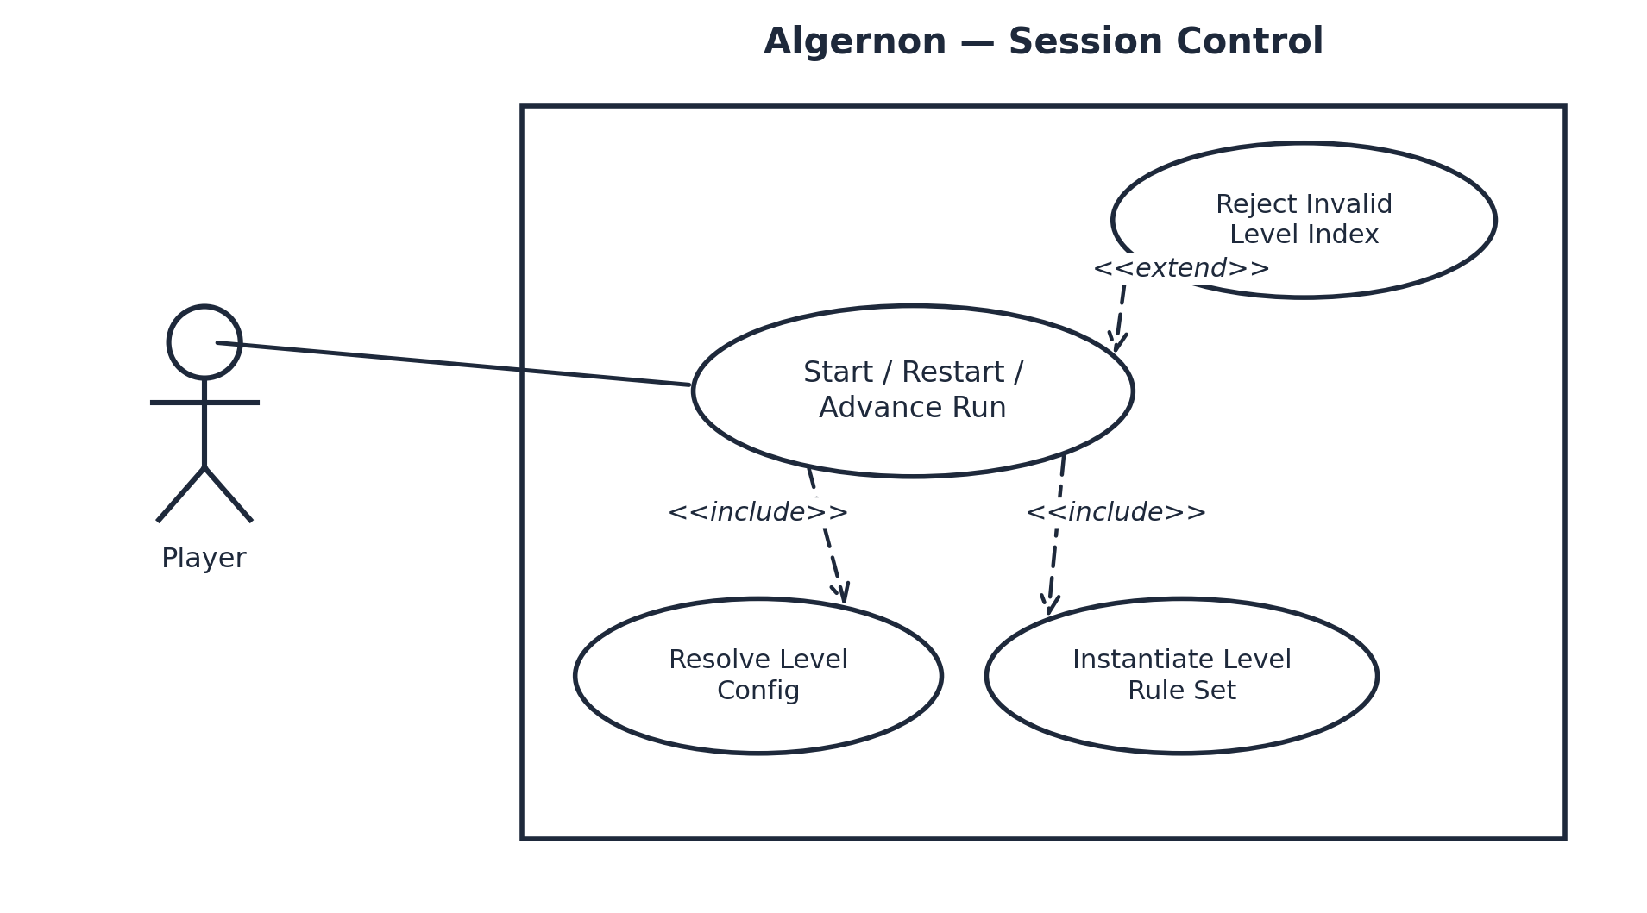
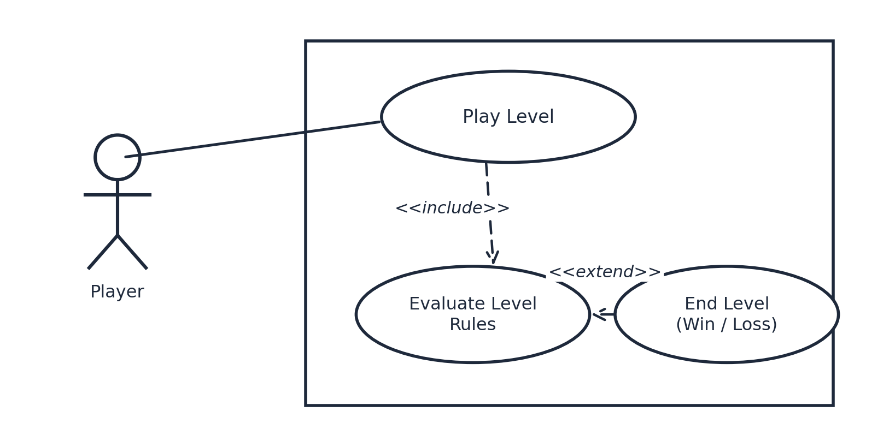

Scenarios
Scenario 1 (first use case diagram)
Name: Start, Restart, or Advance a Run
Summary: The player issues a run-control command from the menu or pause UI; SessionMachine transitions state, LevelCatalogue resolves the target LevelConfig, and the level is loaded.
Actors: Player
Preconditions: LevelCatalogue has finished loading.
Basic sequence:
Step 1: The player selects Start, Restart, or Advance from the menu or pause UI; the UI calls the corresponding public method (StartRun, RestartLevel, or AdvanceLevel).
Step 2: SessionMachine transitions State to LevelLoading.
Step 3: LevelCatalogue resolves the target level index to a LevelConfig (maze size, hazard density, active distortions, time limit).
Step 4: GameCoordinator resets RunTimer to LevelConfig.TimeLimitSeconds, clears the per-level LevelRule instances, and instantiates the LevelRule set the LevelConfig specifies.
Step 5: Scene bootstrapping completes and SessionMachine transitions LevelLoading → Playing.
Step 6: OnLevelStarted fires and control passes to the per-frame loop (Scenario 2).
Exceptions:
Step 1a: The command is StartRun(startingLevelIndex) and startingLevelIndex is outside LevelCatalogue’s range — the <<extend>> “Reject Invalid Level Index” case. StartRun logs an error and returns; State remains unchanged and Step 2 does not execute.
Step 5a: Scene bootstrapping fails (an asset fails to load). SessionMachine transitions to Menu instead of Playing, the failure is logged, and OnRunEnded does not fire because no run statistics were committed for this attempt.
Post conditions: State is Playing with a freshly configured level, or unchanged in Menu after a rejected/failed load.
Priority: 1 (must have)
ID: SC1
Scenario 2 (second use case diagram)
Name: Play a Level to Completion
Summary: While a level is active, the coordinator orchestrates every other feature frame by frame and arbitrates the win/loss verdict.
Actors: Player
Preconditions: A run has been started; SessionMachine.State == Playing.
Basic sequence:
Step 1: Each frame while State == Playing, GameCoordinator reads the player’s current maze cell and the frame’s delta time.
Step 2: GameCoordinator writes the player cell into the SessionSnapshot and pushes it to F3 and F4 so each can update its own per-frame state (objective proximity, hazard/distortion proximity).
Step 3: RunTimer is decremented by the frame delta and the remaining time is written into the snapshot.
Step 4: GameCoordinator polls F3 for objective/exit completion and F4 for a death event raised this frame, and adds both to the snapshot.
Step 5: Every active LevelRule.Evaluate(snapshot) is called; GameCoordinator arbitrates the first non-InProgress RuleVerdict returned.
Step 6: If every rule returns InProgress, RunStatistics.ElapsedTime is updated and the loop repeats next frame from Step 1.
Exceptions:
Step 1a: The player calls Pause(true) — SessionMachine transitions Playing → Paused; Steps 1–6 halt entirely until Pause(false) returns State to Playing, resuming at Step 1.
Step 3a: RunTimer reaches exactly 0.0s while a TimedSurvivalRule is active — the <<extend>> “End Level” case. Step 5’s evaluation resolves to Lose without waiting on the remaining rules; State transitions Playing → Lost and OnLevelEnded fires.
Step 4a: F4 reports a death event this frame while a NoDeathRule is active — the <<extend>> “End Level” case. RunStatistics.Deaths increments, State transitions Playing → Lost, and OnLevelEnded fires.
Post conditions: State is Playing (loop continues), Paused, Won, or Lost; RunStatistics reflects elapsed time and any death this level.
Priority: 1 (must have)
ID: PL1

3. Interface Contract
Every member below lives in Contracts/ and is what the other six features compile against. Each entry states its type, the condition under which it is valid, and a concrete, numeric or boolean test — not a vague description.

Public Methods (Inputs)
Signature | Precondition | Effect | Test
void StartRun(int startingLevelIndex) | State ∈ {Boot, Menu, Won, Lost, RunComplete} | Resolves LevelConfig, resets RunTimer/RunStatistics, instantiates LevelRule set, State → LevelLoading. | StartRun(-1) and StartRun(Count) each leave State unchanged and log exactly 1 error; a valid index reaches Playing within 5 frames.
void RestartLevel() | State ∈ {Playing, Paused, Won, Lost} | Reloads CurrentLevel’s config and resets RunTimer; State → LevelLoading → Playing. | Two calls in the same frame yield exactly 1 OnLevelStarted invocation (idempotent).
void AdvanceLevel() | State == Won | LevelsCleared += 1; advances the catalogue index; State → LevelLoading, or → RunComplete if no levels remain. | Called while State == Playing throws InvalidOperationException; called on the last level sets State == RunComplete, not LevelLoading (0 levels remaining).
void Pause(bool paused) | State ∈ {Playing, Paused} | true: Playing → Paused, halts RunTimer and per-frame polling. false: reverses it. | Pause(true) called twice leaves State == Paused and RunTimer unchanged to 3 decimal places between calls.
void AbortRun() | State != Boot | State → Menu from any state; fires OnRunEnded with the run marked incomplete; cancels an in-flight load. | Called during LevelLoading: OnLevelStarted never fires for that level and State == Menu within 1 frame.

Public Outputs (read-only properties)
Signature / Type | Description | Test
SessionState State { get; } | enum { Boot, Menu, LevelLoading, Playing, Paused, Won, Lost, RunComplete } | 10,000-transition stress test with randomised snapshots: State is one of the 8 declared values on every transition, 0 undefined states.
LevelConfig CurrentLevel { get; } | struct { int MazeWidth, MazeHeight; float HazardDensity; DistortionType[] ActiveDistortions; float TimeLimitSeconds; int PuzzlesRequired; } | Every LevelCatalogue entry loads with TimeLimitSeconds > 0 and 0.0 ≤ HazardDensity ≤ 1.0; a level with PuzzlesRequired == 0 is winnable immediately on reaching the exit cell (boundary test).
RunStatistics Statistics { get; } | struct { float ElapsedTime; int Deaths; int PuzzlesSolved; int LevelsCleared; } | A scripted 3-level run with exactly 2 forced deaths ends with Statistics.Deaths == 2 (exact).

Public Events
Signature | Fires When | Test
event Action OnLevelStarted | Exactly once per LevelLoading → Playing transition. | Subscribe a counter for a scripted 3-level run: counter == 3 at RunComplete.
event Action OnLevelEnded | Exactly once per Playing → Won or Playing → Lost transition. | Forcing RunTimer to 0.0 fires the handler in the same frame RunTimer reaches 0.0 (0 frames of delay).
event Action OnRunEnded | Exactly once when State reaches RunComplete, or when AbortRun() is called. | AbortRun() mid-level fires OnRunEnded exactly once and OnLevelEnded exactly zero times for that level (no double-firing).

4. Data Flow Diagrams
Diagram 0 shows the whole game (all six developers’ processes) with my feature’s process (1.0, Game Session & Level Flow) highlighted. I then zoom into Process 1 and give a decision-tree process description for primitive process 1.3, which is also the process behind the dynamic-binding demo: if LevelRule.Evaluate loses its virtual and every override loses its new, every rule resolves to the base method and 1.3 always returns InProgress — the level becomes unwinnable and unloseable.
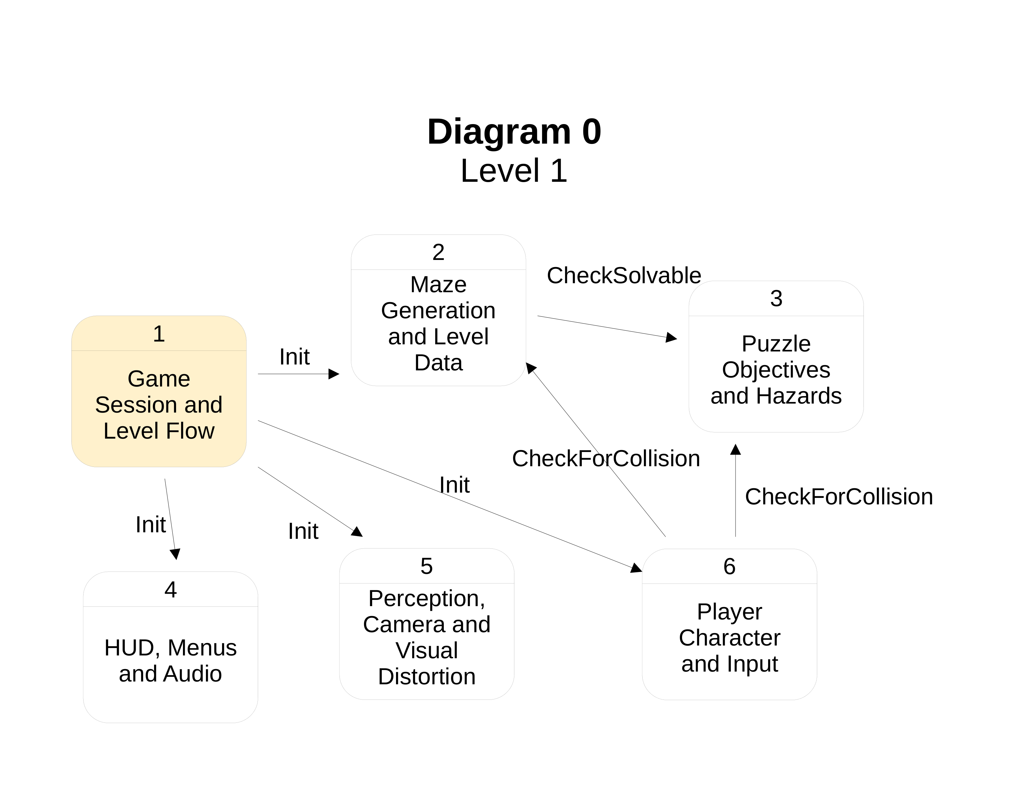
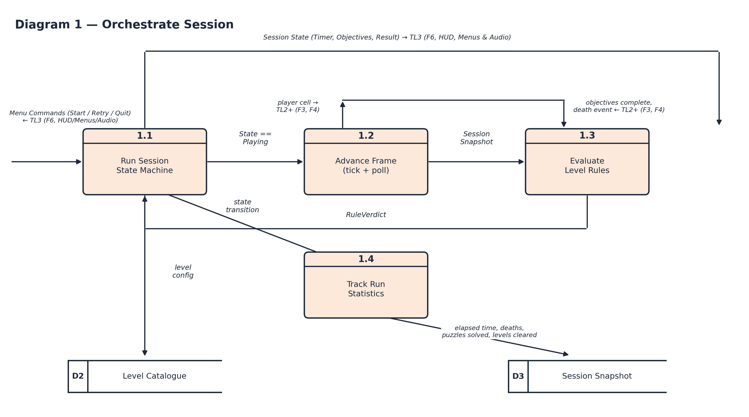

Process Description — 1.3 Evaluate Level Rules
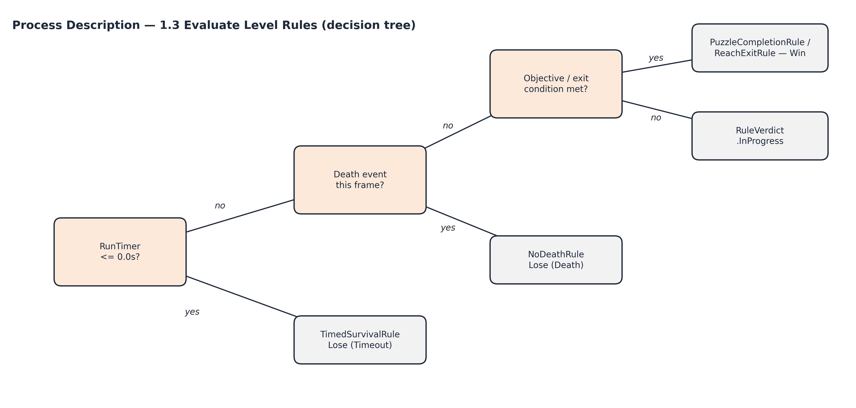
No black holes, no miracles.
- Process 1 has no black holes: every flow that enters it is used somewhere downstream — the menu command (Start/Retry/Quit, routed from TL3/F6’s HUD) drives 1.1, level config resolved from D2 (Level Catalogue) feeds 1.1, player cell and objective/death data to and from TL2+ (F3/F4) feed 1.2, and the RuleVerdict from 1.3 feeds 1.1 and 1.4.
- Process 1 has no miracles: every flow that leaves it is traceable to an input or a store — the player cell written to TL2+ (F3/F4) each frame comes from 1.2’s poll, the session state (timer, objectives, result) written to TL3 (F6, HUD/Menus/Audio) comes from 1.1/1.4, and run statistics written to D3 (Session Snapshot) come from 1.4’s tally of the same events polled in 1.2.
- The context diagram (Diagram 0) and the zoom (Diagram 1) balance: every data flow crossing the boundary of Process 1 in Diagram 0 (player cell & interact event, kill command, level config / spawn & exit cells, maze data read, objective progress & death cause, session state, menu commands, follow target/bounds/distortion schedule) reappears at the boundary of Diagram 1’s children.

5. Timeline

Work items
Each of the 12 tasks above is broken into its fine-grained subtasks below; the bold subtotal row under each task reproduces that task’s original hour estimate exactly, so the 52-hour total and the 39-hour critical path (1→2→3→6→7→8→9→12) are unchanged.
Task | Phase | Hours | Predecessor(s)
1.1 Define SessionState enum (Boot/Menu/LevelLoading/Playing/Paused/Won/Lost/RunComplete) | Design | 0.75 | –
1.2 Define RuleVerdict enum (InProgress/Win/Lose) | Design | 0.25 | –
1.3 Define LevelConfig struct fields | Design | 0.75 | –
1.4 Define SessionSnapshot struct fields | Design | 0.75 | –
1.5 Define GameCoordinator public method/property/event signatures | Design | 1 | –
1.6 Review contract against F2–F7 consumer needs | Design | 0.5 | –
Subtotal — Task 1. Contracts/ interfaces & enum definitions | Design | 4 | —
2.1 Design SessionMachine state-transition table (legal/illegal transitions) | Design | 1.5 | –
2.2 Design LevelRule abstract base + virtual Evaluate contract | Design | 1 | –
2.3 Design the 4 concrete rule specs (win/lose condition each) | Design | 1.5 | –
2.4 Design GameCoordinator ↔ LevelRule composition (activeRules, per-level selection) | Design | 1 | –
2.5 Whiteboard the dynamic-binding demo (virtual/override removal) | Design | 1 | –
Subtotal — Task 2. SessionMachine + LevelRule hierarchy design | Design | 6 | 1
3.1 Implement SessionState enum + State property | Coding | 0.5 | –
3.2 Implement TransitionTo() with guard checks | Coding | 1.5 | –
3.3 Wire OnLevelStarted / OnLevelEnded / OnRunEnded event firing | Coding | 1.25 | –
3.4 Unit-test every legal and illegal transition | Coding | 0.75 | –
Subtotal — Task 3. SessionMachine + SessionState implementation | Coding | 4 | 2
4.1 Implement LevelConfig struct (MazeWidth/Height, HazardDensity, Distortions, TimeLimitSeconds) | Coding | 1 | –
4.2 Implement LevelCatalogue.Resolve(index) with bounds validation | Coding | 1 | –
4.3 Author catalogue data for the initial level set | Coding | 0.5 | –
4.4 Boundary test (index -1, index == Count) | Coding | 0.5 | –
Subtotal — Task 4. LevelCatalogue & LevelConfig | Coding | 3 | 1
5.1 Implement RunTimer.Reset() / Advance(dt) | Coding | 1 | –
5.2 Implement RunStatistics fields + increment hooks | Coding | 1 | –
5.3 Zero/negative time-limit edge-case handling | Coding | 0.5 | –
5.4 Unit test: timer reaching exactly 0.0s | Coding | 0.5 | –
Subtotal — Task 5. RunTimer & RunStatistics | Coding | 3 | 2
6.1 PuzzleCompletionRule | Coding | 1 | –
6.2 TimedSurvivalRule | Coding | 1.25 | –
6.3 NoDeathRule | Coding | 1.25 | –
6.4 ReachExitRule | Coding | 1 | –
6.5 Cross-rule integration smoke test | Coding | 0.5 | –
Subtotal — Task 6. LevelRule subclasses (4 rules) | Coding | 5 | 3
7.1 StartRun / RestartLevel / AdvanceLevel / AbortRun command handlers | Coding | 1.5 | –
7.2 Per-frame Tick: build SessionSnapshot, push to F3/F4 | Coding | 1.25 | –
7.3 Per-frame Tick: poll F3/F4, arbitrate LevelRule verdicts | Coding | 1.25 | –
7.4 Pause(bool) halt/resume wiring | Coding | 0.5 | –
7.5 Wire RunStatistics updates (ElapsedTime, Deaths) | Coding | 0.5 | –
Subtotal — Task 7. GameCoordinator per-frame orchestration | Coding | 5 | 3, 4, 5, 6
8.1 StartRun invalid-index tests (-1, Count) | Testing | 0.75 | –
8.2 RestartLevel double-call / OnLevelStarted count test | Testing | 0.75 | –
8.3 AdvanceLevel-while-Playing exception test | Testing | 0.5 | –
8.4 Pause(true) idempotency test | Testing | 0.5 | –
8.5 AbortRun mid-level test (no OnLevelStarted, single OnRunEnded) | Testing | 0.75 | –
8.6 Timer-at-exactly-0.0s boundary test | Testing | 0.75 | –
8.7 0-puzzle level boundary test | Testing | 0.75 | –
8.8 Full SessionState enum coverage sweep | Testing | 1.25 | –
Subtotal — Task 8. Unit + boundary tests (timer @ 0.0s, 0-puzzle level) | Testing | 6 | 7
9.1 Build randomised-transition harness | Testing | 1.25 | –
9.2 Run 10,000-transition pass, log invariant violations | Testing | 1 | –
9.3 Triage + fix any failures found | Testing | 0.75 | –
Subtotal — Task 9. Stress test (10,000 randomised transitions) | Testing | 3 | 8
10.1 Build demo scene wired to the LevelRule list | Testing | 1 | –
10.2 Strip virtual/override to reproduce the bug | Testing | 0.5 | –
10.3 Verify unwinnable/unloseable behavior, capture recording | Testing | 1 | –
10.4 Confirm total demo build+verify time is < 60s per spec | Testing | 0.5 | –
Subtotal — Task 10. Dynamic-binding demo build & verification (< 60s) | Testing | 3 | 6
11.1 XML doc comments on every Contracts/ method/property/event | Documentation | 2 | –
11.2 NullX stub docs for F2–F7 integration points | Documentation | 1.5 | –
11.3 Proofread against the Interface Contract table | Documentation | 0.5 | –
Subtotal — Task 11. Contracts/ XML doc comments & NullX stub docs | Documentation | 4 | 7
12.1 Write problem/feature description sections | Documentation | 1 | –
12.2 Use case diagrams + scenarios (UC1, UC2) | Documentation | 1.25 | –
12.3 Interface contract tables | Documentation | 0.75 | –
12.4 Data flow diagrams (Diagram 0, Diagram 1) + process description | Documentation | 1.5 | –
12.5 PERT diagram + critical path narrative | Documentation | 0.75 | –
12.6 Final pass: class/sequence diagrams, black-hole/miracle/balance checks | Documentation | 0.75 | –
Subtotal — Task 12. Champion document | Documentation | 6 | 9, 10, 11
Effort by phase: Design 10h · Coding 20h · Testing 12h · Documentation 10h · Total 52h.

PERT diagram
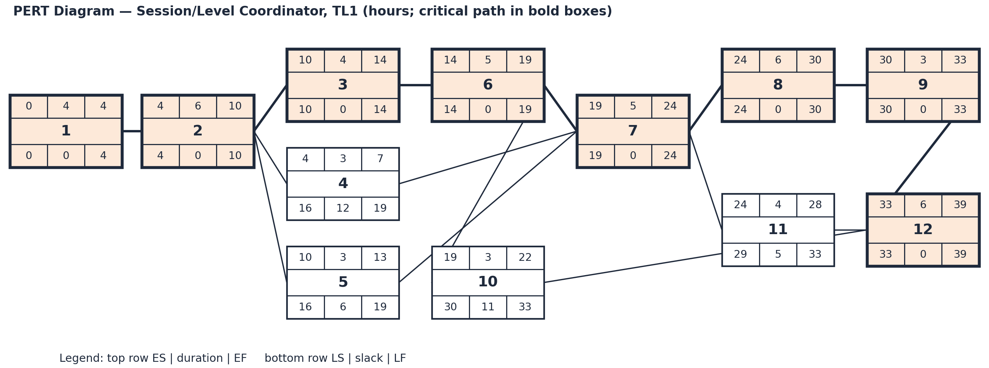
The critical path is 1 → 2 → 3 → 6 → 7 → 8 → 9 → 12, totaling 39 hours. Tasks 4 and 5 carry slack of 12h and 6h respectively because LevelCatalogue and RunTimer can be built in parallel with the SessionMachine/LevelRule design-and-build chain; task 10 (the dynamic-binding demo) carries 11h of slack since it only depends on the LevelRule subclasses (task 6), not on GameCoordinator wiring; task 11 (Contracts docs) carries 5h of slack. The 52 total work-hours exceed the 39-hour critical path because tasks 4, 5, 10, and 11 run in parallel with critical-path work rather than after it.

Gantt timeline
