Class Diagram
Feature: Session / Level Coordinator (TL1) — Algernon
Supporting document for the Systems Analysis presentation — not part of the Champion Document. Companion to Champion Document Section 2 (Use Case Diagram with Scenario) and Section 3 (Interface Contract).

Class Diagram
The diagram below models the classes behind the Session / Level Coordinator feature: GameCoordinator composes its four collaborators, aggregates a pluggable LevelRule set, and builds a SessionSnapshot each frame that every active rule depends on to produce a RuleVerdict.
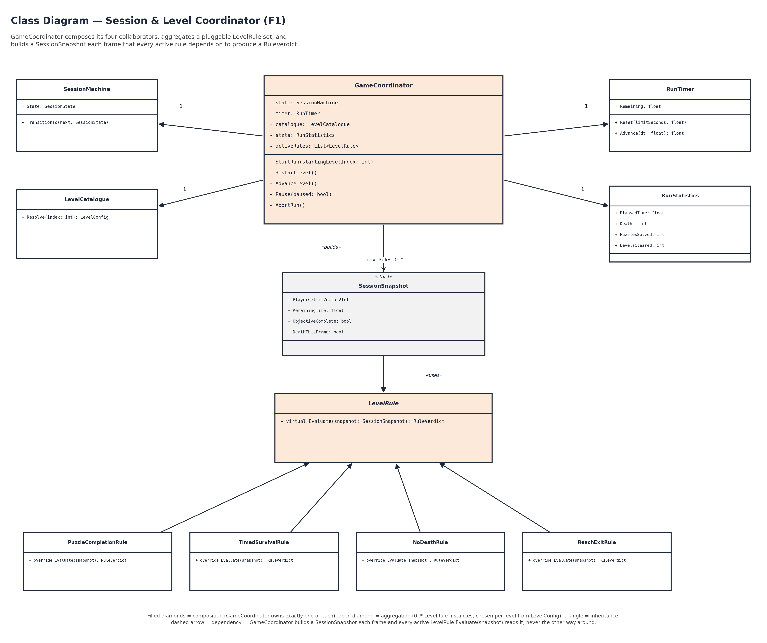

Class List
Every class shown in the diagram above, with its core responsibility. Referenced by the companion Sequence Diagram document (participants for the Play Level flow).
Class | Responsibility
GameCoordinator | Owns SessionState and orchestrates the per-frame loop: builds the SessionSnapshot, pushes it to F3/F4, and arbitrates the LevelRule verdict. Composes SessionMachine, LevelCatalogue, RunTimer, and RunStatistics; aggregates 0..* LevelRule.
SessionMachine | Holds the top-level SessionState and validates every transition (Boot → Menu → LevelLoading → Playing → Paused → Won → Lost → RunComplete).
LevelCatalogue | Resolves a level index to a LevelConfig (maze size, hazard density, active distortions, time limit); validates the index is in range.
RunTimer | Owns the countdown timer for the active level: Reset(limitSeconds) and Advance(dt), including the time-out loss condition.
RunStatistics | Tracks ElapsedTime, Deaths, PuzzlesSolved, and LevelsCleared for the current run.
SessionSnapshot | Per-frame struct GameCoordinator builds and passes to every active LevelRule: PlayerCell, RemainingTime, ObjectiveComplete, DeathThisFrame.
LevelRule | Abstract base for the pluggable win/loss rule set; declares virtual Evaluate(snapshot): RuleVerdict, the method behind the dynamic-binding demo.
PuzzleCompletionRule | Concrete LevelRule: level is won once every required puzzle is solved.
TimedSurvivalRule | Concrete LevelRule: level is lost the frame RunTimer reaches exactly 0.0s.
NoDeathRule | Concrete LevelRule: level is lost the frame F4 reports a death event.
ReachExitRule | Concrete LevelRule: level is won once the player reaches the maze's exit cell.

