Champion Document — F5 Perception
Name: ____________ Feature: F5 — Perception, Camera & Visual Distortion (TL4) Mark: ____ / 30
Mechanical home of the Flowers for Algernon theme: as the levels progress, the player's view sharpens, then decays — it mirrors, rotates, drains of colour and finally goes dark. Every contract item below has a typed signature and a numeric pass/fail bound.

1. Brief Introduction
My feature decides what the player can see. At level start, F1 hands me the mouse's Transform (from F7) and the maze's Bounds (from F2). My code frames the whole maze on screen, then eases into following the mouse, with optional screen shake on top. A fog-of-war grid covers the maze; every cell inside the vision radius around the mouse is revealed, and a revealed cell stays revealed for the rest of the level. A minimap shows the explored cells and can be distorted to match the main view.
Each level runs a distortion schedule. Distortions — mirror, rotation, fog, desaturation and blackout — are ViewEffect objects linked into a Chain of Responsibility. Every frame a CameraState is passed down the chain; each effect may modify it and forward it, and BlackoutViewEffect halts the chain so nothing after it renders. Intensities ramp over time, so desaturation can drain colour exactly as the level timer runs down. Because the pipeline holds only ViewEffect references, removing virtual from Process turns every effect into a pass-through — the dynamic-binding demonstration for the oral exam.
My feature deliberately does not move the mouse, read input, or remap controls — a mirrored view does not flip the arrow keys; that belongs to F7. It does not generate the maze or decide cell size (F2), and it does not own the level timer, win/lose rules, pause menu or HUD layout (F1); I receive intensities and a level index, and I expose a snapshot for F1 to store. Distortions never touch collision or game logic: they change the picture only. Blur is reserved in the enum but deferred to a stretch goal; the completion criteria are met by the other four distortions plus fog.

2. Use Case Diagram with Scenario
Use Case Diagrams
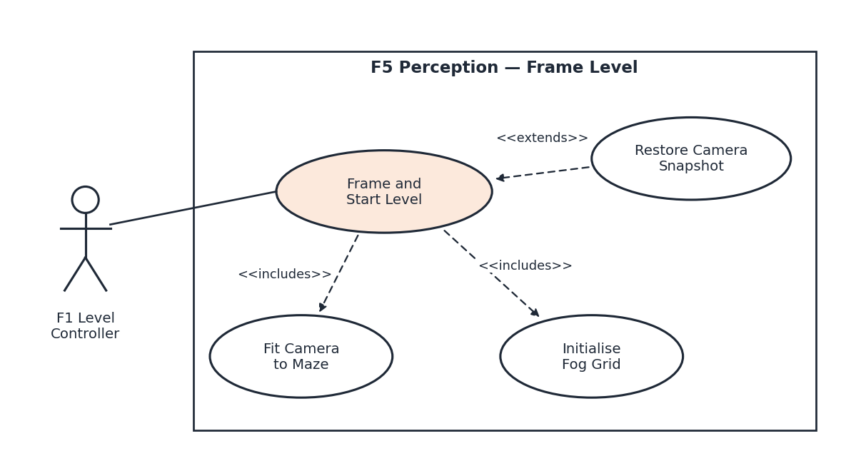
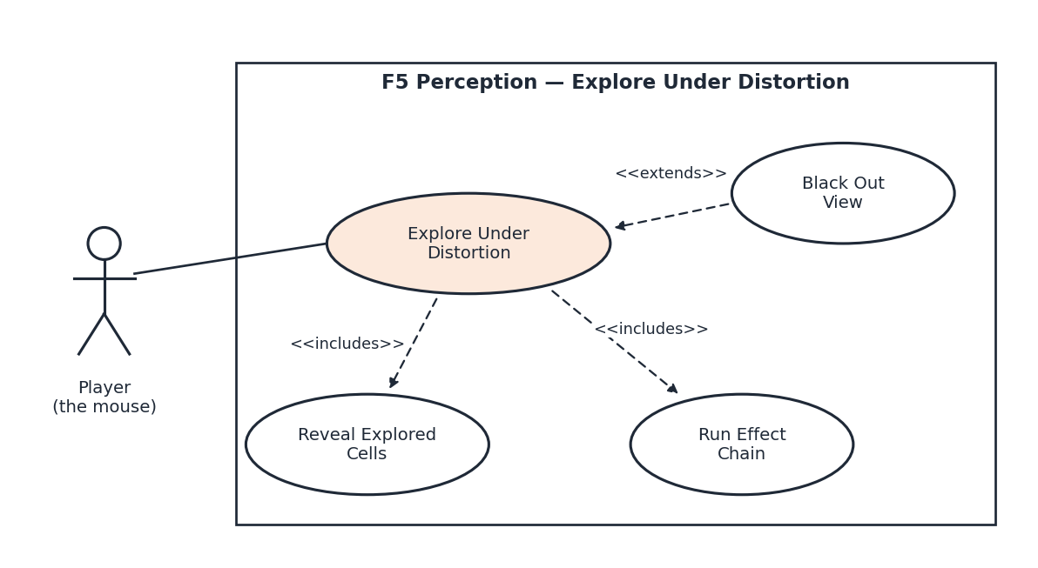
Scenarios
Scenario 1 (first use case diagram)
Name: Frame and Start Level
Summary: At level start, F1 binds the follow target, the camera fits the whole maze on screen, the fog grid is created, and the level's distortion schedule is loaded.
Actors: F1 Level Controller (system)
Preconditions: F2 has produced the maze and its Bounds; F7 has spawned the mouse; the Distortion Schedules table (D1) has loaded.
Basic sequence:
Step 1: F1 calls BindFollowTarget() with the mouse's Transform.
Step 2: F1 calls FrameMaze() with the maze Bounds.
Step 3: CameraRig centres on the bounds and sets orthographic size so the maze plus a 1-cell margin fits the current aspect ratio.
Step 4: FogGrid is allocated at the maze's cell dimensions with every cell unexplored.
Step 5: F1 calls LoadSchedule() with the level index; the effect chain is cleared and the schedule clock is reset to 0.
Step 6: The camera eases from the framed view to following the mouse over 0.5 s, and the Framed event is raised.
Exceptions:
Step 1a: The target is null. Follow is disabled, the camera stays at the framed centre, and one warning is logged. The sequence continues at Step 2.
Step 2a: The bounds have zero, negative or non-finite size. An error is logged, camera and fog are unchanged, Framed is not raised, and the sequence ends; F1 must call again.
Step 3a: The maze is too large to fit at the maximum orthographic size (40). Size is clamped to 40 and the minimap becomes the overview; the sequence continues at Step 4.
Step 5a: The level index has no schedule row. The chain stays empty (identity view) and a warning is logged; the sequence continues at Step 6.
Step 5b: The player chose Restart from pause — the <<extends>> case. F1 calls RestoreState() with its stored snapshot instead; camera pose, active effects, schedule clock and explored cells return to their captured values. The sequence resumes at Step 6.
Post conditions: The maze is framed, the fog grid matches the maze, the schedule clock is running, and the camera follows the mouse.
Priority: 1 (must have)
ID: FL1
Scenario 2 (second use case diagram)
Name: Explore Under Distortion
Summary: As the player moves the mouse, the camera follows, fog lifts permanently around it, and the scheduled distortions are applied to the view through the effect chain.
Actors: Player
Preconditions: Scenario FL1 has completed; the level is running (not paused).
Basic sequence:
Step 1: The player moves the mouse; F7 updates its Transform.
Step 2: CameraRig moves toward the mouse position with smoothing and produces the base CameraState.
Step 3: FogGrid marks every cell whose centre lies within the vision radius of the mouse's cell as explored.
Step 4: The scheduler advances its clock, applies any schedule entries now due, and ramps each active effect's intensity toward its target.
Step 5: ViewEffectPipeline passes the CameraState through the chain in order; each effect modifies it and forwards it to Next.
Step 6: The final state is applied to the Unity camera and post-process material, and MinimapRenderer draws the explored cells.
Step 7: Steps 1–6 repeat each frame until F1 ends the level and calls RevealAll(true) for the win screen.
Exceptions:
Step 2a: A Shake() request is active. A random render offset no larger than the decaying envelope is added after follow; the logical camera position is unchanged. The sequence continues at Step 3.
Step 3a: The vision radius is 0. No cells are revealed this frame, but previously explored cells stay revealed. The sequence continues at Step 4.
Step 5a: The chain reaches BlackoutViewEffect with intensity ≥ 0.5 — the <<extends>> case. The chain halts; no later effect's Process() runs; blackedOut is set, the frame and minimap render black, and BlackoutChanged(true) is raised on the transition. The sequence resumes at Step 6.
Step 5b: The chain is empty. The base state passes through unchanged (identity) and the sequence continues at Step 6.
Step 7a: The player pauses. F1 calls CaptureState() and stores the snapshot; the schedule clock and ramps freeze with scaled time. On resume the sequence continues at Step 1; on restart, Scenario FL1 Step 5b applies.
Post conditions: Explored cells have only grown; the view reflects the schedule for the current level time; game logic is unaffected by any distortion.
Priority: 1 (must have)
ID: ED1

3. Interface Contract
All calls go through ViewDirector, the thin MonoBehaviour façade. F5 knows only a Transform, a Bounds, an int level index and the DistortionId enum (Low Coupling). No call throws: invalid input is logged, ignored or clamped exactly as stated below, so every row is a test. Cell size is taken as 1 world unit, matching F2's maze grid.
Proposed addition (pending F1 agreement): void LoadSchedule(int levelIndex). The published interface has no level identifier, so per-level scheduling — one of my responsibilities — cannot be done without it. The alternative is that F1 issues ApplyDistortion() calls from its own level table, which moves scheduling out of F5.
3.1 Types
Type | Definition | Invariant (testable)
DistortionId | enum { Mirror=0, Rotation=1, Fog=2, Desaturation=3, Blackout=4, Blur=5 } — Blur reserved (stretch) | Undefined integer casts are rejected (see ApplyDistortion).
CameraState | Vector2 position; float orthoSize; float rotationDeg; bool mirrored; float saturation; float fogOpacity; FogMask mask; bool blackedOut; Matrix4x4 ViewMatrix (derived T·R·S) | orthoSize > 0; rotationDeg ∈ [0, 360); saturation, fogOpacity ∈ [0, 1]; ViewMatrix always equals the matrix rebuilt from the fields.
CameraSnapshot | Immutable: position, orthoSize, List<(DistortionId id, float target, float current, int order)>, scheduleClock, levelIndex, visionRadius, revealAll, explored BitArray (deep copy), gridW, gridH | Excludes shake and the follow-target reference (F1 rebinds). Equals() is field-wise.
Intensity semantics | Mirror: mirrored ⇔ i ≥ 0.5 · Rotation: rotationDeg = 360·i mod 360 · Fog: fogOpacity = i · Desaturation: saturation = 1 − i · Blackout: halts chain ⇔ i ≥ 0.5 | Intensity i is clamped to [0, 1] before use.

3.2 Inputs
Call | Parameters / valid range | Postcondition | Invalid input
BindFollowTarget(Transform target) | any Transform | Each LateUpdate the camera approaches target; within 0.25 s of the target stopping, |camera − target| ≤ 0.05 units. | null → follow off, camera holds, 1 warning.
FrameMaze(Bounds mazeBounds) | size.x, size.y > 0, finite | Within 0.5 s all four maze corners plus a 1-cell margin are inside the viewport; orthoSize ≤ 40; FogGrid = ceil(w)×ceil(h), all unexplored; Framed raised once. | size ≤ 0 or NaN → error, no state change, no event.
LoadSchedule(int levelIndex) (proposed) | 0 ≤ index < D1 rows | Chain cleared; clock = 0; rows queued by start time. | Out of range → empty chain + warning.
ApplyDistortion(DistortionId id, float intensity) | defined id; finite intensity, clamped to [0, 1] | New id appended to chain end; existing id keeps its position and gets a new target. Current intensity ramps linearly to target over RampSeconds (default 1.0 s). DistortionChanged raised once. | NaN/∞ or undefined id → ignored + error. Blur → ignored + warning.
RemoveDistortion(DistortionId id) | defined id | Effect ramps to 0 over RampSeconds, then leaves the chain; order of the others is preserved; DistortionChanged(id, 0). | Not in chain → no-op, no event.
ClearDistortions() | — | Chain empty immediately (no ramp); next frame output equals base state; DistortionChanged(id, 0) per removed effect. | —
SetVisionRadius(float cells) | finite; clamped to [0, 50] | From the next frame, every cell whose centre is ≤ radius (Euclidean, cells) from the mouse cell is explored. Explored bits never clear except via FrameMaze or RestoreState. | NaN → ignored + error.
RevealAll(bool reveal) | true / false | true: fogOpacity 0 for rendering and minimap, explored bits untouched. false: mask rebuilt from explored bits. Idempotent. | —
Shake(float magnitude, float seconds) | magnitude clamped [0, 2] units; seconds clamped (0, 5] | Render offset |o| ≤ magnitude·(1 − t/seconds); o = 0 for t ≥ seconds; overlapping shakes use the max envelope. Logical position unchanged. | seconds ≤ 0 or magnitude = 0 → no-op.
RestoreState(CameraSnapshot snapshot) | non-null; gridW/gridH match current FogGrid | CaptureState() called immediately after returns a snapshot Equal to the input; active shake cancelled. | null or grid mismatch → error, no state change.

3.3 Outputs
Output | Type | Consumer | Guarantee (testable)
CaptureState() return | CameraSnapshot | F1 (pause / restart) | Deep copy: later fog or chain changes do not alter it. ≤ 1 ms for a 64×64 grid.
Rendered view | Unity Camera transform + material params _Mirror, _Rotation, _Saturation, _FogTex, _Blackout | Player | Matches the frame's final CameraState. blackedOut ⇒ every pixel is (0, 0, 0).
Minimap | RenderTexture 256×256 | F1 HUD | Explored cells opaque, unexplored transparent; if MinimapDistorted is on, the same mirror and rotation as the main view.
Final CameraState | CameraState (via ViewEffectPipeline.Run(state)) | Test harness | Pure: same input state and chain ⇒ identical output; no Unity scene access.

3.4 Events
Event | Signature | Raised when | Guarantee
Framed | event Action<Bounds> | Framing ease of a valid FrameMaze completes | Exactly once per valid call, ≤ 0.5 s after it.
DistortionChanged | event Action<DistortionId, float> | A target intensity changes, or an effect is removed (value 0) | Once per change — never once per ramp frame.
BlackoutChanged | event Action<bool> | The frame's blackedOut value flips | Only on transitions; never twice in a row with the same value.
ExplorationChanged | event Action<float> | The explored fraction increases | At most once per frame; non-decreasing within a level; exactly 1.0 when all cells explored.

3.5 Contract tests
ViewEffect classes are pure functions over CameraState, so most of the contract is checked without a scene. Each test below has a numeric pass/fail bound.
Test | Setup | Pass bound
Identity chain | 1,000 random CameraStates through an empty pipeline | All fields bit-equal; max |ΔViewMatrix| = 0.
Blackout halts | Chain: Blackout(1.0) → 3 counting spy effects; 1,000 frames | Spy count = 0; blackedOut = true on all 1,000 frames.
Order matters | Point (1, 0) through Rotation(0.25) → Mirror, then Mirror → Rotation(0.25) | Results (0, 1) and (0, −1); distance ≥ 1.9.
Fog persistence | Scripted 500-step walk, radius 3; then RevealAll(true) → RevealAll(false) | 0 explored cells revert; bitset after the toggle identical to before.
Snapshot round trip | 200 random states: capture → mutate → restore → capture | 200 / 200 Equal.
Stress | 20 stacked effects × 10,000 frames | 0 exceptions; 0 B GC per frame after frame 60; mean Run ≤ 0.2 ms; p99 ≤ 1 ms.
Dynamic binding demo | Remove virtual from ViewEffect.Process; rerun effect tests and F1/F7 logic suite | Every effect test output equals its input (view reverts); F1/F7 logic suite still 100 % pass.

4. Data Flow Diagrams
Diagram 0 shows the whole game with my feature as Process 5, highlighted. I then zoom into Process 5 and give a decision-tree process description for primitive process 5.4. Symbols are Gane–Sarson: rounded rectangles with an ID band are processes, square boxes are external entities, and open-ended rectangles are data stores.
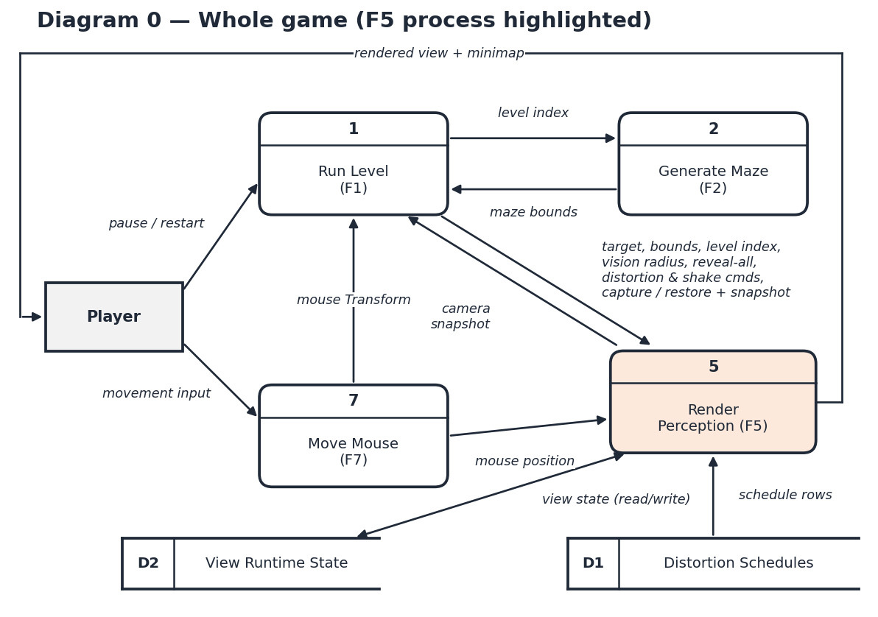
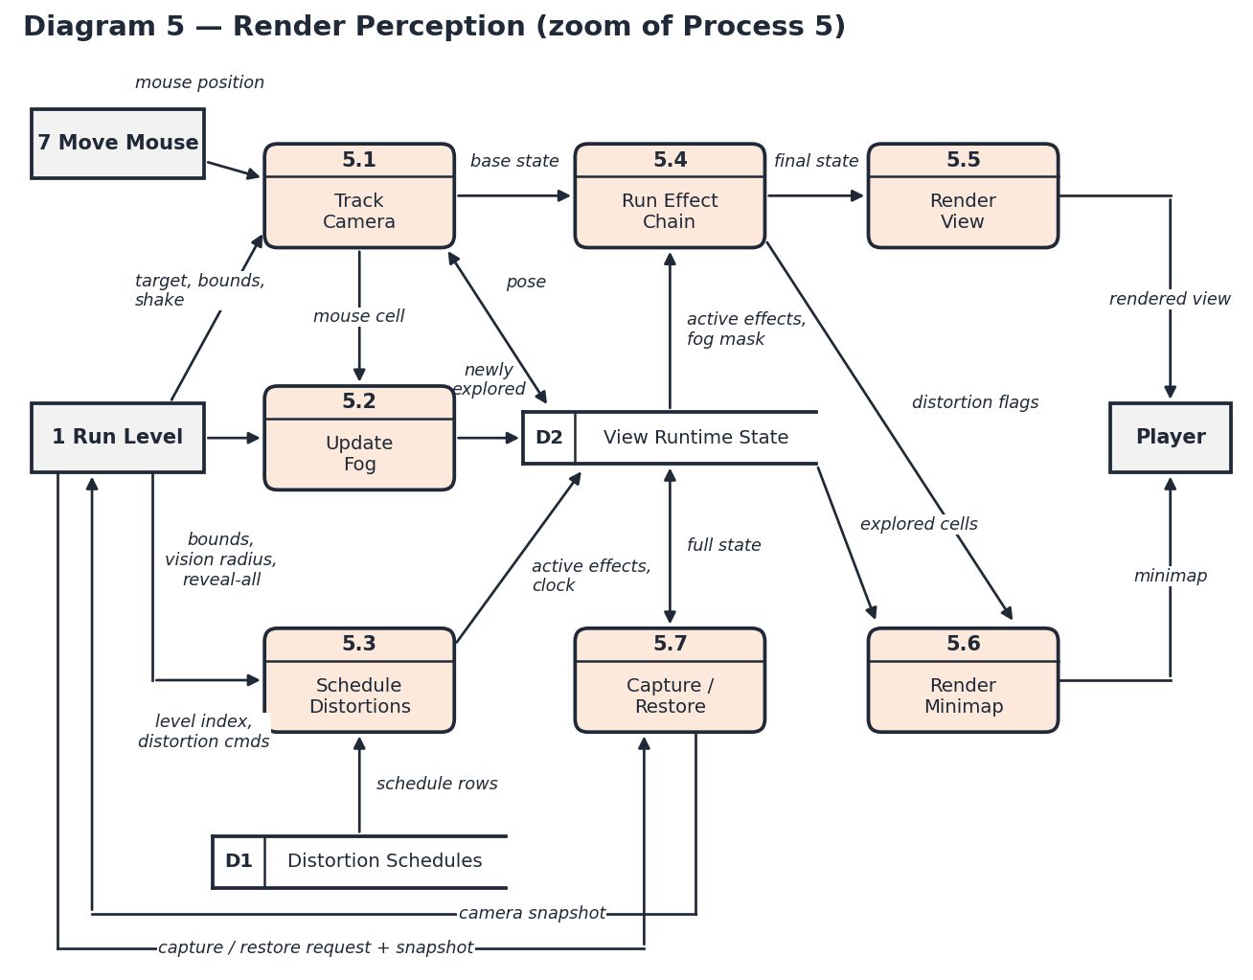
Balancing and black-hole / miracle check
Every flow into or out of Process 5 in Diagram 0 appears at the boundary of Diagram 5: commands from 1 Run Level, mouse position from 7 Move Mouse, schedule rows from D1, view state to and from D2, the camera snapshot back to 1, and the rendered view and minimap to the Player. Inside the zoom, each process has at least one input and one output:
Process | Inputs | Outputs
5.1 Track Camera | target, bounds, shake (1); mouse position (7); pose (D2) | base state (5.4); mouse cell (5.2); pose (D2)
5.2 Update Fog | mouse cell (5.1); bounds, vision radius, reveal-all (1) | newly explored cells (D2)
5.3 Schedule Distortions | level index, distortion cmds (1); schedule rows (D1) | active effects, clock (D2)
5.4 Run Effect Chain | base state (5.1); active effects, fog mask (D2) | final state (5.5); distortion flags (5.6)
5.5 Render View | final state (5.4) | rendered view (Player)
5.6 Render Minimap | explored cells (D2); distortion flags (5.4) | minimap (Player)
5.7 Capture / Restore | capture / restore request + snapshot (1); full state (D2) | camera snapshot (1); full state (D2)

Process Description — 5.4 Run Effect Chain
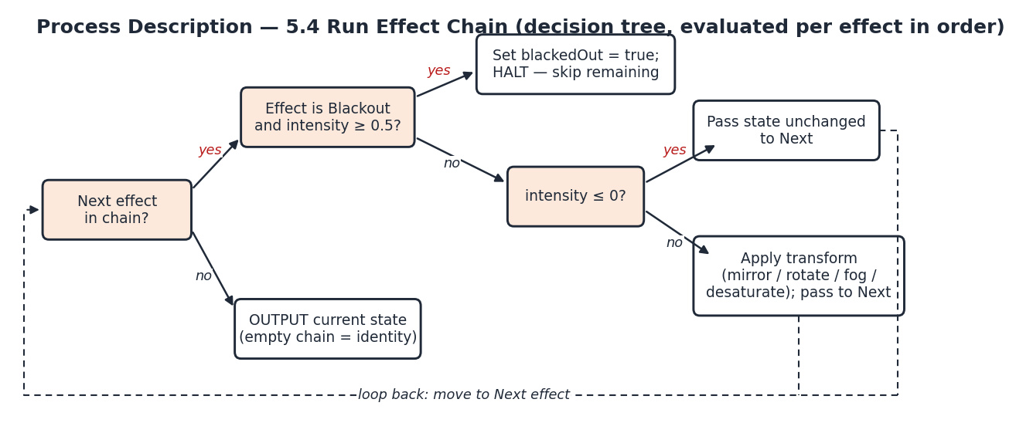
The halt branch is what makes this Chain of Responsibility rather than Decorator: a decorator always delegates to what it wraps, while BlackoutViewEffect ends the request and no later effect receives it.

5. Timeline
Work items
Task | Category | Duration (hours) | Predecessor task(s) | Actual (h) — TL4
1. Interface contract & types design | Design | 4 | —
2. Effect chain & DFD design | Design | 4 | 1
3. Fog & minimap design | Design | 2 | 1
4. CameraRig + ViewDirector façade | Coding | 4 | 1
5. ViewEffect base + pipeline | Coding | 3 | 2
6. Mirror / Rotation / Desat. / Blackout | Coding | 5 | 5
7. FogGrid + FogViewEffect | Coding | 4 | 3, 5
8. MinimapRenderer | Coding | 2 | 7
9. Distortion scheduler & ramping | Coding | 2 | 6
10. Snapshot capture / restore | Coding | 2 | 4, 7, 9
11. Unit tests (effects, chain bounds) | Testing | 5 | 6, 7
12. Integration tests (F1/F2/F7, snapshot) | Testing | 4 | 8, 10
13. Stress test + dynamic-binding demo | Testing | 3 | 11
14. Champion document & diagrams | Documentation | 5 | 2, 3
15. Oral-exam prep & demo script | Documentation | 3 | 12, 13
Total |  | 52

By category: Design 10 h (tasks 1–3), Coding 22 h (tasks 4–10), Testing 12 h (tasks 11–13), Documentation 8 h (tasks 14–15) — 52 h of effort, matching the feature budget. The Actual column is for TL4 to fill in as each task closes.
PERT diagram
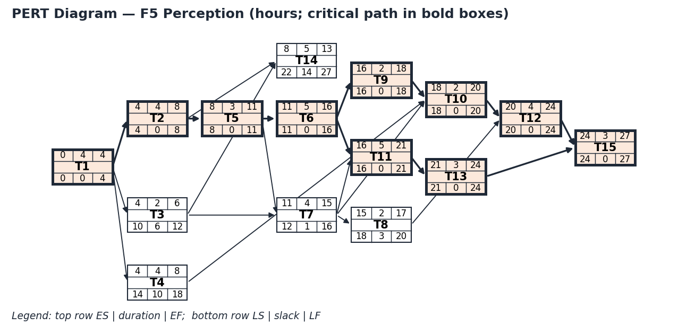
There are two critical paths of 27 hours each: 1 → 2 → 5 → 6 → 9 → 10 → 12 → 15 and 1 → 2 → 5 → 6 → 11 → 13 → 15. Task 7 (fog) carries only 1 hour of slack, task 8 (minimap) 3, task 3 (fog design) 6, task 4 (camera rig) 10, and task 14 (this document) 14.
The 27 hours is network length, which assumes tasks off the critical path run alongside it. As one person I cannot do that, so TL4 should track me against 52 hours of effort and use the network only for ordering. The two estimates I trust least are task 7 (the fog mask shader) and task 10 (snapshot restore touching every internal class). If task 7 passes 6 hours, I drop minimap distortion (optional) before touching any critical-path work, and Blur stays deferred.
Gantt timeline
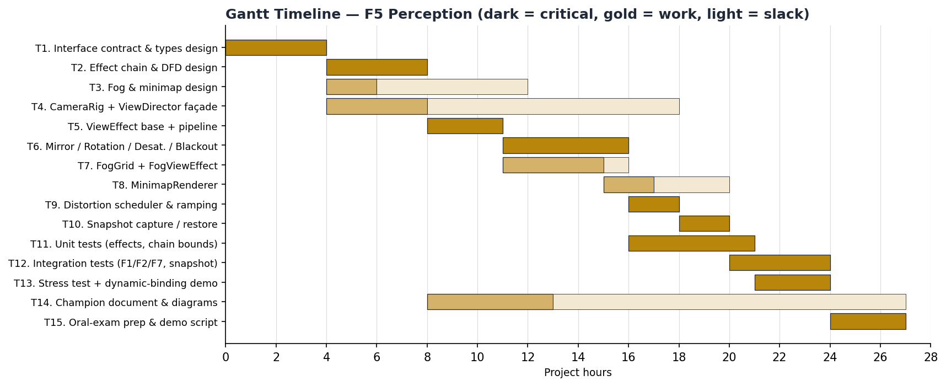

AI Question Log — Summary
[To complete: summarise how AI was used on this document, what you changed and why, the number of questions in the full log, and the log entry reference.]

