F7 — Use Case Diagram
Use Case Diagram for F7 — Player Character & Input. Includes Move Player Through Maze and Apply Control Distortion Stack.
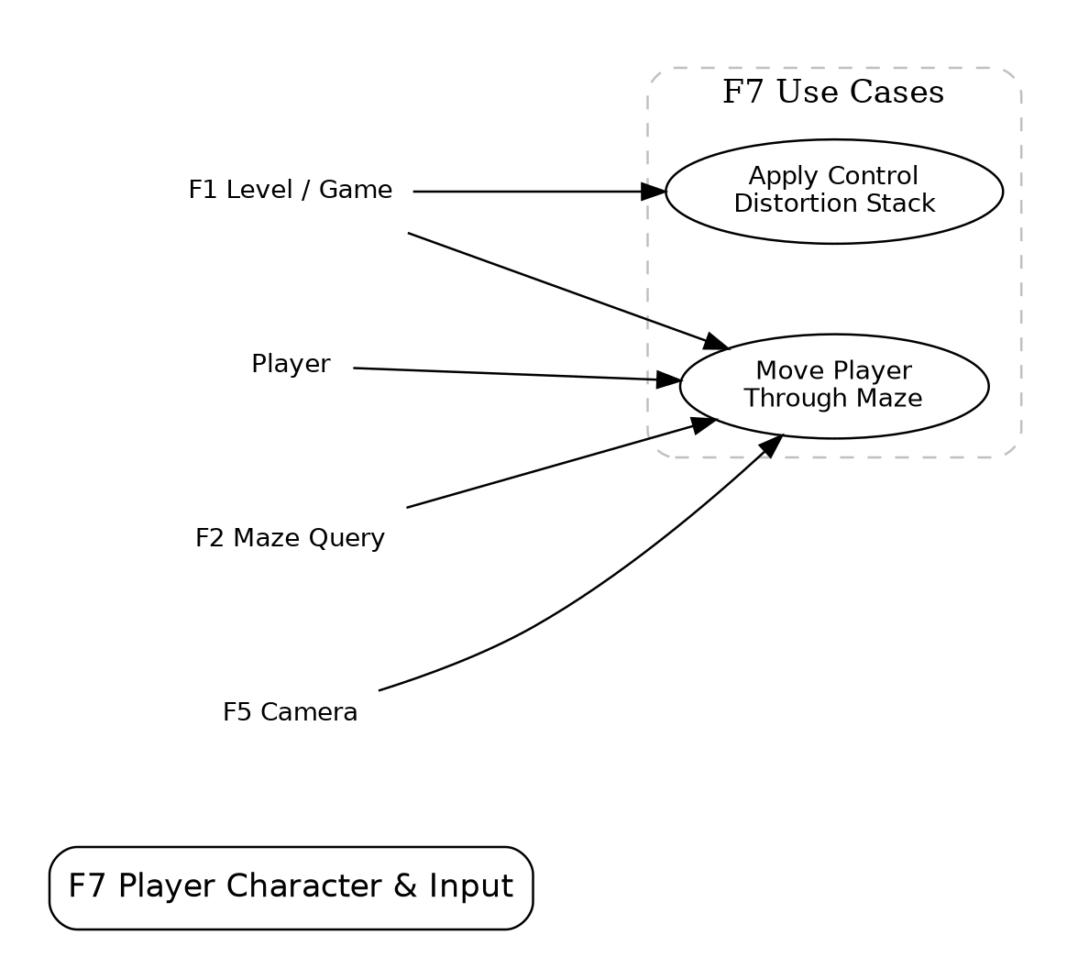
Algernon — F7 Player Character & Input

