F7 — Class Diagram
UML Class Diagram for F7. Each class box is divided into class name, attributes, and operations.
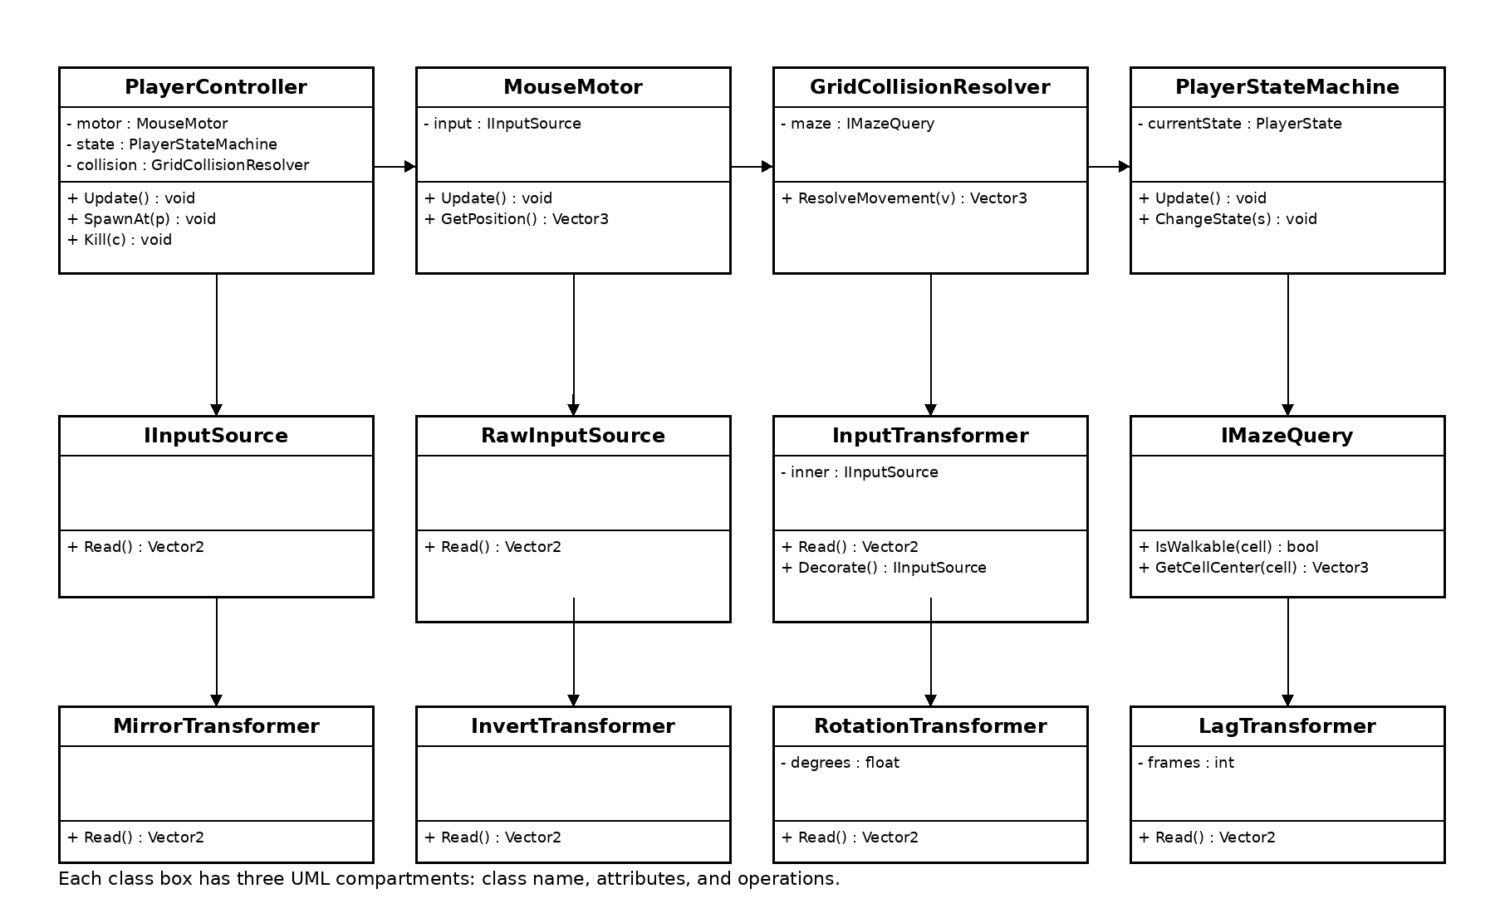
Algernon — F7 Player Character & Input

