F7 — Sequence Diagram
Movement/input sequence for F7. Activation bars show when participating classes are active.
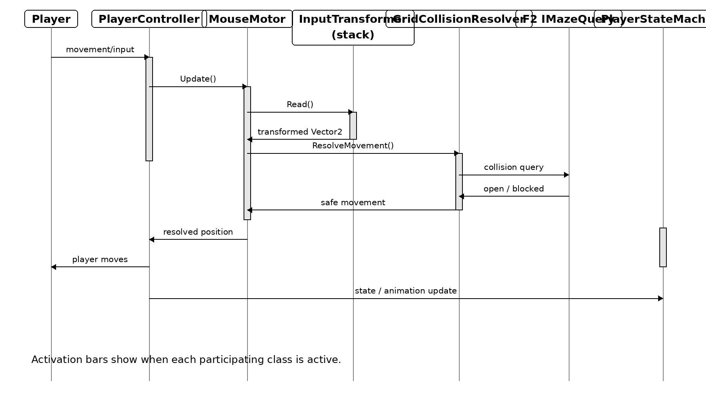
Algernon — F7 Player Character & Input

