F7 — Context DFD (Diagram 0)
Context-level Data Flow Diagram for F7 — Player Character & Input.
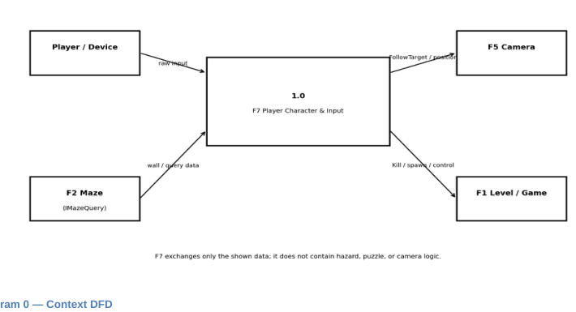
Algernon — F7 Player Character & Input

