F7 — Level-1 DFD (Diagram 1)
Level-1 decomposition of F7 into Read & Transform Input, Resolve Movement, Update State & Animation, and Publish.
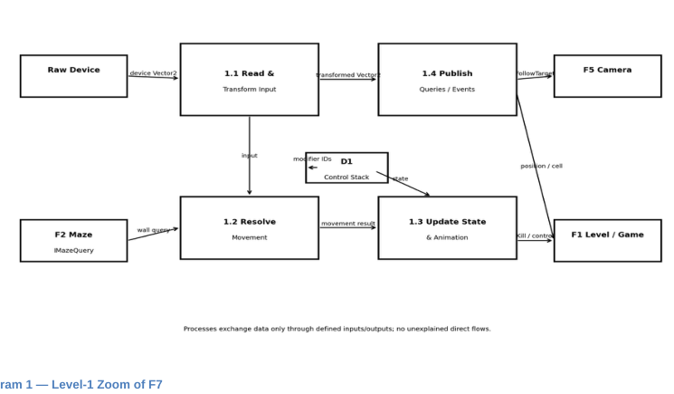
Algernon — F7 Player Character & Input

