F5 Design Supplement
Name: ____________ Feature: F5 — Perception, Camera & Visual Distortion (TL4)
Companion to the F5 Champion Document: dynamic binding, design patterns and their class diagrams, a SourceMaking comparison, sequence diagrams, the full class diagram, and fine-grained time requirements.

1. Dynamic Binding
1.1 Which classes it lives in
Dynamic binding happens at one method, ViewEffect.Process, and at every place that method is called through a ViewEffect reference.
Class | Role in dynamic binding | Declaration / call
ViewEffect (abstract) | Declares the binding point. Its own body also makes a dynamically bound call: Next.Process(s). | public virtual CameraState Process(CameraState s)
MirrorViewEffect, RotationViewEffect, FogViewEffect, DesaturationViewEffect | Overriders that modify the state and forward it. | public override CameraState Process(CameraState s) … return base.Process(s);
BlackoutViewEffect | Overrider that halts: never calls base, so Next is never reached. | public override CameraState Process(CameraState s)
ViewEffectPipeline | The call site. Holds only ViewEffect references, so the compiler cannot know which override runs. | head.Process(state) inside Run()
CountingSpyEffect (tests only) | Overrider that counts calls, used to prove the Blackout halt. | public override …

Not involved: ViewDirector, CameraRig, FogGrid, MinimapRenderer, DistortionScheduler, CameraState and CameraSnapshot. Their methods are ordinary non-virtual calls on a known type.
1.2 Should ViewEffect be a MonoBehaviour?
No. Only ViewDirector inherits from MonoBehaviour. ViewEffect and all five effects are plain C# classes, as the brief's "non-MonoBehaviour" hierarchy says.
The question assumes MonoBehaviour would handle dynamic binding for you. It would not. Unity calls methods such as Update and LateUpdate by looking up their names on each script class when it loads. Those methods are not virtual members of MonoBehaviour, so that mechanism is engine messaging, not C# dynamic binding. Dynamic binding in C# comes only from virtual and override on your own base class, and you write it by hand whether or not a MonoBehaviour is involved.
Making ViewEffect a MonoBehaviour would also cause real problems:
• You could not create effects with new. Each would need a GameObject and AddComponent, which makes building chains in arbitrary orders at runtime awkward.
• The effects would stop being pure functions over CameraState. The unit tests and the 10,000-frame stress test would need a running scene instead of plain NUnit tests.
• The dynamic binding demo would become unclear. If an effect did its work in Update, Unity would still call it by name after virtual was removed, and the view would not revert.
1.3 The code
public abstract class ViewEffect
{
public ViewEffect Next { get; set; }
public DistortionId Id { get; }
public float Intensity { get; set; }
protected ViewEffect(DistortionId id) { Id = id; }

// Binding point. Next.Process is itself a dynamically bound call.
public virtual CameraState Process(CameraState s)
=> Next == null ? s : Next.Process(s);
}

public sealed class MirrorViewEffect : ViewEffect
{
public MirrorViewEffect() : base(DistortionId.Mirror) { }
public override CameraState Process(CameraState s)
{
if (Intensity >= 0.5f) s.mirrored = !s.mirrored;
return base.Process(s); // forward along the chain
}
}

public sealed class BlackoutViewEffect : ViewEffect
{
public BlackoutViewEffect() : base(DistortionId.Blackout) { }
public override CameraState Process(CameraState s)
{
if (Intensity < 0.5f) return base.Process(s);
s.blackedOut = true;
return s; // HALT: Next is never called
}
}

1.4 Running the demo without breaking the build
If you delete virtual and leave the subclasses alone, the project stops compiling: C# reports error CS0506, because override needs a virtual base method. The demo therefore also has to change override to new in each subclass. Doing this with a scripting define symbol lets you switch between the two versions without editing code:
// ViewEffect.cs
#if STATIC_BINDING_DEMO
public CameraState Process(CameraState s) => Next == null ? s : Next.Process(s);
#else
public virtual CameraState Process(CameraState s) => Next == null ? s : Next.Process(s);
#endif

// Each subclass
#if STATIC_BINDING_DEMO
public new CameraState Process(CameraState s)
#else
public override CameraState Process(CameraState s)
#endif

Add STATIC_BINDING_DEMO under Player Settings → Scripting Define Symbols. The pipeline calls Process through ViewEffect references, so every call now runs the base pass-through. Mirror, rotation, fog and desaturation vanish, and even Blackout no longer halts, while F1 and F7 game logic behaves exactly the same.

2. Design Patterns in F5
2.1 Classes involved in each pattern
The brief names Chain of Responsibility as the GoF pattern. Two more GoF patterns are already in the published interface: CaptureState/RestoreState is a Memento, and the "thin façade" ViewDirector is a Facade. Claiming them is optional, but they are useful at the oral exam. Pure Fabrication, Protected Variations and Low Coupling are GRASP principles, not GoF patterns, so they have no class diagram of their own.
Pattern | Role | F5 class(es)
Chain of Responsibility | Handler | ViewEffect (abstract)
 | Concrete handlers | MirrorViewEffect, RotationViewEffect, FogViewEffect, DesaturationViewEffect, BlackoutViewEffect
 | Client (builds chain, launches request) | ViewEffectPipeline, configured by DistortionScheduler
 | Request | CameraState
Memento | Originator | ViewDirector (reads state from CameraRig, ViewEffectPipeline, FogGrid, DistortionScheduler)
 | Memento | CameraSnapshot
 | Caretaker | F1 LevelController (outside F5)
Facade | Facade | ViewDirector
 | Subsystem | CameraRig, ViewEffectPipeline, FogGrid, MinimapRenderer, DistortionScheduler
 | Client | F1 LevelController
2.2 Chain of Responsibility
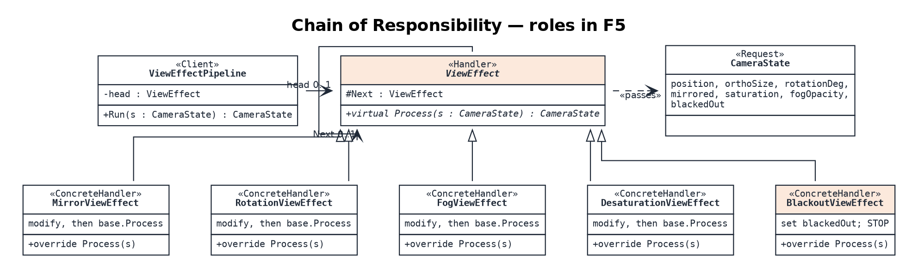
2.3 Memento
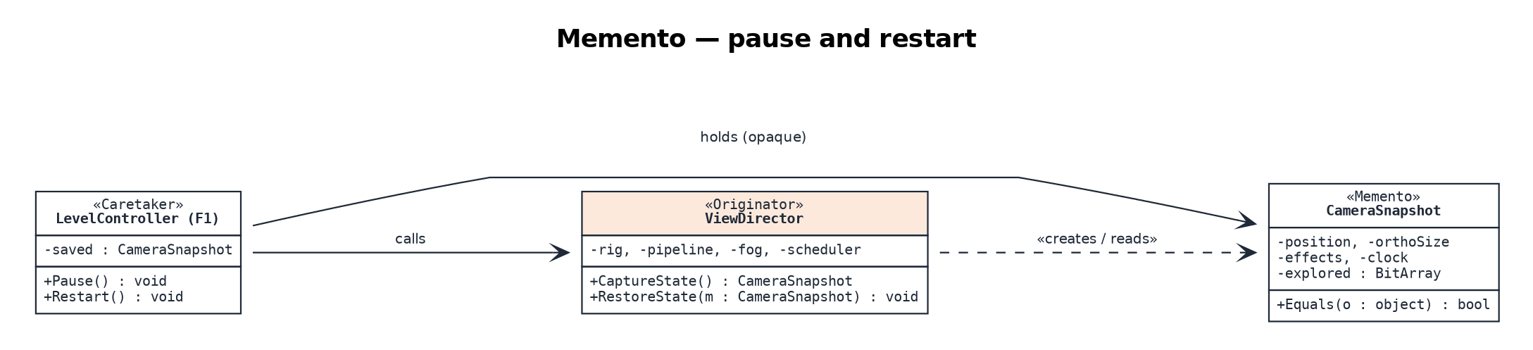
F1 stores the snapshot but never reads its fields. Only ViewDirector can build one or apply one, so F5's internals stay hidden.
2.4 Facade
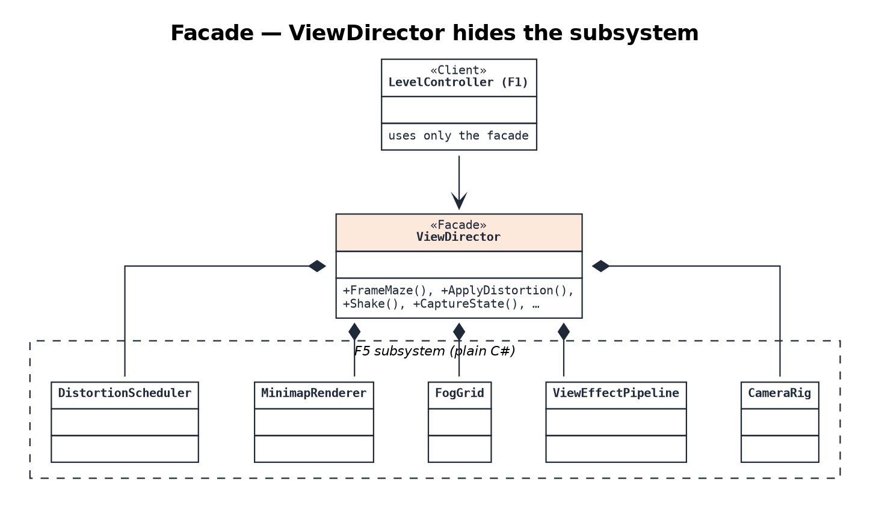
2.5 Comparison with SourceMaking
The table compares F5 with the checklist and structure on SourceMaking's Chain of Responsibility page (sourcemaking.com/design_patterns/chain_of_responsibility), plus its one-line summaries of Memento, Facade and Decorator.
Aspect | SourceMaking | F5 design | Result
Intent | A request moves along a chain of receivers until one handles it. | Every effect adds its change; only Blackout ends the request early. | Variant
Multiple handlers | Allowed: several handlers may contribute, and the request may travel the whole chain. | This is exactly F5's normal case. | Match
Next pointer | The base class keeps the reference to the next handler. | ViewEffect.Next | Match
Passing it on | A derived class calls back to the base, and the base delegates to the next handler. | Concrete effects call base.Process(s). | Match
Building the chain | The client or a third party creates and links the chain. | ViewEffectPipeline links effects; DistortionScheduler decides which and when. | Match
Launch and leave | The client hands each request to the root of the chain and does nothing more. | Run(state) calls head.Process once. | Match
Null next | The last link must not delegate to a missing successor. | Base checks Next == null and returns the state. | Match
Safety net | Provide a catch for requests nobody handles. | No request can go unhandled; an empty chain returns the input (identity test). | Adapted
When not to use | Avoid CoR if only one handler handles each request, or the client already knows which one. | Several effects apply per frame, in an order chosen at runtime. | Appropriate
Related patterns | CoR is often combined with Command or Composite. | Neither is used; the chain is a flat list. | Not used
Memento | Captures an object's internal state so it can be restored later. | CameraSnapshot, with private fields, held opaquely by F1. | Match
Facade | One class stands in for a whole subsystem. | ViewDirector | Match
Decorator (contrast) | Adds responsibilities to an object at runtime by wrapping it; a wrapper always forwards to what it wraps. | Blackout does not forward, which is why F5 is CoR, not Decorator. | Rejected

3. Sequence Diagrams
Diagram 1 follows one rendered frame through eight classes, including the Blackout halt, and shows where dynamic binding occurs. Diagram 2 shows the Memento round trip for pause and restart.
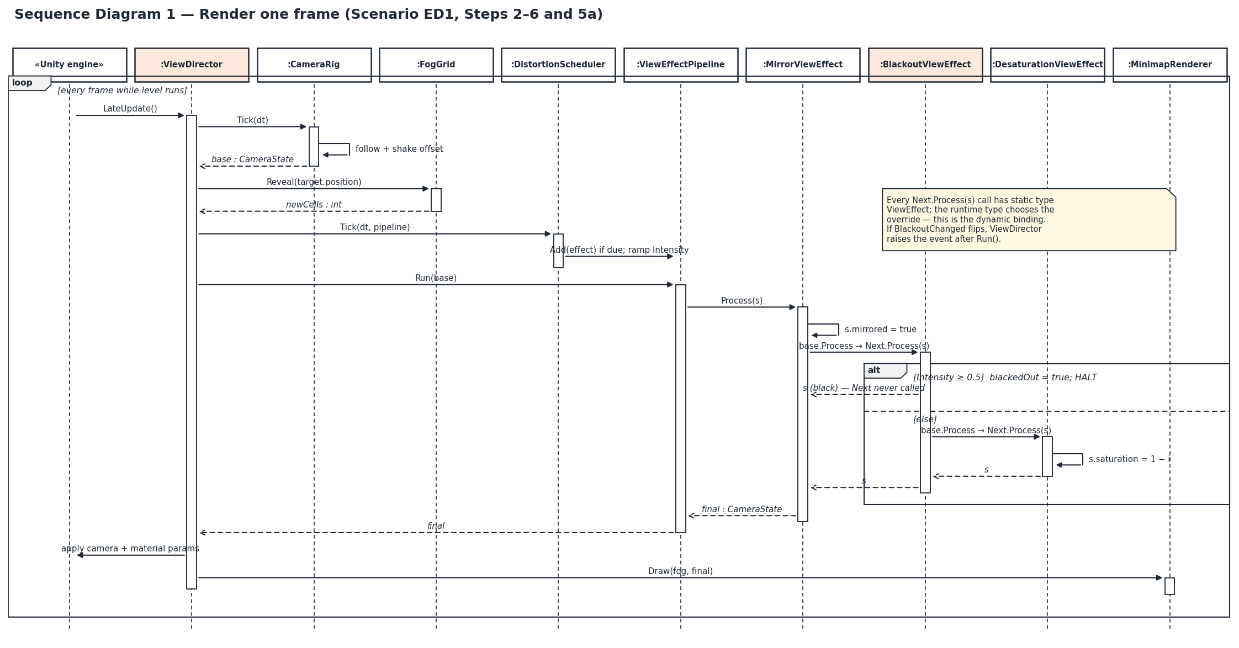
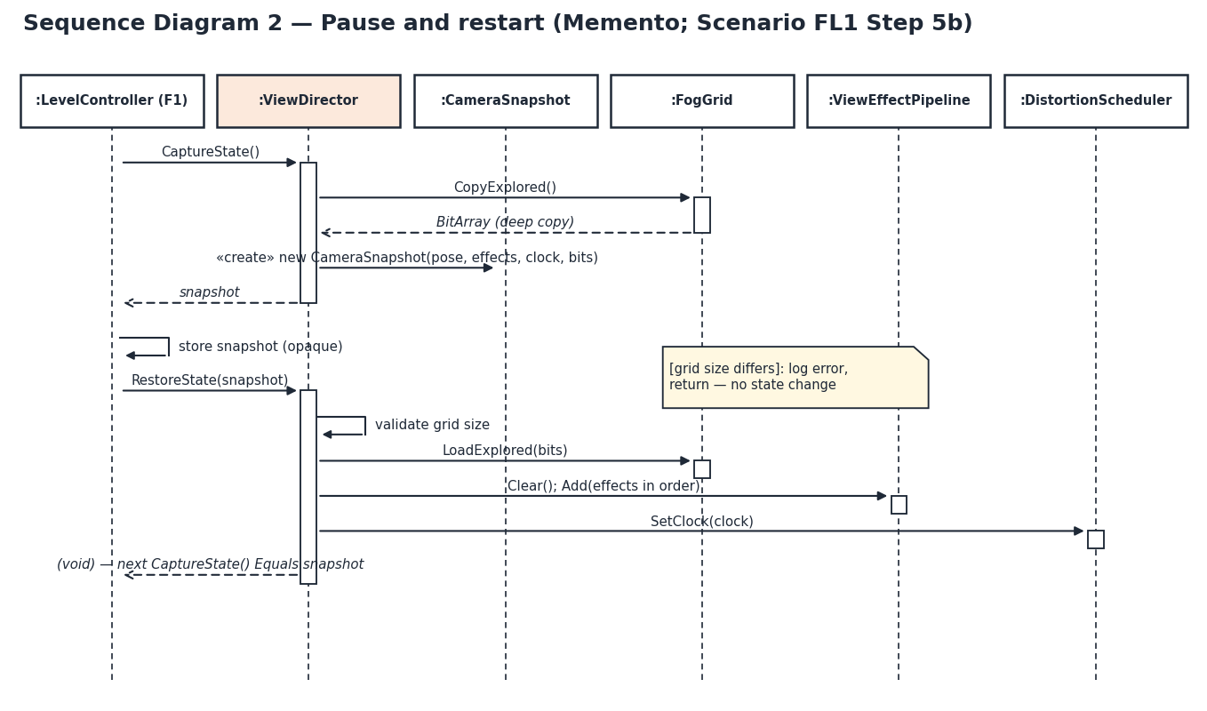

4. Class Diagram
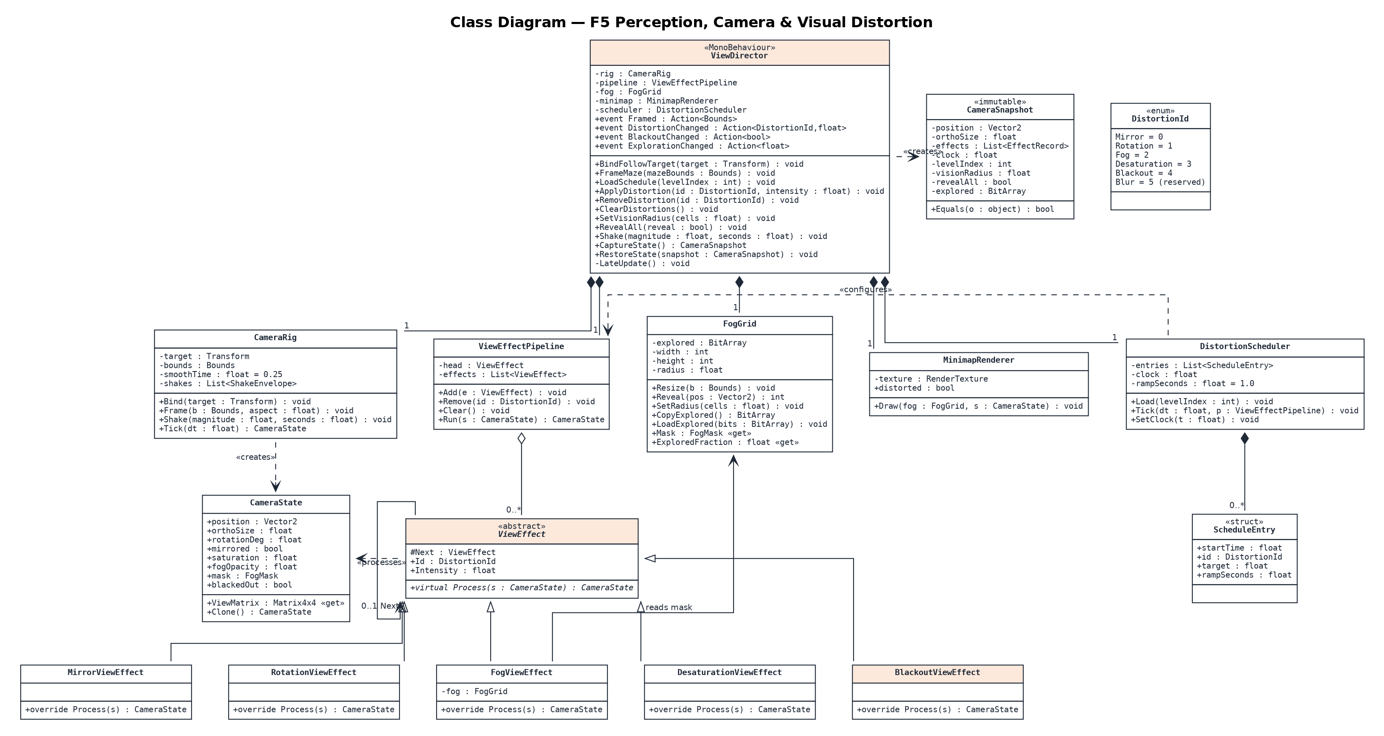
Additions beyond the brief's internal class list, to confirm with the team: DistortionScheduler and ScheduleEntry (per-level scheduling and ramping needed a home); LoadSchedule(int) on ViewDirector, as proposed in the Champion document; and CopyExplored/LoadExplored on FogGrid plus SetClock on DistortionScheduler, which RestoreState needs. DistortionId is used by ViewEffect, ViewEffectPipeline, ScheduleEntry and CameraSnapshot; those dependency lines are left out to keep the diagram readable.

5. Fine-Grained Time Requirements
Each Champion task is split into subtasks of 0.5–2 hours with a concrete "done when" check, so TL4 can mark progress without guessing. The subtasks add up to the same 52 hours: Design 10, Coding 22, Testing 12, Documentation 8.
ID | Subtask | Hours | Done when
T1 Interface contract & types (4 h)
1.1 | Draft all public signatures, DistortionId and events | 1 | Signatures compile as empty stubs
1.2 | Define CameraState and CameraSnapshot fields and invariants | 1.5 | Types table in contract complete
1.3 | Agree LoadSchedule(int) with F1 | 1 | F1 confirms in writing
1.4 | Update contract tables with the final decisions | 0.5 | Champion §3 matches stubs
T2 Effect chain & DFD design (4 h)
2.1 | Chain design: Process contract, halt rule, ordering | 1.5 | Pattern class diagram reviewed
2.2 | Sequence diagrams (frame, pause/restart) | 1 | Both diagrams drawn
2.3 | DFD 0 and zoom, balancing check | 1 | Balance table has no gaps
2.4 | Full class diagram | 0.5 | All brief classes present
T3 Fog & minimap design (2 h)
3.1 | Grid resolution and reveal rule (Euclidean, cells) | 1 | Rule written with worked example
3.2 | Minimap render approach and distortion flag | 1 | Approach agreed with F1 HUD
T4 CameraRig + ViewDirector façade (4 h)
4.1 | ViewDirector stubs wired to internal classes; events declared | 1 | Scene runs with no errors
4.2 | Follow smoothing | 1 | ≤ 0.05 units within 0.25 s
4.3 | FrameMaze zoom-to-fit maths | 1 | All corners visible at 3 aspect ratios
4.4 | Shake envelope | 1 | Offset ≤ envelope; 0 after duration
T5 ViewEffect base + pipeline (3 h)
5.1 | ViewEffect base with Next and virtual Process | 1 | Compiles; spy effect runs
5.2 | Pipeline Add / Remove / Clear with order preserved | 1.5 | Order unit test passes
5.3 | Empty-chain identity | 0.5 | Identity test passes
T6 Four distortion effects (5 h)
6.1 | MirrorViewEffect | 1 | Point (1, 0) maps to (−1, 0)
6.2 | RotationViewEffect | 1 | 0.25 intensity gives 90°
6.3 | DesaturationViewEffect + shader parameter | 1.5 | Saturation visibly drains in-scene
6.4 | BlackoutViewEffect halt | 1 | Spy count = 0 after Blackout
6.5 | Intensity clamping and NaN handling | 0.5 | Invalid-input rows pass
T7 FogGrid + FogViewEffect (4 h)
7.1 | FogGrid bitset and Reveal | 1.5 | Reveal count correct for radius 3
7.2 | Mask texture upload to shader | 1.5 | Unexplored cells dark in-scene
7.3 | FogViewEffect and RevealAll | 1 | Toggle restores identical bitset
T8 MinimapRenderer (2 h)
8.1 | Draw explored cells to a 256×256 RenderTexture | 1.5 | Minimap matches explored set
8.2 | Optional distortion flag | 0.5 | Mirror applies when flag on
T9 Scheduler & ramping (2 h)
9.1 | Schedule asset and Load(levelIndex) | 1 | Rows queue in start-time order
9.2 | Linear ramp and DistortionChanged event | 1 | One event per change, not per frame
T10 Snapshot capture / restore (2 h)
10.1 | CaptureState deep copy | 1 | Mutating after capture does not change it
10.2 | RestoreState with validation | 1 | Null / size mismatch leaves state unchanged
T11 Unit tests (5 h)
11.1 | Test harness and CountingSpyEffect | 1 | Harness runs in Edit Mode
11.2 | Per-effect output tests | 1.5 | 5 effects covered
11.3 | Identity and Blackout-first boundary tests | 1 | Both pass
11.4 | Order-matters and fog-persistence tests | 1.5 | Both pass
T12 Integration tests (4 h)
12.1 | Test scene receiving F1/F2/F7 handover | 1.5 | Level start frames and follows
12.2 | Snapshot round-trip test (200 states) | 1 | 200 / 200 Equal
12.3 | Fix integration defects | 1.5 | All integration tests green
T13 Stress test + binding demo (3 h)
13.1 | 20 effects × 10,000 frames with profiler | 1.5 | 0 GC/frame; mean ≤ 0.2 ms
13.2 | STATIC_BINDING_DEMO symbol and before/after capture | 1.5 | Screenshots of both builds
T14 Champion document (5 h)
14.1 | Update Champion document to as-built | 2 | No contract row contradicts code
14.2 | Regenerate diagrams | 2 | Diagrams match final classes
14.3 | AI question log summary | 1 | Summary and log attached
T15 Oral-exam prep (3 h)
15.1 | CoR vs Decorator talking points | 1 | Explained aloud in under 60 s
15.2 | Demo script and rehearsal | 1.5 | Demo runs start to finish twice
15.3 | Likely-question prep | 0.5 | Answers for 5 practice questions
 | Total | 52

5.2 Weekly plan (assumes 13 hours per week over 4 weeks)
Adjust the weeks to your real deadline; the order respects every predecessor from the PERT chart.
Week | Tasks | Hours | TL4 checkpoint at end of week
1 | T1, T2, T3, T5 | 13 | Stubs compile; empty-chain identity test passes
2 | T4, T6, T7 | 13 | Camera frames and follows; four effects and fog work in-scene
3 | T8, T9, T10, T11, T14.1 (2 h of T14) | 13 | Scheduler ramps; snapshot restores; all unit tests green
4 | T12, T13, T14.2–14.3, T15 | 13 | Integration and stress tests pass; demo rehearsed
 | Total | 52

5.3 Tracking rules
A subtask counts as done only when its "done when" check passes; partly written code counts as 0. If a subtask runs 50 % over its estimate, flag it to TL4 that day. The two riskiest subtasks are 7.2 (fog mask shader) and 10.2 (restore touching every internal class); if either passes 3 hours, drop 8.2 (minimap distortion) first. The 52 hours contain no contingency. Keeping about 8 extra hours (15 %) outside the budget is sensible, but record it as buffer rather than folding it into the estimates.

