Champion Document — F7
Name: Gavin Wolff Feature: Player Character & Input Mark: ____ / 30
Feature statement. F7 owns the player character and player-control input. It reads the active movement binding, passes the input through a runtime-configurable transformation stack, resolves movement against maze walls, maintains player state and animation, and publishes the player information required by other features. F7 exposes its input transformation seam for future bindings, its player position and cell for other systems, and its death interface for F1. F7 depends on F2 for collision queries and provides outputs consumed by F1 and F5.

1. Brief Introduction
My feature is the player character and input system. It reads player movement input, passes that input through a runtime-configurable transformation stack, resolves movement against maze walls, and maintains the player’s state and animation.
The input abstraction deliberately sits between the device and the character. RawInputSource reads the active device through IInputSource. InputTransformer objects can then mirror, invert, rotate, or add frame lag. Because every transformer is also an IInputSource, the stack can be composed at runtime—for example, Lag(Mirror(Raw)). MouseMotor does not need to know how many transformers are active or which concrete transformer types are used.
F7 owns the states Alive, Dead, Frozen, and Spawning. Animation is driven from the current player state. For the GOF Memento pattern, PlayerStateMachine can create a PlayerMemento snapshot and restore it later through PlayerStateCaretaker. F7 also provides the player’s world position, current grid cell, FollowTarget, and cell-change and interaction events.
F7 deliberately does NOT:
- resolve hazards, puzzles, or combat damage; F1 calls Kill when the game rules require the player to die.
- control the camera; F5 receives FollowTarget from F7.
- generate or define the maze; F7 only asks F2 through IMazeQuery whether movement is valid.
- contain separate movement implementations for each distortion combination; the input pipeline applies a configured list of transformations instead.
- include the optional second-player controller in the current estimate; that work is explicitly out of scope and must not begin before Week 10.

2. Use Case Diagram with Scenarios
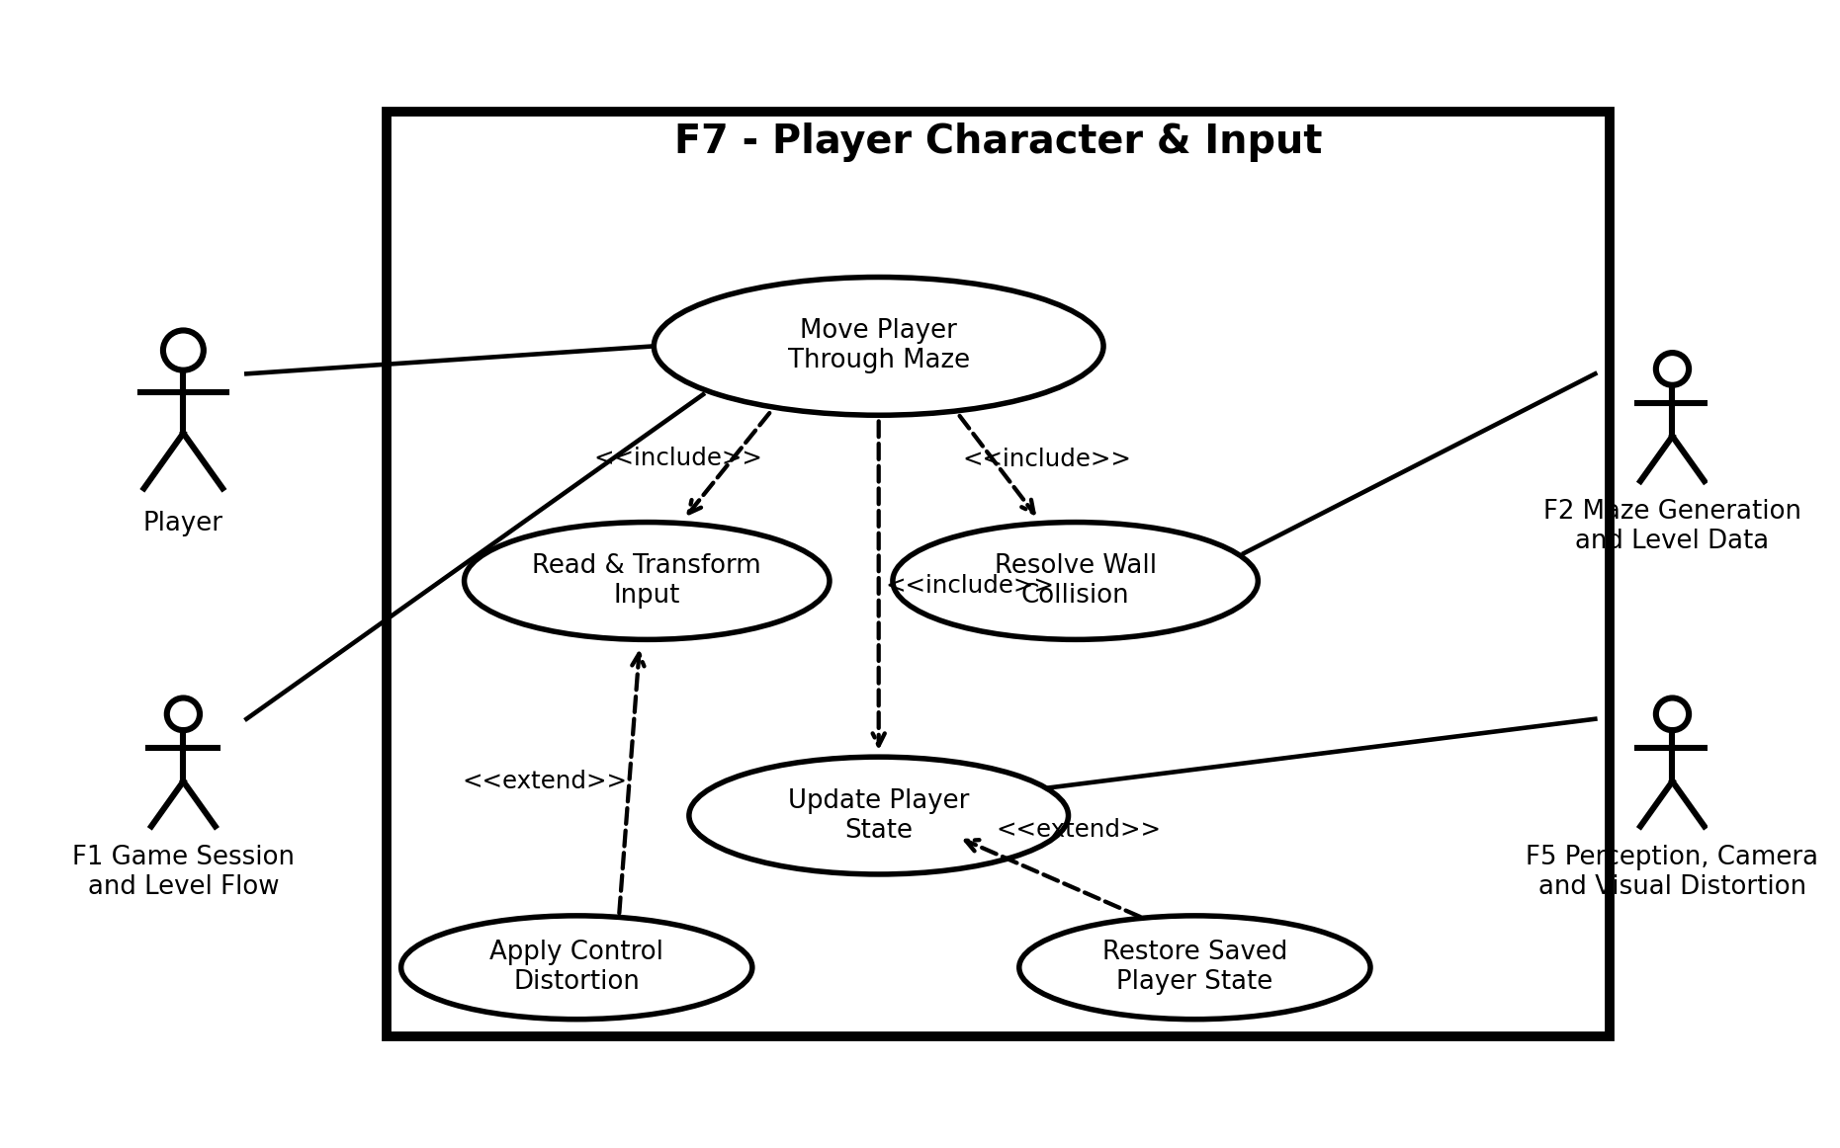
Figure 0 - F7 Use Case Diagram
The main actors and collaborating features are the Player, F1 Game Session and Level Flow, F2 Maze Generation and Level Data, and F5 Perception, Camera and Visual Distortion. The scenarios below describe the core uses of F7: moving the player, processing input, and restoring saved player state.

Use Case 1 — Move Player Through Maze
Item | Description
Name | Move Player Through Maze
Summary | The player supplies directional input; F7 transforms it, resolves movement against maze walls, updates state/animation, and publishes position/cell changes.
Actors | Player; F2 Maze Generation and Level Data; F5 Perception, Camera and Visual Distortion; F1 Game Session and Level Flow
Preconditions | F7 is spawned; input is enabled; a valid IMazeQuery is available; the player is not dead.
Basic sequence:
- Step 1: RawInputSource reads a Vector2 movement input from the current device binding.
- Step 2: F7 passes the Vector2 through the configured InputTransformer stack in its composed order.
- Step 3: MouseMotor checks the player state and normalizes movement so diagonal input does not move faster than cardinal input.
- Step 4: GridCollisionResolver queries F2 through IMazeQuery and computes collision-safe movement for the frame.
- Step 5: PlayerController applies the resolved world position.
- Step 6: PlayerStateMachine updates the player state and animation state.
- Step 7: If the grid cell changed, F7 raises OnCellChanged(Vector2Int); F5 can continue following FollowTarget.
Exceptions:
- Step 1a: Input is disabled. F7 supplies a zero movement vector and resumes at Step 3 without moving the player.
- Step 2a: One or more control modifiers are active. The vector is passed through the configured transformation pipeline before Step 3; order is preserved.
- Step 4a: The requested movement would enter a maze wall. GridCollisionResolver clips or rejects the blocked component, so the player never passes through the wall; the sequence resumes at Step 5.
- Step 3a: The player is Frozen or Dead. F7 applies no movement and continues to Step 6 so state and animation remain in the corresponding non-moving state.
Post conditions: The player's position is collision-safe; state and animation reflect the current player state; a cell-change event is raised only when the cell actually changes.
Priority: 1 (must have) ID: F7-MOVE1

Use Case 2 — Apply Control Distortion Stack
Item | Description
Name | Apply Control Distortion Stack
Summary | A level or game rule supplies an ordered list of ControlModifierId values, and F7 rebuilds the ordered input transformation pipeline at runtime.
Actors | F1 Game Session and Level Flow
Preconditions | F7 has a valid raw input source and the modifier IDs are recognized.
Basic sequence:
- Step 1: F1 calls SetControlStack(IReadOnlyList<ControlModifierId> modifiers).
- Step 2: F7 creates the corresponding InputTransformer objects.
- Step 3: F7 builds the ordered transformation pipeline from the requested modifier IDs.
- Step 4: MouseMotor continues reading only through IInputSource and therefore requires no movement-code change.
- Step 5: The next movement sample uses the new stack.
Exceptions:
- Step 2a: The list is empty. F7 uses RawInputSource directly, producing unchanged input.
- Step 2b: A modifier ID is unsupported. F7 rejects that modifier rather than creating an undefined transformation; the remaining supported stack is retained.
Post conditions: The active input stack exactly represents the accepted modifier order, and subsequent movement samples use that stack.
Priority: 1 (must have) ID: F7-INPUT1

3. Interface Contract
All public inputs and outputs are typed and testable. Movement depends on IInputSource rather than a specific device, which provides the Protected Variations seam for later touch or WebGL bindings.
Interface / Member | Type | Input / Output | Contract / Testable behavior
SpawnAt | void SpawnAt(Vector3 worldPosition) | Input: Vector3; Output: void | Places the player at exactly the supplied world position and enters spawning/alive flow.
Despawn | void Despawn() | Input: none; Output: void | Removes the active player representation and stops movement processing.
Position | Vector3 Position { get; } | Output: Vector3 | Returns the player's current world-space position.
CurrentCell | Vector2Int CurrentCell { get; } | Output: Vector2Int | Returns the grid cell containing the player's current position.
FollowTarget | Transform FollowTarget { get; } | Output: Transform | Returns the Transform F5 follows; F7 does not contain camera logic.
IsAlive | bool IsAlive { get; } | Output: bool | True only while the player is in the alive state.
Kill | void Kill(DeathCause cause) | Input: DeathCause; Output: void | Transitions the player to dead; called by F1, not by F4.
SetControlStack | void SetControlStack(IReadOnlyList<ControlModifierId> modifiers) | Input: ordered modifier list; Output: void | Rebuilds the transformation pipeline in list order.
EnableInput | void EnableInput(bool enabled) | Input: bool; Output: void | When false, movement input contributes Vector2.zero.
FreezeInput | void FreezeInput(float seconds) | Input: float seconds; Output: void | Suppresses movement for the requested non-negative duration.
OnCellChanged | event Action<Vector2Int> | Event: Vector2Int | Raised exactly when CurrentCell changes; payload equals the new cell.
OnInteractPressed | event Action | Event: none | Raised once per accepted interaction press.

Internal classes
Class | Type | Responsibility
PlayerController | MonoBehaviour façade | Thin Unity-facing façade exposing the public F7 contract.
MouseMotor | non-MonoBehaviour | Consumes IInputSource and performs movement without knowing the transformer count or types.
GridCollisionResolver | non-MonoBehaviour | Uses IMazeQuery from F2 to prevent movement through maze walls.
PlayerStateMachine | non-MonoBehaviour | Owns alive, dead, frozen, and spawning states and drives animation state.
RawInputSource | non-MonoBehaviour | Reads the current device and returns Vector2 input.
InputTransformer | non-MonoBehaviour, implements IInputSource | transformation base that passes input through the stack.
MirrorTransformer | InputTransformer | Negates X (horizontal mirror).
InvertTransformer | InputTransformer | Negates Y (vertical inversion).
RotationTransformer | InputTransformer | Rotates the input vector by N degrees.
LagTransformer | InputTransformer | Returns input from N frames earlier.
PlayerMemento | immutable snapshot object | Stores PlayerState, position, and CurrentCell for later restoration.
PlayerStateCaretaker | non-MonoBehaviour | Stores and returns PlayerMemento snapshots without modifying their contents.

Design patterns / GRASP
- GOF Memento: PlayerStateMachine creates PlayerMemento snapshots of the player state, position, and current cell. PlayerStateCaretaker stores the snapshot without changing it. When F7 must restore the player (for example after a respawn/restart), PlayerStateMachine restores from that memento.
- Protected Variations: IInputSource isolates movement code from the input device, allowing later touch or WebGL bindings without changing MouseMotor.
- Polymorphism and Low Coupling: InputTransformer defines virtual Transform(Vector2), concrete transformers override it, and collision depends only on IMazeQuery.

4. Class and Sequence Diagrams
The class diagram follows the TL1 class-diagram layout: a central coordinating class composes its collaborators, relationships show multiplicity/ownership, and each class uses three UML compartments. The GOF pattern for F7 is Memento: PlayerStateMachine is the Originator, PlayerMemento is the snapshot, and PlayerStateCaretaker stores the snapshot.
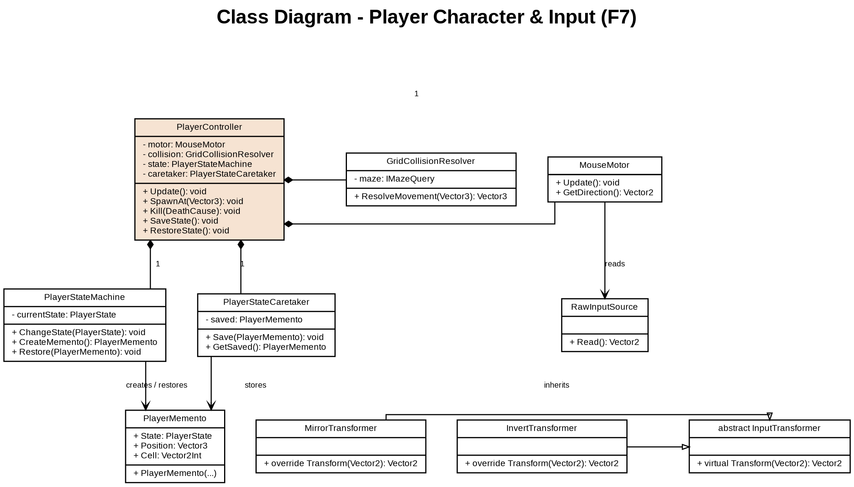

Figure 1 - F7 Class Diagram (TL1-style UML layout)
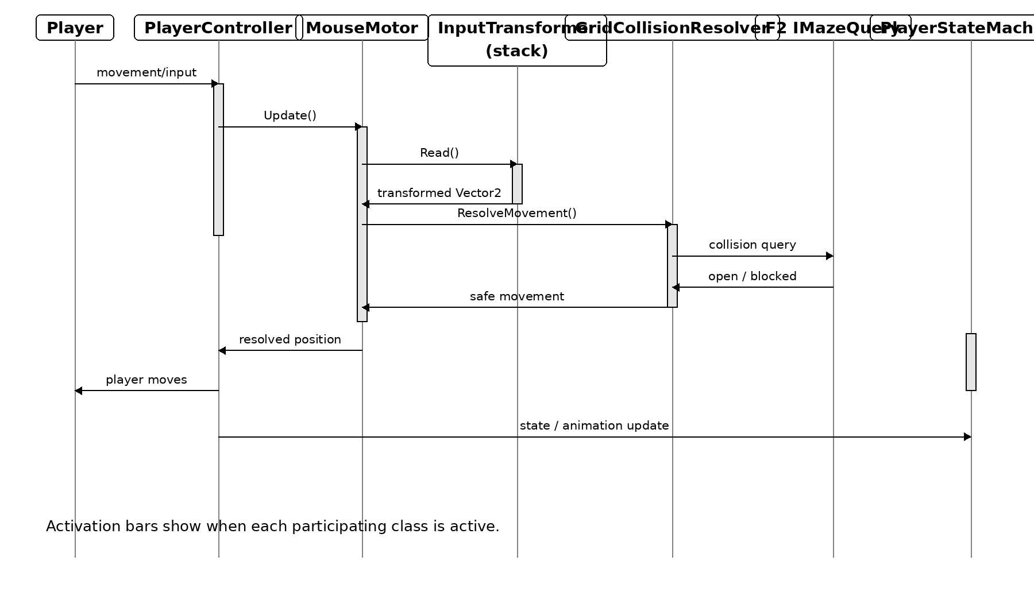
Figure 2 — F7 Movement Sequence Diagram (activation bars shown)
The team feature names used in the diagrams follow the TL1 Champion terminology: F1 Game Session and Level Flow, F2 Maze Generation and Level Data, and F5 Perception, Camera and Visual Distortion.

5. Data Flow Diagrams
The DFDs use hierarchical numbering. In Diagram 0, F7 is Process 6. Diagram 6 decomposes Process 6 into Processes 6.1 through 6.4. Because Input Processing is Process 6.2, Diagram 6.2 decomposes it into primitive Processes 6.2.1 through 6.2.3. Each Gane-Sarson process uses a rounded rectangle with a horizontal divider separating the process number from its description. External entities use rectangular entity symbols.
Context Diagram - Player Input
At the context level, the Player supplies movement and interaction input to Algernon and receives the resulting visual player response. The context process remains Process 0; the F7 numbering begins when the system is decomposed.
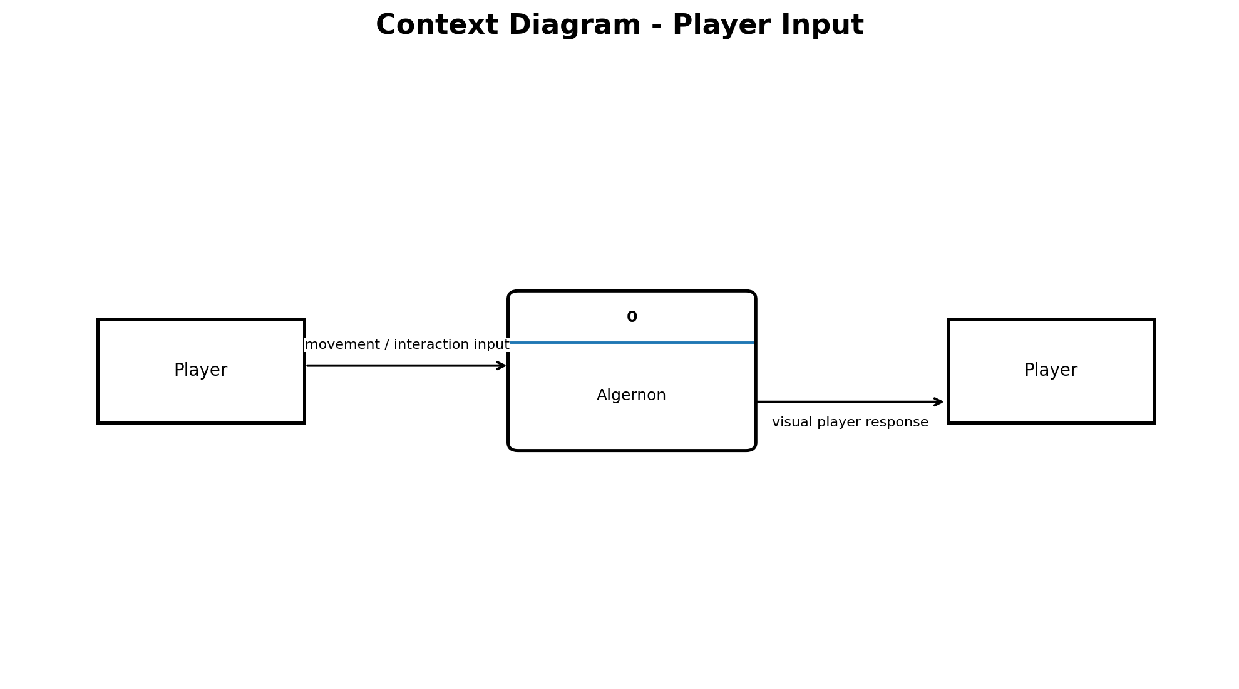
Context Diagram - Player Input
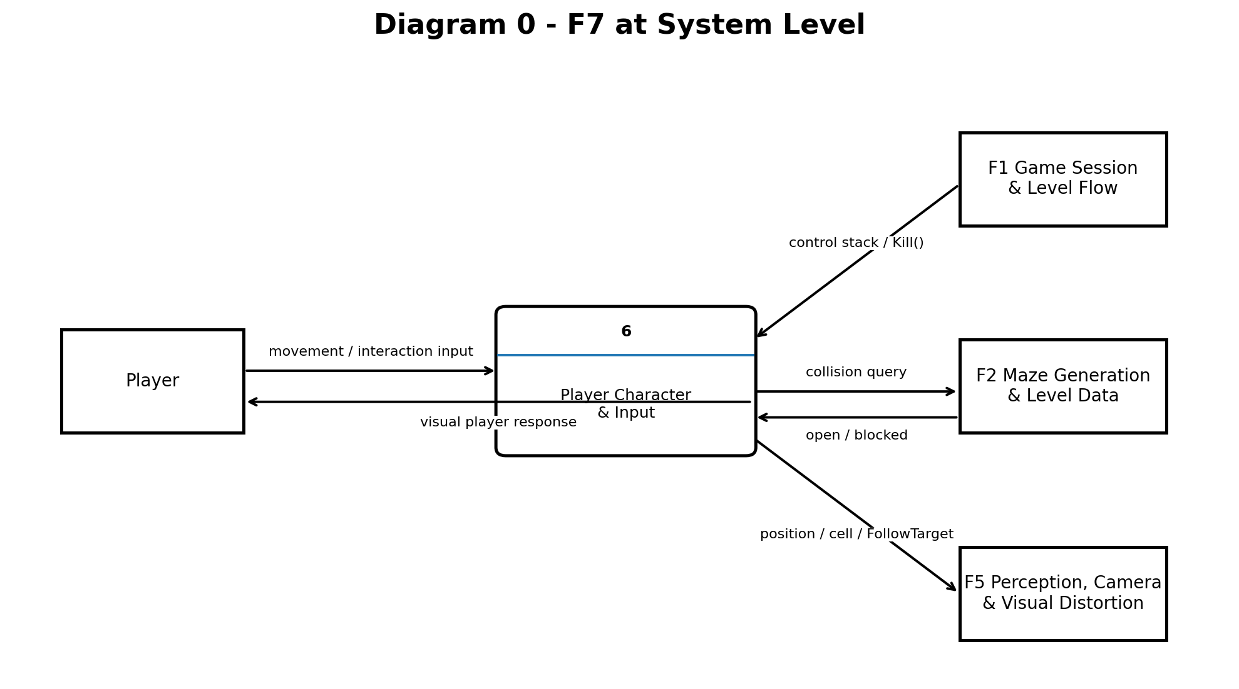
Diagram 0 - F7 at System Level (Process 6)
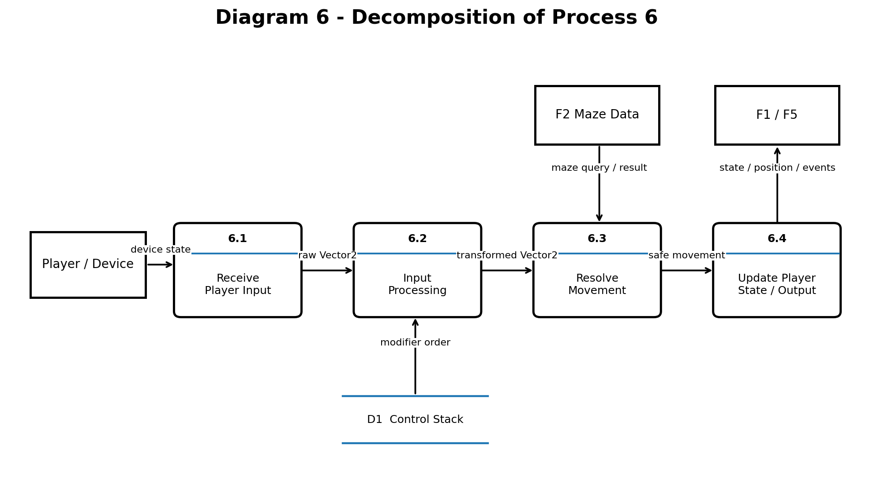
Diagram 6 - Decomposition of Process 6
Diagram 6 shows the next level of F7 processing. Process 6.1 receives the device state, Process 6.2 transforms input, Process 6.3 resolves movement against maze data, and Process 6.4 updates player state and publishes the outputs used by the rest of the game.
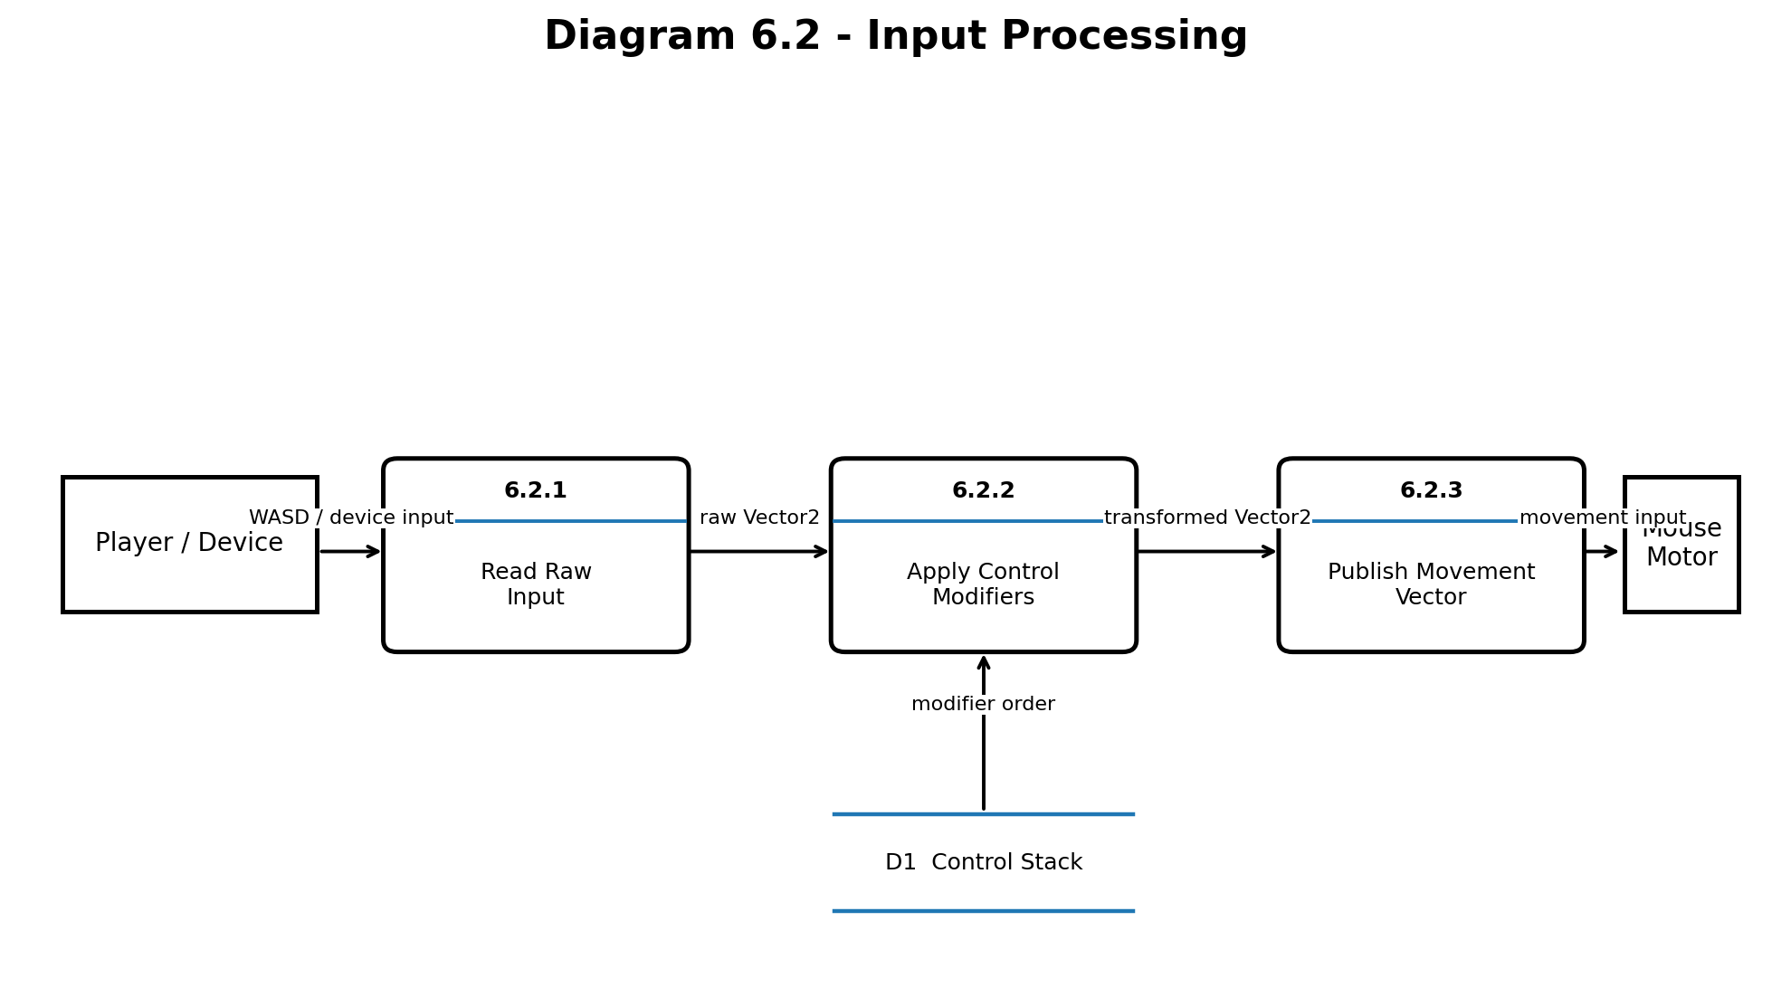
Diagram 6.2 - Input Processing
Field | Description
Input | Vector2 raw device sample; ordered IReadOnlyList<ControlModifierId>.
Process | 6.2.1 reads raw input. 6.2.2 passes the vector through the configured InputTransformer pipeline. 6.2.3 publishes the transformed Vector2 to MouseMotor.
Output | Vector2 transformed input for MouseMotor.
Rule | Mirror negates X; Invert negates Y; Rotation rotates by the configured N degrees; Lag returns the sample from N frames earlier.
Boundary rule | Vector2.zero remains zero through every modifier. Movement normalization occurs after transformation so diagonal input cannot outrun cardinal input.

5.1 Primitive Process Pseudocode - Process 6.2 Input Processing
Input: current device state and ordered ControlModifierId list.
Output: transformed Vector2 movementInput.
1. Read the current movement keys through IInputSource.
2. Convert the device state to a raw Vector2.
3. If input is disabled, set the raw Vector2 to Vector2.zero.
4. For each configured InputTransformer in order, call Transform(currentVector).
5. Preserve Vector2.zero as zero through every transformation.
6. Publish the final transformed Vector2 to MouseMotor.
7. Return the transformed Vector2.
Process boundary: Diagram 6.2 is the primitive decomposition of Process 6.2 Input Processing. It begins with Player/Device input and ends when Process 6.2.3 publishes the transformed Vector2 to MouseMotor. Collision resolution, player-state updates, camera behavior, hazards, and maze generation are outside this primitive process.

6. Acceptance Tests
The acceptance tests below convert the completion criteria into repeatable checks with explicit numeric pass/fail bounds. Observed results should be recorded after implementation; no result is assumed here.

Test 1 — Raw Input
Run 100 input samples for each supported WASD direction and the neutral input. Pass requires 100/100 samples to match the defined Vector2 mapping, with zero incorrect direction values.

Test 2 — Transformer Behavior
Run 100 samples for each transformer: Mirror, Invert, Rotation, and Lag. Pass requires 100/100 samples to match the expected transformation within a numerical tolerance of 0.01 for floating-point vector components.

Test 3 — Transformer Composition and Order
Run 100 samples through representative stacks, including Lag(Mirror(Raw)) and at least one stack with three or more modifiers. Pass requires 100/100 outputs to match the expected composition order, with zero ordering errors.

Test 4 — Zero-Input Boundary
Run 100 zero-input samples through every individual transformer and the representative stacked configurations. Pass requires 0 non-zero outputs.

Test 5 — Diagonal Movement
Run 100 diagonal movement samples at the same configured speed as cardinal movement. Pass requires 0 samples in which diagonal movement magnitude exceeds the corresponding cardinal movement magnitude by more than 0.01.

Test 6 — Collision Safety
Run 100 movement attempts toward hand-built maze-wall boundaries, including direct and diagonal approaches. Pass requires 0 wall penetrations and 100/100 final positions to be collision-safe according to IMazeQuery.

Test 7 — Player State
Run 100 scripted state transitions covering Spawning, Alive, Frozen, Dead, and respawn. Pass requires 0 invalid state transitions and 0 movement while Frozen or Dead.

Test 8 — Cell and Event Behavior
Run 100 scripted movement sequences crossing and not crossing cell boundaries. Pass requires 0 false OnCellChanged events and 100% agreement between the event payload and the new CurrentCell.

Test 9 — Non-Keyboard Binding
Run 100 movement samples using the alternate input source. Pass requires the alternate source to produce the expected movement and 0 changes to MouseMotor movement logic.

Test 10 — Transformer Stress
Process 1,000 input samples per frame through a 10-deep transformer stack. Pass requires 0 functional failures and no incorrect output vectors.

Acceptance summary
A test passes only when every stated numeric bound is satisfied. Any violation is a failure and should record the input, modifier stack, player state, and relevant frame/sample for reproduction.

7. Timeline
The total planned effort is 56 hours: Design 9 h, Coding 25 h, Testing 14 h, and Documentation 8 h. The table below expands the estimate into individually trackable tasks with durations and predecessor relationships. The optional second-player controller is excluded from these 56 hours.
Effort check: Design 9 h · Coding 25 h · Testing 14 h · Documentation 8 h = 56 h total.
Critical dependency chain: interface/architecture → input abstraction → transformer stack → movement/collision → state/events → integration testing. Testing can begin as individual components become complete, so the full 56 hours is not necessarily one uninterrupted serial path.
ID | Phase | Task | Description | Hours | Predecessor
D1 | Design | Review F7 requirements | Responsibilities, interface, dependencies, completion criteria | 1.0 | —
D2 | Design | Player architecture | PlayerController, MouseMotor, collision, state responsibilities | 2.0 | D1
D3 | Design | Input abstraction | IInputSource and RawInputSource seam | 1.5 | D1
D4 | Design | transformation structure | InputTransformer wrapping and runtime stack | 2.0 | D3
D5 | Design | Player state design | Alive, Dead, Frozen, Spawning | 1.0 | D2
D6 | Design | Collision interface | GridCollisionResolver ↔ IMazeQuery | 1.0 | D2
D7 | Design | UML diagrams | Class and sequence diagrams | 0.5 | D2–D6
C1 | Coding | Project structure | Create F7 scripts/folders/namespaces | 0.5 | D7
C2 | Coding | IInputSource | Implement input abstraction | 1.0 | C1
C3 | Coding | RawInputSource | Read keyboard/WASD and return Vector2 | 2.0 | C2
C4 | Coding | InputTransformer | Implement transformation base | 2.0 | C2
C5 | Coding | MirrorTransformer | Negate X | 1.0 | C4
C6 | Coding | InvertTransformer | Negate Y | 1.0 | C4
C7 | Coding | RotationTransformer | Rotate by N degrees | 1.5 | C4
C8 | Coding | LagTransformer | Return input from earlier frames | 3.0 | C4
C9 | Coding | Transformer composition | Build/verify runtime modifier stack | 1.0 | C5–C8
C10 | Coding | MouseMotor | Transform input into movement | 3.0 | C3–C9
C11 | Coding | GridCollisionResolver | Prevent wall clipping through IMazeQuery | 3.0 | D6,C10
C12 | Coding | PlayerStateMachine | Implement player states | 2.0 | D5
C13 | Coding | PlayerController | Connect F7 systems through MonoBehaviour | 2.0 | C10–C12
C14 | Coding | Public interface | SpawnAt, Despawn, Kill, EnableInput, FreezeInput | 1.0 | C13
C15 | Coding | Position/cell queries | Position, CurrentCell, FollowTarget | 0.5 | C13
C16 | Coding | Events | OnCellChanged and OnInteractPressed | 0.5 | C15
T1 | Testing | Raw input tests | Verify WASD Vector2 values | 1.0 | C3
T2 | Testing | Mirror tests | Verify X inversion | 0.5 | C5
T3 | Testing | Invert tests | Verify Y inversion | 0.5 | C6
T4 | Testing | Rotation tests | Common and arbitrary rotations | 1.0 | C7
T5 | Testing | Lag tests | Verify frame delay | 1.0 | C8
T6 | Testing | Stacked modifiers | Test compositions such as Lag(Mirror(Raw)) | 1.0 | C9
T7 | Testing | Zero-input boundary | (0,0) survives every transformer | 0.5 | T2–T6
T8 | Testing | Diagonal movement | No diagonal speed advantage | 0.5 | C10
T9 | Testing | Collision unit tests | Hand-built 3×3 IMazeQuery stub | 1.5 | C11
T10 | Testing | Wall boundary tests | Verify no wall clipping | 1.0 | T9
T11 | Testing | State tests | Spawning, alive, frozen, dead, respawn | 1.0 | C12
T12 | Testing | Integration testing | Input → movement → collision pipeline | 1.5 | C13–C16
T13 | Testing | Stress test | 1,000 samples/frame through 10-deep stack | 1.0 | T6
T14 | Testing | Non-keyboard binding | Alternate source without movement changes | 1.0 | C2,C10
T15 | Testing | Final acceptance | Verify all completion criteria | 1.0 | T1–T14
DOC1 | Documentation | Architecture documentation | Responsibilities and class relationships | 1.5 | C13
DOC2 | Documentation | transformation documentation | Explain pattern and selection | 1.0 | C9
DOC3 | Documentation | Protected Variations | Explain IInputSource seam | 1.0 | C2
DOC4 | Documentation | Class diagram | Match UML to implementation | 1.0 | C16
DOC5 | Documentation | Sequence diagram | Movement/input sequence | 0.5 | C16
DOC6 | Documentation | Testing documentation | Record test cases and pass/fail criteria | 1.0 | T15
DOC7 | Documentation | Final Champion cleanup | Proofread, verify requirements, submission prep | 2.0 | DOC1–DOC6
Phase totals: Design — 9 h · Coding — 25 h · Testing — 14 h · Documentation — 8 h · Total — 56 h.
Milestone 1: Architecture complete after the 9-hour design phase.
Milestone 2: Input system complete after the raw input and transformer work.
Milestone 3: Movement/collision complete after MouseMotor and GridCollisionResolver.
Milestone 4: Player system complete after PlayerStateMachine, PlayerController, interfaces, queries, and events.
Milestone 5: Testing complete after unit, boundary, collision, state, integration, stress, and alternate-input tests.
Milestone 6: F7 complete after documentation and final Champion cleanup.

8. Completion Criteria
- The player moves with WASD and never clips through maze walls.
- Mirror, Invert, Rotation, and Lag work individually and in stacked combinations with order preserved.
- Zero input remains zero through every transformer.
- Diagonal movement is normalized so a 45° input is not faster than cardinal movement.
- The player transitions cleanly among Alive, Dead, Frozen, and Spawning, with animation driven from state.
- Position and CurrentCell are queryable, FollowTarget is exposed for F5, and OnCellChanged is emitted on actual cell changes.
- Kill is callable by F1, and F7 does not resolve hazards, puzzles, combat damage, or camera behavior.
- At least one non-keyboard binding is implemented as the abstraction proof; movement code remains unchanged when the binding changes.
- A 1,000-sample-per-frame stress test can pass through a 10-deep transformer stack without functional failure.

