Table of Contents

Case Study 3

Introduction 3

Brief Description 3

Cause Effect Graphing 3

Function 1: float caluculateKDA (int kill, int death, int assist) 3

Identified Causes & Effects 3

Cause Effect Graph 4

Decision Table 4

Test Cases 4

Function 2: float baronDragonRatio (int baron, int dragon) 5

Identified Causes & Effects 5

Cause Effect Graph 5

Decision Table 5

Test Cases 5

Function 3: void rankCalculation (float KDA, float BD) 6

Identified Causes & Effects 6

Cause Effect Graph 6

Decision Table 6

Test Cases 6

# Case Study

## Introduction

League of Legends is a multiplayer online battle arena video game developed and published by Riot Games for Microsoft Windows and macOS. Inspired by the Warcraft III: The Frozen Throne Mod Defense of the Ancients, the game follows a freemium model and is supported by microtransactions.

## Brief Description

League of Legends has a competitive side where the player plays the game with full focus and aiming to win the game, this is because they are awarded with ranks such as **silver, gold, platinum, diamond, master and challenger**. Now in this case there is a player whose rank is platinum, as it is about to be determined where the player has played 4 games of promotions from platinum rank to diamond rank. The player rank is calculated by the KDA (kill, death, assist) and the ratio of defeating the **baron and dragons**. KDA is achieved when the player defeats the enemy in a 5v5 match, that how much kills the player did, how much the player died in that game and how much he got assist in killing the enemy. Baron and dragon give **Buff** to the players who ever kills it. So, from these 2 important aspects that is player’s KDA and the player baron and dragon ratio hence the player rank is calculated.

The player aim is to get **Diamond Rank** this season. In order to get that rank player kills should be in between 15 to 30 where 15 and 30 is also included, the deaths of the player should be in between 0 to 6 where 0 and 6 is included, the assists of the player should be in between 0 to 10 where 0 and 10 is also included, the player baron captured should be between 0 to 3 where 0 and 3 is also included and the player dragon captured should be in between 0 to 4 where 0 and 4 is also included. The KDA ratio should be between 2 to 33 including 2 and 33 but after the calculation it should be in between 6 to 20 where 6 and 20 is included and the Baron and dragon ratio should be between 0 to 3 where 0 and 3 is included but after calculation it should be in between 1 to 3 where 1 and 3 is also included. After fulfilling all the conditions that is required by the league of legends then the player will be able to achieve the Diamond Rank. So, according to this test cases is being generated with the provided code.

Higher the rank of the player higher the reward, which means the player will get a reward such as pre-paid skins of champions if the player will achieve high rank.

# Cause Effect Graphing

## Function 1: float caluculateKDA (int kill, int death, int assist)

### Identified Causes & Effects

|  |  |
| --- | --- |
| **Causes** | **Effects** |
| **C1:** kill>=15 && kill<=30 | **E1:** KDARatio calculated |
| **C2:** deaths>=0&&deaths<=6 | **E2:** Invalid Range |
| **C3:** assist>=0&&assist<=10 |  |
| **C4:** death != 0 |  |

### Cause Effect Graph

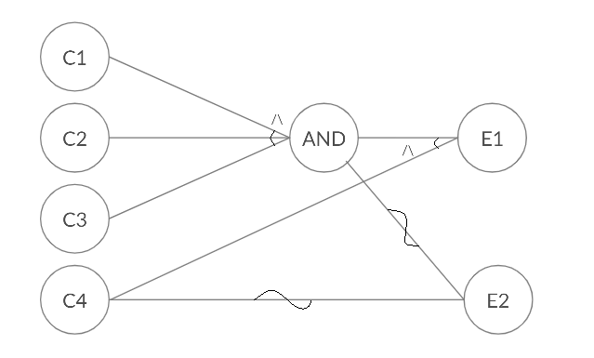

Figure 1 Cause Effect Graph Function 1

### Decision Table

|  |  |  |  |  |  |  |  |  |  |
| --- | --- | --- | --- | --- | --- | --- | --- | --- | --- |
| **Action** | **T1** | **T2** | **T3** | **T4** | **T5** | **T6** | **T7** | **T8** | **T9** |
| **C1** | 0 | 1 | 0 | 0 | 1 | 0 | 1 | 1 | 1 |
| **C2** | 0 | 0 | 1 | 0 | 1 | 1 | 0 | 1 | 1 |
| **C3** | 0 | 0 | 0 | 1 | 0 | 1 | 1 | 1 | 1 |
| **C4** | - | - | - | - | - | - | - | 0 | 1 |
| **E1** | 0 | 0 | 0 | 0 | 0 | 0 | 0 | 0 | 1 |
| **E2** | 1 | 1 | 1 | 1 | 1 | 1 | 1 | 1 | 0 |

### Test Cases

|  |  |  |  |  |
| --- | --- | --- | --- | --- |
| **Test case** # | **Input (Causes)** | | | **Expected Output (Effects)** |
| **Kill** | **Death** | **Assist** |
| **T1** | 14 | 0 | 11 | Invalid Range |
| **T2** | 25 | 8 | 13 | Invalid Range |
| **T3** | 12 | 3 | 15 | Invalid Range |
| **T4** | 10 | 10 | 5 | Invalid Range |
| **T5** | 20 | 2 | -1 | Invalid Range |
| **T6** | 35 | 4 | 6 | Invalid Range |
| **T7** | 30 | -1 | 8 | Invalid Range |
| **T8** | 28 | 0 | 7 | Invalid Range |
| **T9** | 29 | 5 | 9 | KDA Ratio calculated |

## Function 2: float baronDragonRatio (int baron, int dragon)

### Identified Causes & Effects

|  |  |
| --- | --- |
| **Causes** | **Effects** |
| **C1:** baron>=0 && baron<=3 | **E1:** BaronDragon ratio calculate |
| **C2:** dragon >= 0 && dragon <= 4 | **E2:** Invalid Range |

### Cause Effect Graph

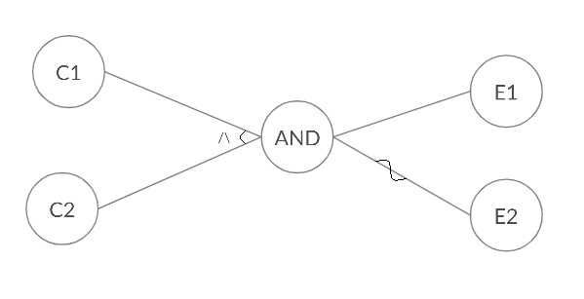

Figure 2 Cause Effect Graph Function 2

### Decision Table

|  |  |  |  |  |
| --- | --- | --- | --- | --- |
| **Action** | **T1** | **T2** | **T3** | **T4** |
| **C1** | 0 | 1 | 0 | 1 |
| **C2** | 0 | 0 | 1 | 1 |
| **E1** | 0 | 0 | 0 | 1 |
| **E2** | 1 | 1 | 1 | 0 |

### Test Cases

|  |  |  |  |
| --- | --- | --- | --- |
| **Test case** # | **Input (Causes)** | | **Expected Output (Effects)** |
| **Baron** | **Dragon** |
| **T1** | -1 | 5 | Invalid Range |
| **T2** | 2 | -1 | Invalid Range |
| **T3** | 4 | 3 | Invalid Range |
| **T4** | 2 | 4 | BaronDragon ratio calculate |

## Function 3: void rankCalculation (float KDA, float BD)

### Identified Causes & Effects

|  |  |
| --- | --- |
| **Causes** | **Effects** |
| **C1:** KDA >= 6 && KDA <= 20 | **E1:** Rank Calculation |
| **C2:** BD >= 1 && BD <= 3 | **E2:** Invalid Range |

### Cause Effect Graph



Figure 3 Cause Effect Graph Function 3

### Decision Table

|  |  |  |  |  |
| --- | --- | --- | --- | --- |
| **Action** | **T1** | **T2** | **T3** | **T4** |
| **C1** | 0 | 1 | 0 | 1 |
| **C2** | 0 | 0 | 1 | 1 |
| **E1** | 0 | 0 | 0 | 1 |
| **E2** | 1 | 1 | 1 | 0 |

### Test Cases

|  |  |  |  |
| --- | --- | --- | --- |
| **Test case** # | **Input (Causes)** | | **Expected Output (Effects)** |
| **KDA ratio** | **BD ratio** |
| **T1** | 5 | 4 | Invalid Range |
| **T2** | 15 | 5 | Invalid Range |
| **T3** | 2 | 2 | Invalid Range |
| **T4** | 20 | 3 | Rank Calculation |

**As the test cases have been identified and written down and also checked through JUNIT in the code section.**