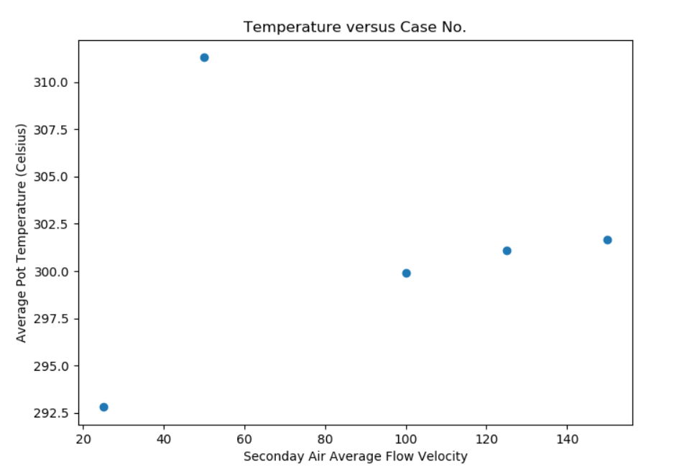

586666 –velocity in blue shows moving down the domain

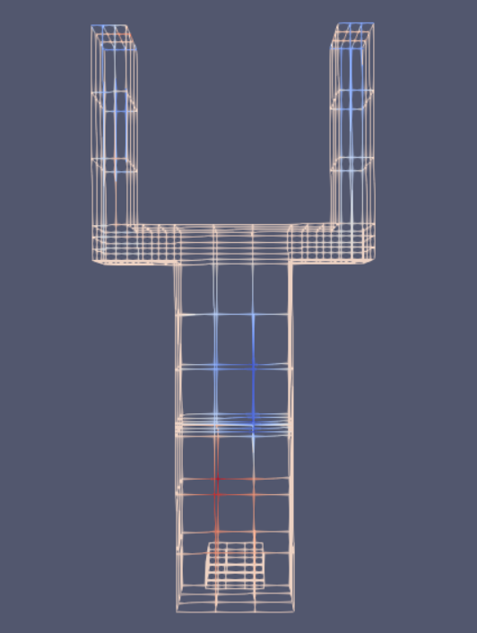

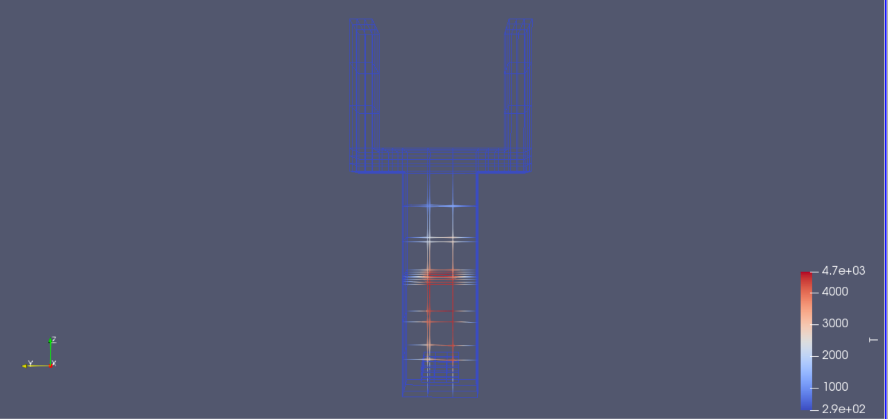

TEMP CFD says near the secondary air inlet, temps reach 4700 C after 3 seconds in combustion chamber. Not reasonable. Burnout? Diverging?

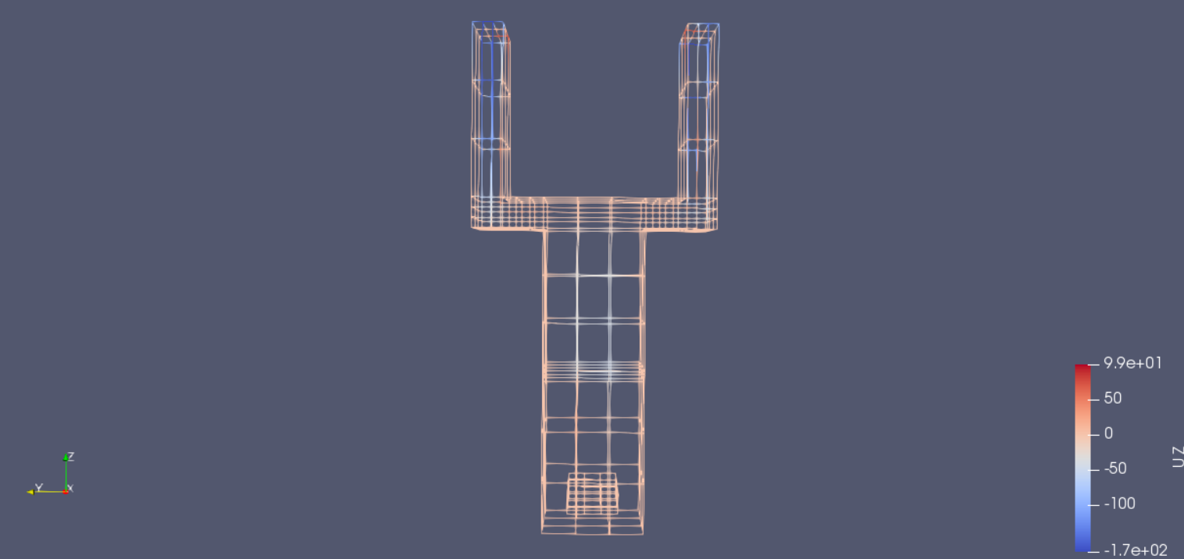

Flow mostly positive in z-direction (some backflow near the outlet---not hot enough for density gradient to allow flow through the domain)

Case_50

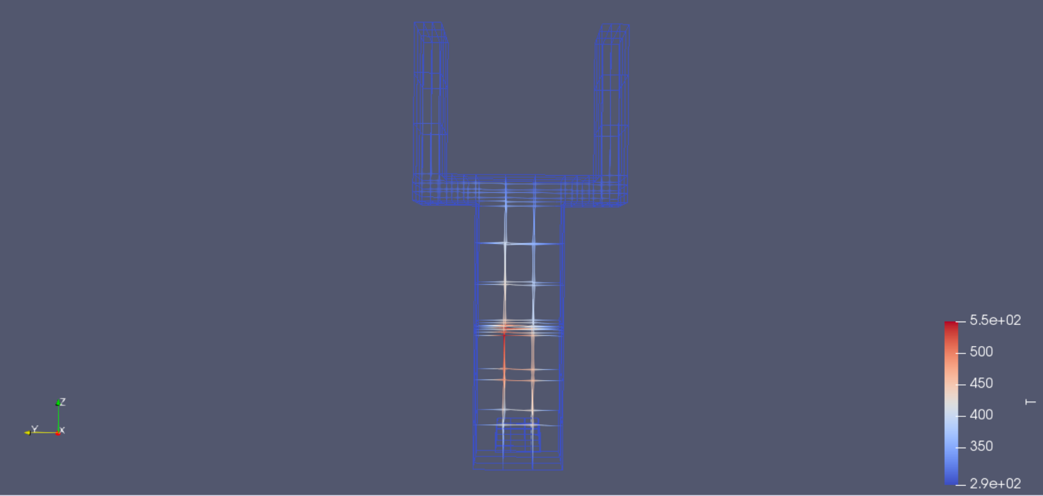

550 C within combustion chamber after 5 seconds. Seems more reasonable.

Lowest case (case 25) after 5 seconds:

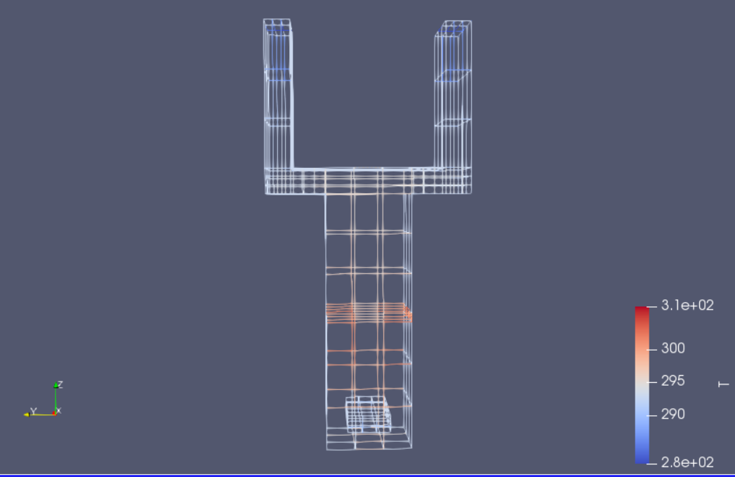

-Around 300C gas temperature. Not enough air supplied??

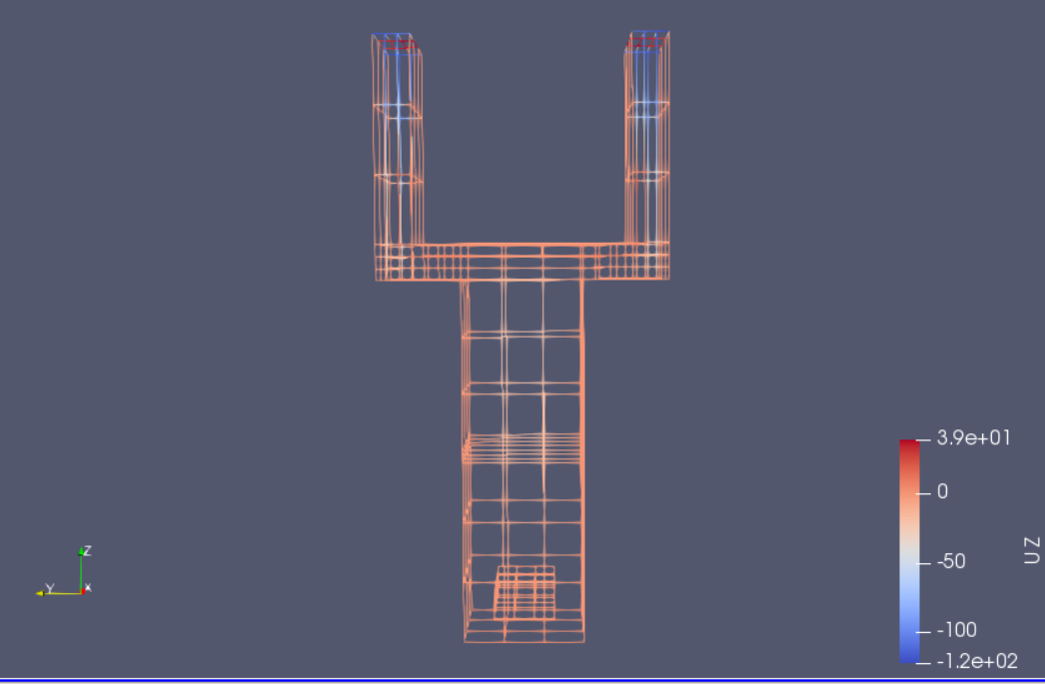

Case 25 Uz at 5 seconds

