LAB ACTION PLAN FOR WEEK 4
Objective:
To enable students to:
- Understand the structure and lifecycle of a Maven project.
- Build and package Java and Web applications using Maven.
- Add dependencies using pom.xml, compile and test using plugins.
- Resolve errors and conflicts arising from dependency mismatches.
- Work with parent and multi-module Maven projects.
- Generate executable JARs and deployable WARs using Maven.
Students must document observations, include screenshots of executions, and answer scenario-based questions after completing the tasks.
- Understanding Maven Project Structure
Maven standardizes the project structure for both Java and web-based applications. src/
├── main/
│ ├── java/ → Application source code
│ └── resources/ → Configuration files like config.properties
└── test/
├── java/ → Unit test source code
└── resources/ → Test resources
The compiled files and reports are generated in the target/ directory after a successful build.
- Steps to Perform Maven Build and Testing
----mvn clean install
- clean: Deletes the previous build (target/ folder)
- install: Builds, tests, and installs the package to local .m2 repository
After execution:
- target/ folder contains compiled .class files and the final .jar or .war
- Artifact is stored in:
~/.m2/repository/groupId/artifactId/version/
Add a Dependency (e.g., Gson):
In pom.xml:
<dependency>
<groupId>com.google.code.gson</groupId>
<artifactId>gson</artifactId>
<version>2.10</version>
</dependency>
After running:
mvn clean install
Check:
- Gson JAR is downloaded to .m2/repository/com/google/code/gson/gson/
- If version is wrong or not found → BUILD FAILURE with dependency resolution error
- Configure Java Version via Compiler Plugin
In pom.xml:
<plugin>
<groupId>org.apache.maven.plugins</groupId>
<artifactId>maven-compiler-plugin</artifactId>
<version>3.11.0</version>
<configuration>
<source>17</source>
<target>17</target>
</configuration> </plugin>
Check:
- Run mvn package
- Inspect generated JAR: jar tf target/myapp.jar
- JUnit Testing and Reports
Place test files in src/test/java. Example:
public class AppTest {
@Test
public void testSum() {
assertEquals(5, 2 + 3);
}
}
Run:
mvn test
Check:
- target/test-classes/ → compiled test .class files
- target/surefire-reports/ → .txt or .xml test results
If test fails → corresponding log and failure trace shown
- Handling Errors in pom.xml
- Typos in version numbers or missing repositories cause BUILD FAILURE
- Maven shows precise error in console
- Fix the dependency tag → re-run mvn clean install

- Adding Resource Files
Put config.properties inside:
src/main/resources/config.properties
To read:
InputStream input = getClass().getClassLoader().getResourceAsStream("config.properties");
After build, check target/classes/ → file should exist there.
- Multi-Module and Parent Projects
Structure:
parent/
├── pom.xml (packaging: pom)
├── core/
| └── pom.xml
└── web/
└── pom.xml
- Parent pom.xml defines <modules> and common dependencies
- Each submodule builds independently into its target/ directory

- Executable JARs

Add to pom.xml:

<build>
<plugins>
<plugin>
<groupId>org.apache.maven.plugins</groupId>
<artifactId>maven-jar-plugin</artifactId>
<configuration>
<archive>
<manifest>
<mainClass>com.example.Main</mainClass>
</manifest>
</archive>
</configuration>
</plugin>
</plugins>
</build>
Run:
mvn package
java -jar target/myapp.jar

- Building a WAR File
Create a Maven web project with structure:
src/main/webapp/
└── WEB-INF/web.xml

Add:
<packaging>war</packaging>
Command:
mvn package
Generates target/mywebapp.war → deploy on Tomcat server.
- Scenario-Based Questions:

- If my error is about:
Failed to execute goal org.apache.maven.plugins:maven-compiler-plugin:3.8.1:compile
[ERROR] -> [Help 1]
[ERROR] To see the full stack trace of the errors, re-run Maven with the -X switch.
How can I resolve it using maven terminal?
Ans: mvn clean install -X

- A dependency you added is not recognized by the compiler. What steps would you take to confirm it is available in .m2 and listed in dependency tree?
Ans: ls ~/.m2/repository/groupId/artifactId/version/
mvn dependency:tree
mvn clean install

- A teammate sends a .patch file for a bug fix. How would you apply it and include it in your Maven build?
Ans: git apply fix.patch
mvn clean install

- You have multiple JUnit test failures and want to rerun only failed tests. How would you approach this?
Ans: mvn surefire:test -Dtest=ClassName#methodName

- Your Maven build fails due to “Unsupported class version error.” What plugin and configuration would you review?
Ans: <plugin>
<groupId>org.apache.maven.plugins</groupId>
<artifactId>maven-compiler-plugin</artifactId>
<version>3.11.0</version>
<configuration>
<source>17</source>
<target>17</target>
</configuration>
</plugin>

- You need to change your Java application from a WAR to a standalone JAR. What pom.xml changes are needed?
Ans: <packaging>jar</packaging>

- You are required to change the default build output directory from target/ to build_output/. How would you configure it?
Ans: <build>
<directory>build_output</directory>
</build>

- You want to skip tests during the Maven build. What command would you use?
Ans: mvn clean install -DskipTests

- How would you generate a site report (with test coverage, dependency analysis) for a Maven project?
Ans: mvn site

- How do you build a Java project using Maven, and what files are generated in the target/ folder after running mvn clean install?
Ans: mvn clean install

- How does Maven resolve dependency conflicts when two libraries use different versions of the same dependency, and how can you view and manage the dependency tree?
Ans: mvn dependency:tree

- How do you write and run a JUnit test in a Maven project, and where are the compiled test classes and reports stored after running mvn test?
Ans: mvn test

- How can you create an executable JAR with a main method using Maven, and which plugin helps configure this behavior?
Ans: Use maven-jar-plugin with <mainClass> in pom.xml.

- How do you install and use a custom third-party JAR file in your Maven project, and how can you confirm it’s included in the build and classpath?
Ans: mvn install:install-file -Dfile=lib/custom.jar \
-DgroupId=com.example -DartifactId=customlib \
-Dversion=1.0 -Dpackaging=jar

- How do you create a Maven web project that packages into a WAR file, and what is the standard folder structure for such a project?
Ans: src/main/webapp/
└── WEB-INF/web.xml

- What command do you use to build a WAR file in Maven, where is it generated, and how can you deploy it to a server like Apache Tomcat?
Ans: mvn package

- How do you add JSTL and servlet-api dependencies in a Maven web project, and why should the servlet API use provided scope instead of compile?
Ans: <dependency>
<groupId>javax.servlet</groupId>
<artifactId>javax.servlet-api</artifactId>
<version>4.0.1</version>
<scope>provided</scope>
</dependency>
<dependency>
<groupId>javax.servlet.jsp.jstl</groupId>
<artifactId>jstl-api</artifactId>
<version>1.2</version>
</dependency>

- How do you set up a multi-module Maven web project with separate modules for core logic and web interface, and how are these modules built and connected?
Ans: Parent pom.xml has <modules> list, each submodule has its own pom.xml. Run mvn install from parent to build all.

- How do you configure a Maven web project, and how does its packaging and execution differ from a traditional WAR-based application?
Ans: WAR-based needs a servlet container (Tomcat), JAR can be run standalone with java -jar.

Conclusion
Mastering Maven empowers students to structure projects efficiently, manage complex dependencies, and automate testing and packaging. By practicing real-world scenarios—such as resolving build errors, handling resource files, applying patches, and deploying to servers—students gain valuable hands-on experience aligned with professional software development workflows. Maven not only streamlines builds but also enforces standardization and reusability across projects. Through Maven, students learn efficient project management, dependency control, multi-module integration, and reproducible builds. Understanding Maven’s lifecycle, plugin system, and error handling prepares students for professional DevOps and CI/CD workflows. This lab equips students with hands-on experience in packaging, testing, resolving conflicts, and deploying real-world Java and Web applications.

Maven Project
1. maven clean
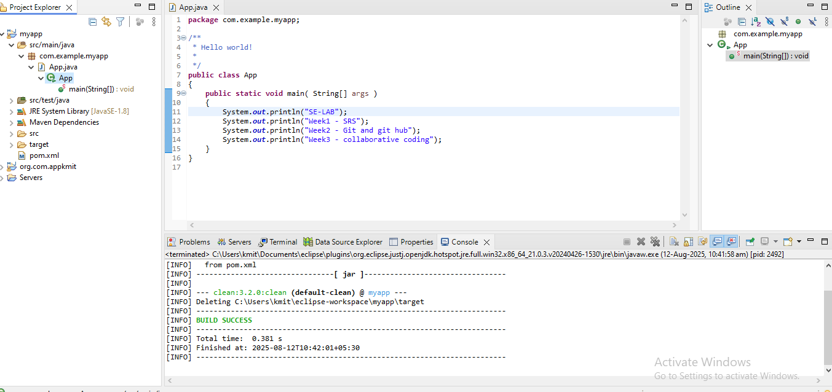
2. maven install
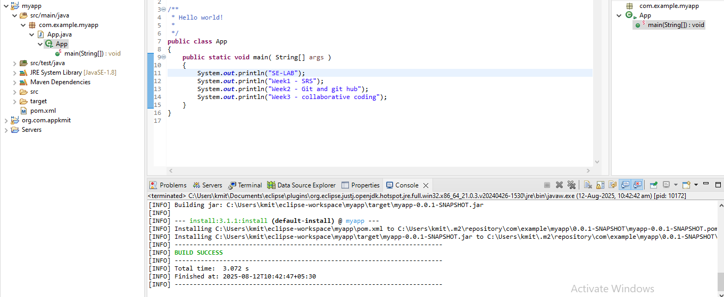
3. maven test
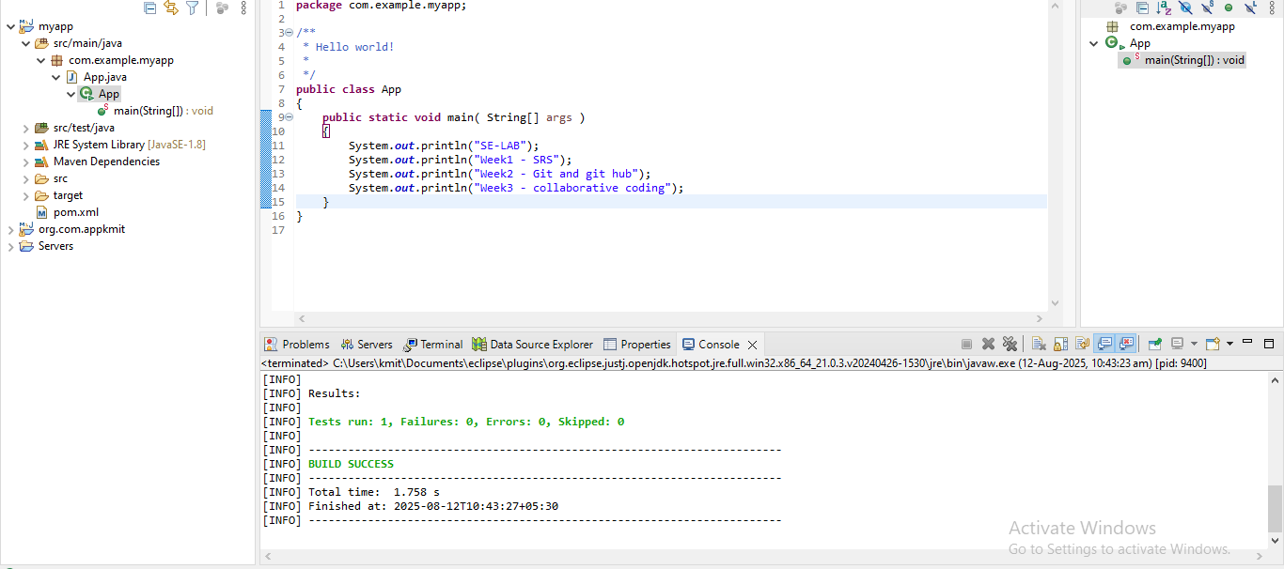
4. maven build
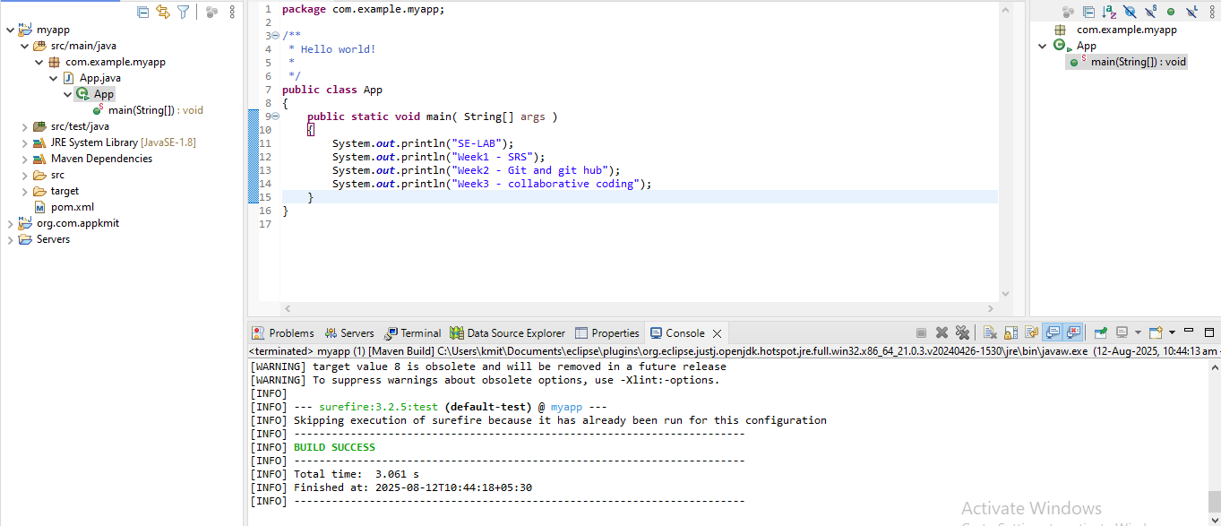
5. run java application
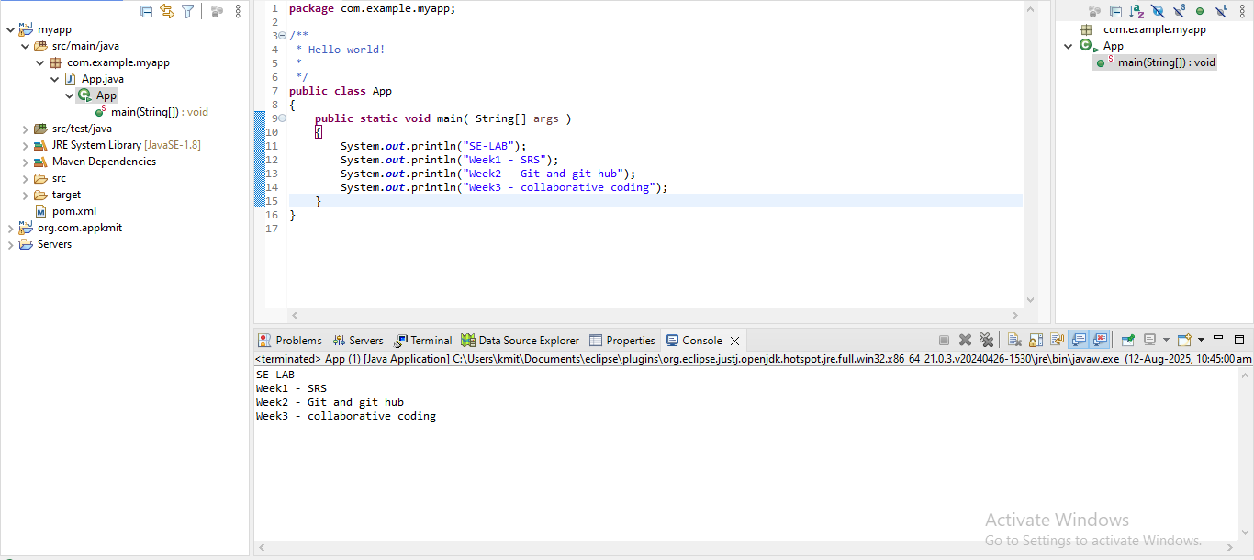

WEB-APP
