Software Architecture and Design Specification
Project: Online Quiz System
Version: 1.0
Authors: Team Jackfruit (Tejas, Sanjana, Vikas, Vaishnavi)
Date: 12-10-2026
Status: Baseline for Sprint-1

Revision History
Version | Date | Author | Change Summary
1.0 | 12-10-2026 | Team | First complete version, aligned with SRS v1.1 and the code on main

1. Introduction

1.1 Purpose
This document describes the architecture and design of the Online Quiz System, a console-based multiple-choice quiz program written in C. It shows how the requirements in the SRS (v1.1) are met by components, functions and data flow, so that the four team members can build their modules separately and test them against the Test Plan.

1.2 Scope
It covers the whole program: the main menu, the quiz engine, scoring and result display, and result storage with the leaderboard. It does not cover deployment (the program is one local executable) or anything outside the SRS scope, such as accounts, networking or a GUI.

1.3 Audience
Developers building the modules, testers writing test cases, the course evaluators, and anyone who works on the project later.

1.4 Definitions
- MCQ: multiple-choice question with exactly one correct option.
- REQ-n, NFR-n, SEC-n: functional, non-functional and security requirements in the SRS.
- STRIDE: a list of threat types (Spoofing, Tampering, Repudiation, Information disclosure, Denial of service, Elevation of privilege), used in 3.9.

2. Document Overview

2.1 How to use this document
Section 3 describes the architecture (components, pattern, traceability to requirements, security). Section 4 describes the design (sequence diagrams, functions, error handling, screens). Developers should read 3.4 and 4.3 before changing a module. Testers should read 3.8 and 4.4.

2.2 Related documents
SRS (SRS.md), Test Plan (docs/TEST_PLAN.md), and the team task split with the shared function signatures (TEAM-TASKS.md).

3. Architecture
The goals are a small, readable program that four people can build at the same time (NFR-5) and that never crashes on bad input or a missing file (NFR-4). The constraints are plain C (C99) built with gcc -Wall -std=c99 and no third-party libraries; console only, one user, no network and no database; data is saved only in local text files; and the shared function names and structs in quiz.h, score.h and storage.h are fixed so the modules can be built in parallel.

3.3 Component (UML) Diagram
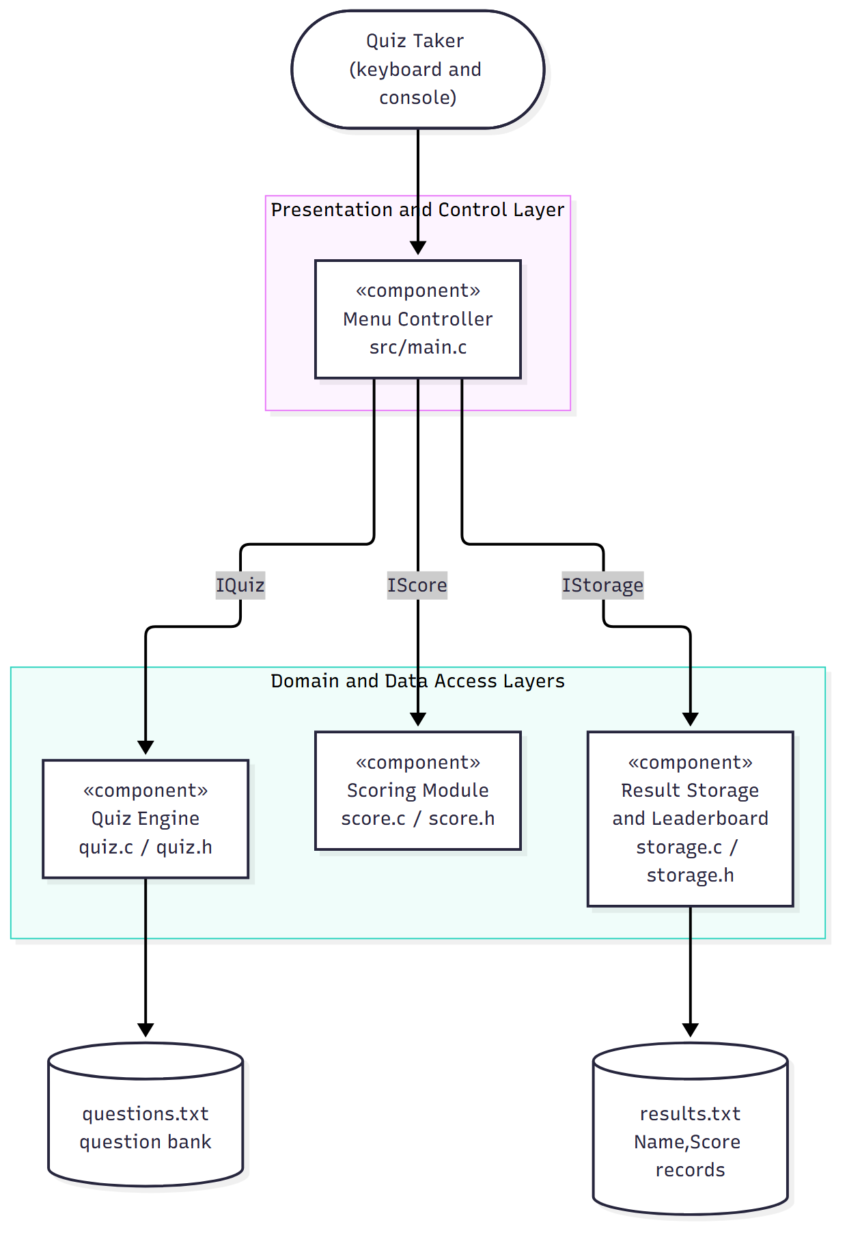
Figure 1: Components, the functions each one offers, and the data files.

3.4 Component Descriptions
Component | Files | What it does | Functions it offers | Owner
Menu Controller | src/main.c | Shows the menu, checks the menu choice, asks for the player name, calls the chosen feature, shows instructions, exits cleanly | none (entry point) | Tejas
Quiz Engine | src/quiz.c, include/quiz.h | Loads the question bank (data/questions.txt), shows one question at a time, checks and records each answer | IQuiz: load_questions, run_quiz | Sanjana
Scoring Module | src/score.c, include/score.h | Compares answers with the correct options, counts correct and incorrect answers, works out the percentage and Pass/Fail (40%), shows the result screen | IScore: calculate_result, show_result | Vikas
Result Storage and Leaderboard | src/storage.c, include/storage.h | Adds Name,Score to results.txt, reads the results back, shows the leaderboard from high score to low | IStorage: save_result, show_leaderboard | Vaishnavi

The only link between modules is the two shared data types: score.h includes quiz.h (for Question) and storage.h includes score.h (for Result). Modules do not call each other's functions. The Menu Controller calls them one after another.

3.5 Chosen Architecture Pattern and Rationale
Pattern: layered architecture (one program made of separate modules).
Layer | Contents | Rule
Presentation and control | main.c | Talks to the user and calls the layers below; has no scoring or file code
Domain | quiz.c, score.c | Quiz rules and scoring; knows nothing about the menu
Data access | storage.c, the two text files | The only code that reads or writes results.txt

Rationale. The program has one user, runs as one process, and has three clear parts, which match how the team shares the work. Layers give each owner their own files (so pull requests do not clash), let each module be tested alone (tests/test_score.c uses only score.c), and keep file-format details out of the menu code.
Alternatives rejected. Client-server or microservices (there is no network and no second user), one big main.c (four people would edit one file and nothing could be tested alone), and a database (the SRS says no database and a text file is enough for a short leaderboard).
Key design decisions
- Text files for questions and results: no extra software is needed and a person can read them.
- Shared function names and structs are fixed, so a module can be built before the modules it depends on exist.
- Fixed-size arrays created by the caller and no dynamic memory, so there are no memory leaks (the question limit is MAX_QUESTIONS, 100).

3.6 Technology Stack and Data Stores
- Language and build: C (C99), GCC and make (make builds quiz, make test runs the score tests).
- Version control and CI: Git and GitHub; a GitHub Actions workflow runs make on every push and pull request.
- Question bank: data/questions.txt. For each question: one line of text, four option lines, then one line with the correct letter A to D.
- Results store: results.txt. One Name,Score line per attempt, appended.

3.7 Risks and Mitigations
Risk | Impact | Mitigation
Question file is in the wrong format or missing | Quiz cannot start | load_questions returns an error; the menu shows an error and continues (NFR-4)
Two people edit the same file | Merge conflicts | One owner per file; one pull request per issue, reviewed by the repo owner
results.txt edited by hand or damaged | Wrong leaderboard | Lines in the wrong format are skipped; the remaining risk is accepted (3.9)

3.8 Traceability to Requirements
Requirement | Component | Function / location
REQ-1 to REQ-6 (menu, validation, navigation, exit) | Menu Controller | show_menu(), read_menu_choice(), loop and switch in main()
REQ-7 to REQ-10 (score, counts, percentage, Pass/Fail at 40%) | Scoring | calculate_result(), PASS_PERCENT
REQ-11 (display result) | Scoring | show_result()
REQ-12 (pass result to storage) | Menu Controller, Storage | save_result(name, &result) call in start_quiz()
REQ-13 (save name and score) | Storage | save_result()
REQ-14 to REQ-16 (read, sort, missing file) | Storage | show_leaderboard()
REQ-17 (load questions) | Quiz Engine | load_questions()
REQ-18 to REQ-22 (show, validate, record, next, finish) | Quiz Engine | run_quiz()
NFR-1 Performance | all | no heavy processing; input handled line by line
NFR-2 Security (SEC-1 to SEC-6) | all | see 3.9
NFR-3 Usability | all | Error: prefix and re-prompt (4.5)
NFR-4 Reliability | all | error table in 4.4
NFR-5 Maintainability | all | layering and file ownership (3.4, 3.5)

3.9 Security Architecture
The system has no accounts, no network and no special rights. Bad data can come in from two places: the keyboard, which cannot be trusted, and the two local files, which any user of the computer can edit. Spoofing and repudiation are not handled, because there is no login by design (single local user).
Threat | Scenario | Control | Requirement
Tampering | A name with a comma or new line damages the results file or fakes another record | Commas, \r and \n in the name are replaced by spaces before saving | SEC-2
Tampering | Editing results.txt by hand | Risk accepted; lines in the wrong format are skipped | SEC-4
Information disclosure | Error text shows paths or system details | Only fixed one-line messages; no file names or addresses | SEC-1
Denial of service, buffer overflow | Very long input, empty input, end of input, missing or unreadable file | Size-limited fgets buffers, extra characters discarded, end of input detected, every file call checked | SEC-3, SEC-4, SEC-6
Elevation of privilege | Making the program open a file of the user's choice | File names are fixed in the code and never taken from input | SEC-5

4. Design

4.1 Design Overview
main() runs a menu loop. Option 1 calls start_quiz(), which asks for a name, loads the questions, runs the quiz, calculates and shows the result, and saves it. Option 2 calls show_leaderboard(). Option 3 prints the instructions. Option 4 or end of input leaves the loop and exits.
Shared data structures
typedef struct { /* quiz.h */
char text[256];
char options[4][128]; /* A, B, C, D */
char correct; /* 'A'..'D' */
} Question;

typedef struct { /* score.h */
int score, correct, incorrect, total;
double percent;
int passed; /* 1 = Pass, 0 = Fail */
} Result;

main.c holds the questions in a static array of MAX_QUESTIONS (100) and the answers in a char array that is set to zero first, so unanswered questions never count as correct.

4.2 UML Sequence Diagrams
Sequence 1: Start Quiz (REQ-4, REQ-7 to REQ-13, REQ-17 to REQ-22)
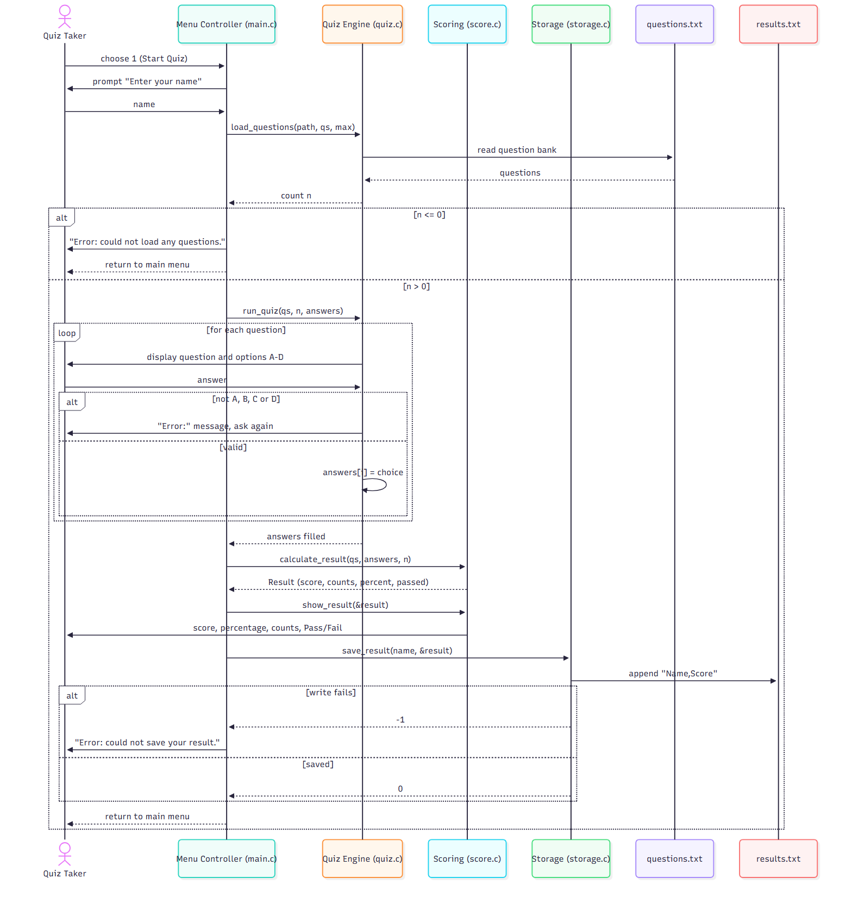
Sequence 2: View Leaderboard (REQ-14 to REQ-16)
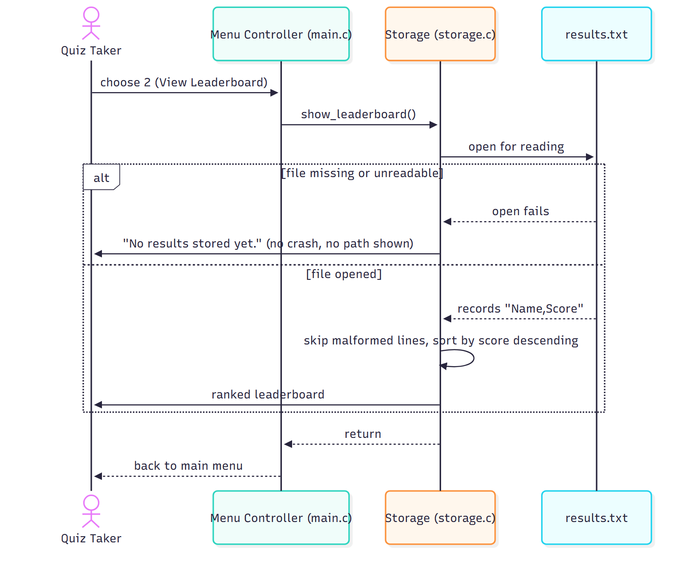

4.3 API Design
All interfaces are C functions declared in the header files. There is no network.
Function | Interface | What it does | Returns | On error
int load_questions(const char *path, Question qs[], int max) | IQuiz (quiz.h) | Reads up to max questions from the file into qs | Number loaded, or -1 on error | File missing or no valid question: -1 (the caller prints the message)
void run_quiz(const Question qs[], int n, char answers[]) | IQuiz (quiz.h) | Shows questions 0 to n-1 one at a time and stores each answer as 'A' to 'D' | nothing; answers[i] is filled | Invalid choice: Error: line and the same question again. End of input: stops, remaining answers stay 0
Result calculate_result(const Question qs[], const char answers[], int n) | IScore (score.h) | Checks the answers and works out score, counts, percentage and Pass/Fail (>= 40%) | A Result | NULL argument or n <= 0: all-zero Result
void show_result(const Result *r) | IScore (score.h) | Prints score, percentage, counts and Pass/Fail | nothing | r is NULL: Error: result is unavailable.
int save_result(const char *name, const Result *r) | IStorage (storage.h) | Appends one Name,Score line to results.txt; commas and new lines in the name become spaces (SEC-2) | 0 on success, -1 on error | NULL argument or file problem: -1, prints nothing
void show_leaderboard(void) | IStorage (storage.h) | Reads results.txt and prints the entries from highest to lowest score | nothing | File missing or unreadable: short "no results yet" message; bad lines are skipped

File formats
questions.txt (repeated per question)
<question text>
<option A>
<option B>
<option C>
<option D>
<correct letter A-D>

results.txt (one per attempt)
<name>,<score>

4.4 Error Handling, Logging and Monitoring
Each error is shown as one line starting with Error:, and then the program goes back to a safe place (usually the menu). No error message contains a file name, path or system error code (SEC-1).
# | Condition | Response | Requirement
E1 | Menu input is not 1 to 4 (letters, empty, too long) | Error: please enter a number from 1 to 4. then the menu again | REQ-3, SEC-3
E2 | End of input at the menu | Goodbye message, clean exit | SEC-6
E3 | Question file missing, unreadable or empty | Error: could not load any questions. and back to the menu | NFR-4
E4 | Invalid answer during the quiz | Error: line and the same question again | REQ-19
E5 | Results file cannot be written | Error: could not save your result. and back to the menu | SEC-4
E6 | Results file missing at the leaderboard, or a line in the wrong format | Short "no results yet" message, or the line is skipped | REQ-16, SEC-4
E7 | Scoring called with NULL or n <= 0 | Zeroed Result; show_result(NULL) prints Error: result is unavailable. | NFR-4

Logging. The quiz keeps no log file, because a log file would be one more place where information could leak. Errors are shown on the screen only.
Monitoring and checks. The GitHub Actions build runs on every push and pull request, and make test runs the unit tests for scoring. Both must pass before the repo owner merges a pull request.

4.5 UX Design
- One screen at a time; every screen ends with a prompt.
- Menus are numbered; quiz answers are single letters A to D.
- Every error starts with Error: and is followed by a new prompt.
- No colour or cursor control, so it works in any terminal.
===== Online Quiz System =====
1. Start Quiz
2. View Leaderboard
3. Instructions
4. Exit
Enter your choice (1-4):

4.6 Open Issues and Next Steps
# | Item | Plan
1 | REQ-12 says "score and percentage" are passed to storage, but the file stores name and score only (BR-4) | The whole Result is passed; only name and score are saved
2 | Equal scores have no set order on the leaderboard | They keep the order they were saved in

5. Appendices

5.1 Glossary
See SRS Appendix A.

5.2 References
- IEEE 42010: Architecture description.
- IEEE 1016: Software design descriptions.
- Online Quiz System SRS v1.1 (SRS.md).
- OWASP: input validation guidance; CWE-120 (buffer overflow).

5.3 Tools
Mermaid (component and sequence diagrams), matplotlib (use case diagram), GCC, GNU Make, GitHub Actions.

