**American University of Sharjah**



**COE 420L –Software Engineering Lab**

**Lab 1**

|  |  |
| --- | --- |
| **Jeremy Dsilva** | **b00074902** |
| **Aghyad Alahmad** | **b00074294** |
| **Priyanka Prakash Chand** | **g00069559** |
| **Mohommad** | **b00065549** |

**Link to GitHub Repository:** <https://github.com/SoftwareEngineeringSpring/COE420Lab1>

**GitHub Accounts**

|  |  |  |  |
| --- | --- | --- | --- |
|  |  |  |  |
| **Member A** | **Member B** | **Member C** | **Member D** |

**Creating an organization:**

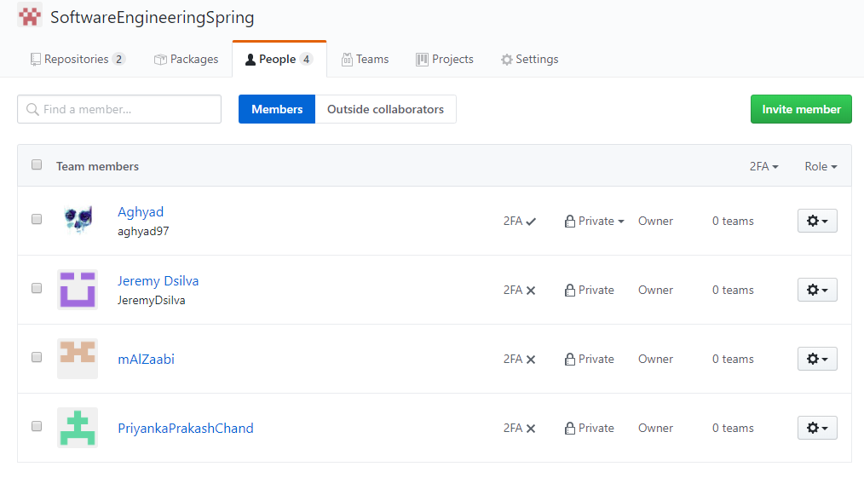

**Creating a Repository**

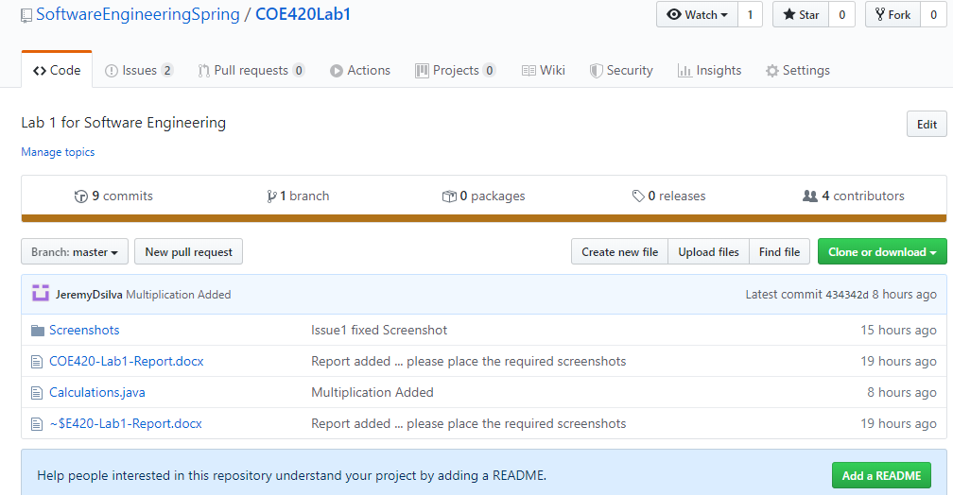

**Commits of changes (from each team member)**

**Exercise 1 Member A:**

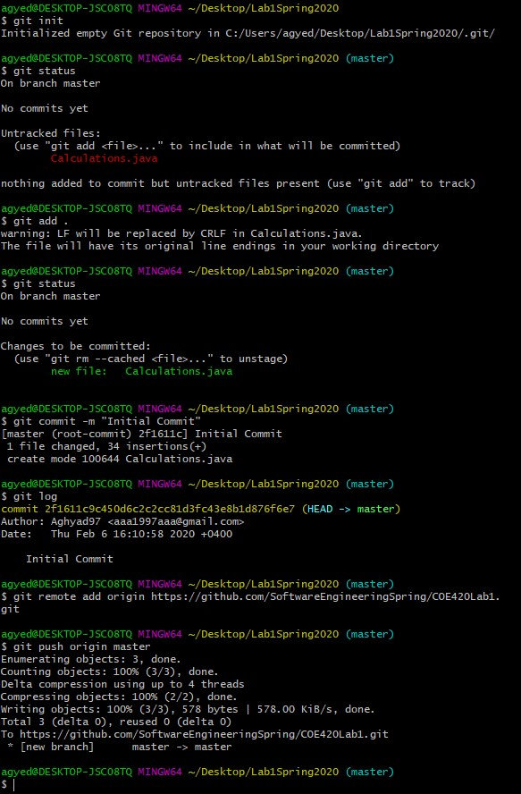

**Member B:**

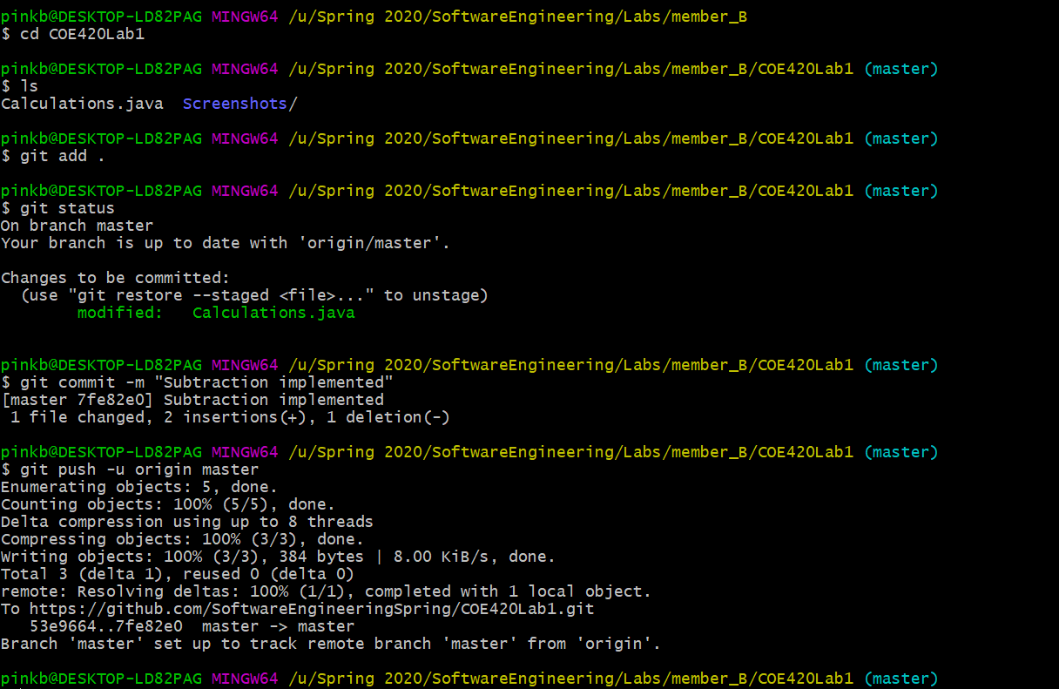

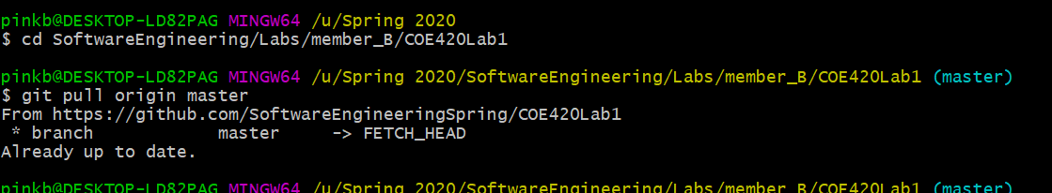

**Member C:**

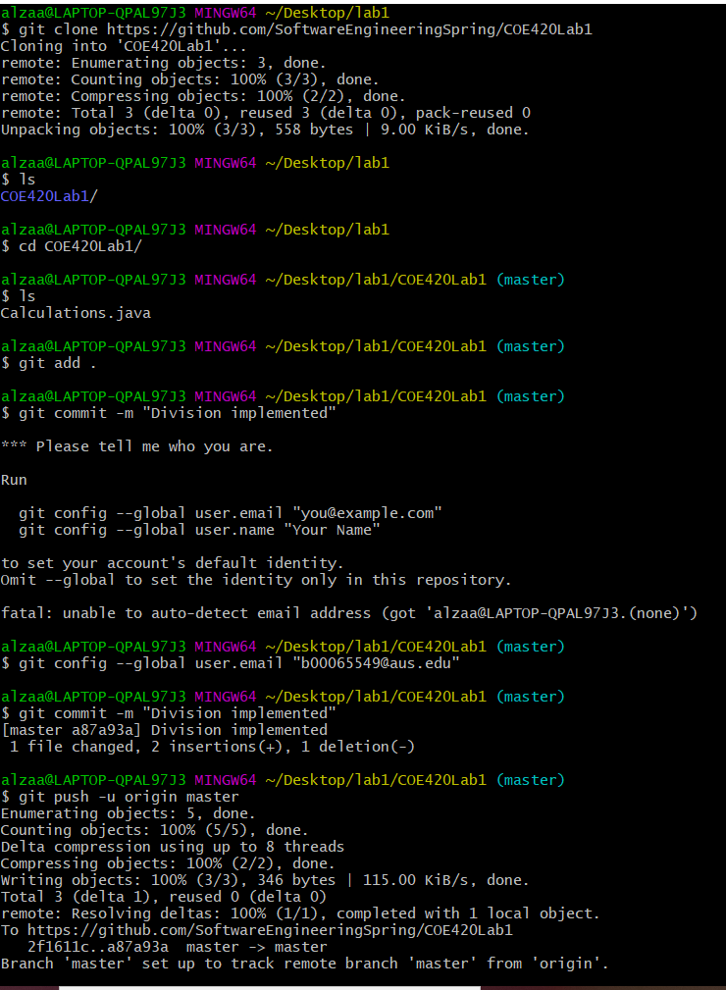

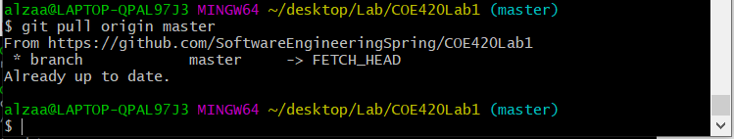

**Member D:**

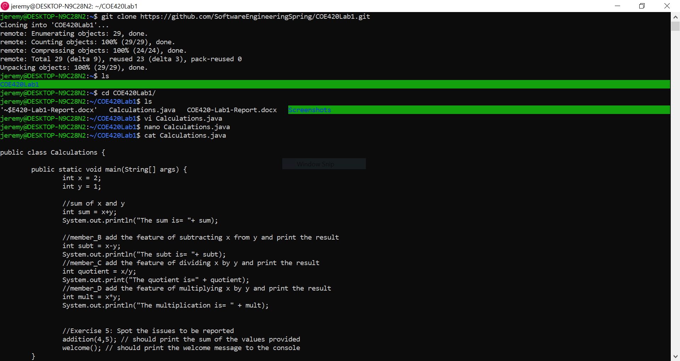

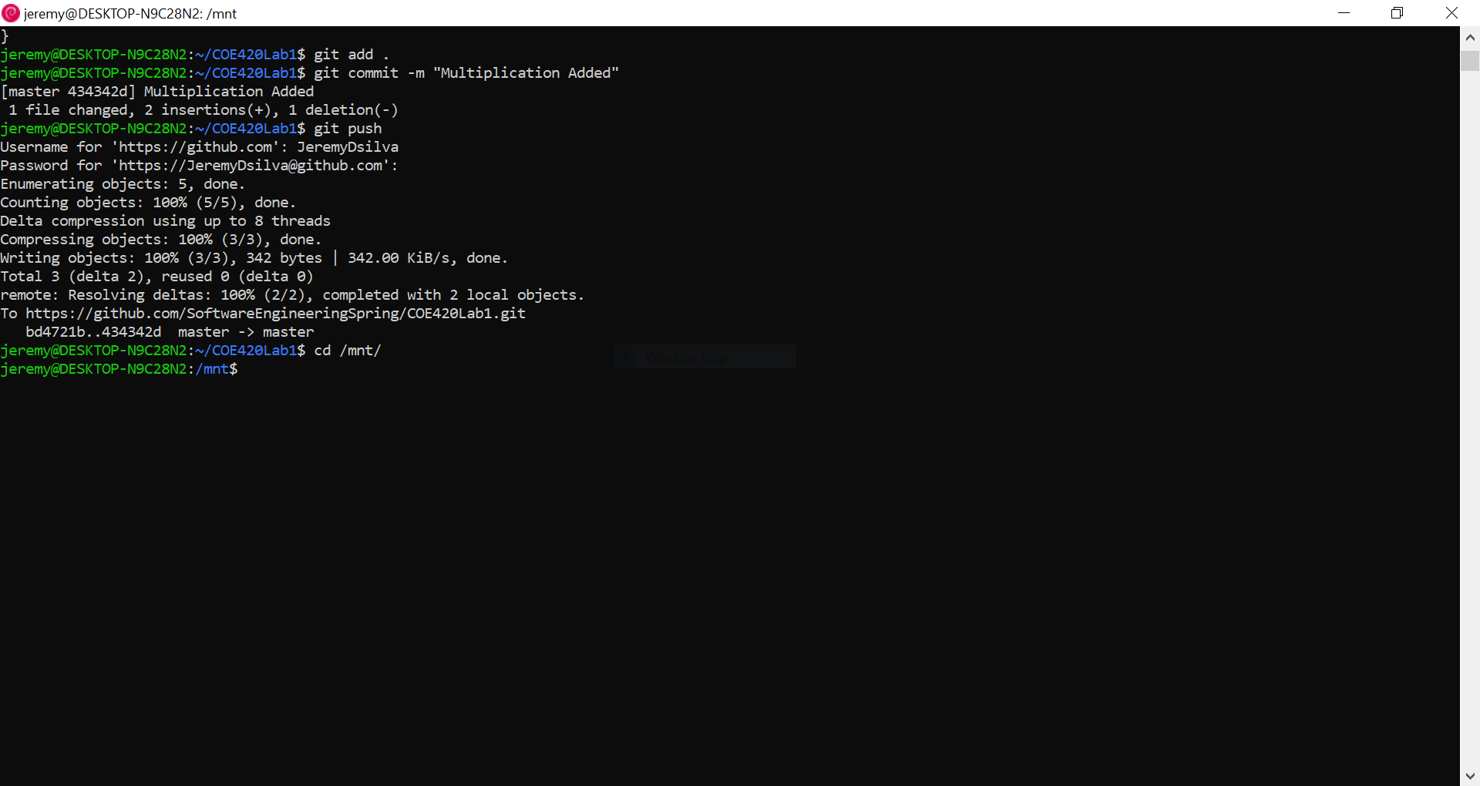

**Exercise 5: Reporting issues on GitHub**

