

School of Computing, Science and Engineering

Software Evolution

CRN: 50256

Maintaining and Evolving a Software System

Assignment type: Group Project

Group 1

Members: Omotola Shogunle
Ibrahim Masembe
Norbert Nazarej

DATE OF SUBMISSION: 11TH OF MAY 2018

INTRODUCTION
A financial broker firm uses a menu driven Security Broker System to manage clients and trade securities with current market values. The system was not developed by members of the team and our task to carry out software evolution practices on the current system. These practices involved:
1. Documentation of the entire system, the original system had little or no documentation associated with it
2. Improve the system output so it is more readable to the users of the system.
3. Implement a more realistic trading executions, users are not allowed to buy securities at a price lower than current market value or sell securities at a price higher than current market value.
4. Finally implement a security class, that encapsulates the data related to each security symbol. This class would also help when improving the system’s output to users
Members commenced by understanding how the original implementation of the system works, followed by documenting using comments based on our understanding and UML diagrams for a visual representation of the system. Furthermore, task were spilt between team members and deadlines in order to reach deadline for project To manage the process we used tools like Trello for communication, Git-hub to manage versions of the system and collaborative inputs and Eclipse to work on the project. This report will detail the process of the requirements implementation, from the project time line, the documentation of the system using PEP 8 style guide for python, the diagrams of classes that show relationships and the overall architecture of the system, a detailed explanation of the user guide to the system, evidence of requirement implementation, and to conclude the group’s reflection on experience evolving the Security Broker System.

PROJECT PLAN
The first sprint for the project was focused on the team understanding the system and its implementation, this was carried out within the firsts 2 weeks followed by the documentation of the classes. The next task was to draw the UML diagrams for the system, this was carried out simultaneously as implementing a realistic order execution. The time line was from the 12th – 31st of March.
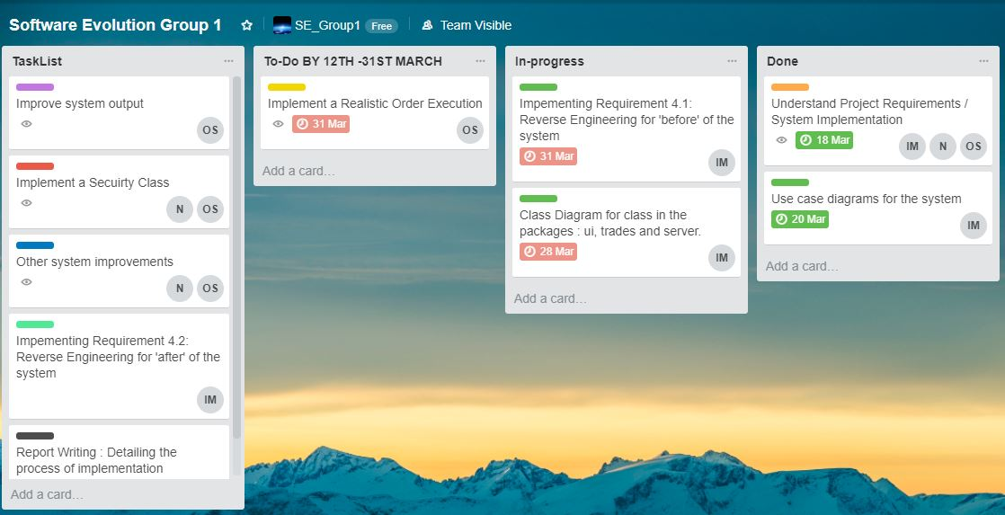

The second sprint members were tasked with implementing the security class and improve the system output to the sole and when the file is saved. Time line 1st – 16th of April 2018. Refer to Appendix A for Trello board image
The third sprint members role was to come up with ideas to improve the system, other functions that may be required. Also, task was given to member to make the ‘after’ UML diagrams and use cases and the overall system architecture diagram. Time line 17th – 27th of April 2018. Refer to Appendix B for Trello board image
Final sprint given that all requirements have been met, members begin to write report for project. Time line 30th of April – 8th of May. Refer to Appendix C for Trello board image

Appendix

Appendix A:

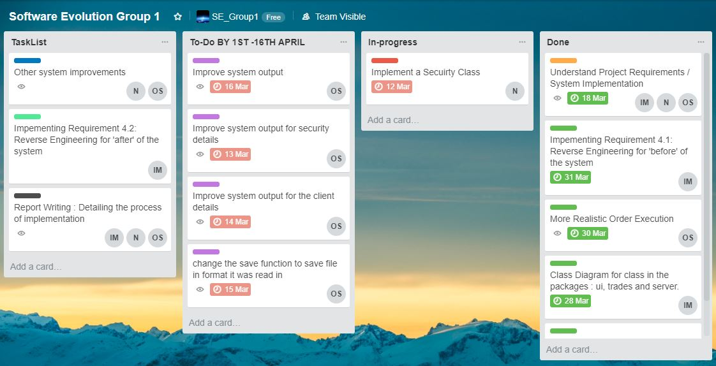

Appendix B:

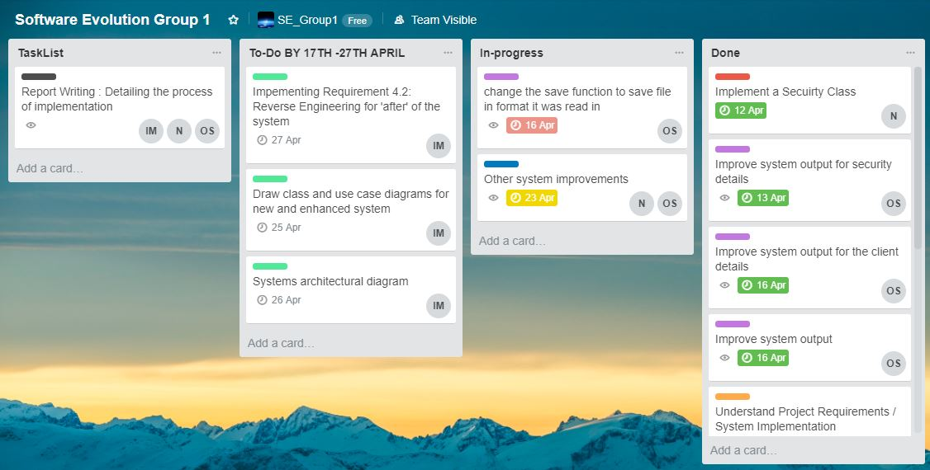

Appendix C:

