Software Requirements Specification

for

Android Weather Application

Version 1.0

Prepared by:

Alex Wagstaff

Elizabeth Lavallée

Hannah Burzynski

Kyle Ratliff

CS 3398 Group 1

Table of Contents

I. Preface 3

1. Introduction 3

2. Purpose 3

3. Document Conventions 3

4. Intended audience 3

5. Proposed Document Scope 3

6. Definitions 3

II. Overall Description 4

1. Document Perspective 4

2. Document Functions 4

3. User Characteristics 4

4. End-User Operating Environment 4

5. Design and Implementation Constraints 4

III. Functional Requirements 5

Summary 5

1. GPS Position 5

1.1. Use Case 1: 5

1.2. Use Case 2: 6

2. Manual Selection 6

2.1. Use Case 3: 6

3. Data Return Errors 7

3.1 Use Case 4: 7

3.2. Use Case 5: 7

IV. Non Functional Requirements 8

1. Reliability: 8

2. Robustness: 8

3. Maintainability 8

4. Security 8

# Preface

## 1. Introduction

This section introduces the client to the requirement document. All members have agreed on all aspects of this document.

## 2. Purpose

A weather application that delivers real-time information about the weather to the user near the user’s location or a location at the user’s request.

## 3. Document Conventions

This document uses the dotted-numbered outline format to organize information. There are different sections within this document to describe the intended functionality and scope of the weather application.

## 4. Intended audience

This requirements document is intended for end-users and programmers of this software system.

## 5. Proposed Document Scope

This requirements document provides information about the weather application.

The system has the following functions:

1. Authenticating user’s position using GPS technology and other Android API.

2. Display real-time weather for the user’s position.

3. Allow user to request real-time weather information from other locations.

4. Display real-time weather near the position at the user’s request.

## 6. Definitions

|  |  |
| --- | --- |
| Term | Definition |
| Application | The software system in question to be developed. |
| API | Application programming interface. In this instance, refers to the interfaces used by the application to make calls to external libraries. |
| GPS | Global Positioning System. The application will use this aspect of the android device to determine the user’s location for weather data retrieval. |
| User | The user of the application. |
| Android Device | A mobile device running the Android operating system. The application will be built with this operating system in mind. |
| OpenWeather  Map API | A specific API to be used to gather weather information. Information retrieved consists of the type of current weather (rain, sunny, snowing, etc.) as well as current temperature, high and low temperatures, and current level of humidity. |

# Overall Description

## 1. Document Perspective

The software specification document describes the functional and nonfunctional requirements of an account creation and management system for an Android weather application. For functional requirements, the document first describes a basic path taken by a user, and then describes the requirements the software shall fulfill in order to follow the said basic path. The document also describes some nonfunctional yet essential qualities the software shall possess.

## 2. Document Functions

This document provides the client with a basic guide on how the user will operate the software. The developers are provided with a rudimentary blueprint for the software.

## 3. User Characteristics

The system is designed with average web users in mind. So, the user is expected to have basic knowledge on how to operate a computer/laptop/phone/tablet, as well as have basic familiarity with how to install and use an Android operation.

## 4. End-User Operating Environment

The service can be used by anyone with an android device and internet connectivity. Users can download the application and begin using the service to receive weather data based on location.

## 5. Design and Implementation Constraints

The user must have an android device with an active internet connection to use the software.

# Functional Requirements

## Summary

This application will display the weather information for a location that the user specifies. The application will use the following tools:

* Android Studio as the integrated development environment
* Git for version control
* GitHub to store the repository of code
* JUnit for unit testing
* SimpleUML to convert from code to a UML class diagram
* Javadoc for code documentation
* OKHTTP for building and sending the HTTP request
* OpenWeatherMap API for getting weather data from the OpenWeatherMap service

## 1. GPS Position

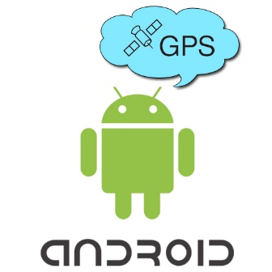Authenticating the user’s position is the first step in delivering real-time weather updates. Following are some cases the user may encounter while trying to receive weather information.

### 1.1. Use Case 1:

Name : GPS Signal OK

Priority : Essential

Trigger : User interaction with mobile device

Precondition : User has valid Internet Connection and GPS position

Basic Path : Default path on startup

1. User starts the Android application on mobile device.

2. The Android application calls for GPS position.

3. The Android application successfully receives the GPS position.

4. The Android application uses the position to fetch real-time weather information using OpenWeatherMap API.

5. The display shows real-time weather updates.

Requirements:

This use case is the default state for the application on startup.

### 1.2. Use Case 2:

Name : No GPS Signal

Priority : Essential

Trigger : User interaction with mobile device

Precondition : User has valid Internet Connection but no GPS

Basic Path :

1. User starts the Android application on mobile device.

2. The Android application calls for GPS position.

3. The Android application does not receive the GPS condition within the WaitForGPS window.

4. The display shows “GPS not available”, “Retry” and “Select city”.

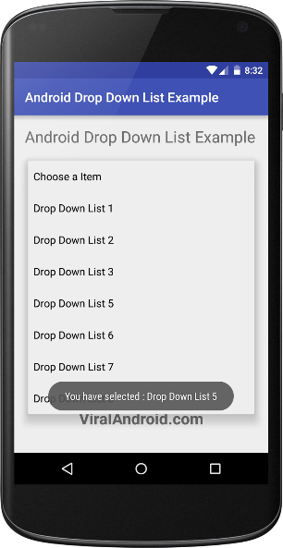Requirements:

## 2. Manual Selection

The application will allow the user to select a city from a ComboBox list.

### 2.1. Use Case 3:

Name : User selects a city

Priority : Essential

Trigger : User interaction with mobile device

Precondition : User has valid Internet Connection

Basic Path :

1. While in the Android application the user selects <ADD CITY>.

2. The Android application uses the CITY to fetch real-time weather information using OpenWeatherMap API.

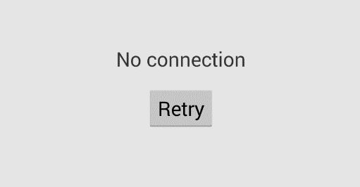3. The display shows real-time weather updates.

Requirements:

## 3. Data Return Errors

The ap will return an error with information in the event it does not receive data for the GPS or selected location within the expected time frame.

### 3.1 Use Case 4:

Name : No Usable Internet Available – GPS or Selected Location

Priority : Essential

Trigger : User interaction with mobile device

Precondition : Internet connection is either insufficient or non-existent

Basic Path :

1. The Android application attempts to fetch real-time weather information using OpenWeatherMap API but does not receive a reply within the WaitForWeather window.

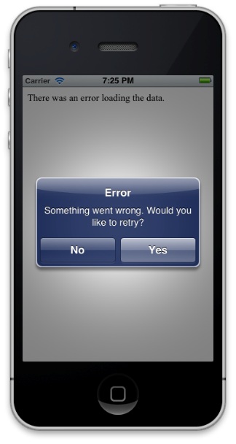2. The display shows “No connection” and “Retry”

Requirements:

### 3.2. Use Case 5:

Name : No Data Available for Selected Location or GPS

Priority : Essential

Trigger : User interaction with mobile device

Precondition : API fails to return the expected data

Basic Path :

1. The Android application attempts to fetch real-time weather information using OpenWeatherMap API but does not receive an unexpected reply or no usable data within the reply

2. The display shows “Error” with the option to retry.

Requirements:

# 

# IV. Non Functional Requirements

The application will have background images to match the current weather status.

## 1. Reliability:

The application shall return the current weather information for the location requested using the OpenWeatherMap API.

## 2. Robustness:

The application shall display errors in the event of no internet connection, no GPS signal available, or if the weather information is unavailable for the location requested.

## 3. Maintainability

The application shall be periodically tested to ensure maintained connectivity to the API, and be updated any time the API structure or link is updated.

## 4. Security

The application shall not store nor share GPS or any other information from the mobile device to other sources.