CS4398 Group 1

Acceptance Test Cases

**Test 1: Display the user’s location for the default location.**

1. Run the application.
2. Confirm that the first location shown is the user’s location (within a reasonable range).

**Test 2: Display the current weather data for the user’s location.**

1. Run the application.
2. Confirm that the current weather data is displayed for the default location.

**Test 3: Display the current weather data for a location selected from the dropdown menu.**

1. Run the application.
2. Select a city from the dropdown menu.
3. Confirm that the current weather data is displayed for that chosen location.

Execution of Test Cases

**Test 1: Display the user’s location for the default location.**

1. Application was started.
2. Northern Round Rock was the user’s location, but Georgetown is within a reasonable range from their location. Georgetown showed as the user’s location, so the test is successful.

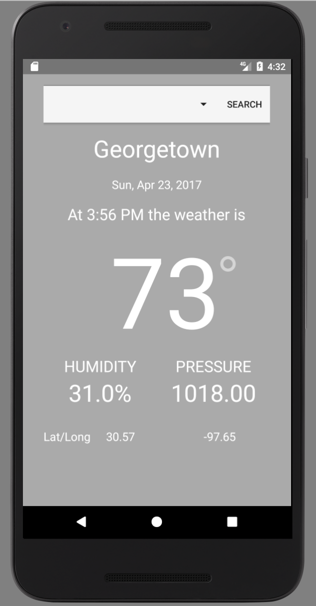

**Test 2: Display the current weather data for the user’s location.**

1. Application was started.
2. The current weather data for Georgetown was displayed. The test was successful.



**Test 3: Display the current weather data for a location selected from the dropdown menu.**

1. Application was started.
2. Austin, US was selected from the dropdown menu.
3. The current weather data for Austin TX (US) was displayed. The test was successful.

