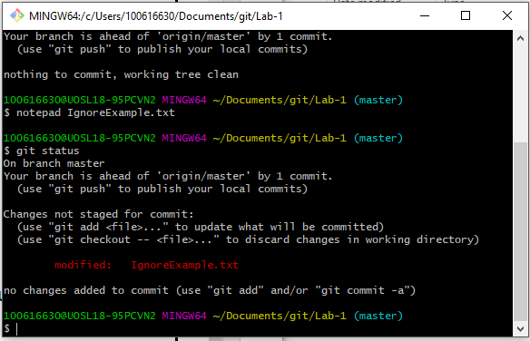

Editing IgnoreExample and checking status

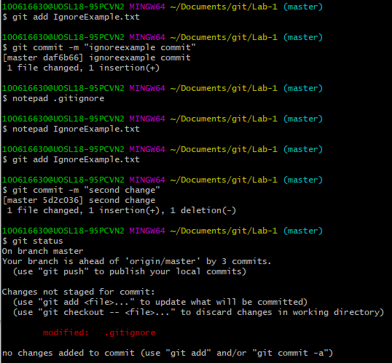

Add IgnoreExample to .gitignore and then edit IgnoreExample and commit and then check status

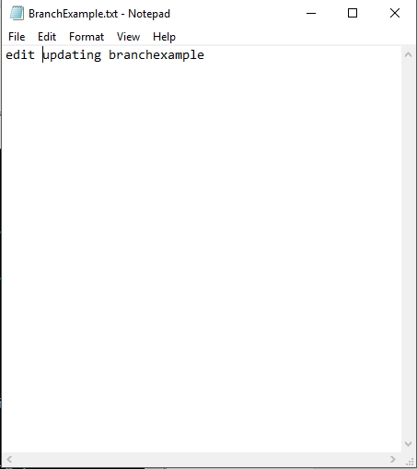

BranchExample file in Secondbranch



BranchExample file in master

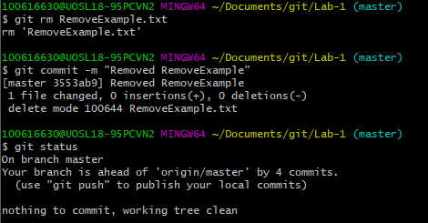

Used rm to delete the RemoveExample which automatically deleted the file and cleaned