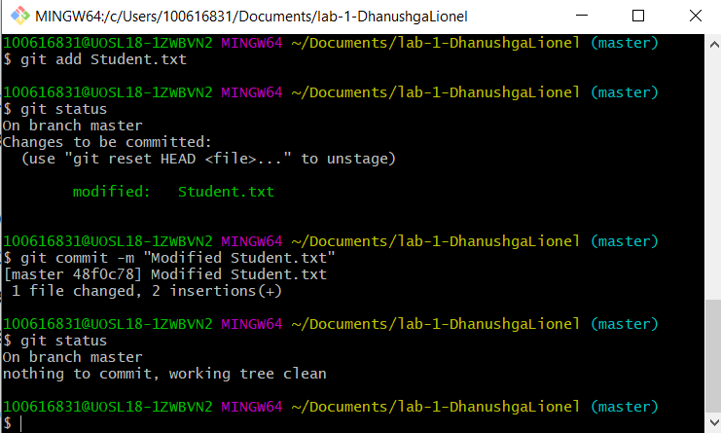

Modified Student.txt and committed

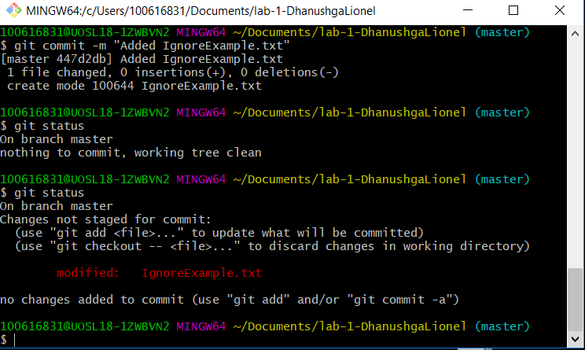

Modified IgnoreExample.txt

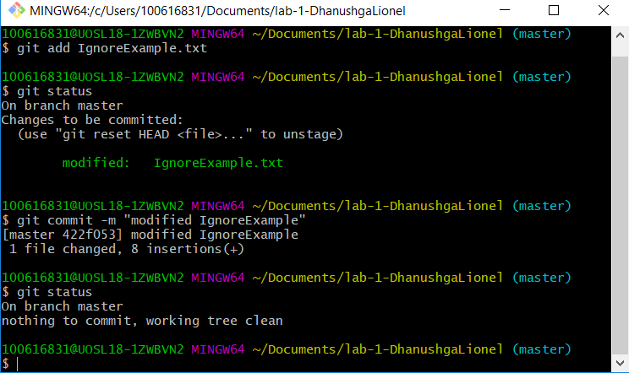

Committed Changes to IgnoreExample.txt

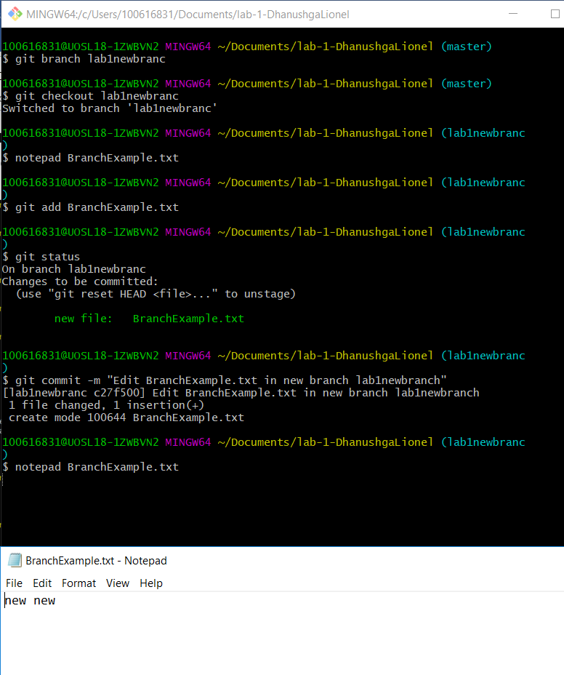

Made new branch lab1newbranc and then committed BranchExample.txt using notepad command

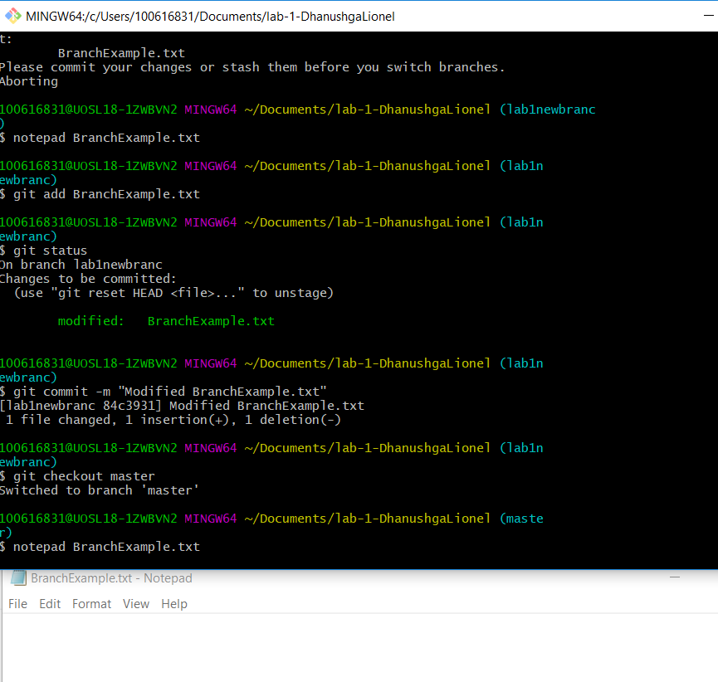

Switch back to master and screen shot of file

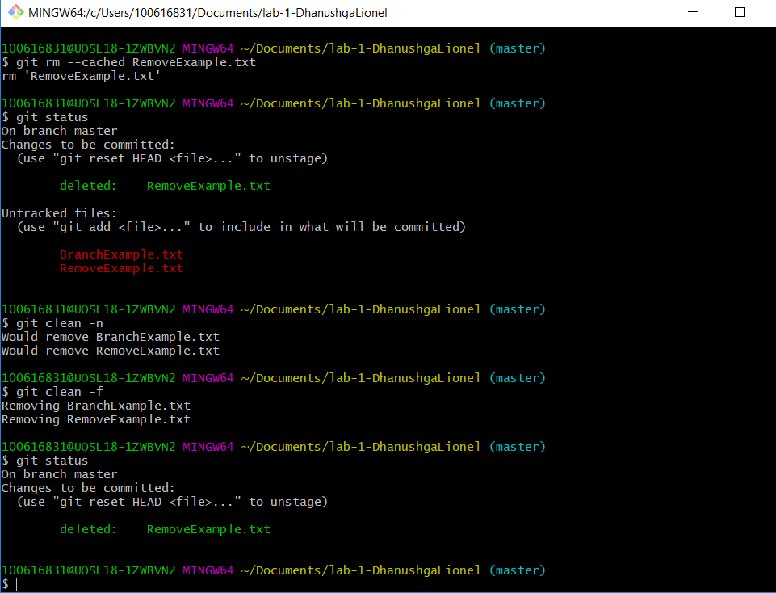

Deleted RemoveExample.txt