SCREENSHOTS:

Ignore Example:

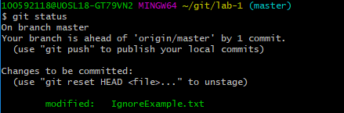

\*\*TOLD TO IGNORE THE .GITIGNORE STEP

Branch Example:

In new branch:

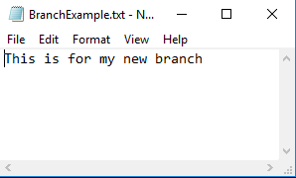

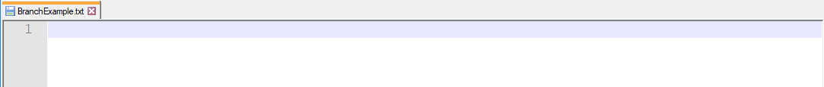

Remove Example:

