Screenshot 1:

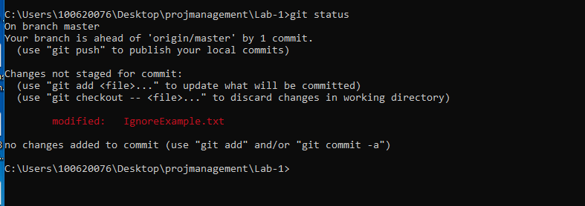

Screenshot 2: After .gitignore changes

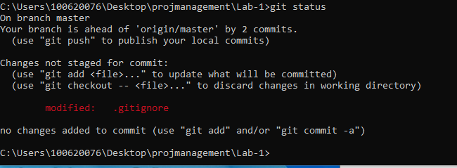

Screenshot 3: After making changes to IgnoreExample.txt

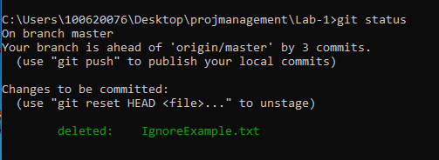

(Note this is because I have modified my installation to untrack items as they are added to .gitignore. In reality, because the file was already tracked, it would show changes!

Screenshot 3: Branch file in new branch

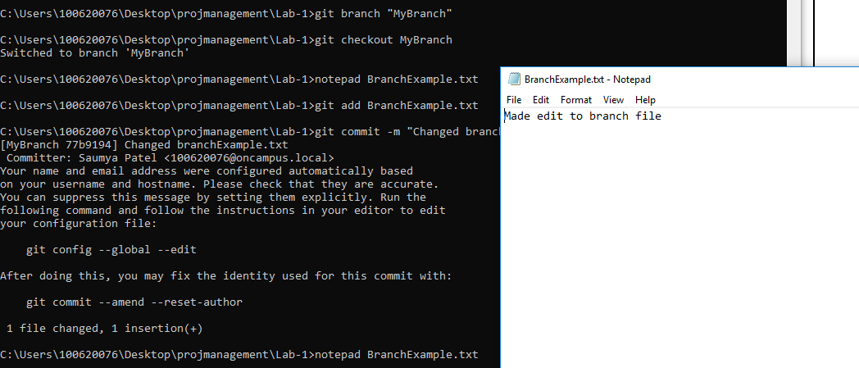

Screenshot 4: Branch file in Master:  
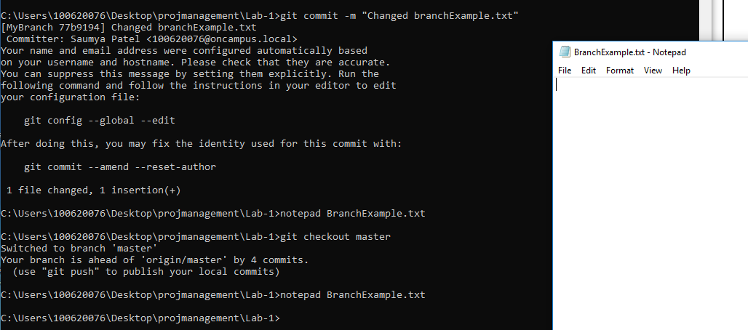

Screenshot 5: Post deletion

