**Screenshots**

* Appending data to “IgnoreExample.txt” File and committing it to repository.

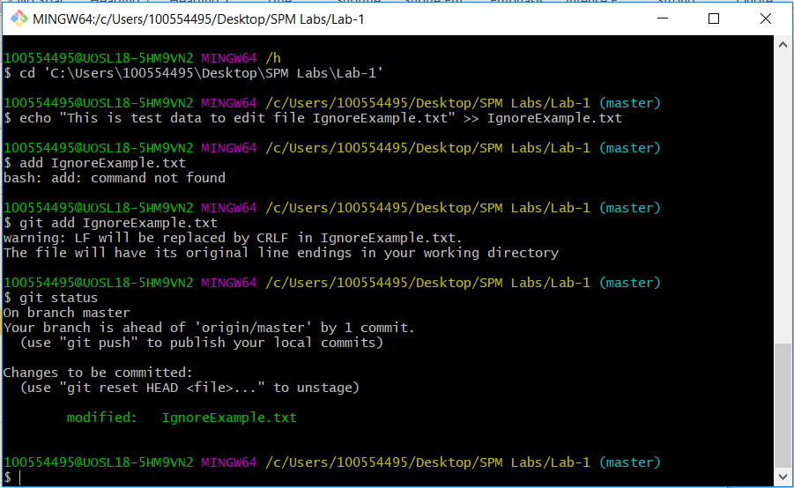

* Git add to add modified “BranchExample.txt” file into repository. Screenshot of status below.

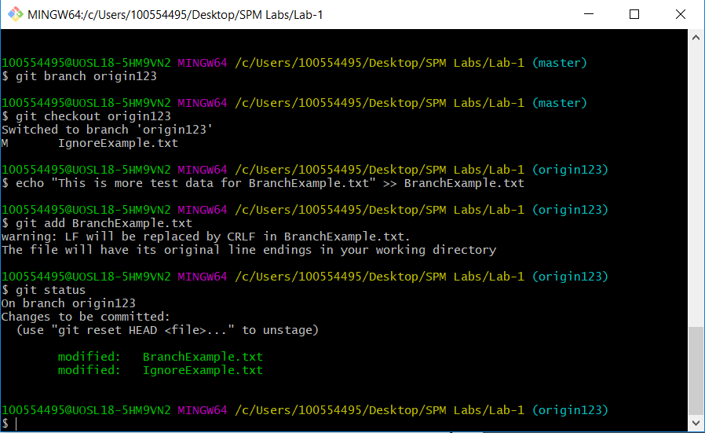

* Master branch screenshot of “BranchExample.txt”. Data is not copied over.

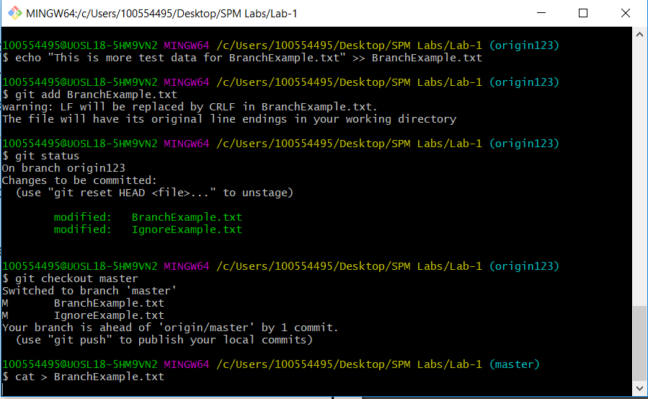

* Removed “RemoveExample.txt” File using rm command.

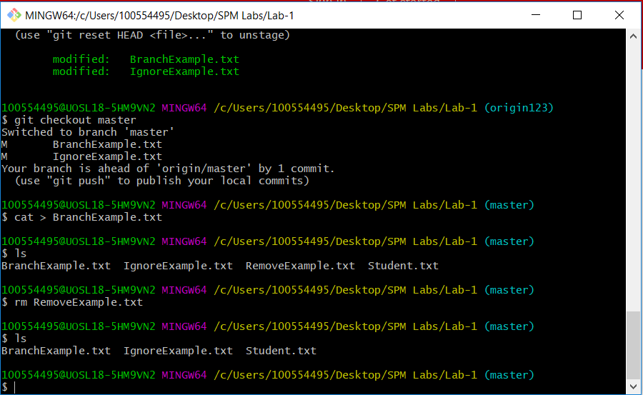

* Committed changes.

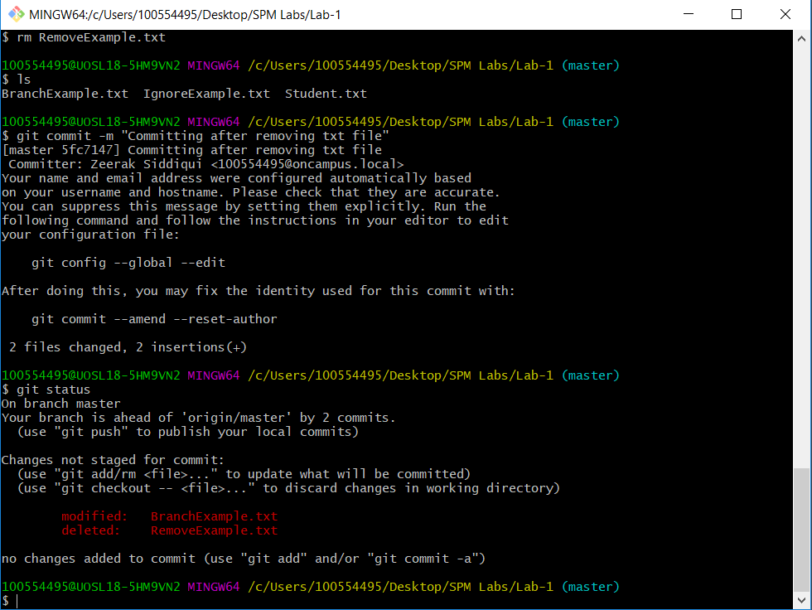

* Used Clean command.

