Lab1 Screenshots

Added student file and used git add.

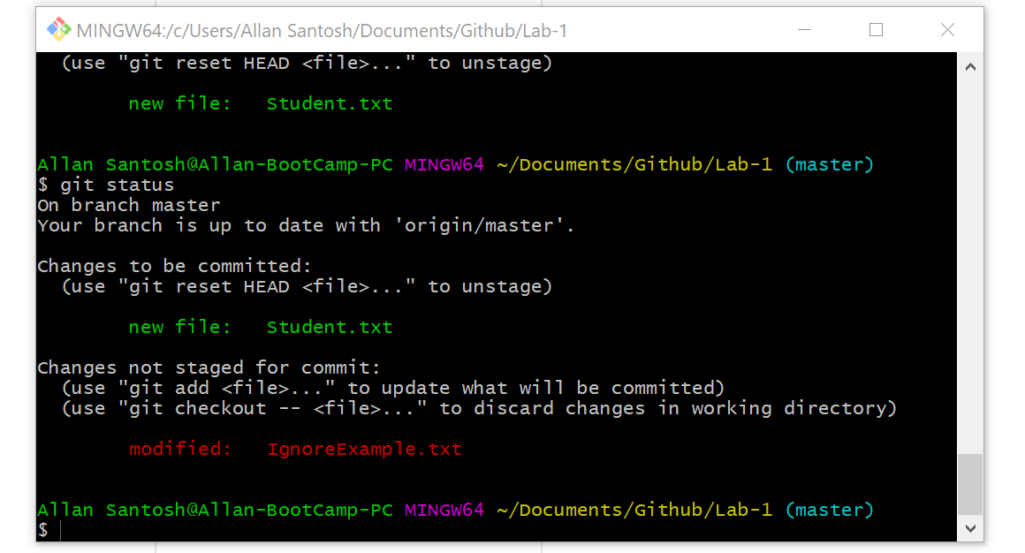

Modified ignore example and used git add

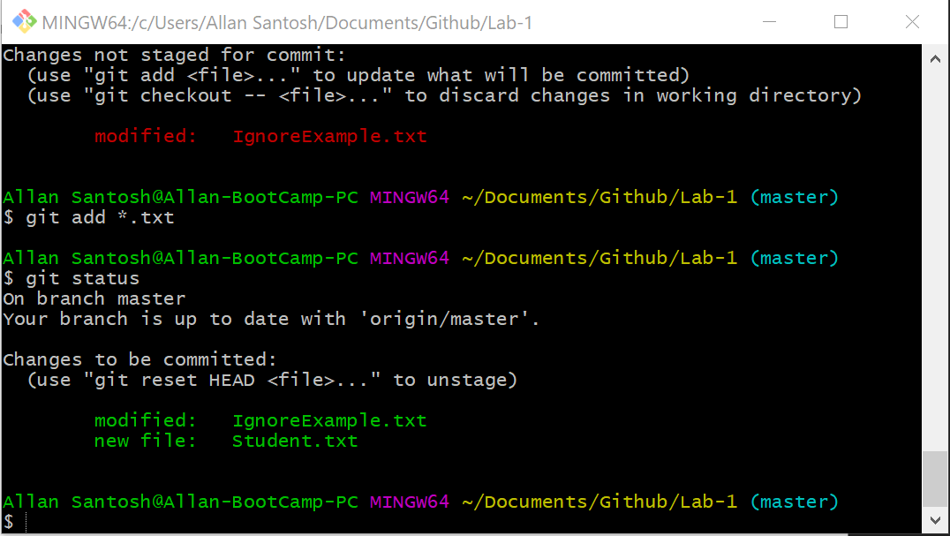

Editing ignore example one more time

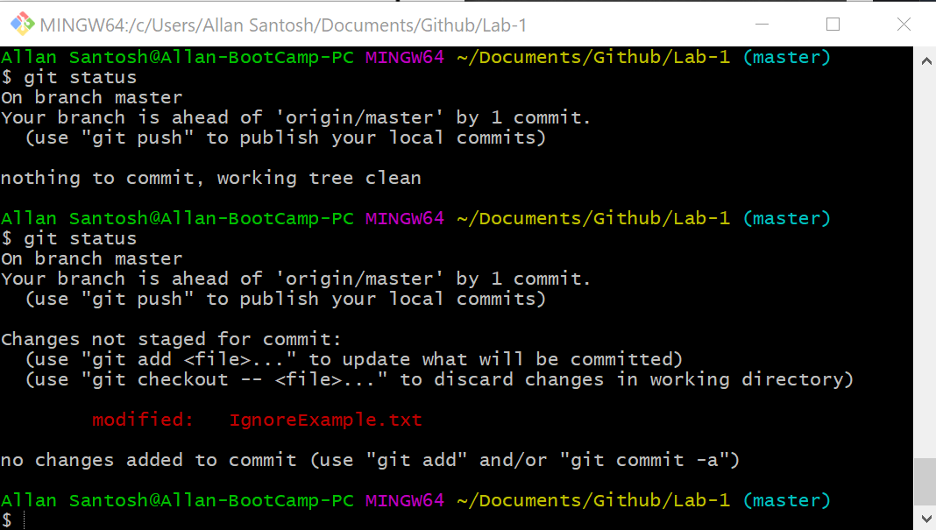

Edited the branchexample then added it and then committed it in the new branch I created

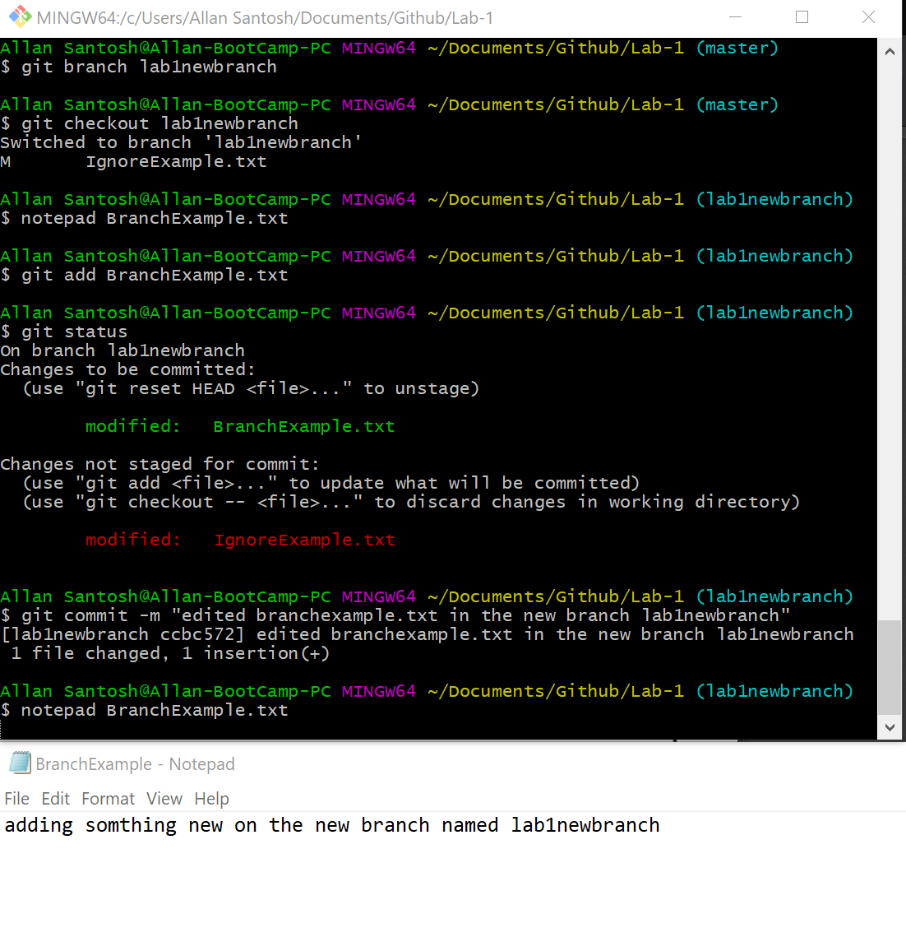

Changed back to the master branch and then used notepad command

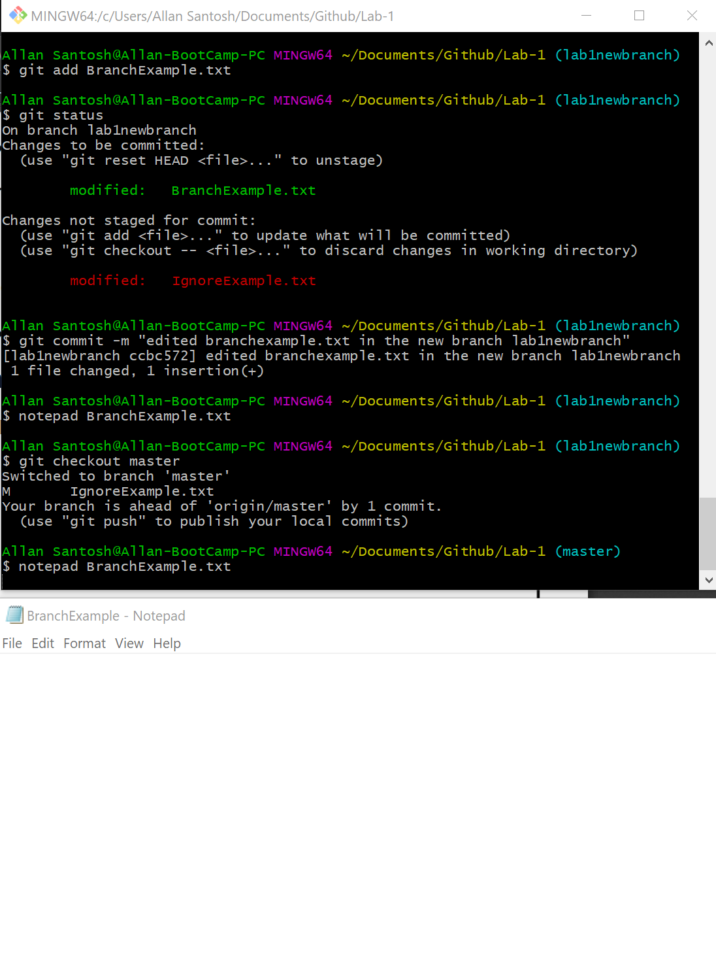

After using git rm –cached and git clean, this is the result

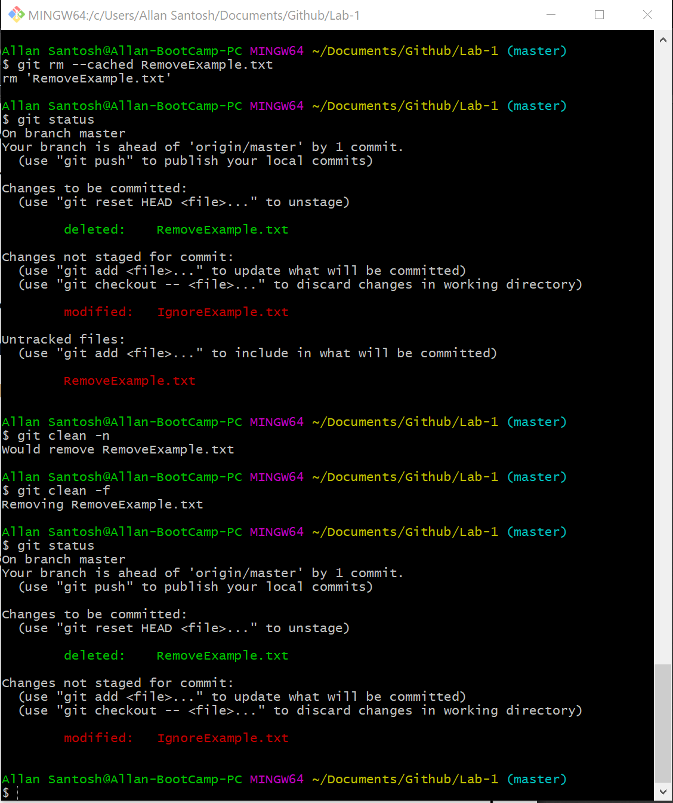

After committing

