Edit contents of IgnoreExample.txt

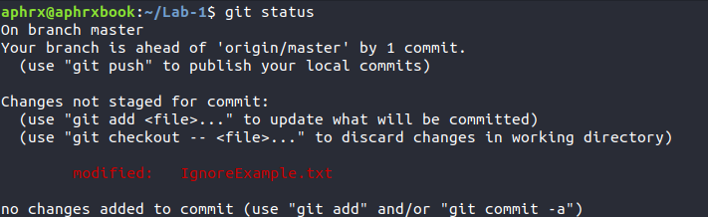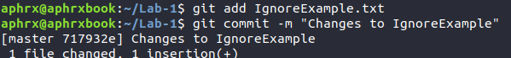

Could not get gitignore to work...

Screenshot of BranchExample.txt in test branch

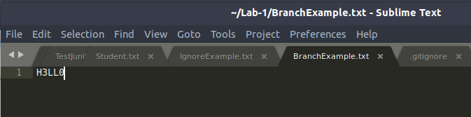

Screenshot of BranchExample in master branch

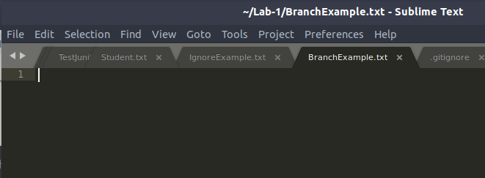

Removing RemoveExample.txt

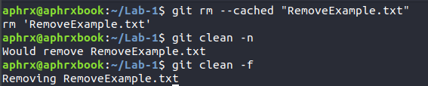

git status after removing file

