

**SOFE 3490U**

**LAB 1 - Introduction To GitHub**

|  |  |
| --- | --- |
| **Name** | **ID** |
| Harsh Patel | 100580778 |

Git Status first screenshot:

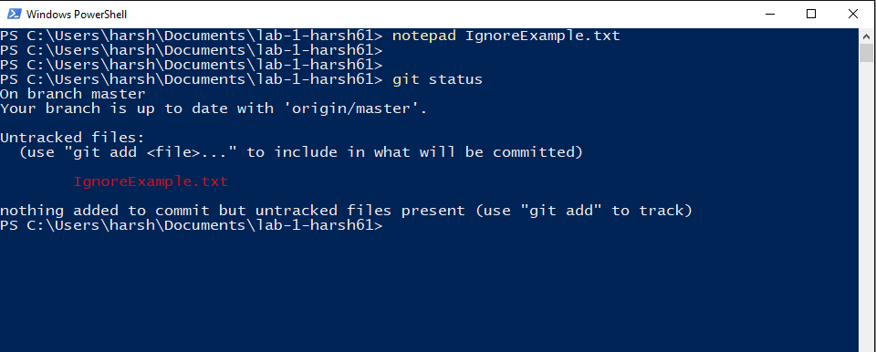

Git Status second screenshot:

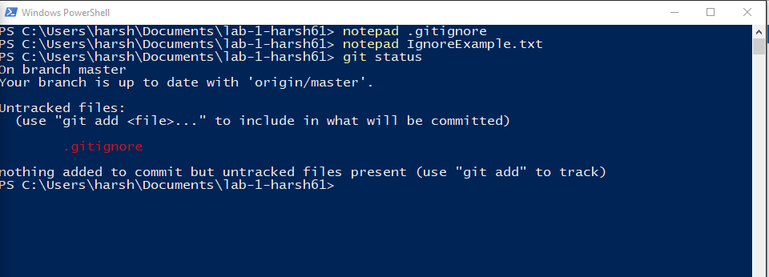

Working in the branch and created a branch text file:

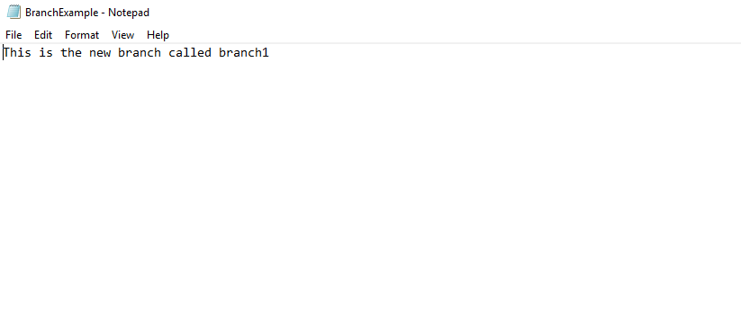

Now working on the master branch for the same text file:

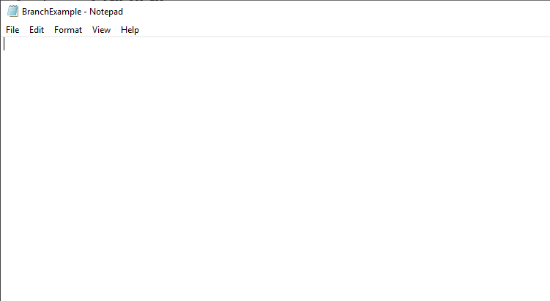

Git status on the master branch:

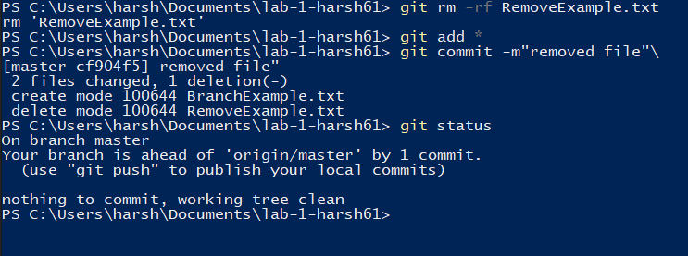

Git status on the master branch removing a file and using clean:

