Joseph Veneziano

100572553

Lab 1 Practical

Clone the repository: https://github.com/TAYOsman/Lab-1.git

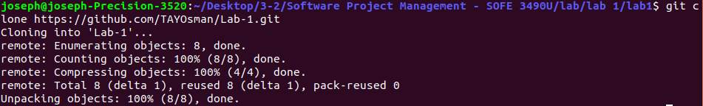

Edit “Student” file to include your own Student Name & Student ID, Commit changes

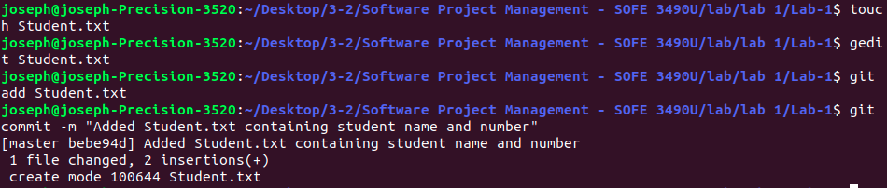

-Edit content of IgnoreExample.txt

-Use git status command and screenshot the output

-Commit changes

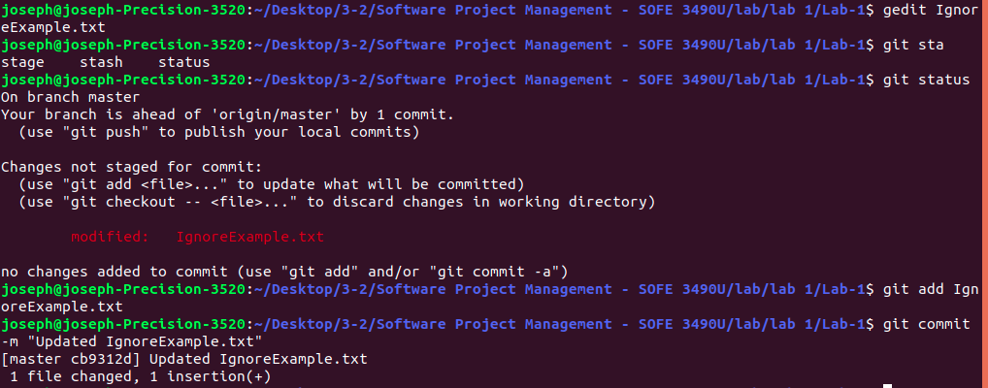

Add IgnoreExample.txt to .gitignore file

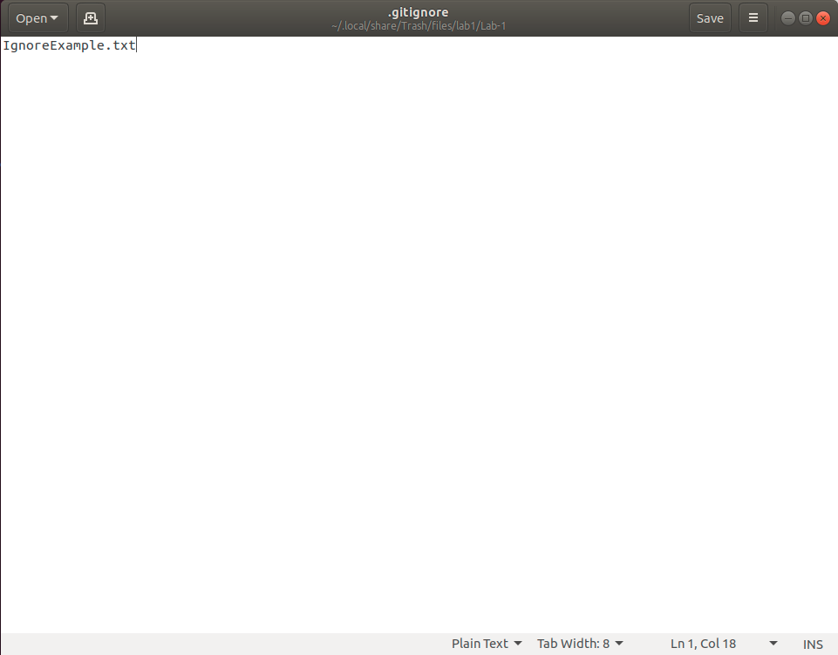

-Edit content of IgnoreExample.txt

-Use git status and screenshot the output

TA said we are able to skip

-Create a new branch using git branch command

-Switch to The new branch

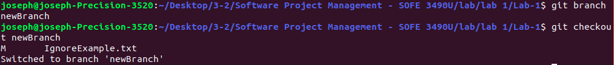

-Edit BranchExample.txt via notepad command notepad Branch Example.txt

-Use git add To Update BranchExample.txt , commit and use notepad

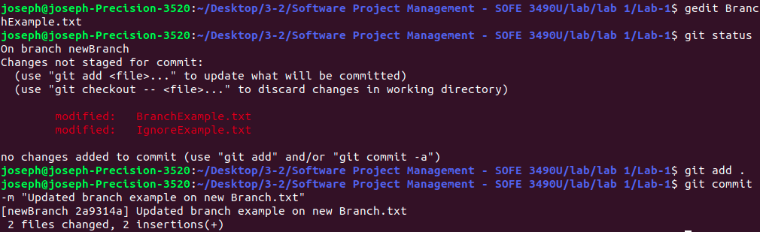

-Screenshot the content of the file

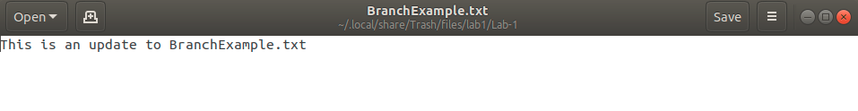

-Switch back to master branch



-Use same notepad command



-Screenshot content of text file

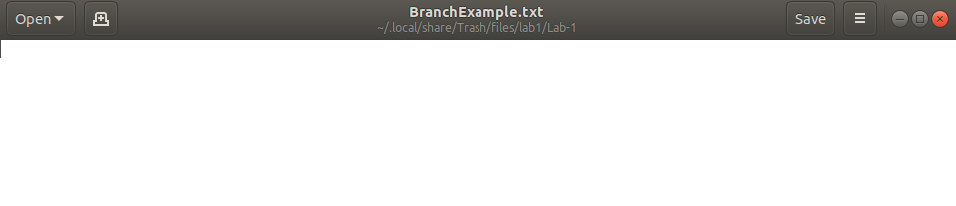

-Delete RemoveExample.txt via remove command

-Commit

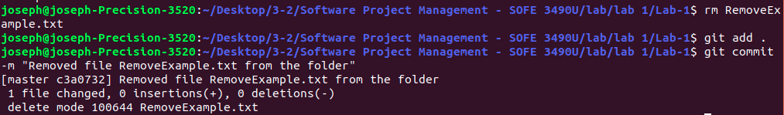

-Use git status and screenshot the output

-Use clean command to remove file completely

-Use git status command and screenshot the ouput

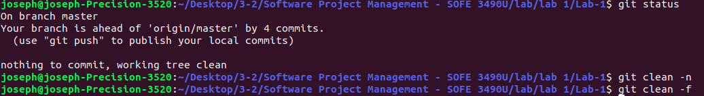

-Use git add to add your word document with the screenshots to the repository, it should look something like this: git add Screenshots.docx

-Commit