Software Project Management Lab 1

Using Git & Github

Name: Joshua Smith
Student ID: 100550790
Date: January 21st 2019

Cloning The Repository
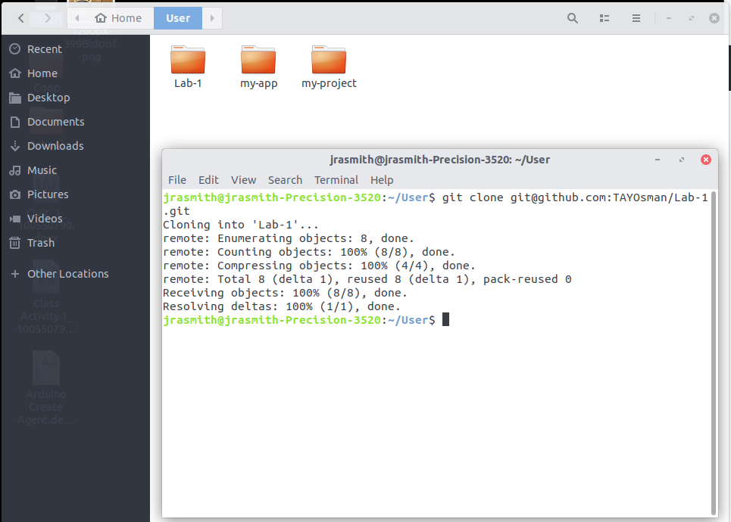
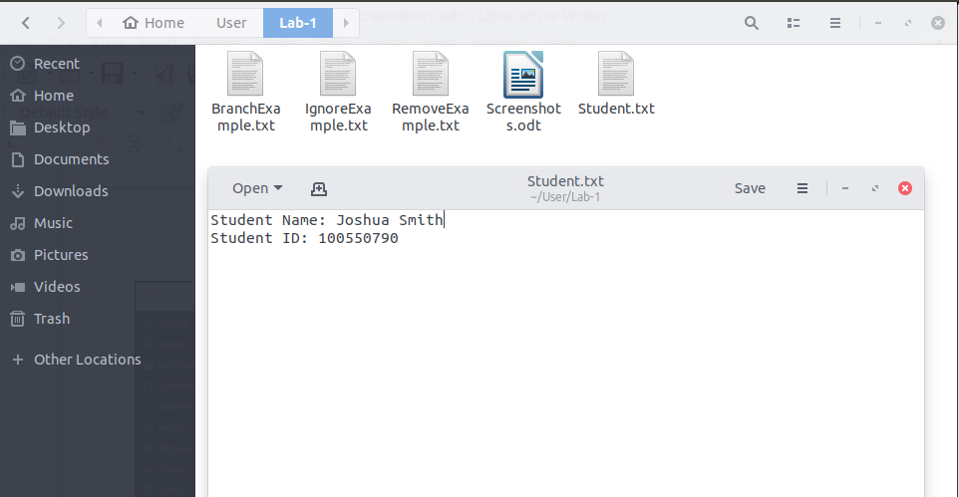
Added Student File

bmission'.
jrasmith@jrasmith-Precision-3520:~/User/Lab-1$ git add ,
fatal: pathspec ',' did not match any files
Commit Changes to Student.txt
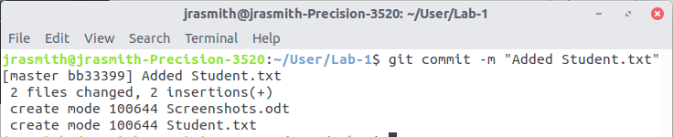
Git Status Command
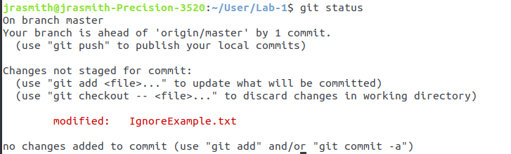
Create a New Branch
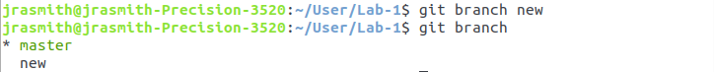
Change to the New Branch
Edit the Branch Example.txt
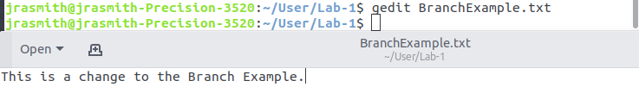

Change the BranchExample.txt
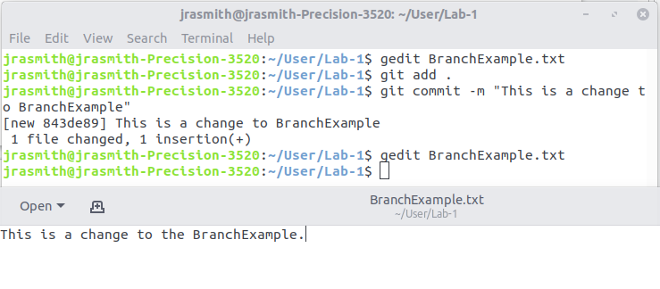
Change Back to Master Branch
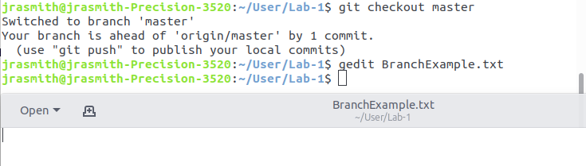
Remove RemoveExample.txt
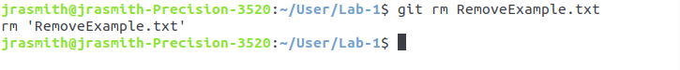
Commit of Removed File
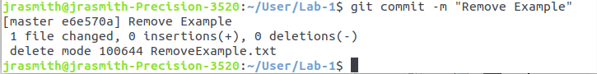

Git Status
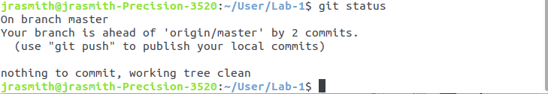
Clean Command to Remove File Completely
** Chose not to used cached removal, thus the file was already gone.

