1. Edit content of IgnoreExample.txt, Use git status command and screenshot the output

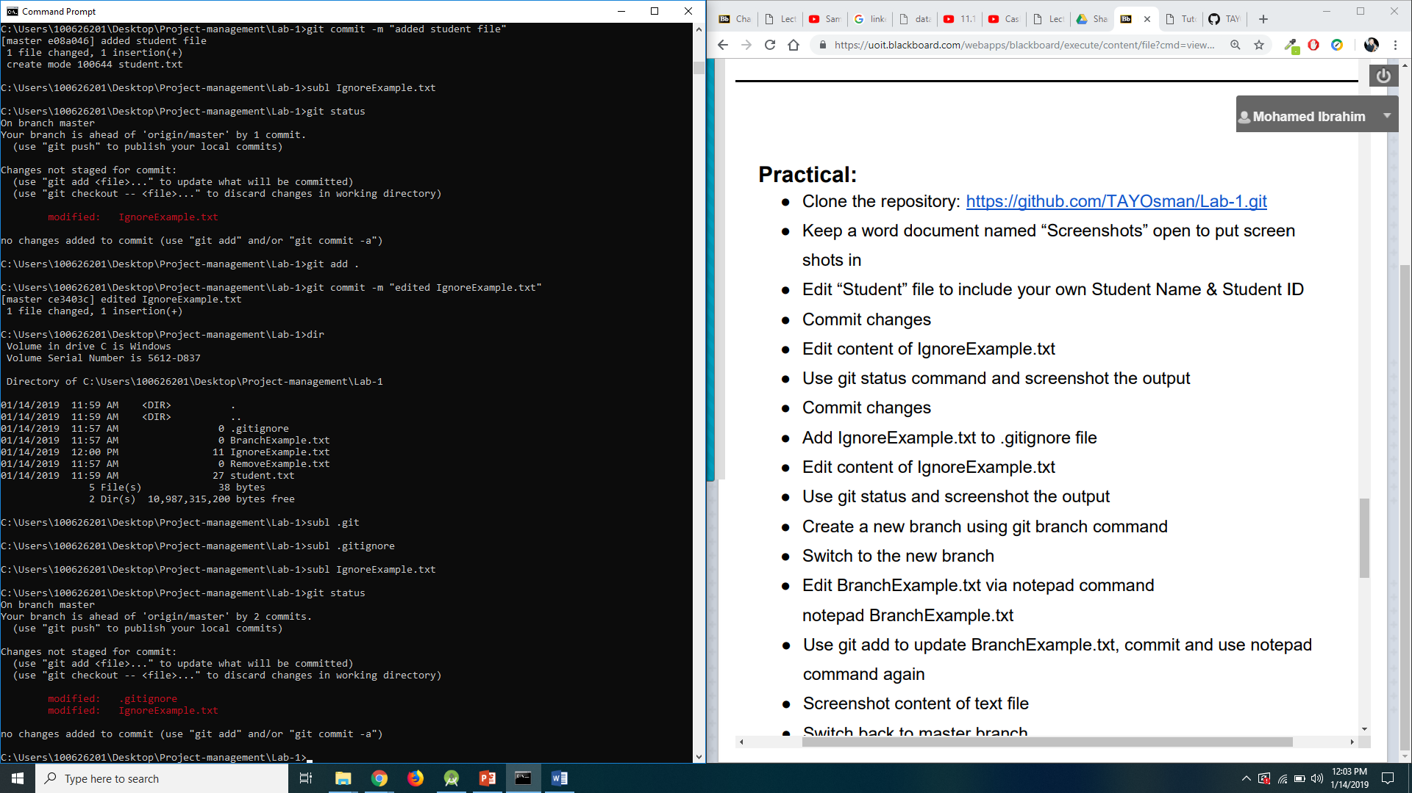

1. Edit content of IgnoreExample.txt, Use git status and screenshot the output

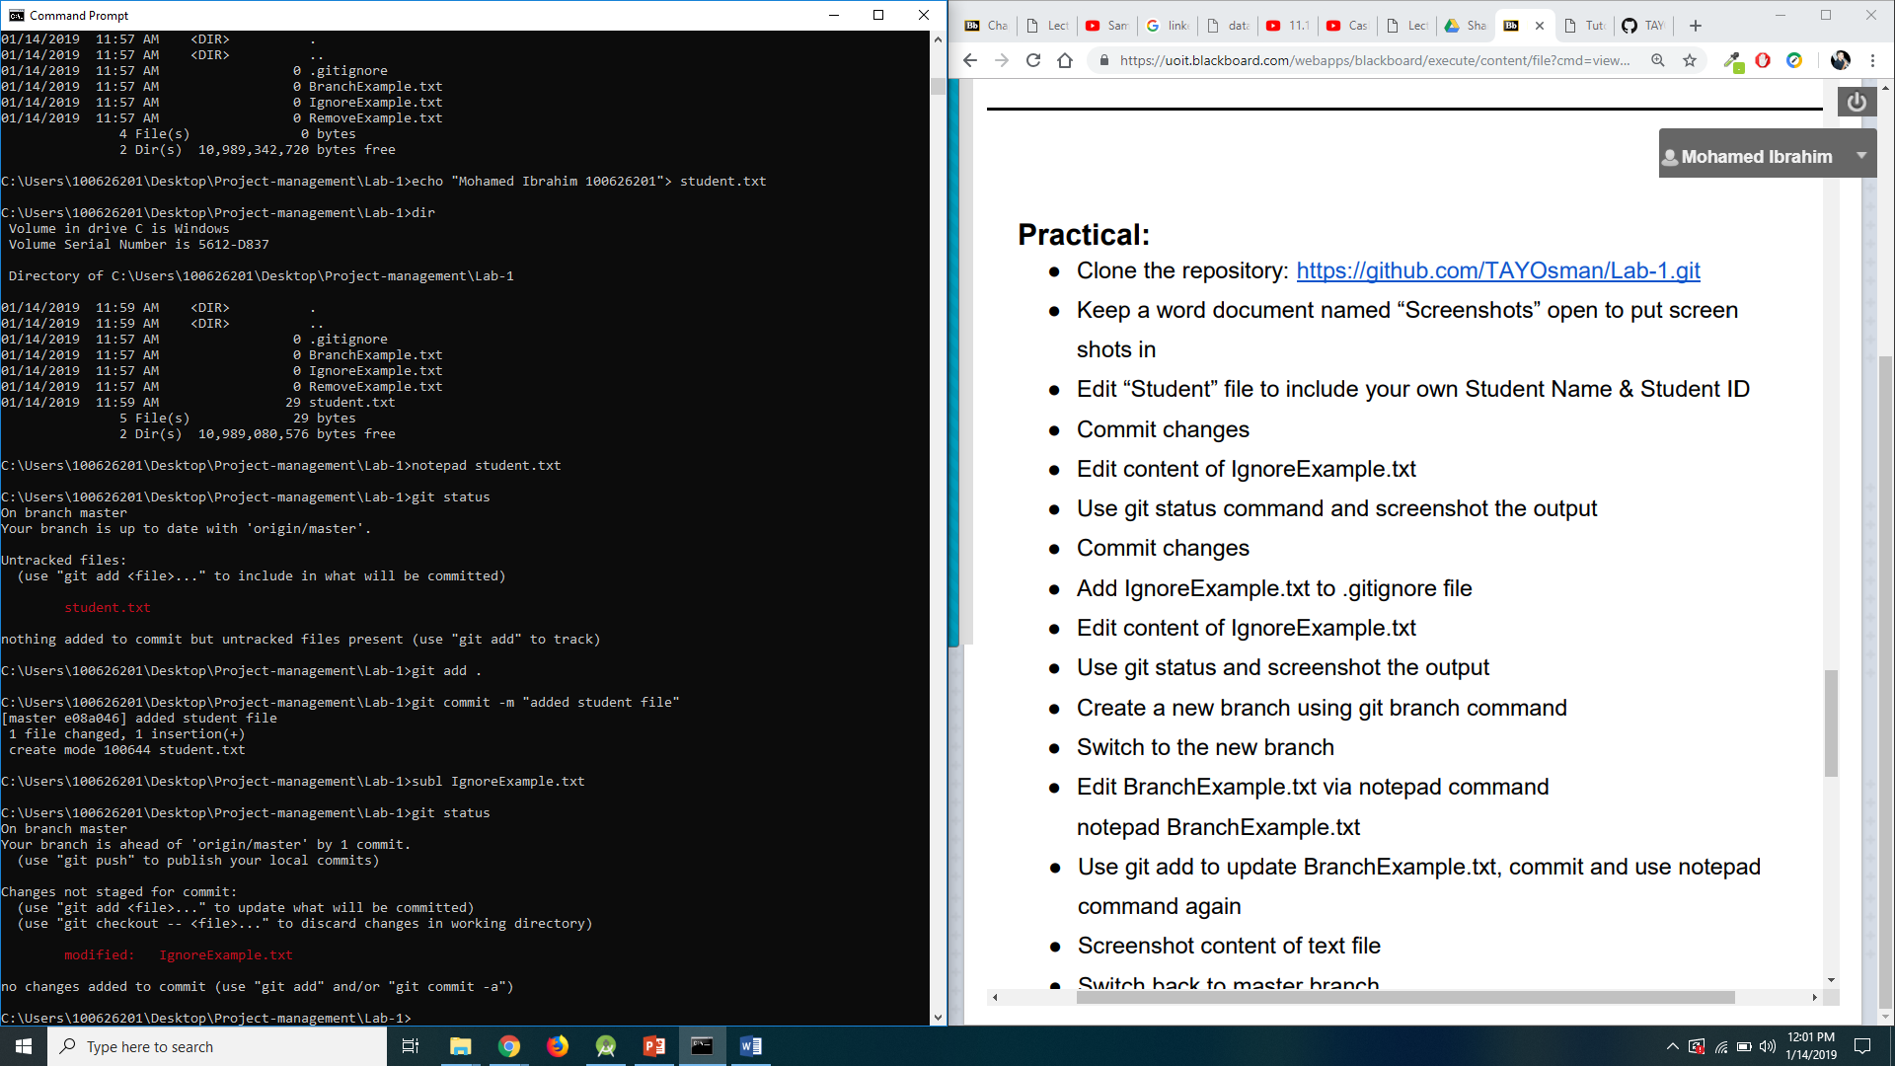

1. Use git add to update BranchExample.txt, commit and use notepad command again. Screenshot content of text file

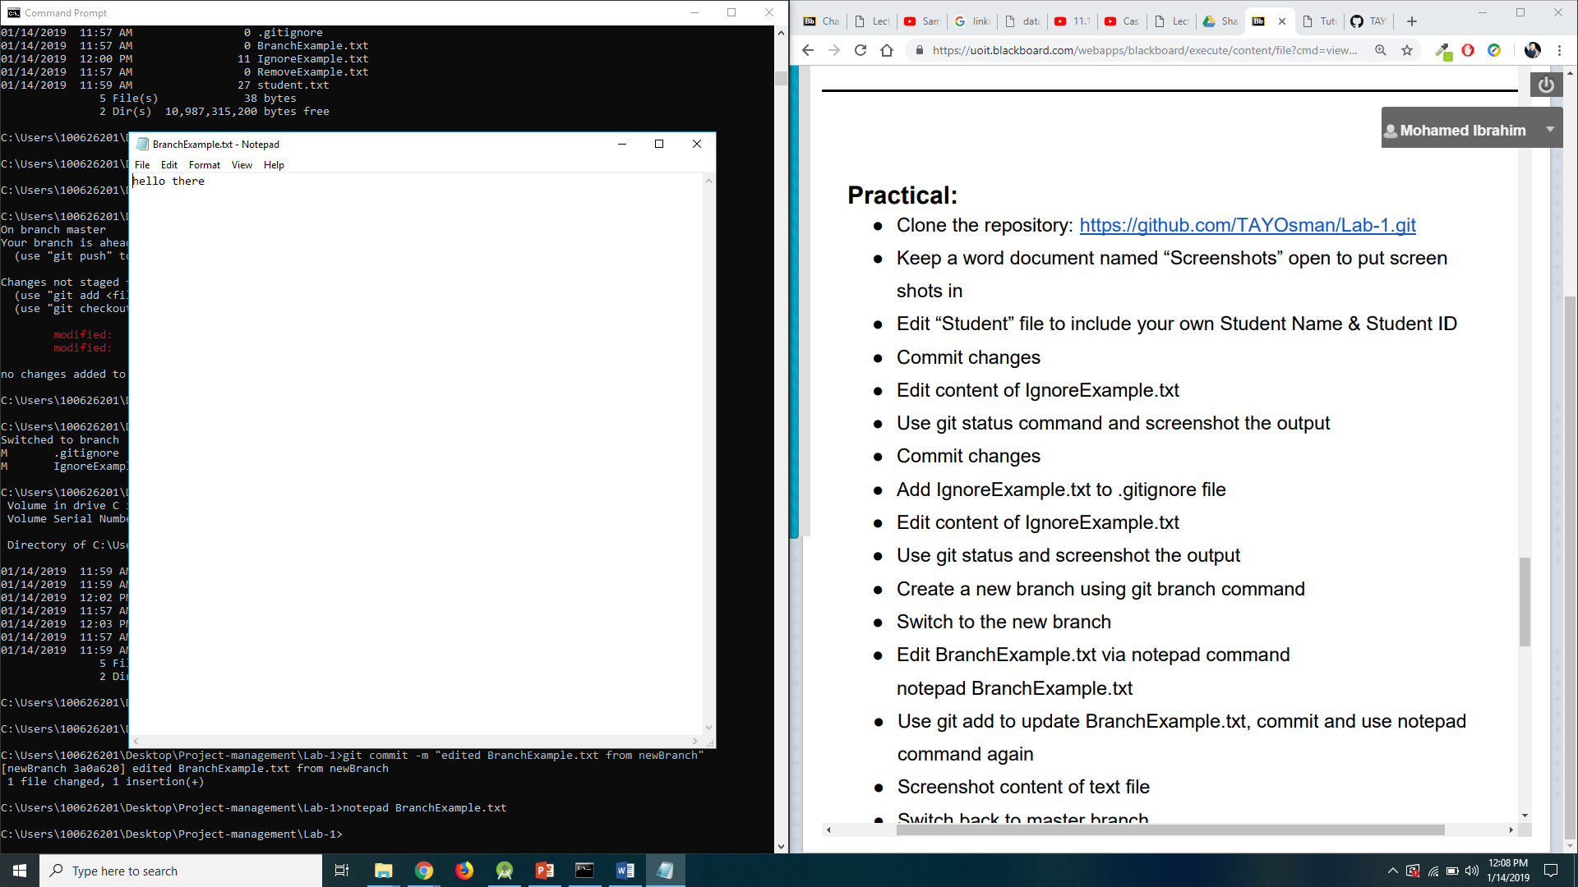

1. Switch back to master branch. Use same notepad command. Screenshot content of text file

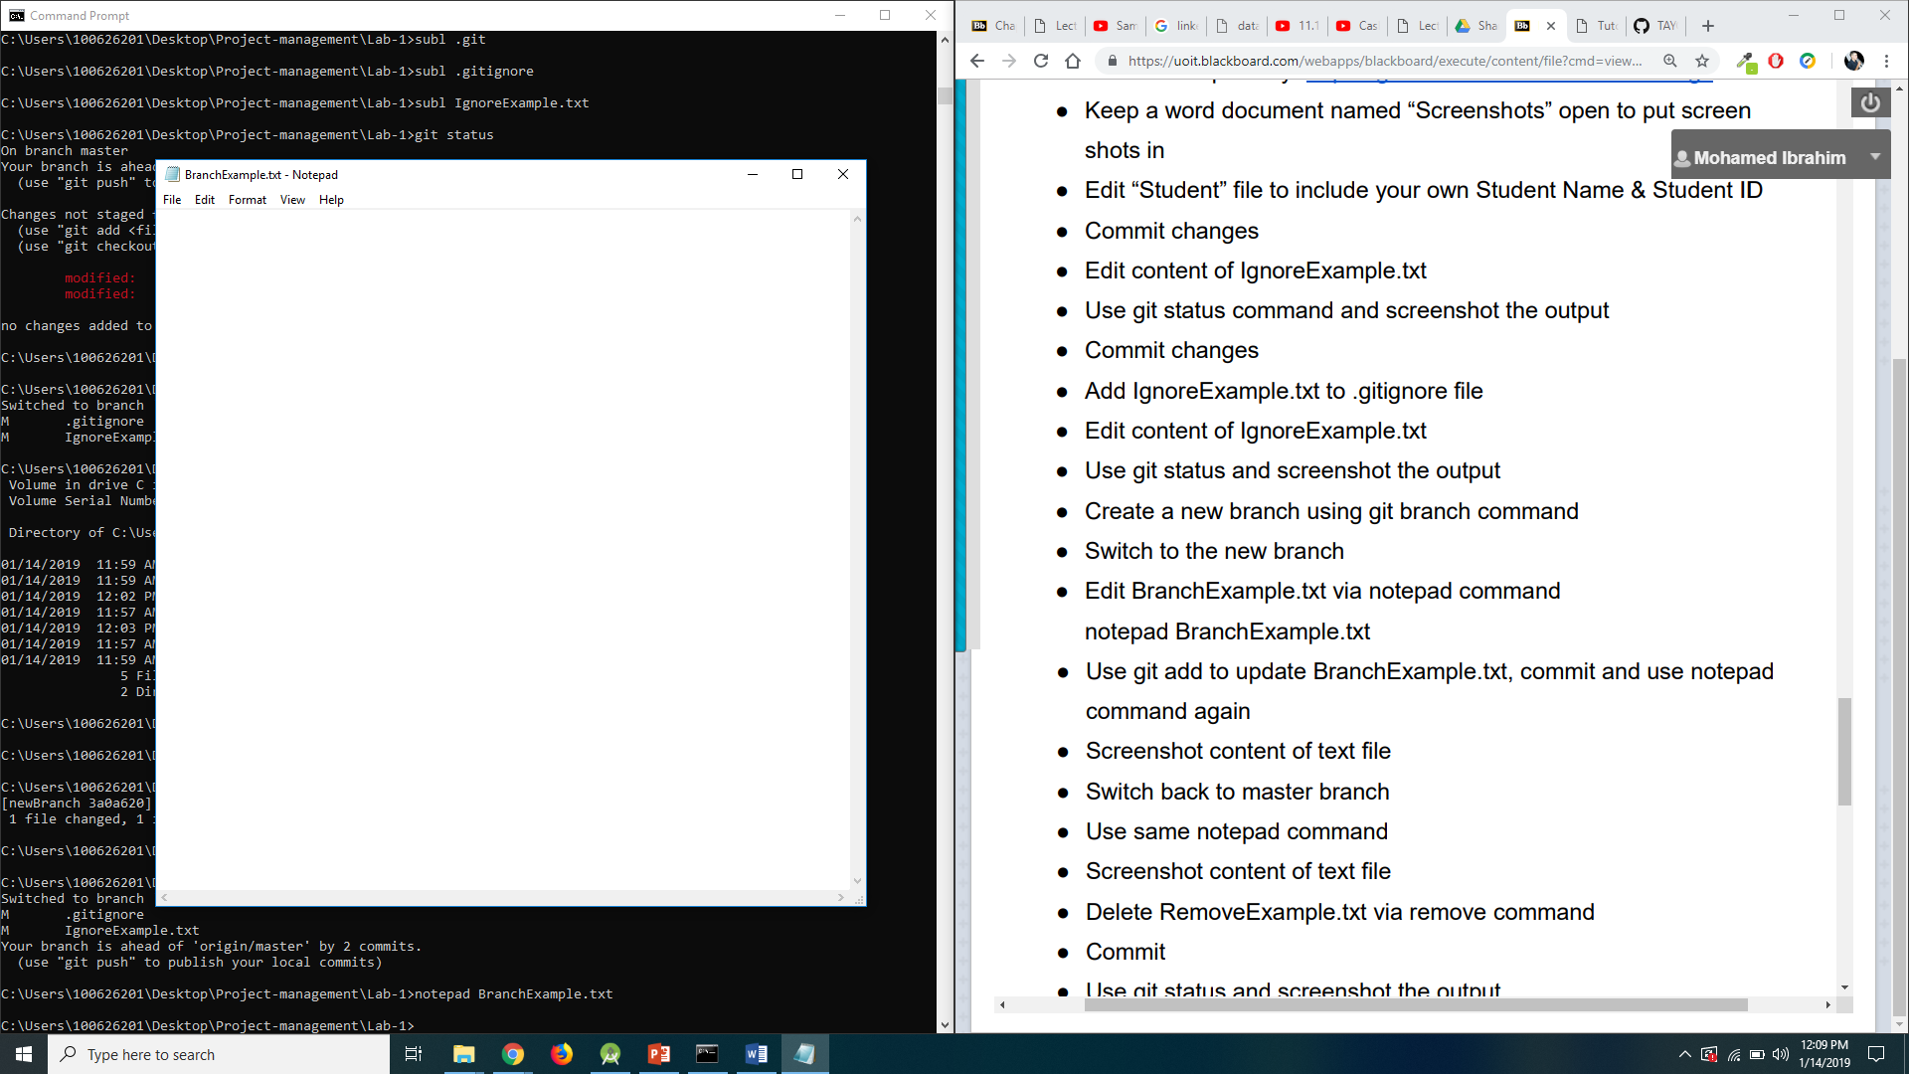

1. Delete RemoveExample.txt via remove command. Commit. Use git status and screenshot the output

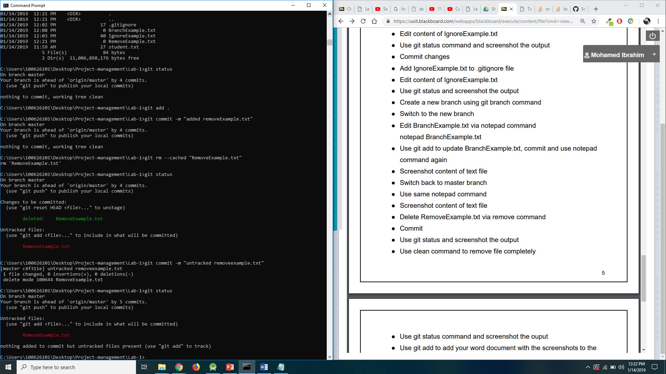

1. Use clean command to remove file completely 6. Use git status command and screenshot the output

