Showing adding my name and email

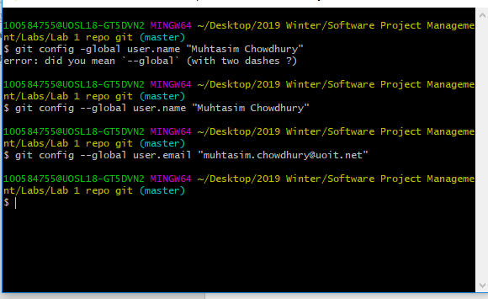

Editing IgnoreExample.txt and adding all other files. Committing files

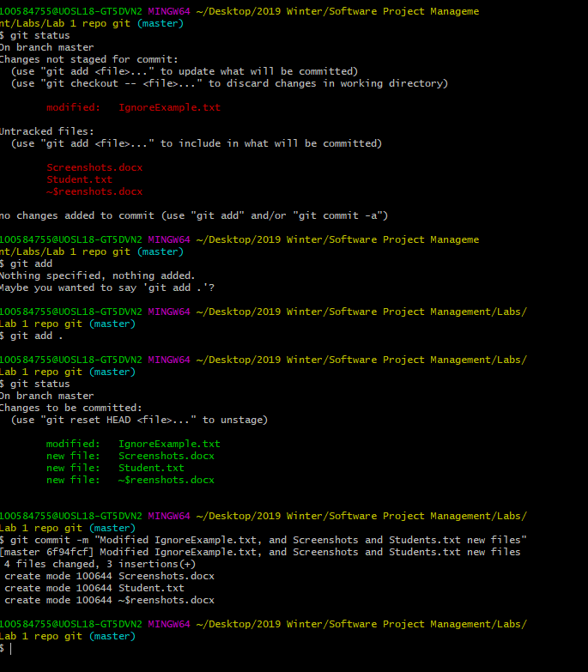

Editing the IgnoreExample.txt after adding it to .gitignore

