Randell Roopsingh 100470075

Git Status Command

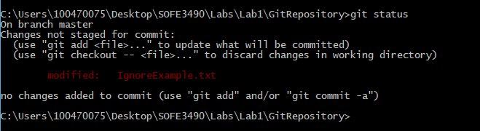

Git Status after .gitignore and ignoreexample.txt

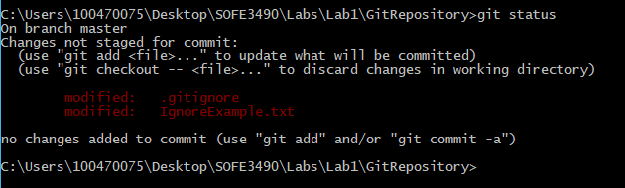

Git Commit to Branch

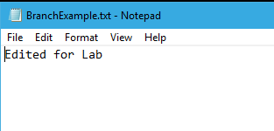

Git Master Branch

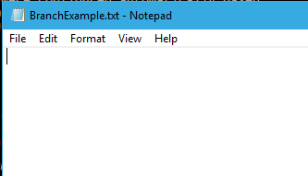

Removed File

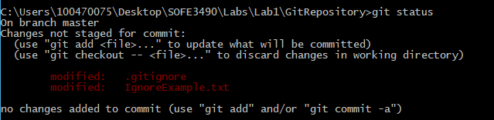

Clean Command

