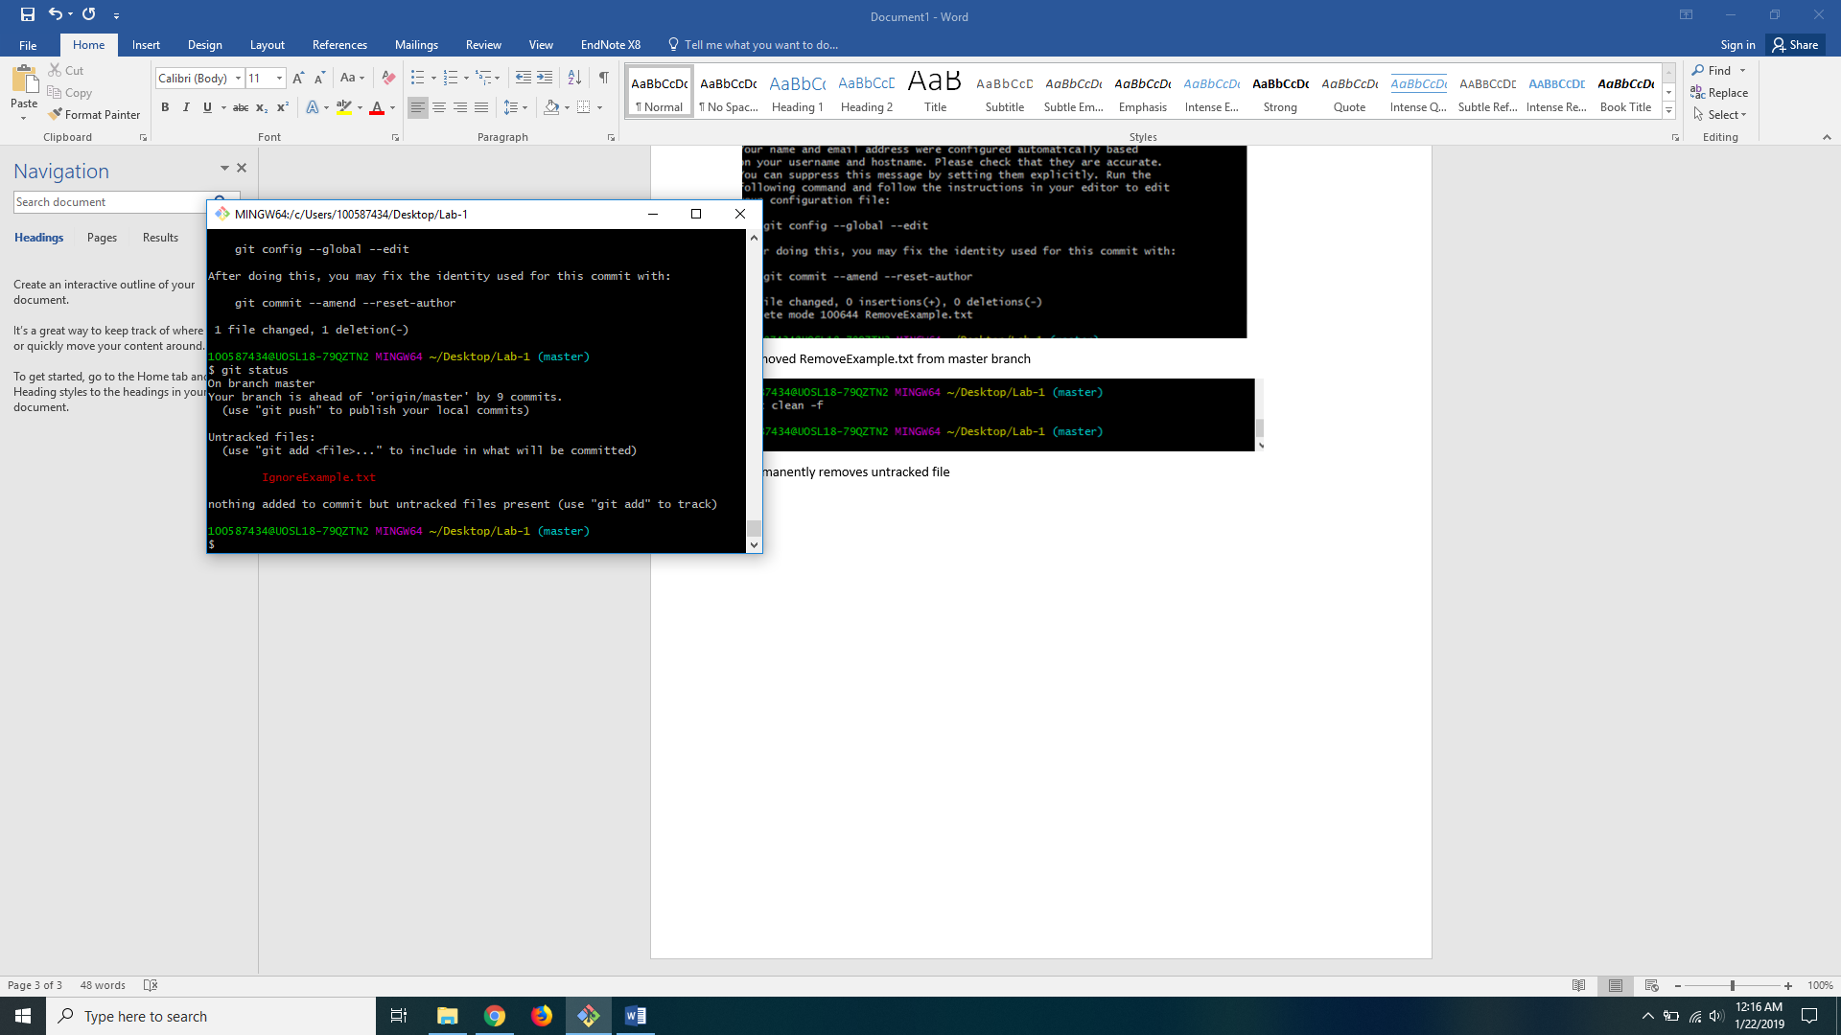

Shows that IgnoreExample.txt is an untracked file and needs to be added and commited.

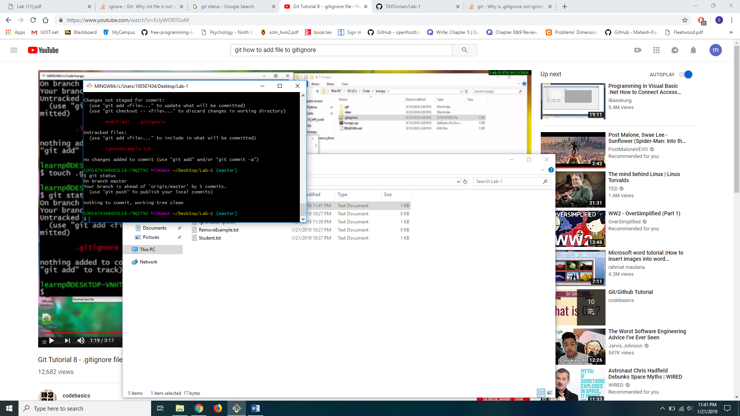

IgnoreExample.txt gets ignored when added to .gitignore and is no longer listed under untracked files.

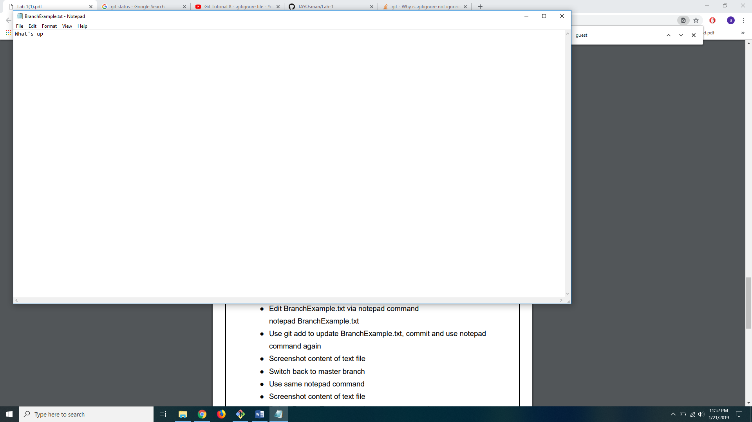

File is edited in newBranch

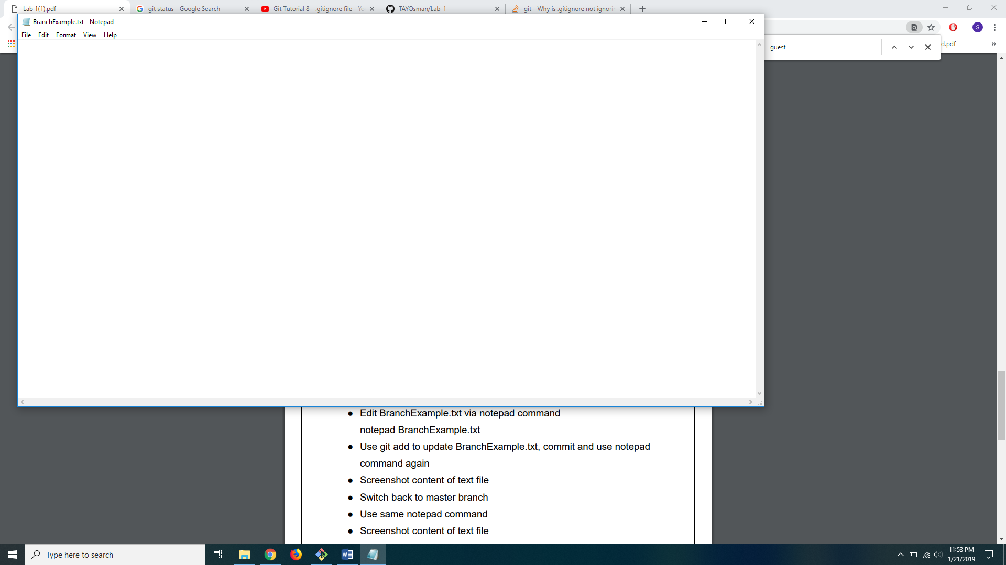

File remains unedited in master branch

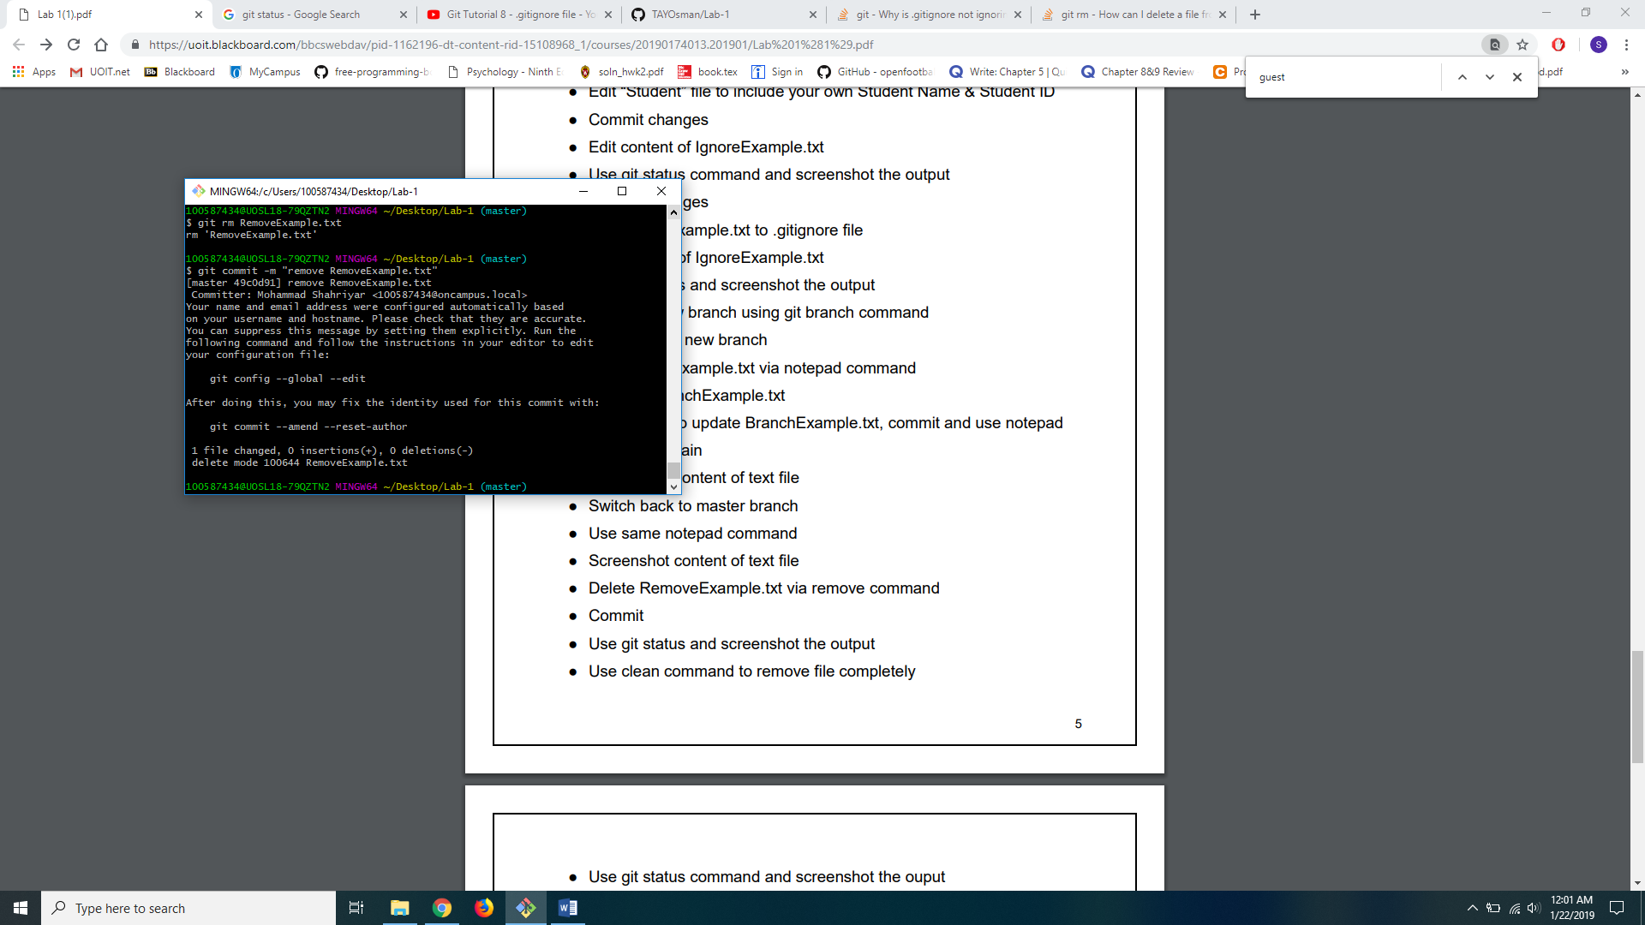

Removed RemoveExample.txt from master branch

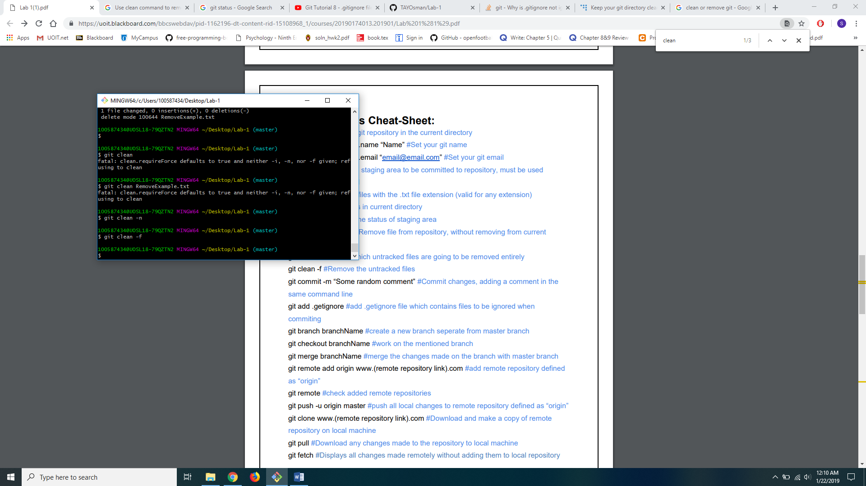

Permanently removes untracked file