Screen shot after edit content of IgnoreExample.txt

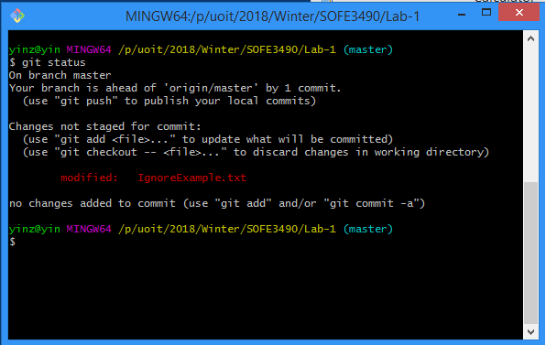

Screenshot after add IgnoreExample.txt to .gitignore file according to the lab. Nevertheless, IgnoreExample.txt cannot be ignored by git since IgnoreExample.txt has been tracked. In order to perform proper ignoring of the file, tracked file should be untracked first.

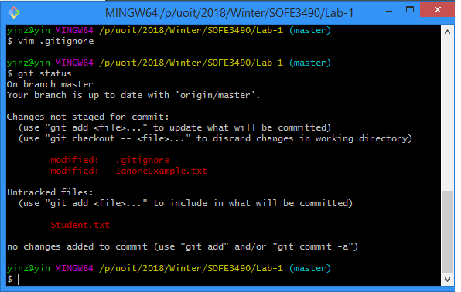

Context of text file

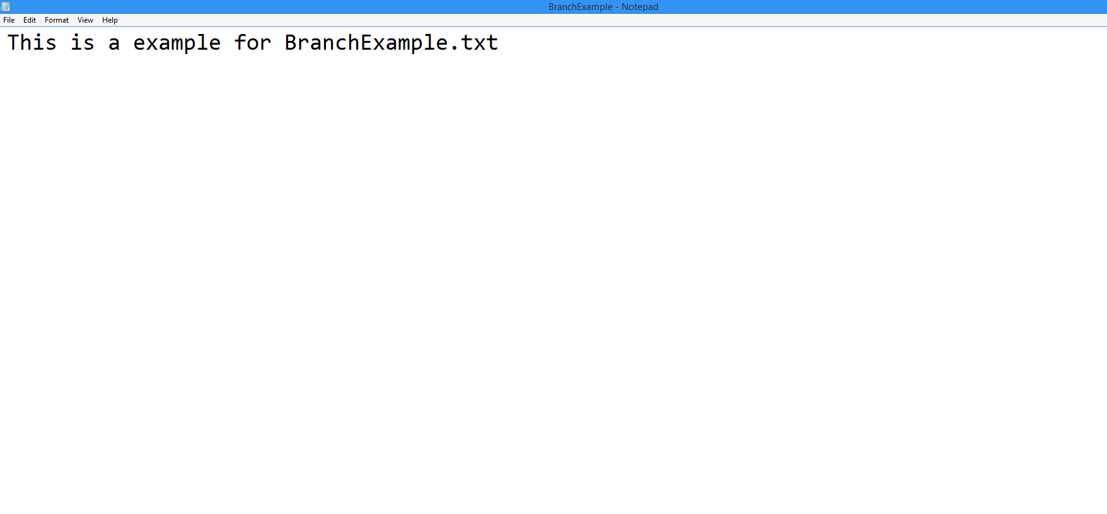

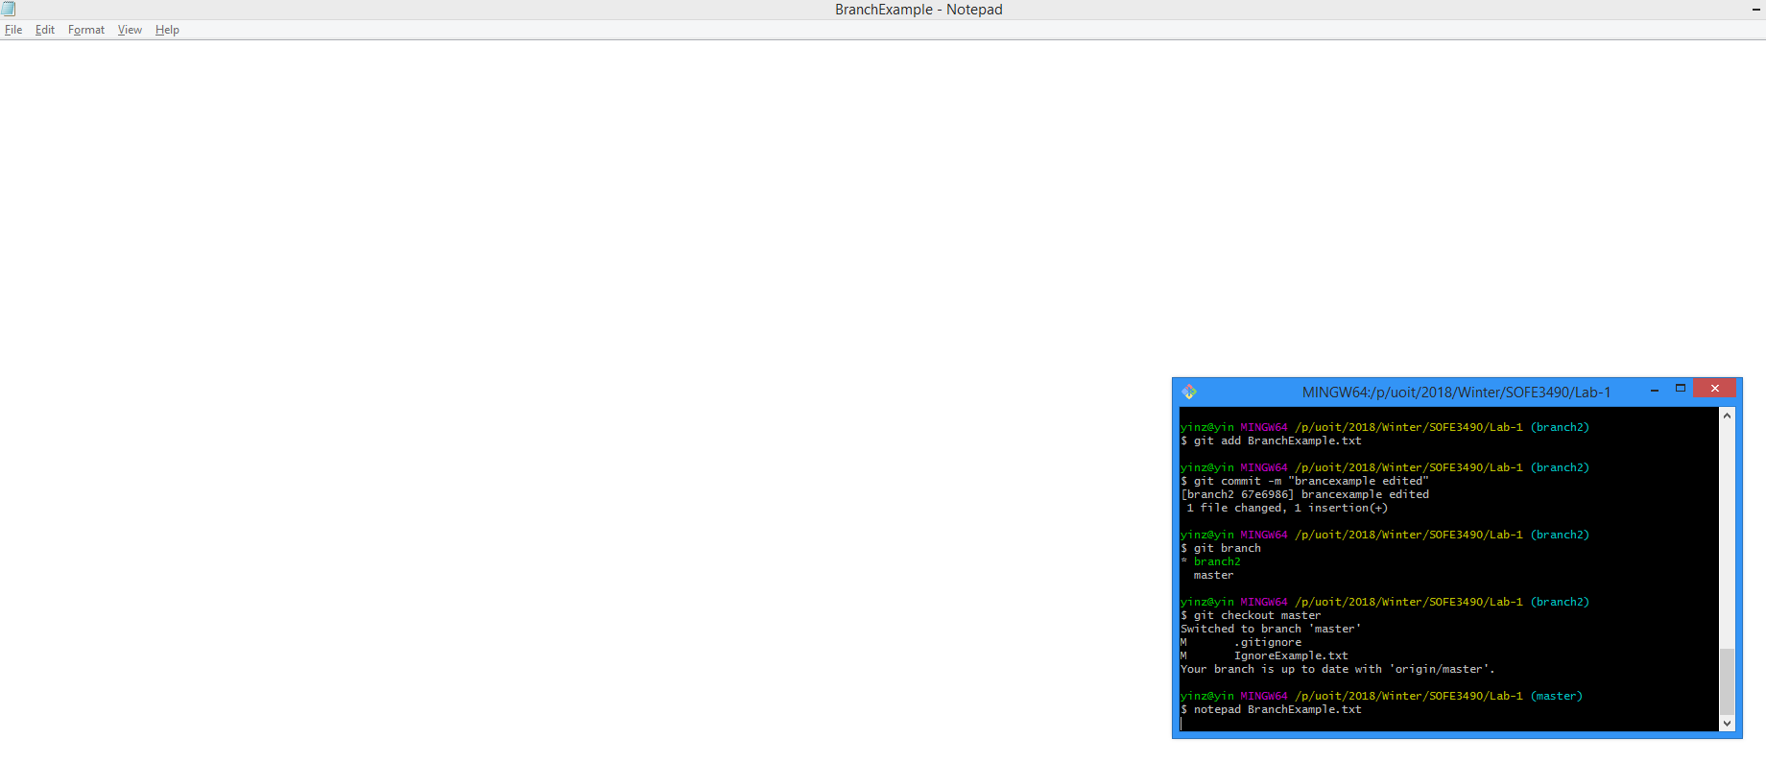Context of BranchExample.txt after switched branch

Git status after removing of the file

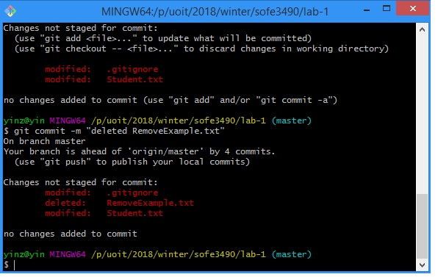

After using clean, any untracked file will be deleted.

