SOFE-3450 Lab 4 - Fall Monitor

March 25th, 2019

Matthew Bernard 100625495, Randell Roopsingh 100470075, Matthew Cardy 100489683

**1. Risks Associated with Activities**

Figure 1 is the activity diagram and the activities that will be apart of the project. Table 1 lists the potential risks associated with each activity and the countermeasures we will take to mitigate that risk. The seven activities listed are: Recruit staff, Website Development, Fall monitor Software, Database, Train Staff, Acquire User Info, and Install and Test.

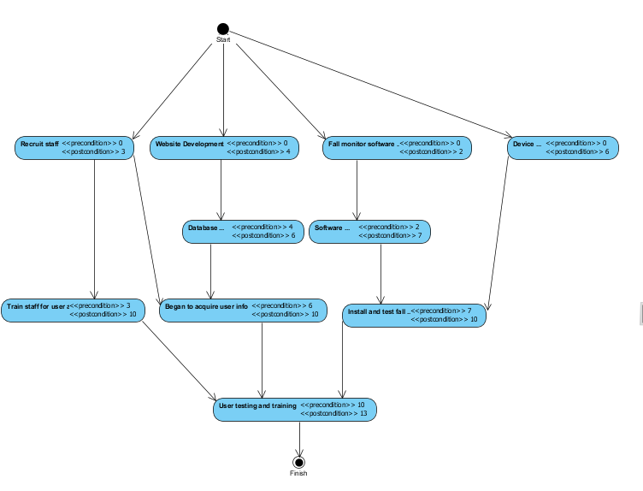

**Figure 1: Activity Diagram**

**Table 1: Risks and Countermeasures**

|  |  |  |
| --- | --- | --- |
| **Activity** | **Risk** | **Countermeasure** |
| Recruit Staff | Difficulty finding qualified staff in time allotted | Use sponsored job postings on job websites |
| Recruit Staff | Time consumption because of performing interviews and reading resumes | Hire outside company to hire staff |
| Website Development | cost estimation issues | Check similar projects previously completed |
| Website Development | testing could not catch all errors of the large website | Deliver the project in iterations |
| Fall monitor software | software must not fail when needed | Extensive testing |
| Fall monitor software | Software is complex and could exceed budget | Use prototyping and modern estimation methods |
| Database | database must be able to handle a large amount of traffic | Using buffers and flow control to control traffic |
| Database | could rent or buy server space | Compare options to decide which is more appropriate |
| Train Staff | staff may not be available for training | Make sure staff is available in the interview |
| Train Staff | staff may require additional training | Plan for Contingency overtime training |
| Acquire User Info | legal complications might occur | Hire lawyer or get aid from government |
| Acquire User Info | test security of database | Sample group testing may be required |
| Install and Test | errors can occur in the installation | Use iteration method to deliver product |
| Install and Test | testing must be comprehensive to ensure quality | Dedicated testing team could be an option |

**2. Resources**

The following contains the 3 resources that we will have for the project. Along with each resource is a list of the activities each team member is assigned. The activities assigned are those from the activity diagram in Figure 1 and in Table 1.

Front end developer- Matthew Bernard

* Website Development
* Developer of Fall monitor software

Back end programmer - Randell Roopsingh

* Database
* Install and Test

Manager - Matthew Cardy

* Recruit Staff
* Train Staff
* Acquire User Info

**3. Microsoft Project Professional File**

See the attached .mpp file for all of the details talked about in this project.