Software Project Management

Lab 2

|  |  |
| --- | --- |
| Name | Student ID |
| Joshua Smith | 100550790 |
| Matthew Boivin | 100592118 |

PART A:

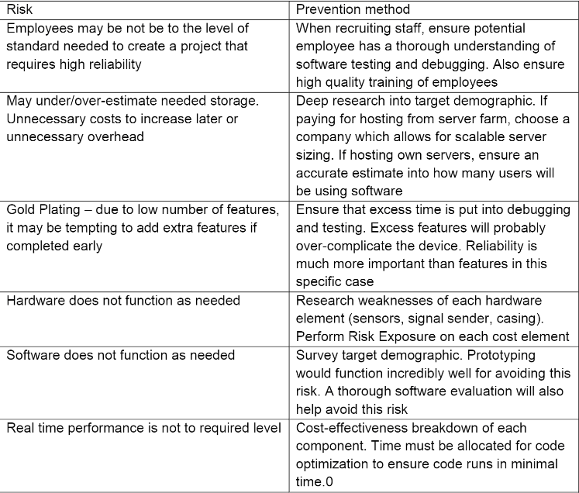

PART B:

|  |  |  |
| --- | --- | --- |
| Resource Name | Resource Type | Resource Responsibility |
| Matt | Worker | Hardware implementer |
| Josh | Worker | Sofware Implementer |
| Bill | Worker | Data Collector |

PART C:

The holiday is March 29th