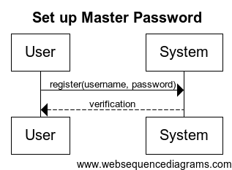

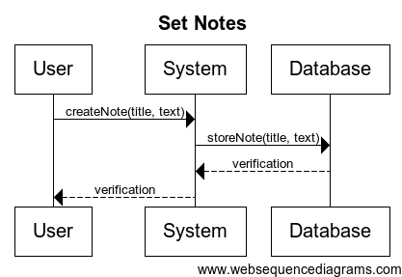

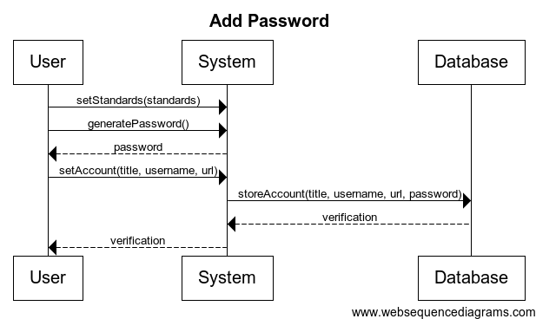

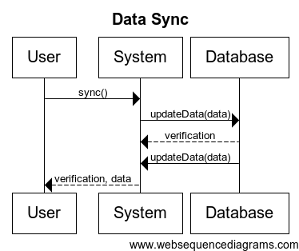

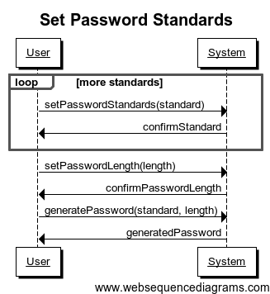

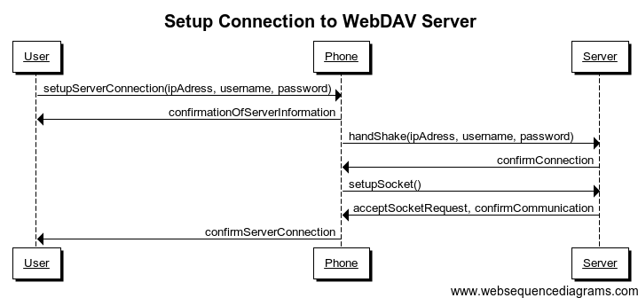

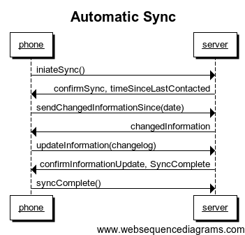

**Operation**: setLength(value)

**Cross-references**: UC 3

**Preconditions**: The User has initiated the process of creating a new password.

**Postconditions**: The value for length has been set and this value will be used for the next generated password.

**Operation**: setNumCaps(value)

**Cross-references**: UC 3

**Preconditions**: The User has initiated the process of creating a new password.

**Postconditions**: The number of capital letters has been set and this value will be used for the next generated password.

**Operation**: setNumLower(value)

**Cross-references**: UC 3

**Preconditions**: The User has initiated the process of creating a new password.

**Postconditions**: The number of lowercase letters has been set and this value will be used for the next generated password.

**Operation**: setNumNums(value)

**Cross-references**: UC 3

**Preconditions**: The User has initiated the process of creating a new password.

**Postconditions**: The number of numbers has been set and this value will be used for the next generated password.

**Operation**: setNumSpecial(value)

**Cross-references**: UC 3

**Preconditions**: The User has initiated the process of creating a new password.

**Postconditions**: The number of special characters has been set and this value will be used for the next generated password.

**Operation**: saveConnections(hostname, password)

**Cross-references**: UC 5

**Preconditions**: The User has access to a WebDAV server and knows the hostname and password needed to connect to that server.

**Postconditions**: The connection is saved and the device will now sync passwords with this server.

**Operation**: setAutoSync(value)

**Cross-references**: UC 9

**Preconditions**: N/A

**Postconditions**: The system will or will not automatically sync all passwords on startup based on whether “value” was “yes” or “no”.

**Operation**: register(username, password)

**Cross-references**: UC1

**Preconditions**: User has started application

**Postconditions**: Master account with username and password is created

**Operation**: createNote(title, text)

**Cross-references**: UC6

**Preconditions**: User is on the note creation screen

**Postconditions**: A note with a title and text is created and stored on the local device

**Operation**: storeNote(title, text)

**Cross-references**: UC6

**Preconditions**: User has created a note on the local device

Device is connected to the server

**Postconditions**: The newly created note on the local device is stored on the server as well

**Operation**: setStandards(standards)

**Cross-references**: UC8

**Preconditions**: User is on the password generator screen

**Postconditions**: The standards for password generation are set

**Operation**: setAccount(title, username, url)

**Cross-references**: UC8

**Preconditions**: User has generated a password and is on the account creation screen

**Postconditions**: An account is created with the given title, optional username, optional url, and the password that was already generated.

**Operation**: storeAccount(title, username, url, password)

**Cross-references**: UC8

**Preconditions**: User has created an account on the local device

Device is connected to the server

**Postconditions**: The newly created account on the local device is stored on the server as well

**Operation**: updateData(data)

**Cross-references**: UC10

**Preconditions**: User has told the device to sync with the server

Device is connected to the server

**Postconditions**: System compares timestamps for each entry and sets them to the most recent on the device and the database