CityMotoRacer

Thank you for purchasing this Game.

MotoRacer game can be build to android,ios & windows phone 8.
It is strongly recommend to import this package in an empty Project to avoid tag and iTween conflicts.

BUILD SETTINGS
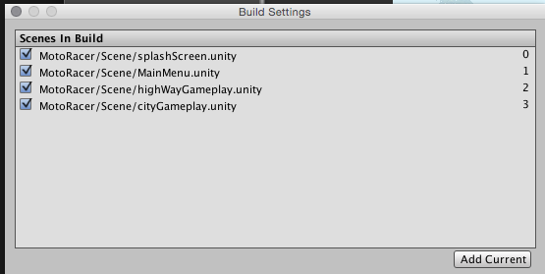

Make sure you added these scenes as per order.

Scripts :

playerBIKEControl.cs
This script will control player bike based on mobile acceleration input or key input.

GamePlayController.cs
This script will create new rocks, side objects, traffics cars, Rock Mountains etc.

EndScoreDisplayer.cs
This script will have a static event showFullScreenAd ,
You can make ad network calls to display ads when it is fired .

Support
For Quick questions & support, contact me at kiran.killstreak@gmail.com
Skype kirankillstreak

Thanks
Kiran

