Inverters

CENG 2112.01 Lab for Digital Circuits

Submitted by
David Dulaney
2344357

Computer Science
University of Houston-Clear Lake
Houston, Texas 77058
Feb 3,2026

Contents
Abstract 3
Introduction 3
Requirements 3
Prelab 4
Implementation 4
Design Code/Design Diagrams 5
Schematics 5
Testbench 6
Waveform/Results 6
Conclusion 7

Abstract
An inverter is a device that requires one input based off two options which are 0 and 1, then it will produce one output. This output will be the opposite of the input depending if there are an even or odd number of inverters in a circuit. The way to understand how inverters work, it is best to use one inverter and observe its’ output, then use two inverters together and observe their output. The important finding in this experiment is that when there are an odd number of inverters in a circuit, the output will always be opposite of the input, whereas if there is an even number of inverters then the output produced will be the same as the input. Because of this, if you want an inverter to produce the same output as an input, you need an even amount of inverters in your circuit, otherwise use an odd amount of inverters.

Introduction
An inverter (part # 7404) is a device that when given an input, the opposite will be the output. For example, if I send an input of 1 through an inverter, the output will be 0. The inverter was created primarily to convert direct current, and it helped overcome the limitations of fixed-speed motors.

Requirements
The requirement for this lab is to simulate what an odd number of an inverters will output as well as what an even number of inverters will input using Multisim as well as use a logic analyzer within Multisim to check the waveforms of different outputs (1 and 0). Then we used a bread board to wire one input into an inverter to get an output, then use that output as the next inverter’s input to see if the output will produce the same result as the simulation’s two inverters. Then we added a third inverter, thus using the second inverter’s output as the third inverter’s input to check if the output produces the same result as the simulation’s three inverters. We also coded a schematic in Vivado using VHDL as well as to have a testbench of the waveforms to match the results from Multisim

Prelab
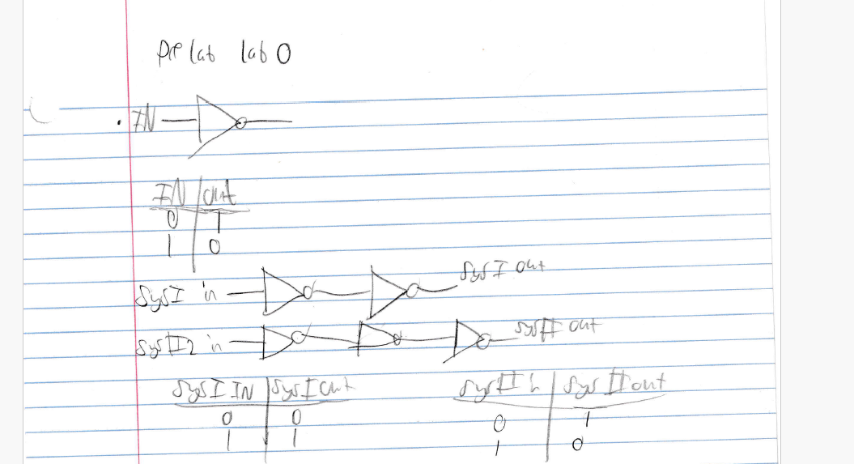
Figure 1: Prelab showing an input with cascading inverters.

Implementation
The first step in implementation was to build a schematic with a word generator and a logic analyzer with one inverter with the inverter’s input coming from the word generator then the output going to the analyzer. We repeated these steps for two inverters and three inverters. Then we simulated the inverters in VHDL to see if we get the same outcome as our schematics.

Design Code/Design Diagrams
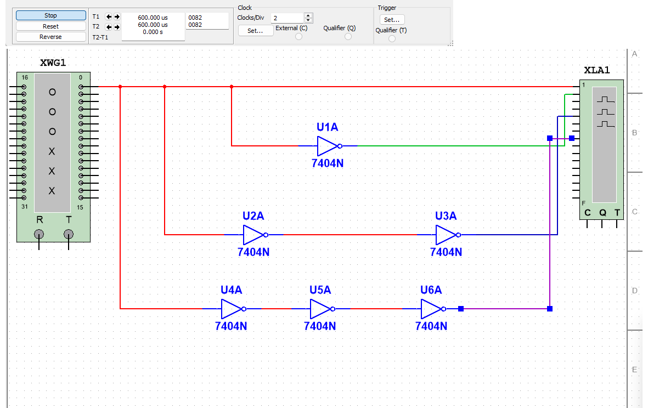
Figure 2: Diagram for inverters to be designed
We concluded with this design because it is a perfect example of how a circuit with 1 inverter will have the same output as a circuit with any number of odd inverters, whereas a circuit with 2 inverters will produce the opposite of the circuit with 1 inverter. This is shown in figures 6.1 and 6.2.
----------------------------------------------------------------------------------
-- Company:
-- Engineer:
--
-- Create Date: 01/20/2026 02:57:49 PM
-- Design Name:
-- Module Name: InverterIC - Behavioral
-- Project Name:
-- Target Devices:
-- Tool Versions:
-- Description:
--
-- Dependencies:
--
-- Revision:
-- Revision 0.01 - File Created
-- Additional Comments:
--
----------------------------------------------------------------------------------

library IEEE;
use IEEE.STD_LOGIC_1164.ALL;

-- Uncomment the following library declaration if using
-- arithmetic functions with Signed or Unsigned values
--use IEEE.NUMERIC_STD.ALL;

-- Uncomment the following library declaration if instantiating
-- any Xilinx leaf cells in this code.
--library UNISIM;
--use UNISIM.VComponents.all;

entity InverterIC is
Port ( Input_Port : in STD_LOGIC;
SYS1 : out STD_LOGIC;
SYS2 : out STD_LOGIC;
SYS3 : out STD_LOGIC);
end InverterIC;

architecture Behavioral of InverterIC is

begin
SYS1 <= not Input_Port;
SYS2 <= not(not Input_Port);
SYS3 <= not(not(not Input_Port));

end Behavioral;

Schematics
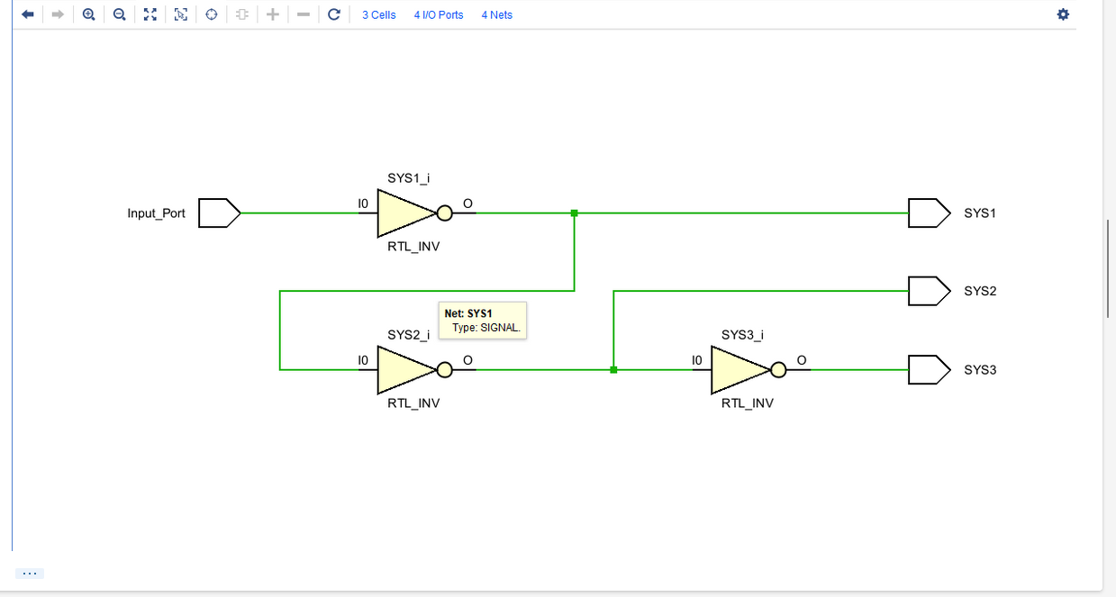
Figure 3: schematic for inverters

Testbench
----------------------------------------------------------------------------------
-- Company:
-- Engineer:
--
-- Create Date: 01/20/2026 03:14:37 PM
-- Design Name:
-- Module Name: InverterIC_TB - Behavioral
-- Project Name:
-- Target Devices:
-- Tool Versions:
-- Description:
--
-- Dependencies:
--
-- Revision:
-- Revision 0.01 - File Created
-- Additional Comments:
--
----------------------------------------------------------------------------------

library IEEE;
use IEEE.STD_LOGIC_1164.ALL;

-- Uncomment the following library declaration if using
-- arithmetic functions with Signed or Unsigned values
--use IEEE.NUMERIC_STD.ALL;

-- Uncomment the following library declaration if instantiating
-- any Xilinx leaf cells in this code.
--library UNISIM;
--use UNISIM.VComponents.all;

entity InverterIC_TB is
-- Port ( );
end InverterIC_TB;

architecture Behavioral of InverterIC_TB is
component InverterIC is
Port ( Input_Port : in STD_LOGIC;
SYS1 : out STD_LOGIC;
SYS2 : out STD_LOGIC;
SYS3 : out STD_LOGIC);
end component;
signal CableIn: std_logic;
signal SYS1Cable: std_logic;
signal SYS2Cable: std_logic;
signal SYS3Cable: std_logic;
begin
UUT: InverterIC port map(Input_Port => CableIn, SYS1 => SYS1Cable, SYS2 => SYS2Cable, SYS3 => SYS3Cable);
process
begin
CableIn <= '0'; wait for 10ns;
CableIn <= '1'; wait for 10ns;
end process;
end Behavioral;

Waveform/Results
The waveforms in figures 3 and 4 represent multiple inverters being used at once. In figure 3, the red line shows the voltage when an input is 0 with an odd amount of inverters. while the green line is what happens when the input is 1 with an even amount of inverters. The blue and purple lines use the same amount of inverters to their counterparts respectively and the results were the same. Figure 4 confirms the behavior of these inverters is correct.
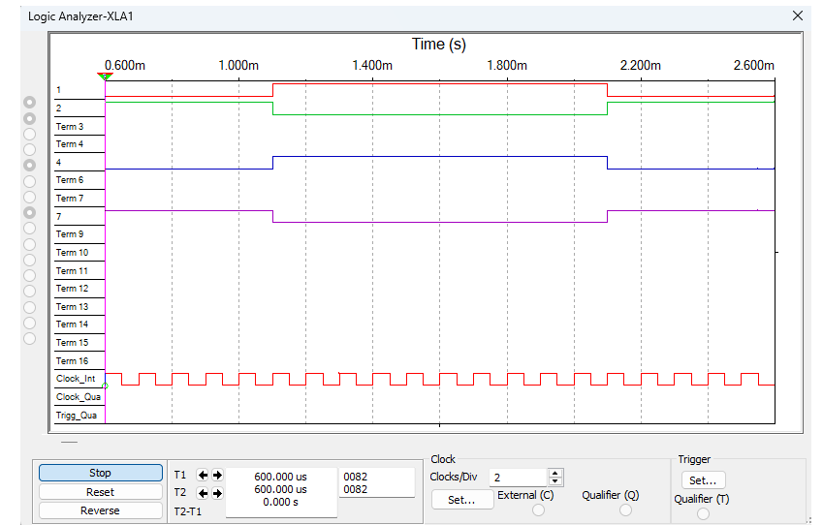
Figure 4: Waveform of multiple inverters in use
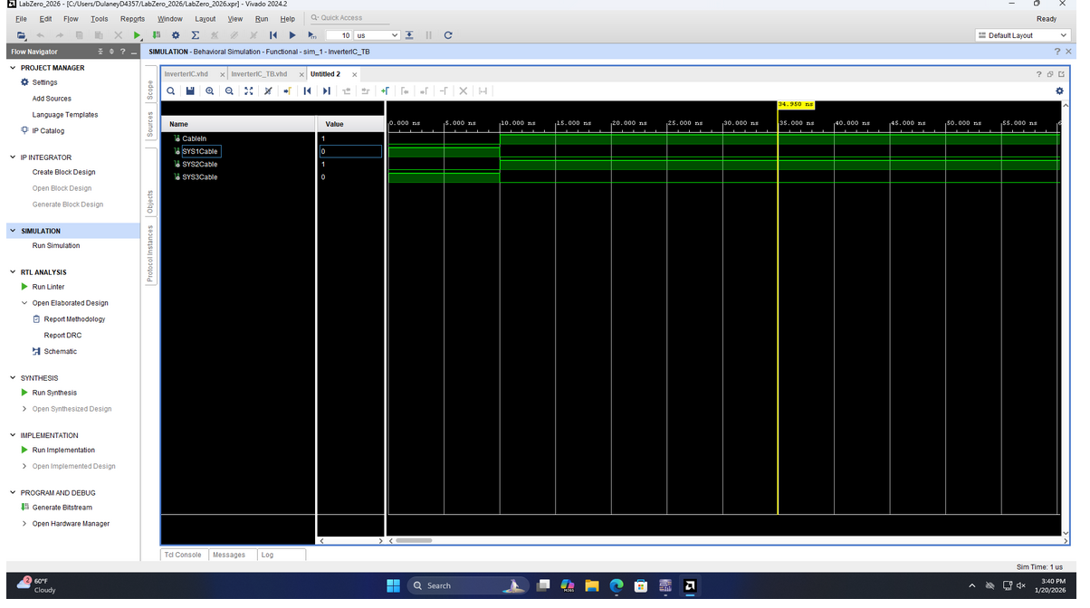
Figure 5: Behavioral simulation of multiple inverters
The result in figure 6.1 shows the input that the program is submitting is 0 and the output is 1 (indicated by a green light on led 0) by using one inverter on the left, as well as the output being 1 (indicated by a green light on led 2) when using three inverters on the right side.
The result in figure 6.2 shows the input that the program is submitting is 1 and the output is 1 (indicated by a green light on led 1) by using two inverters on the left.

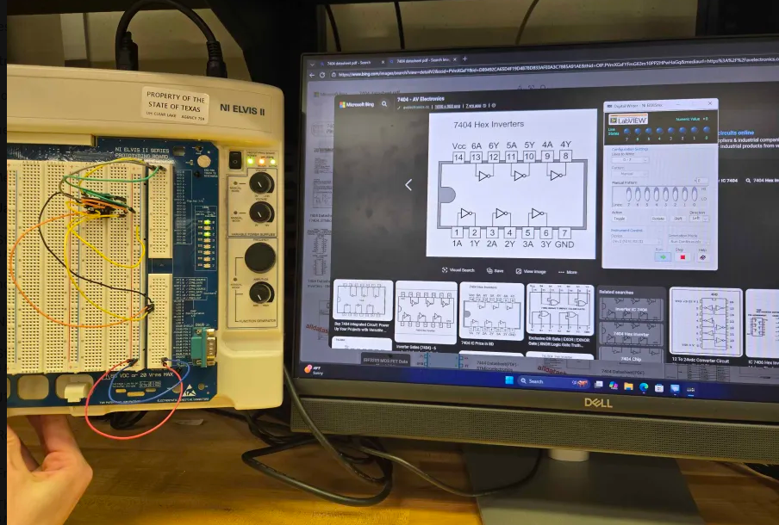
Figure 6.1: physical board showing 3 inverters P1
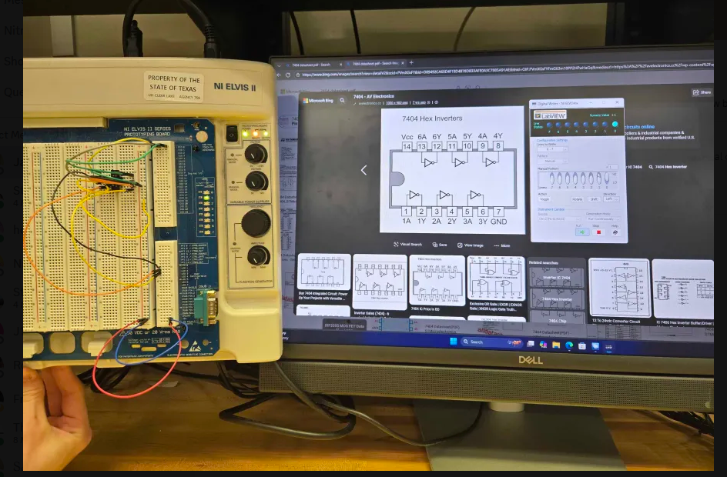
Figure 6.2: physical board showing 3 inverters P2

Conclusion
This experiment was designed to understand that an inverter will produce the opposite output of its’ input as well as being able to seek out efficiency with inverters. The main takeaway is that an inverter will produce the same output as its’ input as long as there are an even number of inverters in the circuit, otherwise it will produce the opposite output in a circuit with an odd number of inverters in the circuit.

