**CSCE 5430 SOFTWARE ENGINEERING**

**CORE FUNCTIONALITIES**

**GROUP: BRAINSTORMERS**

* In development phase 1, we have implemented design for User Registration, User login and Dashboard.
* We have used Android Studios, java, php, xml, Mysql for implementation of our Project.
* The code for our project is provided below.

LOGIN PAGE:

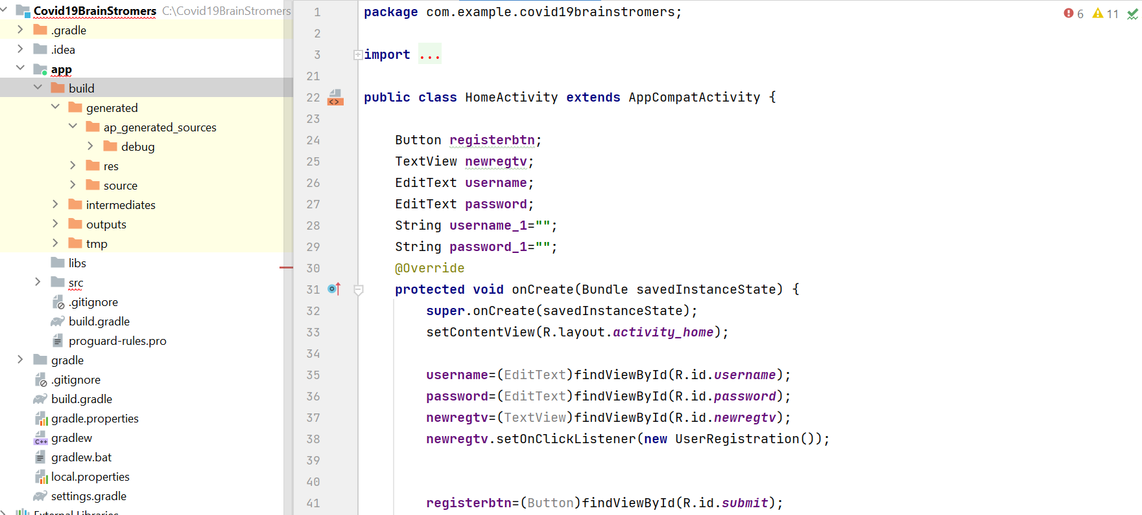

* The above picture is related to home activity class contains new registration textview, username and password edit textview widgets and login button widget.
* In the onCreate method all the above wedgets are obtained through ids from xml file that contain design.

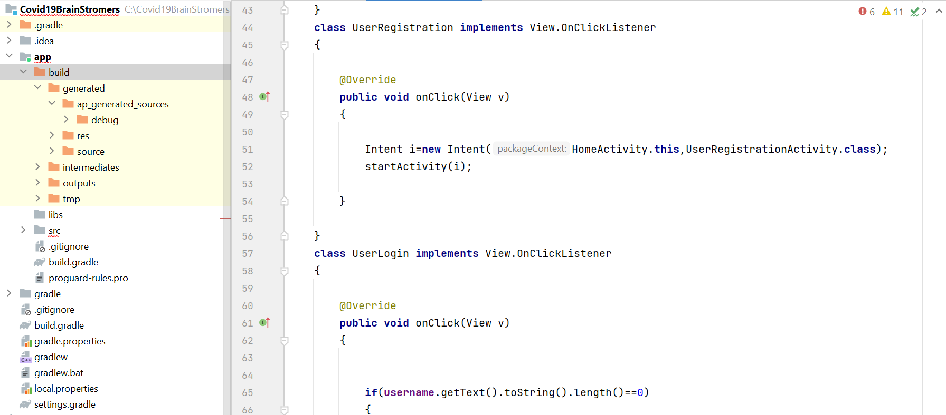

* The UserRegistration class contain onClick method which is executed when user click on new registration link on the activity. This method creates intent object to navigate to user registration activity.

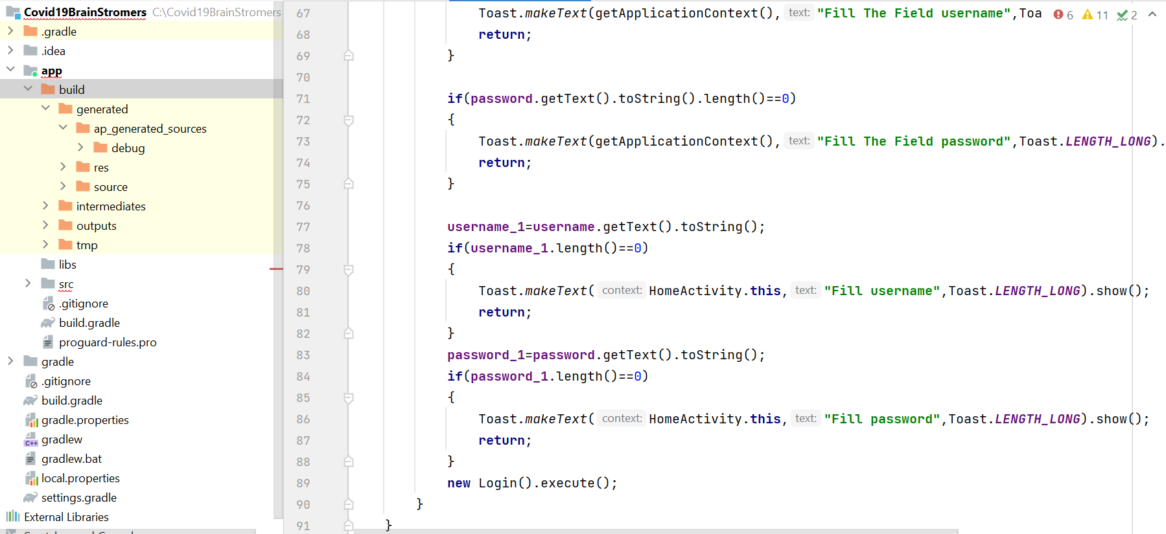

* When the user gives username and password the above code checks that data is given or not. If lengths of username, password is zero then it shows message and stops operation.
* If the username and password is given then Login object is created and executed.

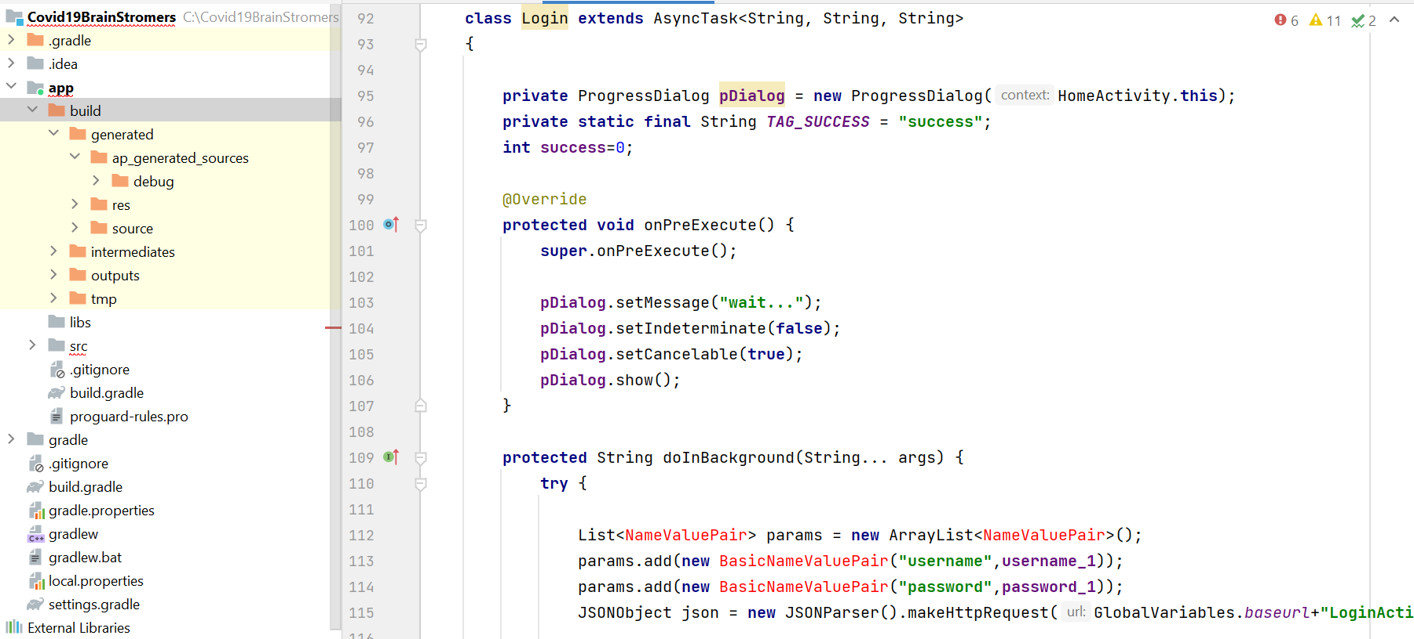

* Login class which extends AsyncTask class that runs the code in background.
* In the class a progress dialog is created to show proper messages when connected to server.
* In onPreExecute method dialog box is initialized with message and displays.
* In the doInBackground method, it prepares list object with parameter of username and password and also creates an object to JSONObject which is responsible to make request to php file on server and passes parameters to it.

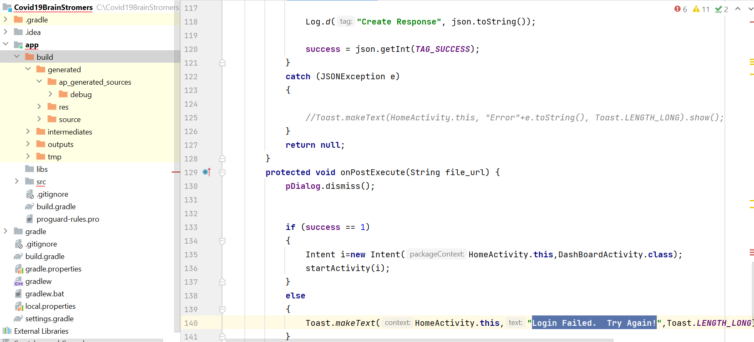

* In onPostExecute method, it gets response from php file from server with success code and response success is 1 then login success and creates intent object to navigate to DashboardActivity otherwise display login failed message.

USER REGISTRATION PAGE:

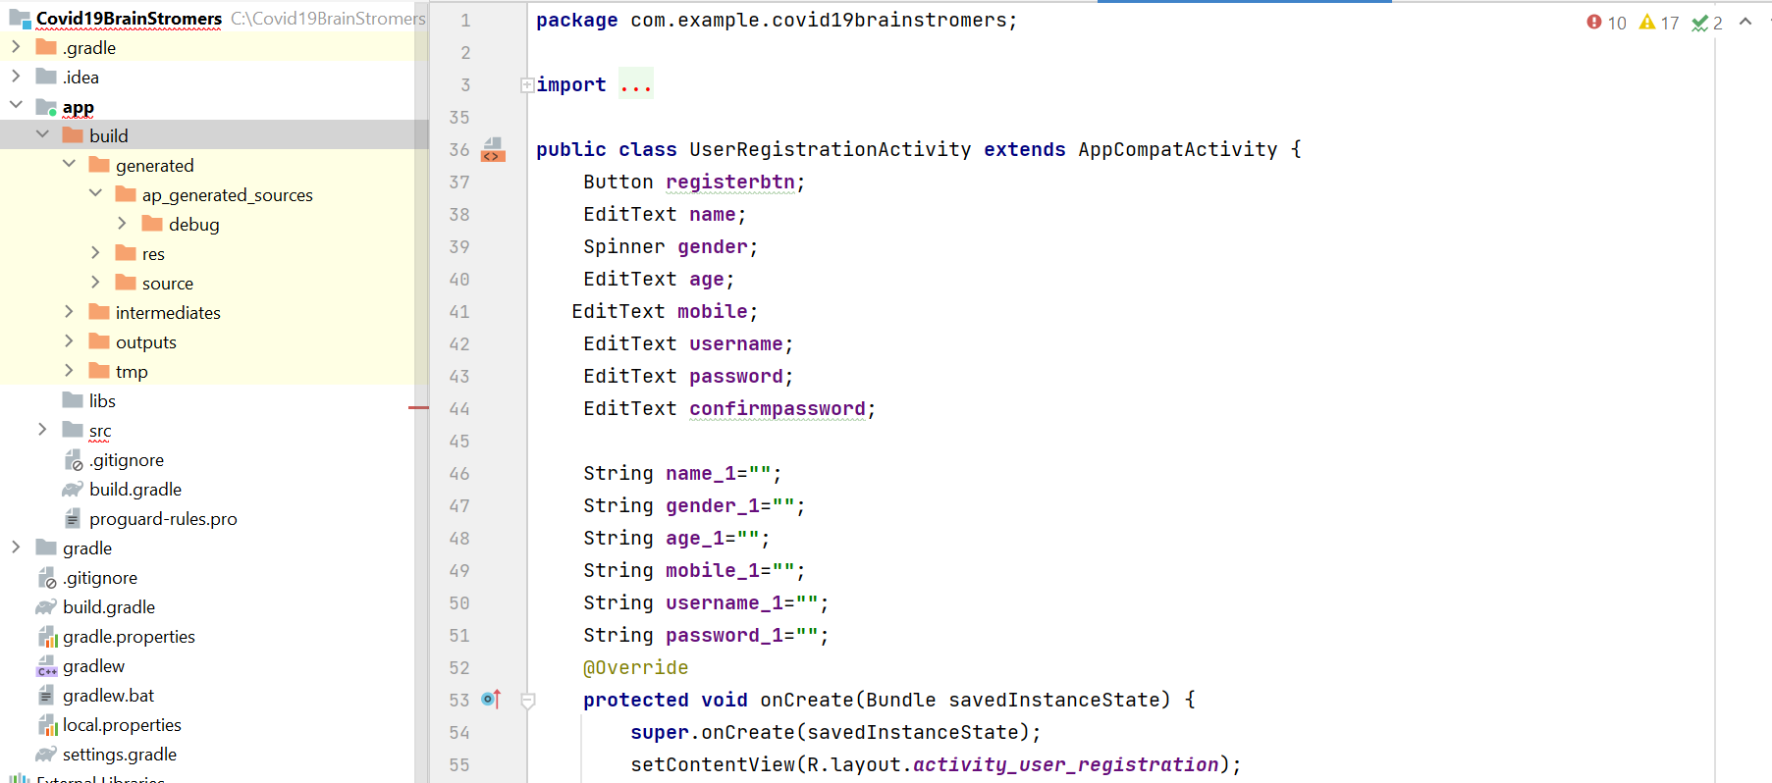

* In the user registration activity class it contains registration button and edit text widget reference variable.

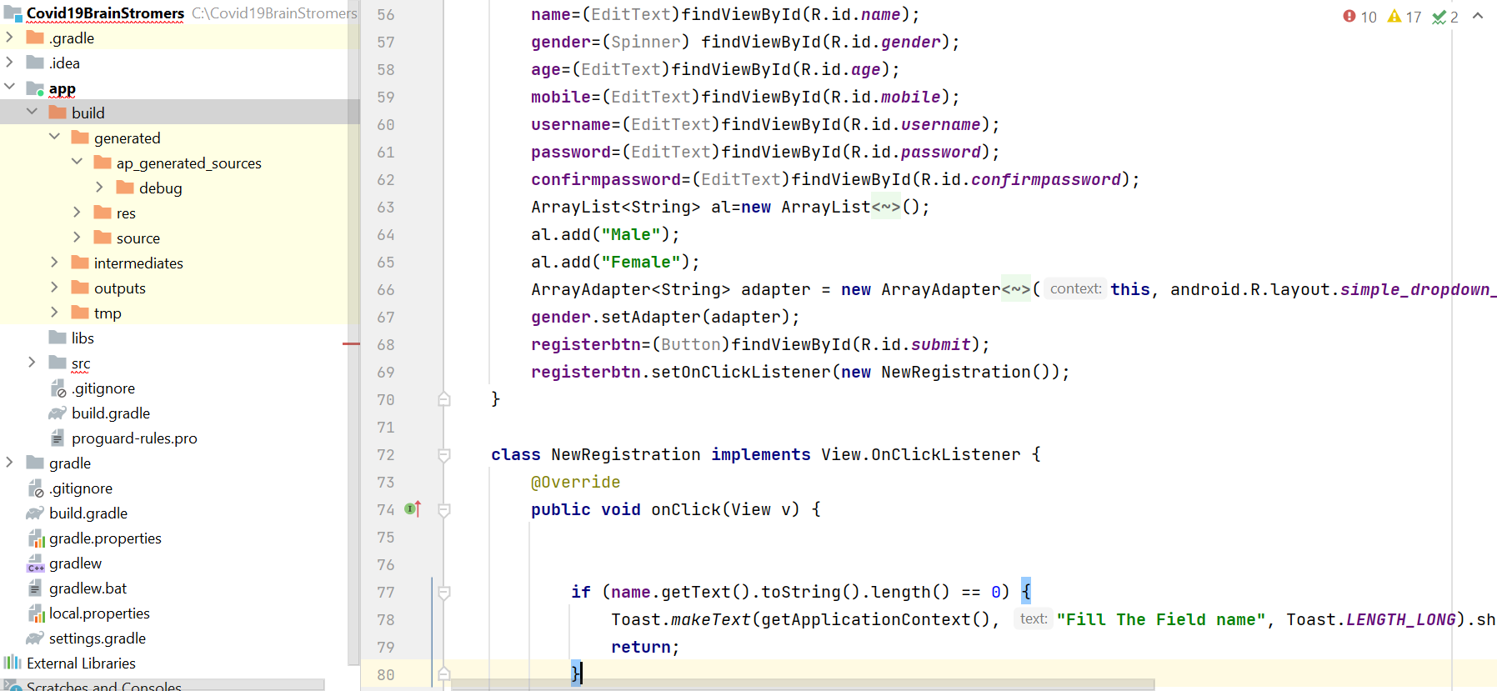

* In the onCreate method of registration it gets all widget objects through ids from xml file.
* For gender Spinner array list is used to add Male and Female items to it.
* Registration button is registered with click listener and calls on click method when clicked on register button.

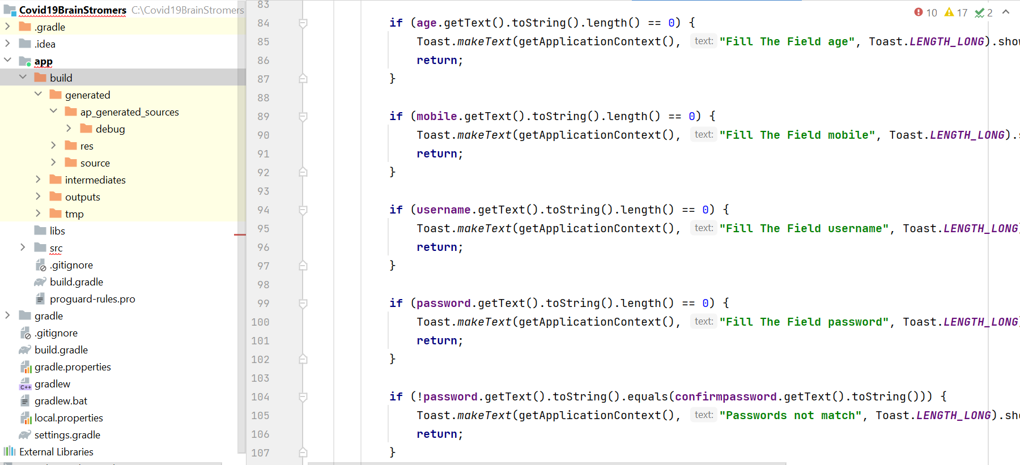

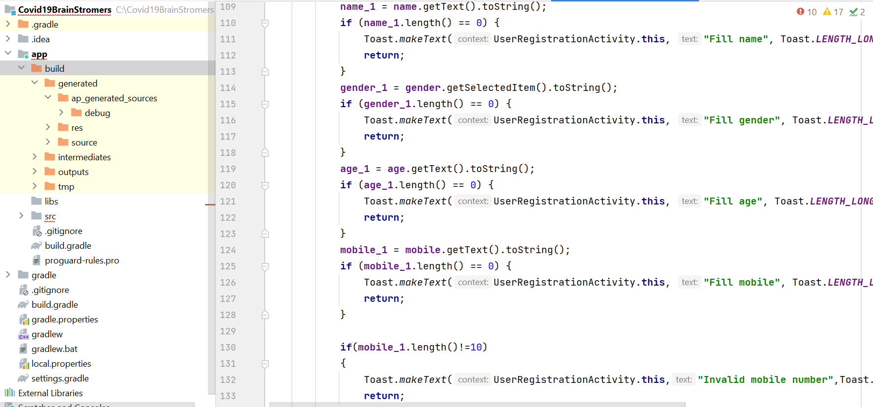

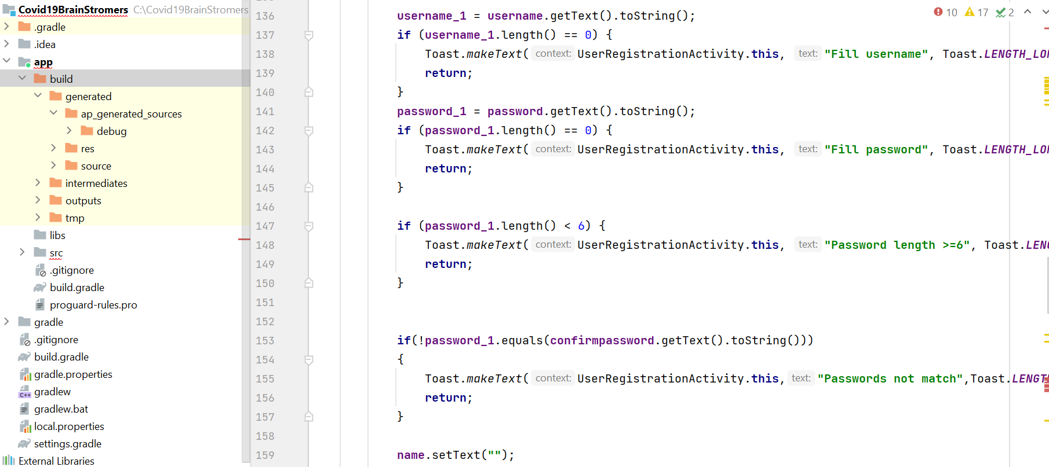

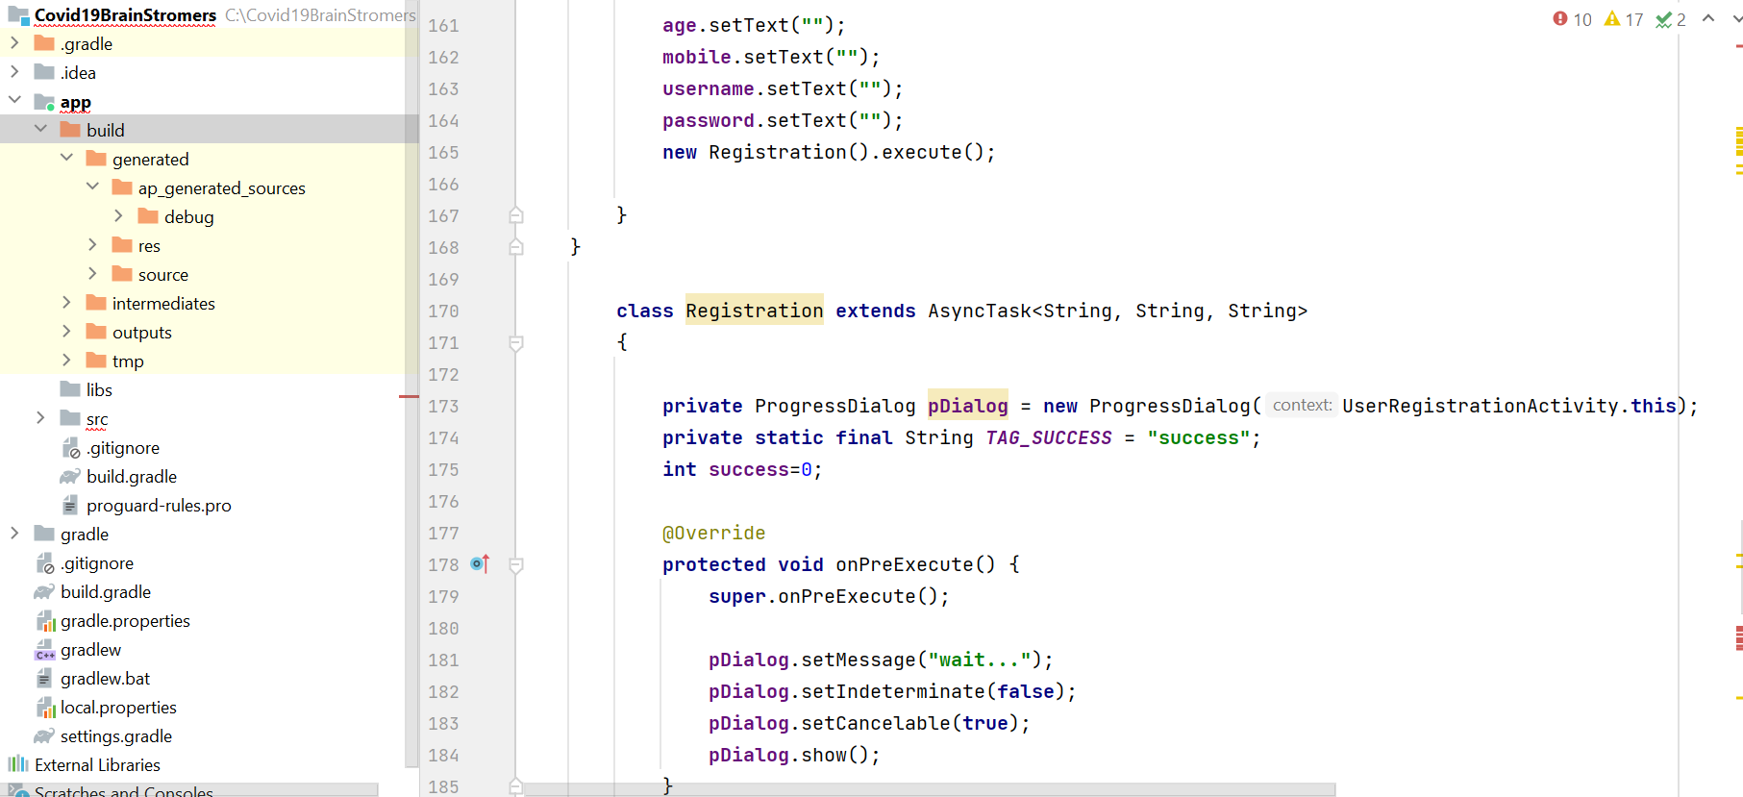

* In the on click method in above screens it check whether data is given in the form fields or not and then creates Registration object and calls execute method which calls three methods onPreExecute, doInBackground and onPostExecute. In onPreExecute it initializes dialog object and shows a wait message.

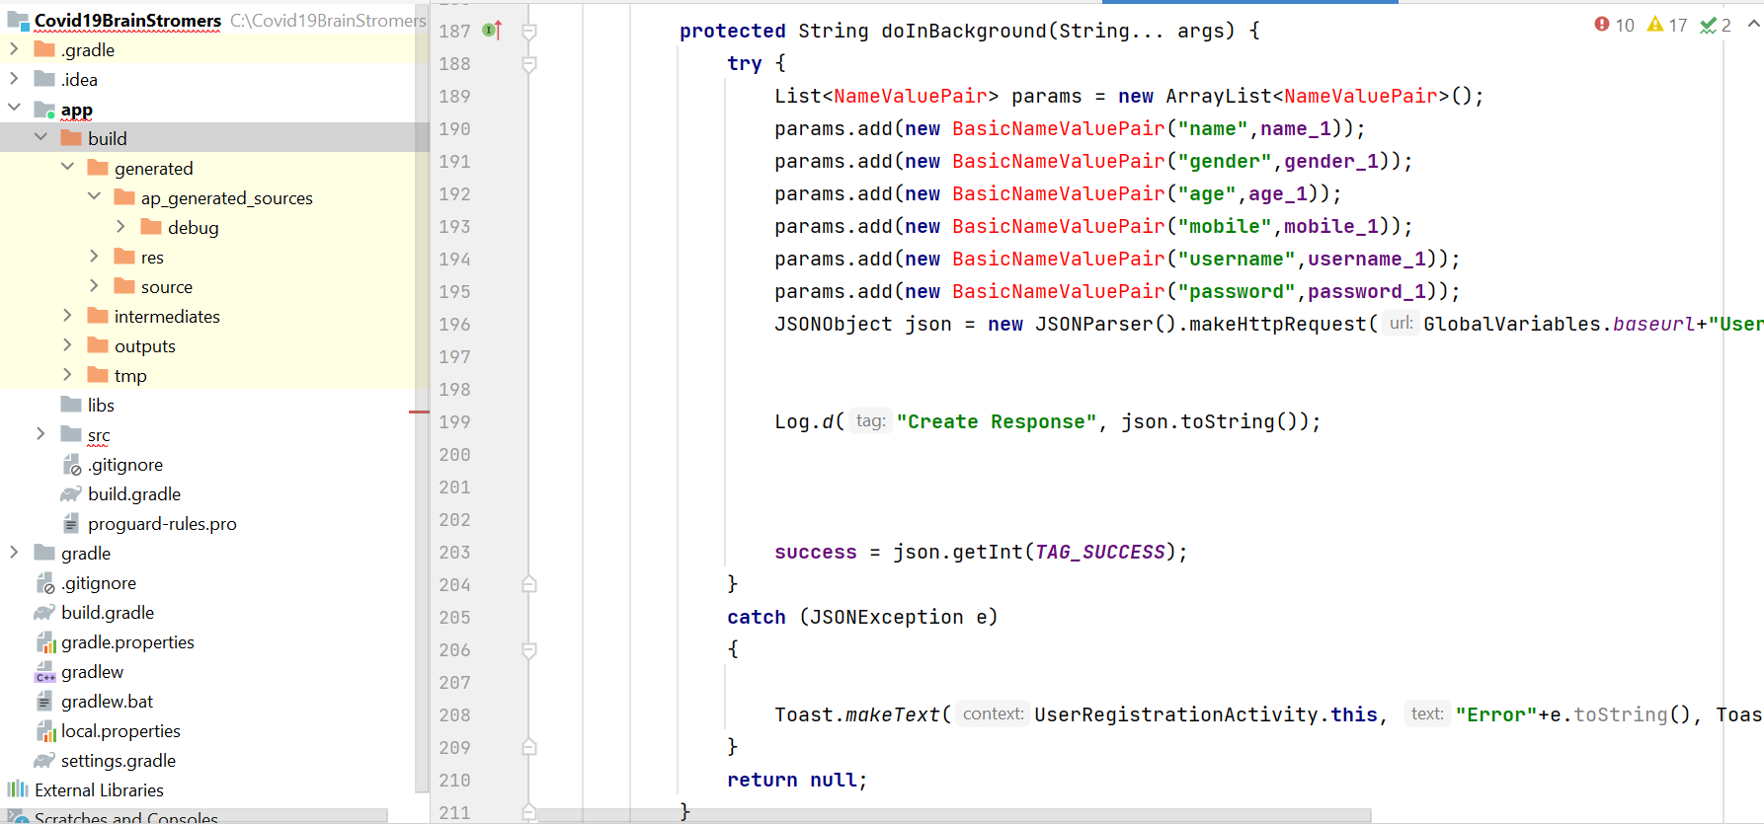

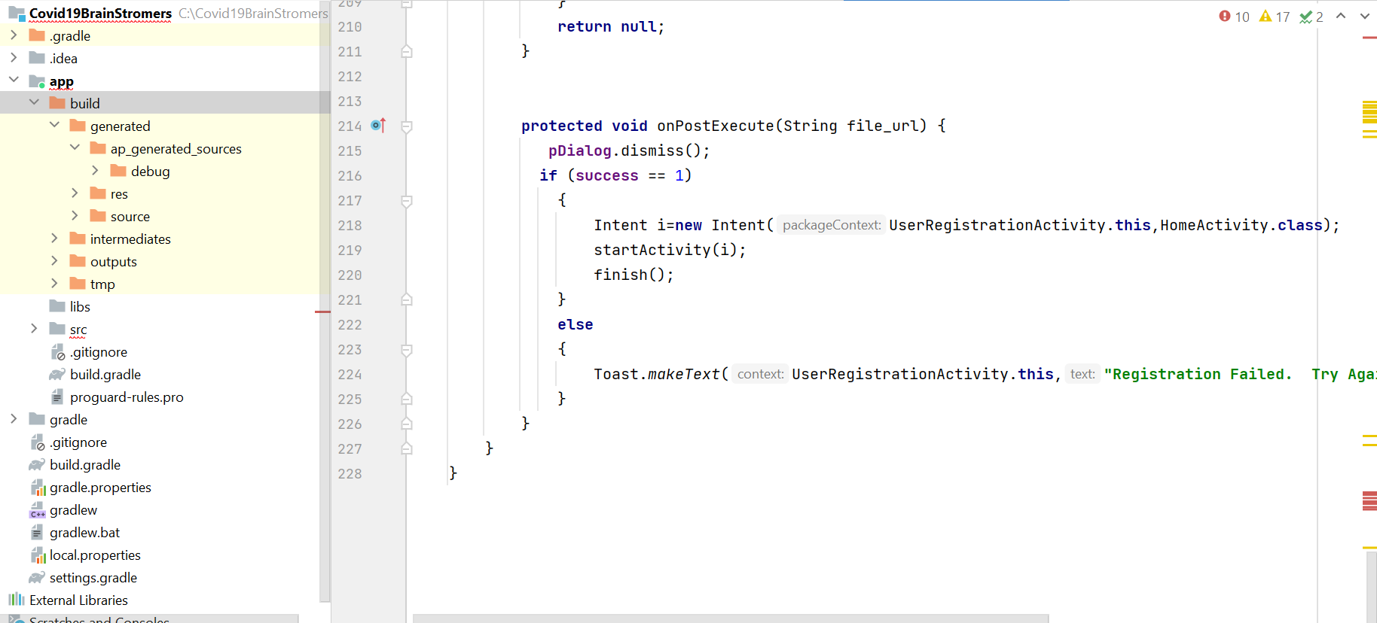

* In doInBackground method it creates a parameter list object with the data given in registration form fields in the activity and makes a request to new registration php file on the servers which actually stores data to database and sends back response code, on success 1 and 0 failure. If the success code is 1 then creates intent object to navigate to HomeActivity to login.

DASHBOARD PAGE:

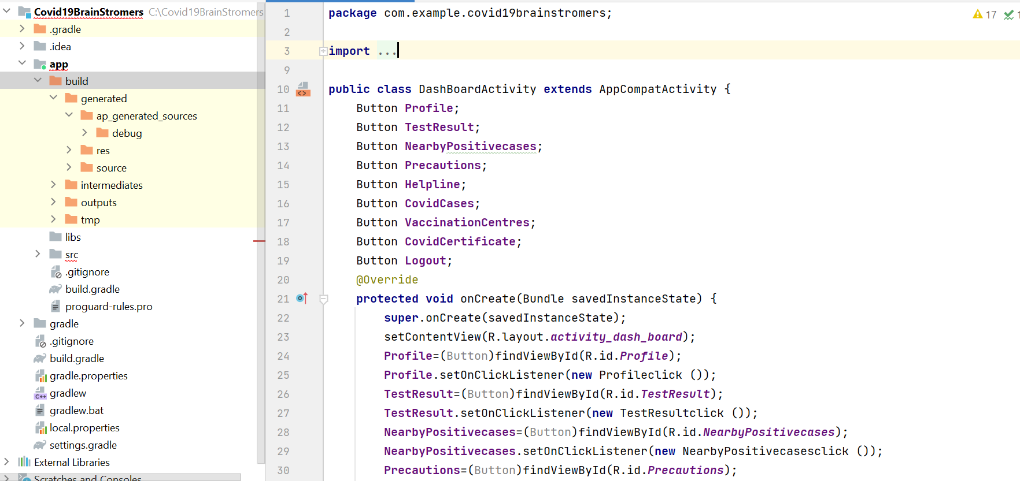

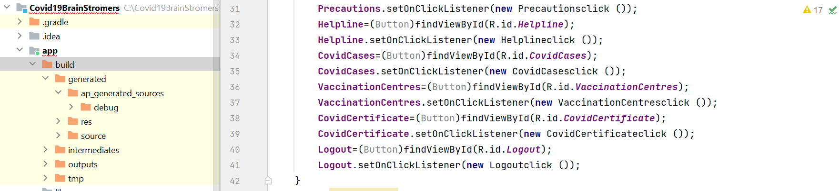

* This Dash board activity gets all objects of various operations performed by the user such as view profile, update test result, see nearby positive cases, precautions to take, helpline numbers, covid cases and vaccination centers.