Software Requirements Document for PCorrector

Author:

Uristen Madi

Ordabayev Akylbek

Aidarov Shokhan

Shalkarbai Nurzhigit

Group 007

|  |  |  |  |
| --- | --- | --- | --- |
| **Version** | **Date** | **Author** | **Change** |
| 0.1 | 09/13/07 | SM | Initial Document |
|  |  |  |  |
|  |  |  |  |
|  |  |  |  |
|  |  |  |  |

Table of Contents

1 Introduction 3

1.1 Purpose 3

1.2 Scope 3

1.3 Definitions, acronymns, abbreviations 3

1.4 References 3

1.5 Overview 3

2 Overall Description 4

2.1 Product Perspective 4

2.2 Product functions 5

2.3 User characteristics 5

2.4 Constraints 5

2.5 Assumptions and Dependencies 5

3 Specific Requirements 6

3.1 External Interface Requirements 6

3.2 FEATURES 6

3.3 Performance requirements 6

3.4 Design Constraints 6

3.5 Software System Attributes 6

3.6 Other Requirements 7

# Introduction

## Purpose

## This application for correcting pictures and uploading to social network

## Scope

## It provides feedback to the customer

## Definitions, acronymns, abbreviations

User

|  |  |
| --- | --- |
| Term | Description |
| User | Person who use our application |
| Instagram | Place where the user sends pictures |
| Corrector | Action which corrects image |

## References

OPENCV API -**opencv**.org/

## Overview

[OMIT]

# Overall Description

The PCorrector application is a pictures correcting tool for users of Instagram.

The application will allow users to correct their pictures and send it to Instagram.

The application will also allow in future to correct a short video.

## Product Perspective

This application is similar existing application in Instagram . It is unique , though ,in that it allows users to do more operation with their pictures and short video.

### Concept of Operations

### The PCorrector application will run on the mobile phone with Android operation system. The application will store information in mobile phone. The application will integrate with user Instagram account. It will use opencv open source framework to change a pictures.

### Major User Interfaces

### Hardware Interfaces

This software requires standard mobile phone with camera.

### Software Interfaces

Standard.

### Communication Interfaces

Standard.

### Memory Constraints

Storage memory.

### Operations.

### Site Adaptation Requirements

No requirements.

## Product functions

### G:\Безымянный.png

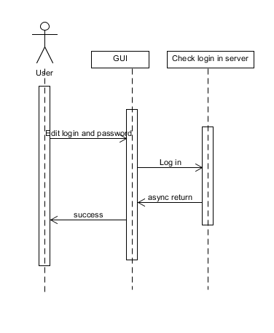

2.2.1 Log in

Description: log in to integrate with Instagram.

Actors: User.

2.2.1.1 Edit login and password.

2.2.1.2 The login and password will checked Instagram.

2.2.1.3 If result will be success user can use our application.

Pre-conditions: Have access to internet

Post-conditions: No

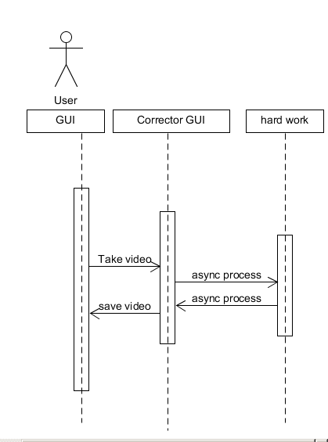

2.2.3 Correct Video

Description: To correct user video.

Actors: User.

2.2.2.1 Get video from gallery or taking video with camera.

2.2.2.2 The result will coming to corrector GUI .

2.2.2.3 After will be used some operations.

2.2.2.4 Saved

Pre-conditions: No

Post-conditions: No

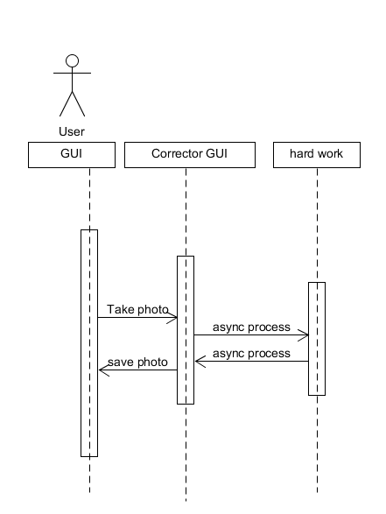

2.2.3 Correct Photo

Description: To correct user photo.

Actors: User.

2.2.3.1 Get photo from gallery or taking photo with camera.

2.2.3.2 The result will coming to corrector GUI .

2.2.3.3 After will be used some operations.

2.2.3.4 Saved.

Pre-conditions: No

Post-conditions: No

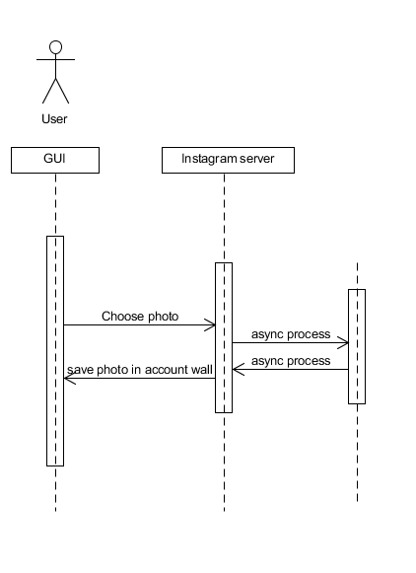

2.2.4 Send photo or video to Instagram

Description: Send photo or video to Instagram to user wall.

Actors: User.

2.2.4.1 Choose photo or video

2.2.4.2 Send photo or video to Instagram

2.2.4.4 Save data in account wall.

Pre-conditions: Internet.

Post-conditions: No

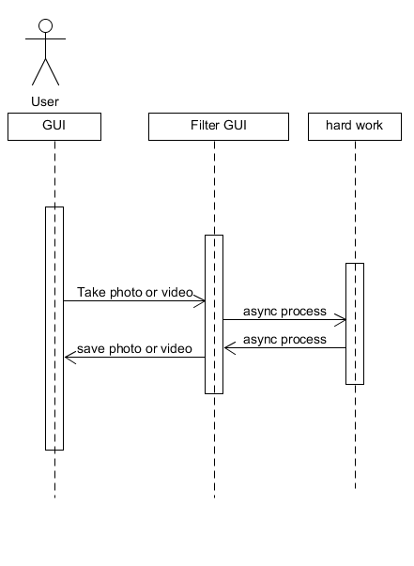

2.2.5 Send photo or video to Instagram

Description: Send photo or video to Instagram to user wall.

Actors: User.

2.2.5.1 Choose photo or video

2.2.5.2 Send photo or video to Instagram

2.2.5.4 Save data in account wall.

Pre-conditions: Internet.

Post-conditions: No

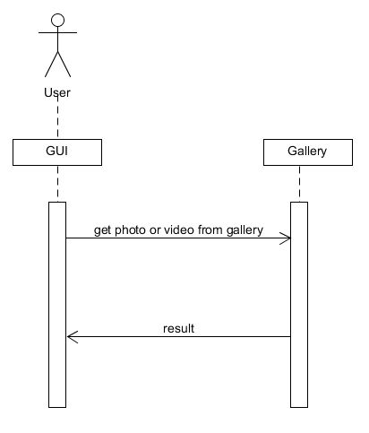

2.2.6 Get photo or video from gallery

Description: Get photo or video from gallery

Actors: User

2.2.6.1 We get photo or video from gallery

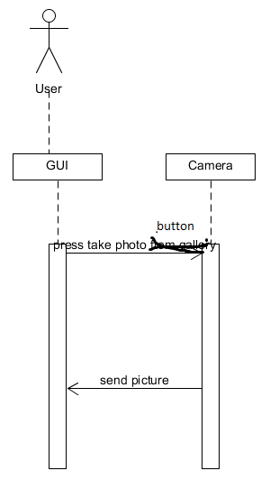

2.2.7 Take photo

Description: Take photo with camera

Actors: User

2.2.7.1 We take photo with camera.

2.2.7.2 After photo will be used by user

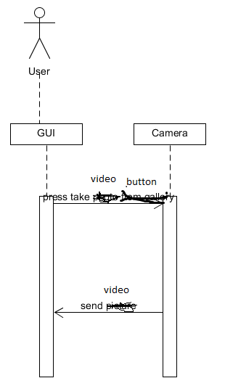

2.2.8 Take video

Description: Take video with camera

Actors: User

2.2.8.1 We take video with camera.

2.2.8.2 After video will be used by user.

## User characteristics

User: Can take, change ,correct a photo and video.

## Constraints

## Assumptions and Dependencies

Android 2.3 and earlier and camera with 5mp or more.

# Specific Requirements

## External Interface Requirements

### User Interfaces

### Hardware Interfaces

### Software Interfaces

### Communications Interfaces

## FEATURES

**3.2.1 Login into Instagram and log out**

**3.2.1.1 Login success/fail**

3.2.1.1.0 The user shall have internet.

3.2.1.1.1 The user shall type his/her unique username into a username field.

3.2.1.1.2 The user shall type his/her password into a password field.

3.2.1.1.3 The user shall press “Login” button to enter into system.

3.2.1.1.4 The system shall check for existence of this user in database( internet).

3.2.1.1.5 The system shall redirect user to main page, if user is exists in database.

3.2.1.1.6 [Inverse Requirement] The system should not allow the user to enter to system, if user types

wrong username or password, or both, or leaves it empty.

3.2.1.1.7 [Error Handling] The system should display an error message, if user types wrong username

or password, or both, and presses login button.

**3.2.1.2 Remember me**

3.2.1.2.0 The system shall automatically log in after 3.2.1.1

**3.2.1.3 Log out**

3.2.1.3.0 After 3.2.1.1 and 3.2.1.2 The system should allow the user log out if log out button pressed.

3.2.1.3.1 The system shall show dialog box.

3.2.1.3.2 The system shall delete all information (username, password, pictures and video),

If user click ‘Ok’ button from dialog box.

3.2.1.3.3 The system shall return to main menu, If user click ‘Cancel’ button from dialog box.

**3.2.2** **Send to Instagram**

**3.2.2.1 Send photo**

3.2.2.1.1 The user shall have internet.

3.2.2.1.1 The system should allow user to choose (multiple choose) some pictures from folder ‘Ready Photo’ to send Instagram.

3.2.2.1.2 After 3.2.2.1.1 system shall send it to Instagram.

**3.2.2.2 Send video**

3.2.2.2.1 The user shall have internet.

3.2.2.2.1 The system should allow user to choose (multiple choose) some video’s from folder ‘Ready Video’ to send Instagram.

3.2.2.2.2 After 3.2.2.2.1 system shall send it to Instagram.

**3.2.3 Correct photo**

**3.2.3.1 Take Photo or Video**

3.2.3.1.0 The system should check device memory.

3.2.3.1.1 The system should allow the user take photo or video if 3.2.1.1.1 will be success.

**3.2.3.2 Get Photo or Video from Gallery.**

3.2.3.1.0 The system should allow the user get some photo or video from Gallery.

**3.2.3.2 Correcting**

3.2.3.2.0 The system should allow user use some filter or correct some photo or video from 3.2.3.1 or 3.2.3.2

**3.2.3.3 Save Photo or Video**

3.2.3.3.0 The system should check device memory.

3.2.3.3.1 If 3.2.3.3.0 is success, The system should allow user save photo in ‘Ready photo’ and video in ‘Ready Video’.

3.2.3.3.2 The user shall give some unique name to photo or video.

3.2.3.3.3 After 3.2.3.3.2 the system shall save it in device memory.

## Performance requirements

## Design Constraints

## Software System Attributes

### Reliability

### Availability

### Security

### Maintainability

### Portability

## Other Requirements